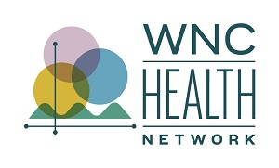
2024 WNC Community Health Survey Methodology

Survey Methodology

The 2024 WNC Community Health Survey was conducted from March to June 2024 across 18 counties in Western North Carolina: Avery, Burke, Buncombe, Cherokee, Clay, Graham, Haywood, Henderson, Jackson, Macon, Madison, McDowell, Mitchell, Polk, Rutherford, Swain, Transylvania, and Yancey. The survey aimed to supplement available secondary data, address regional data gaps, and enable counties to explore specific local health concerns.

Professional Research Consultants, Inc. (PRC) implemented a mixed-mode survey methodology combining telephone (landline and cell) and online surveys. The approach ensured a representative sample of the regional population, allowing for stratification by demographic characteristics while enhancing data collection efficiency.

A significant component of the 2024 survey involved community outreach, incorporating an oversampling strategy via online surveys. These efforts, led by WNC Health Network and the Mountain DEEP team, focused on specific populations, including Black/African American, Hispanic/Latinx and American Indian/ Alaska Native residents, to improve representativeness. The oversampling initiative included a pilot project employing survey ambassadors, as well as engagement through social media and public health partners, resulting in a 28% increase in community outreach survey responses compared to 2021.

Survey Instrument
The survey instrument was developed collaboratively by Mountain DEEP, WNC Regional Data Team, and WNC Healthy Impact’s data workgroup, with input from PRC. Many of the survey questions were drawn from the CDC Behavioral Risk Factor Surveillance System (BRFSS) and other validated public health surveys. Additional questions were designed by WNC Healthy Impact and regional partners to address local health concerns. Each county had the option to include three county-specific questions, with data from these questions available upon request but not included in the regional WNC Data Workbook.

Sampling Approach & Design
PRC designed the survey methodology to minimize sample bias and maximize representativeness. A mixed-mode methodology was used, incorporating:
- Telephone Surveys: Conducted by PRC using live interviewers and computer-aided telephone interviewing (CATI) technology. Calls were made during evening and weekend hours, with up to five call attempts per number. Surveys were conducted in English and Spanish.
- Online Surveys: PRC partnered with a third-party provider to identify and invite respondents to complete an online version of the survey, ensuring better representation of younger and more urban demographic segments.
- Community Outreach: WNC Health Network and local partners promoted an online survey link to drive additional participation. Mountain DEEP and Survey Ambassadors primarily engaged community members through in-person events, while public health partners distributed promotional materials through social media campaigns and printed outreach.
  - To encourage participation, Mountain DEEP provided $25 Walmart gift cards as incentives, while Survey Ambassadors had access to a raffle for five $100 Walmart gift cards.

Survey Administration & Response Rates
PRC administered 3,664 randomly sampled surveys across the region. The community outreach efforts led by WNC Health Network and partners contributed an additional 2,234 responses, bringing the total sample size to 5,898 (Table 1).

Table 1: Survey Response Rates by County and Region
COUNTY | RANDOM-SAMPLE SURVEYS  (PRC) | COMMUNITY OUTREACH SURVEYS  (WNC Health Network) | TOTAL SURVEYS
Avery County | 150 | 16 | 166
Buncombe County | 400 | 508 | 908
Burke County | 201 | 291 | 492
Cherokee County | 201 | 12 | 213
Clay County | 147 | 61 | 208
Graham County | 122 | 14 | 136
Haywood County | 229 | 164 | 393
Henderson County | 356 | 399 | 755
Jackson County | 200 | 145 | 345
Macon County | 201 | 71 | 272
Madison County | 200 | 94 | 294
McDowell County | 200 | 31 | 231
Mitchell County | 151 | 52 | 203
Polk County | 205 | 41 | 246
Rutherford County | 200 | 23 | 223
Swain County | 150 | 97 | 247
Transylvania County | 201 | 63 | 264
Yancey County | 150 | 152 | 302
WNC REGION TOTAL | 3,664 | 2,234 | 5,898

The final dataset was weighted to reflect the demographic composition of the region, ensuring accurate representation of Western North Carolina’s population (Figure 1).

Figure 1: Population & Survey Sample Characteristics
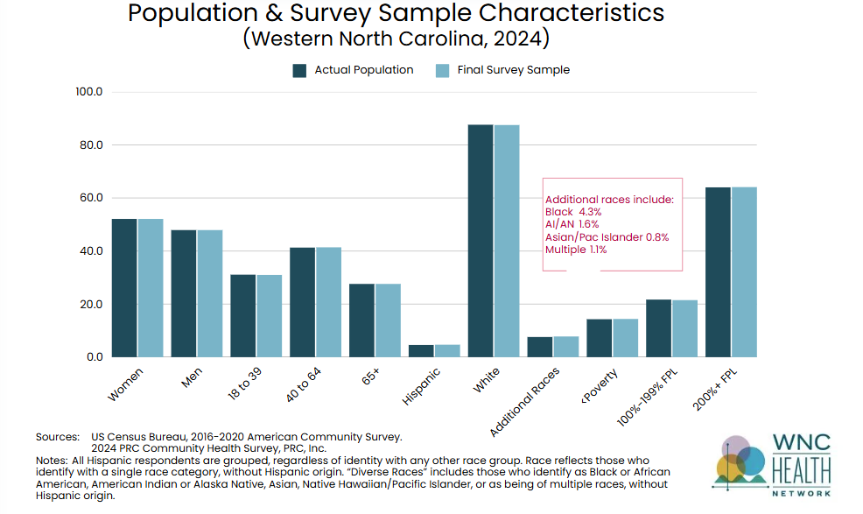

Margin of Error
For the full regional sample of 5,898 respondents, the maximum margin of error is ±1.3% at a 95% confidence level. County-level error margins vary, ranging from ±3.3% in Buncombe County to ±9.8% in Graham County (Table 2).
Table 2: Approximate Error Ranges at the 95 Percent Level of Confidence

 | Sample | Error Rate
Avery County | n = 166 | ± 8.0%
Buncombe County | n = 908 | ± 3.3%
Burke County | n = 492 | ± 4.6%
Cherokee County | n = 213 | ± 6.9%
Clay County | n = 208 | ± 6.9%
Graham County | n = 136 | ± 9.8%
Haywood County | n = 393 | ± 5.2%
Henderson County | n = 755 | ± 3.6%
Jackson County | n = 345 | ± 5.7%
Macon County | n = 272 | ± 6.2%
Madison County | n = 294 | ± 6.2%
McDowell County | n = 231 | ± 6.9%
Mitchell County | n = 203 | ± 6.9%
Polk County | n = 246 | ± 6.9%
Rutherford County | n = 223 | ± 6.9%
Swain County | n = 247 | ± 6.9%
Transylvania County | n = 264 | ± 6.2%
Yancey County | n = 302 | ± 5.7%
WNC Service Area | n = 5,898 | ± 1.3%

Survey Limitations
Despite the robust methodology, several limitations should be considered:
- Sampling Bias: While the mixed-mode approach improved representation, reliance on telephone interviews may have introduced selection bias, potentially underrepresenting households without landlines or those primarily using VoIP services.
- Self-Selection in Online Surveys: Online surveys, particularly those accessed through community outreach efforts, may not fully represent the broader population due to voluntary participation.
- Geographical and Demographic Disparities: Some counties had smaller sample sizes, leading to higher error margins that may affect the reliability of localized data.
- Post-Stratification Adjustments: While weighting techniques improved representativeness, they can amplify the influence of certain demographic groups, potentially introducing minor distortions.
- Language and Literacy Barriers: The survey was available in English and Spanish, but additional language options and alternative formats could have enhanced accessibility for non-English-speaking or low-literacy populations.

Information Gaps
Although the survey effectively captured data on health behaviors and outcomes, some gaps remain:
- Underrepresentation of Certain Populations: Despite oversampling efforts, response rates from some racial and ethnic groups remained low, limiting independent subgroup analyses. These groups include Asian/ Pacific Islander and Multiple Races.
- Limited Data on Youth and Unhoused Populations: The survey focused on adults (18+), with proxy responses provided for children’s health, potentially missing key youth health indicators. Additionally, geographically isolated, transient and unhoused populations may have been underrepresented due to outreach constraints.
- Contextual and Lived Experiences: While the survey provides robust quantitative data, qualitative insights into residents’ lived experiences and social determinants of health are limited.

Conclusion
The 2024 WNC Community Health Survey represents a comprehensive effort to assess regional health needs while improving data equity through community-driven outreach and oversampling strategies. Despite inherent limitations, the findings provide valuable insights into health behaviors, disparities, and opportunities for targeted public health interventions across Western North Carolina.

