
Prioritizing Indicators with Your Community
Having completed your Community Health Assessment, you and your partners have become very familiar with your county’s population-level data, which we will refer to as indicators. An indicator is a measure that helps quantify the achievement of a result—the condition of well-being and the “end” you have in mind for your community.
Create an indicator list for each of your priority issues. List all of the indicators that helped you reach your decision to make each issue a priority. Include the indicators that reflect risk factors related to your priority. You can also brainstorm with your group, reflecting on the questions, “How else might we measure the result we have in mind, and how we envision experiencing that result?”
Prioritize your list. It is important to prioritize your indicator list to 1 to 3 (no more than 5) indicators that speak the most to the changes you wish to see and experience in your community. These will be your “headline indictors,” or the measures that you collectively watch over time.
The following three criteria are good starting points for choosing indicators (see p. 55 in the Trying Hard Is Not Good Enough by Mark Friedman for a more detailed description):
- Communication Power— can be understood by a broad and diverse audience. Common sense and compelling.
- Proxy Power –something of central importance to the result. Can this measure represent a plain language statement of well-being? Can it represent lots of other indicators that are likely to move together in the same direction?
- Data Power— do we have quality data on a timely basis? Annually? Is it credible in our county? Can comparisons be made to state or national data?

Use dot-voting. A simple dot-voting technique can be used to rate an indicator based on these criteria. Use 3 different colors of dot stickers, each one representing one of the 3 criteria, e.g. green for communication power, yellow for proxy power and blue for data power. Give each participant 2 or 3 dot stickers of each color—use your judgement, based on the number of people voting. Use the following script as a guide for your team:
- Use your green dots to vote for the indicators that have the most communication power, meaning it is easy to understand by most people in our community and is attention-grabbing or compelling. Only use one dot per indicator; do not double or triple your vote. You do not have to use all of your dots (i.e. if you only see one indicator that has strong communication power, only vote for that one, one time and keep the other dots). [Then allow people time to get up and complete this round of voting]
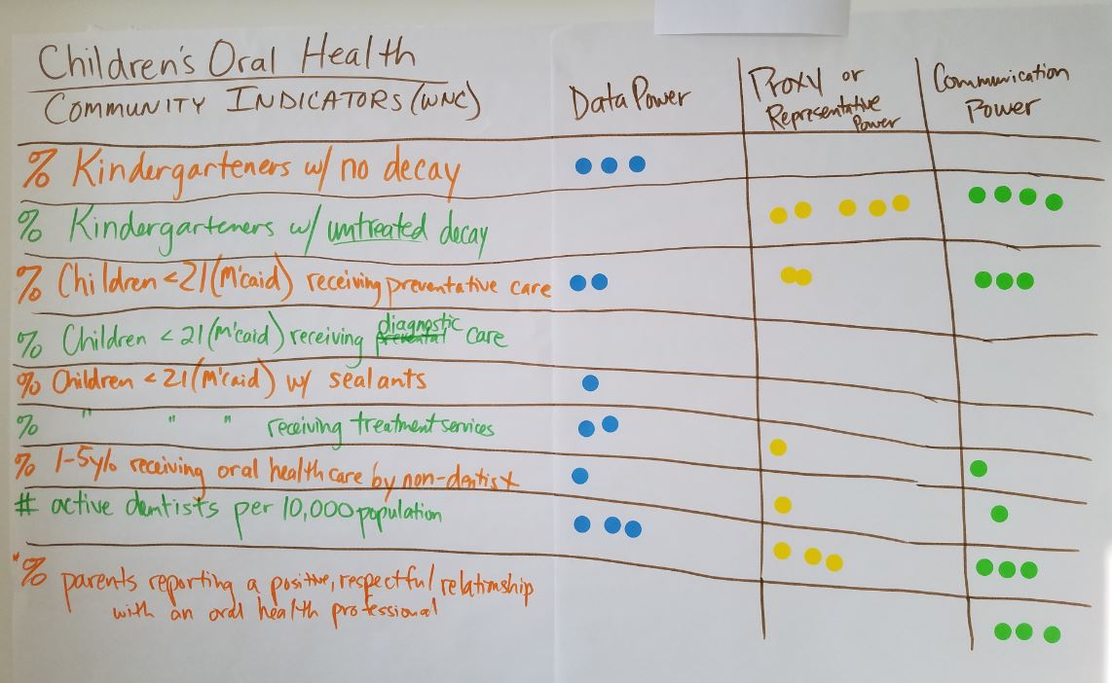
- Use your yellow dots to vote for the indicators that have the most proxy power, meaning it is of central importance to and representative of the result. It may also be a good representative of a grouping of indicators that are likely to move together. [continue instructions from #1 starting with, “Use only one dot…”]
- Use your blue dots to vote for the indicators that have the strongest data power, meaning it is quality data that we have access to on a timely basis that is relevant to our county and can compare against state and national data. [continue instructions from #1 starting with, “Use only one dot…”]
If you have indicators that are ranked high in all three categories, then you have an excellent indicator to use to get started on moving from talk to action toward your desired result. Also, an indicator with a high ranking in all three categories will likely resonate for your community. If none of your indicators rank high on all three categories, then start with the best of what you have. In addition to headline indicators, this prioritization process helps you identify:
- Secondary Indicators: any other measures for which there is good data. These data are still a valuable part of the “Story Behind the Curve” in your e-CHIP.
- Data Development Agenda: your priorities for new and improved data. You can starting working to develop new and better data, while moving forward with getting from talk to action based on the best data you currently have.

Adapted by WNC Healthy Impact from Trying Hard Is Not Good Enough, by Mark Friedman and Guide to Results-Based Planning and Facilitation, National Results & Equity Collaborative

