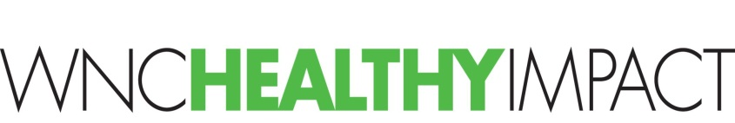
Clarifying Results & the Experience of Success with Your Community

Asking the question: “What result(s) do we want for our community?” helps us to focus community-health improvement work on the ends we have in mind for our communities.

In this context, a result is a condition of well-being for children, families and/or the entire community. Results are intentionally aspirational and visionary. Results stated in plain language provide common ground for communities. People who have very different ideas about what to do about your priority health issues (i.e., what actions to take), can still agree on results like:

- All kids succeed in school in ABC County
- Safe neighborhoods in XYZ town
- Supportive families that bounce back in ABC County
- People in LMN neighborhood are healthy at all ages
- Thriving economy in WNC

You may already have results-type language to pull from. Look at the Executive Summary of your Community Health Assessment (CHA) (CHA Template, p. 7) or existing vision statements from ongoing workgroups or coalitions. See the back side of this document for more examples of priority-specific results statements.
Next, invite your partners to envision success. In a few minutes, you can have them imagine what will be different about your community when you are successful at achieving the result you envisioned together.
You can ask your group:
- “How would we like to see our community change or be different because of our community health improvement work?”
- “How would we experience this?” and “How would we know it when we saw it?”

This activity can energize your group and put them in a positive frame of mind. The generated description of how you would experience success can be a touch stone for your group moving forward: “Will this project/program help us get the result and experience we envisioned together?”
Translating Priority Areas to Results (conditions of well-being for a population in plain language):

Priority Area  (interest area for focus) | Multiple Priority Areas/ Cross-Cutting | Substance Abuse  (youth prevention) | Substance Abuse  (opioid overdose, unintentional poisoning) | Mental Health  (access to services/care) | Diabetes  (management)
Sample Results (also needs to name population & geography) | - Productively engaged, employed and contributing  - Healthy, safe and thriving  - Resilient community | - Youth belong to strong and helpful families  - Youth engage in healthy activities and behaviors  - Resilient youth  - Babies born unexposed to substances | - Resilient  - Belong to strong and helpful families | - Happy  - Feel cared for and supported  - Connected to care  - Belong to strong and helpful families | - Healthy people  - Connected to care

Priority Area  (interest area for focus) | Physical Activity  (places to be active) | Nutrition  (access to healthy food) | Tobacco  (use by pregnant women) | Tobacco  (healthy environments) | Social Determinants of Health  (economy)
Sample Results (also needs to name population & geography) | - Active people  - Vibrant parks and trails | - Well-nourished children  - Families free from hunger | - Tobacco-free babies | - Clean and healthy public spaces  - Tobacco-free children | - Thriving communities  - Affordable Homes

