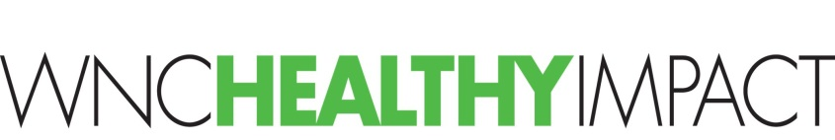
Getting to Strategies – “Getting Organized” Checklist

This checklist will help you think through and create your local approach to organizing, planning, and implementing your Community Health Improvement Plan (CHIP). We know that how we approach community health improvement work can make or break our partnerships and efforts. This is a good time in the cycle to reflect on how you get this work done.
- Clarify if this is a new or continuing priority.
- Are there existing groups/coalitions (that you participate in or not) that already convene around this issue in your community?
  - If yes, meet with the convener to explore how not support, rather than duplicate, each other’s work
  - If yes, confirm that your key partners (health department, hospital, and others) are connected to the group. If not, would that be helpful?
- Clarify what strategies/programs are already active related to your priority issues (you may have already done this as part of your CHA – see CHA template, p. 29, “What’s Already Happening?”).
  - Is there evidence that these strategies are working, i.e. customers/target audience are “better off” – have experienced changes in knowledge, attitude, skill, behavior and/or circumstance?
  - Could these strategies reach a different audience?
- What group/team structure is in place, if any, to support the CHIP?
- Who/what group will make decisions about which strategies will be included in the CHIP?
- Team structure and roles to consider:
  - Leadership team/steering committee – a cross-sector, community-wide team of individuals with the ability to make decisions for their agencies/organizations. This group is at an appropriate level to take accountability for monitoring community indicators, recommending new and continuing strategies, and supporting work groups. They often meet quarterly; sometimes annually.
  - Action teams/work groups/task forces – cross-sector, community-wide teams who meet regularly to develop and implement plans of action for specific strategies. This is group is at an appropriate level to take accountability for identifying and monitoring performance measures for programs/initiatives and to make changes to the action plan, as needed.
  - Team leaders
  - Team facilitator
- Are the roles and responsibilities of each team clearly stated and understood by team members?
- Define the purpose of your teams. Will the work of your teams be to implement new strategies together? Align strategies that each member organization is leading? Expand or enhance existing strategies?
- Do you have guiding principals or ways of working together as a team? Consider using the WNC Healthy Impact “Establishing Group Agreements” tool.
- Are the roles and responsibilities of support staff clearly stated and understood by everyone involved?
- Which staff member is responsible for building and updating the electronic Community Health Improvement Plan (e-CHIP)?
- How will you gather feedback from the group(s) about how things are going? Consider using a few questions from the WNC Healthy Impact “Collaborative Group Effectiveness” questionnaire tool on a regular basis to monitor the progress of the group.
- Have you attended a “Getting to Results” training? WNC Health Network offers these for free, quarterly. This will help you prepare for implementing and monitoring the strategies your select for your CHIP.

Resources
- WNC Health Network team – call or email anytime!
- Developing Coalitions: An Eight Step Guide, by Prevention Institute
- Work Together, County Rankings & Roadmaps

