Name of the Key Health Issue
[Use this space to include your Coalition or Organization’s logo]

Brief statement about the types of data that were considered and the process used (e.g. Alzhiemers and Dementia were discovered to be issues of high concern in both secondary data and the Online Key Informant Survey of community leaders in a data review from our Community Health Assessment data team).

What do the numbers say?
Change out this graph for one relevant to your key health issue for this document
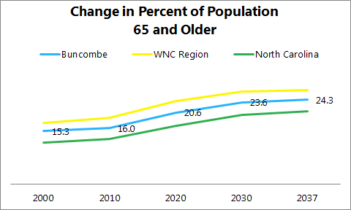
- Related morbidity data
- Related mortality data
- Relavant demographic trends
- Other relevant data

What did the community say?
What’s Helping? | What’s Hurting?
- Add themes from any community listening sessions and/or key informant interviews  - “Insert quotes from listening sessions and/or key informant interviews” | - Add themes from any community listening sessions and/or key informant interviews  - “Insert quotes from listening sessions and/or key informant interviews”
What else do we know?
- Miscellaneous sections to capture other information that is relevant
- Outlier discoveries from listening sessions
What is already happening?*
- Programs
- Active grants
- Agency efforts
- Existing partnership/coalitions
- Etc.

*not an exhaustive list; examples of the type of work already addressing this issue. Feel free to add what you know!

You could add more headings/sections, as needed, to give your participants the information they need to use the Rating & Prioritizing Key Health Issues worksheet. Other categories could include:
- What works to do better? – Evidence-based practices to address this issue
- What works to do better? – What people most affected by issue think
- How this issue is linked to other important issues
- Consequences of not addressing this issue (including cost in $; maybe include information about how this issue is showing up in hospitals with admissions and readmissions)
- Opportunities for short-term wins

Tool adapted by WNC Health Network from Buncombe County CHIP data team –
Buncombe County Health and Human Services, MAHEC and Mission Health, October 2018

