2018

[Insert Name] County
Community Health Assessment

YOUR LOGO(s) HERE
TEMPLATE NOTE TO WNC HEALTHY IMPACT PARTNERS
*Note: This entire page should be deleted as you finalize your CHA product*
This document has been created as part of WNC Healthy Impact as a guide for the completion of your county-level 2018 Community Health Assessment Product.

About this Template:
- Cover:
  - Modify with logos (no state logos; accreditation seal is ok) and images as preferred. This is your “2018” CHA regardless of when it is submitted within the December 2018 – March 2019 window.
- Compliance and guidance:
  - Our goal is to be supportive of the requirements of local health departments and hospitals for CH(N)A in creating this product.
  - As always, you will continue to be accountable for final compliance details and will may adjust this template as you see fit.
  - Our guidance in this template is not intended as legal, accreditation, or tax advice.
  - For up-to-date NC DPH requirements, visit https://publichealth.nc.gov/lhd/, or contact Kathryn Dail, Kathy.dail@dhhs.nc.gov.
- Formatting:
  - Some of the text in this document is written in red like this or in italics like this for data suggestions, which means the text is guidance for you that should be replaced or deleted in the final draft.
  - This report will be submitted electronically; you may use electronic links in the report as desired. Depending on what will work best for your key audiences, you may want to consider linking to videos, using QR codes so that people can easily access links even if they’re looking at a paper copy, and embedding links to your Scorecard.
- Accreditation benchmarks:
  - Sections related to Accreditation benchmarks have been noted like this: “Relates to Accreditation Activity 1.x.” This text should be deleted from the final document after you read it and add the content needed in that section.

Working with Your Hospital(s):
- Please remember that your partner hospital(s) will be using this final CHA report to create their Community Health Needs Assessment.
- The hospitals will be receiving a Community Health Needs Assessment template, which is designed to insert sections from this community-wide CHA.
- As always, please partner closely with your hospital in all phases of Community Health Improvement, including finalizing your CHA report.
- It is best practice to also give your hospital the chance to review any press materials mentioning their facility before you distribute to your local media.

Support WNC Health Network Can Offer for Free:
- Proofreading and copyediting
- Minor graphic design (cover layout, headers)
- Formatting assistance
- Hosting study hall sessions to get in-person peer support and maximize your work time.
- Activities to develop community results/vision statement
- Assistance understanding and interpreting regional data and/or inserting any of the data tables, graphs, etc. from WNC Healthy Impact regional data products

[INSERT NAME] COUNTY
COMMUNITY HEALTH ASSESSMENT

ACKNOWLEDGEMENTS
This document was developed by [local health department name] in partnership with [hospital(s) & other key partners; include all your hospitals if multiple hospitals cover your area] as part of a local community health (needs) assessment process. We would like to thank and acknowledge several agencies and individuals for their contributions and support in conducting this health assessment:

County and hospital(s) to insert list of who they want to acknowledge in supporting the community health assessment process and creation the final document. Per CHNA Requirements this needs to include: Duration of participant (can simply be season and year). Input also needs to include ALL the people involved: CHA advisory committee, prioritization, work groups, etc.

Name | Agency | Role/ Contribution | Duration of Participant | Agency Website
Ex. First, Last | ABC Health Department | Head of CHA Advisory Committee | Winter 2017 | www.abchealth.org
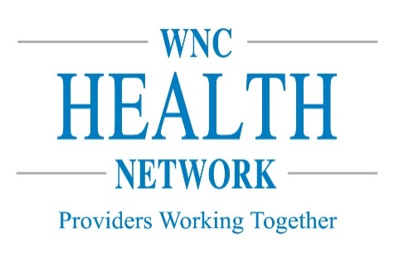
Our community health assessment process and products were supported collaboratively by WNC Healthy Impact, a partnership between hospitals and health departments to improve community health in western North Carolina. This innovative regional effort is coordinated, housed and financially supported by WNC Health Network, the alliance of western NC hospitals working together to improve health and healthcare. Learn more at www.WNCHN.org.



TABLE OF CONTENTS
The final step of completing your CHA Report should be going through this TOC, making sure it aligns with that you actually included in your report, and changing out the Xs for page numbers.

[Insert Name] County 2018 CHA Executive Summary X
Community Results Statement X
Leadership X
Partnership/collaborations X
Regional/Contracted Services X
Theoretical framework/model X
Collaborative Process Summary X
Key Findings X
Health Priorities X
Health Priority 1 X
Health Priority 2 [If you have more than 2 priorities list additional here] X
Next Steps X
Chapter 1 – Community Health Assessment Process X
Purpose X
Definition of Community X
WNC Healthy Impact X
Data Collection X
Core Dataset Collection X
Additional Community-Level Data X
Health Resources Inventory X
Community Input & Engagement X
At-Risk & Vulnerable Populations X
Chapter 2 – [Insert Name] County X
Location and Geography X
History X
Population X
Chapter 3 – A Healthy [Insert County Name] X
Elements of a Healthy Community X
Community Assets X
Chapter 4 – Social & Economic Factors X
Income X
Employment X
Education X
Community Safety X
Housing X
Family & Social Support X
Chapter 5 – Health Data Findings Summary X
Mortality X
Health Status & Behaviors X
Clinical Care & Access X
At Risk Populations X
Chapter 6 – Physical Environment X
Air Quality X
Water X
Access to Healthy Food & Places X
Chapter 7- Health Resources X
Health Resources X
Process X
Findings X
Resource Gaps X
Chapter 8 – Identification of Health Priorities X
Health Issue Identification X
Priority Health Issue Identification X
Priority Issue #1 X
Priority Issue #2 X
Chapter 9 - Next Steps X
Sharing Findings X
Collaborative Action Planning X
Works Cited X
Appendices X
Appendix A - Data Collection Methods & Limitations X
Secondary Data from Regional Core X
Secondary Data Methodology X
Data limitations X
Gaps in Available Information X
WNC Healthy Impact Survey (Primary Data) X
Survey Methodology X
About the [insert county name] Sample X
Benchmark Data X
Information Gaps X
Online Key Informant Survey (Primary Data) X
Online Survey Methodology X
Local Survey Data or Listening Sessions (if applicable) X
Data Definitions X


[INSERT NAME] COUNTY 2018 COMMUNITY HEALTH ASSESSMENT EXECUTIVE SUMMARY

Note: Per DPH executive summary guidelines, this executive summary should be approximately 750 Words.

Community Results Statement
Community Result is a plain language statement of well-being. It is aspirational. For example, “Healthy, Happy Productive People in X County;” “Children in X County are Healthy and Safe;” “Thriving and Resilient Families in X County;” “Active and Well-Nourished Citizens.” These kinds of statements might already exist for a standing health coalition.
Contact WNCHN staff for ideas on how to develop a community results statement.

Leadership for the Community Health Assessment Process
Briefly describe here what leadership for the CHA process looks like in your community. List key leaders in the table below.

Name | Agency | Title | Agency Website
Ex. First, Last | ABC Health Department | Head of CHA Advisory Committee | www.abchealth.org

Partnerships
Briefly describe here what partnership for the CHA process looks like in your community. List key leaders in the table below.

Name | Agency | Title | Agency Website
Ex. First, Last | ABC Health Department | Head of CHA Advisory Committee | www.abchealth.org

Regional/Contracted Services
Our county received support from WNC Healthy Impact, a partnership and coordinated process between hospitals, public health agencies, and key regional partners in western North Carolina working towards a vision of improved community health. We work together locally and regionally to assess health needs, develop collaborative plans, take action, and evaluate progress and impact. This innovative regional effort is coordinated and supported by WNC Health Network. WNC Health Network is the alliance of hospitals working together to improve health and healthcare in western North Carolina. Learn more at www.WNCHN.org.

Theoretical Framework/Model
WNC Health Network provides local hospitals and public health agencies with tools and support to collect, visualize, and respond to complex community health data through Results-Based Accountability™ (RBA). RBA is a disciplined, common-sense approach to thinking and acting with a focus on how people, agencies, and communities are better off for our efforts.

Through WNC Healthy Impact, all hospitals and their public health partners can access tailored Results-Based Accountability training and coaching; scorecard licenses and development (including the electronic Hospital Implementation Strategy); and scorecard training and technical assistance.

Collaborative Process Summary
Relates to Accreditation Activity 1.1.a (Evidence of community collaboration in planning/conducting assessments)

[County Name]’s collaborative process is supported by WNC Healthy Impact, which works at the regional level.

Locally, our process is insert information about your local CHA process here. Include details that help your community understand how you got from data collection to priorities.
Phase 1 of the collaborative process began in January, 2018 with the collection of community health data. For more details on this process see Chapter 1 – Community Health Assessment Process.

Key Findings
Summarize major findings from the primary, secondary, and resource assessment and analyses.

Health Priorities
Identify the top health priorities selected for the community health improvement plans. Per state requirements, identify at least the top two priorities.

Health Priority 1
Health Priority 2

Next Steps
Indicate next steps for developing the community health improvements plans. Ideas you could include in this section:
- Describing how your leadership and/or work groups will support planning and taking action around the priorities
- Working with your teams and/or community members to better understand the story and root causes behind your priority issues
- Engaging with existing and new partner to help do better on these issues
- Identifying what works to do better on these issues, including evidence-based strategies (e.g. literature review), what is working in other communities, and what people most affected by the issues think would work to do better on the priorities (e.g. listening sessions)
- Selecting priority strategies, creating performance measure to help you know how people are better-off because of the strategies
- Publishing the Community Health Improvement Plan (CHIP) on an electronic Scorecard that anyone can access to monitor progress (could link to last cycle’s Scorecard as an example)
- Consider adding a link or contact info here for people who want to access the full data set


CHAPTER 1 – COMMUNITY HEALTH ASSESSMENT PROCESS

Purpose
Community health assessment (CHA) is an important part of improving and promoting the health of county residents. A community health assessment (CHA) – which is a process that results in a public report – describes the current health indicators and status of the community, what has changed, and what still needs to change to reach a community’s desired health-related results.

What are the key phases of the Community Health Improvement Process?
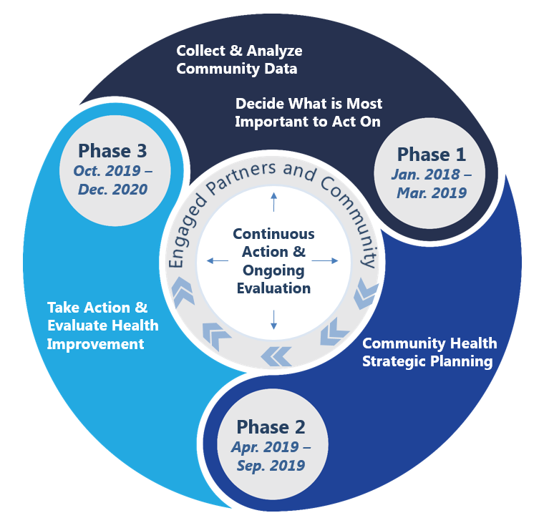
In the first phase of the cycle, process leaders for the CHA collect and analyze community data – deciding what data they need and making sense of it. They then decide what is most important to act on by clarifying the desired conditions of wellbeing for their population and by then determining local health priorities.

The second phase of the cycle is community health strategic planning. In this phase, process leaders work with partners to understand the root causes of the identified health priorities, both what’s helping and what’s hurting the issues. Together, they make a plan about what works to do better, form workgroups around each strategic area, clarify customers, and determine how they will know people are better-off because of their efforts.

In the third phase of the cycle, process leaders for the CHA take action and evaluate health improvement efforts. They do this by planning how to achieve customer results and putting the plan into action. Workgroups continue to meet, and monitor customer results and make changes to the plan as needed. This phase is vital to helping work groups understand the contribution their efforts are making toward their desired community results.

Definition of Community
Your local hospital will pull this definition into their CHNA report.
Community is defined as "county" for the purposes of the North Carolina Community Health Assessment Process. [Insert] county is included in [insert hospital(s) name(s)] community for the purposes of community health improvement, and as such they were key partner in this local level assessment.

WNC Healthy Impact
WNC Healthy Impact is a partnership and coordinated process between hospitals, public health agencies, and key regional partners in western North Carolina working towards a vision of improved community health. We work together locally and regionally to assess health needs, develop collaborative plans, take action, and evaluate progress and impact.

This regional initiative is designed to support and enhance local efforts by:
- Standardizing and conducting data collection,
- Creating communication and report templates and tools,
- Encouraging collaboration,
- Providing training and technical assistance,
- Addressing regional priorities, and
- Sharing evidence-based and promising practices.

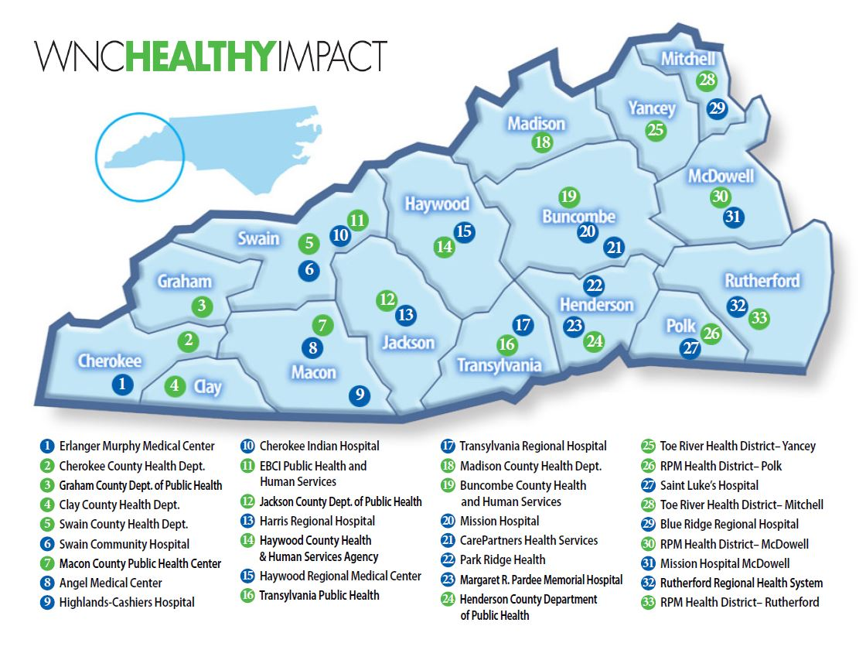
This innovative regional effort is supported by financial and in-kind contributions from hospitals, public health agencies, and partners, and is coordinated by WNC Health Network. WNC Health Network, Inc. is an alliance of hospitals working together, and with partners, to improve health and healthcare. Learn more at www.WNCHN.org.

Data Collection
Relates to Accreditation Activity 1.1.g. – Use scientific methods for collecting/analyzing data – also more detail included in methods section in the appendix.

The set of data reviewed for our community health assessment process is comprehensive, though not all of it is presented in this document. Within this community health assessment we share a general overview of health and influencing factors, then focus more on priority health issues identified through a collaborative process. Our assessment also highlights some of our community strengths and resources available to help address our most pressing issues.

Core Dataset Collection
The data reviewed as part of our community’s health assessment came from the WNC Healthy Impact regional core set of data and additional local data compiled and reviewed by our local CHA team. WNC Healthy Impact’s core regional dataset includes secondary (existing) and primary (newly collected) data compiled to reflect a comprehensive look at health. The following data set elements and collection are supported by WNC Healthy Impact data consulting team, a survey vendor, and partner data needs and input:
- A comprehensive set of publicly available secondary data metrics with our county compared to the sixteen county WNC region
- Set of maps accessed from Community Commons and NC Center for Health Statistics
- WNC Healthy Impact Community Health Survey (cell phone, landline and internet-based survey) of a random sample of adults in the county
- Online key informant survey
See Appendix A for details on the regional data collection methodology.

Additional Community-Level Data
Counties to insert additional information about their data process if data outside of the regional core were added or reviewed – clarify types of data/sources. For example, if you locally reviewed NC DETECT data for your county that could be mentioned here – or if you got additional data from DSS, schools, etc. to learn more about specific health concerns. Also, if you did new data collection – focus groups, listening sessions, etc. you can briefly mention that here. You don’t need to talk about the data details (numbers or themes) here, just mention that you reviewed additional community-level data. In Appendix A – methods – you can describe the process in greater detail.

Health Resources Inventory
We conducted an inventory of available resources of our community by reviewing a subset of existing resources currently listed in the 2-1-1 database for our county as well as working with partners to include additional information. Where gaps were identified, we partnered with 2-1-1 to fill in or update this information when applicable. See Chapter 7 for more details related to this process.

Community Input & Engagement
Including input from the community is a critical element of the community health assessment process. Our county included community input and engagement in a number of ways:
This section is a placeholder for inserting specific information about how community input & engagement works within your local process – modify or add bullets below as appropriate.
- Partnership on conducting the health assessment process
Consider including a photo here that represents community involvement.
- Through primary data collection efforts (survey, key informant interviews, listening sessions, etc.)
- By reviewing and making sense of the data to better understand the story behind the numbers (i.e. describe your data teams)
- In the identification and prioritization of health issues

In addition, community engagement is an ongoing focus for our community and partners as we move forward to the collaborative planning phase of the community health improvement process. Partners and stakeholders with current efforts or interest related to priority health issues will continue to be engaged. We also plan to work together with our partners to help ensure that programs and strategies in our community are developed and implemented with community members and partners.

At-Risk & Vulnerable Populations
Relates to Accreditation Activity 1.1.h (Identify population groups at risk for health problems)

Throughout our community health assessment process, our team was focused on understanding general health status and related factors for the entire population of our county as well as the groups particularly at risk for health disparities or adverse health outcomes. For the purposes of the overall community health assessment, we aimed to understand differences in health outcomes, correlated variables, and access, particularly among medically underserved, low-income, and/or minority populations, and others experiencing health disparities.

The at-risk and vulnerable populations of focus for our process and product include:

- Description
- Description
- Description
- Description
- Description

Public Health Agencies are required to identify and include “at-risk” population groups in their Community Health Assessment, Benchmark 1, Activity 1.1 and a variety of other Accreditation Activities. If a certain relevant population group is not included in your data for some reason, explain why in this section.

As you identify “at-risk” populations for your Community Health Assessment, you might want to take into consideration the additional accreditation requirements related to the identified “at-risk” groups:
- Benchmark 10, Activity 10.2
- Benchmark 11, Activity 11.1
- Benchmark 19, Activity 19.1
- Benchmark 22, Activity 22.1

Though there are not universally accepted definitions of the three groups, here are some basic definitions from the Health Department Accreditation Self-Assessment Instrument (in some cases definitions have been slightly altered to better represent our region):

Underserved populations relate to those who do not access health care either because there is a lack of services or providers available or because of limitations such as income, literacy/language barriers or understanding on how to access services, cultural competency of clinicians, trust, transportation, etc.

At-risk populations are the members of a particular group who are likely to, or have the potential to, get a specified health condition. This could be from engaging in behavior (such as pregnant women who smoke) that could cause a specified health condition, having an indicator or precursor (high blood pressure) that could lead to a specified health condition or having a high ACE score (traumatic experiences), which is correlated with increased risk of specified health conditions.

A vulnerable population is one that may be more susceptible than the general population to risk factors that lead to poor health outcomes. Vulnerable populations, a type of at-risk population, can be classified by such factors as race/ethnicity, socio-economic status, cultural factors and age groups.

Health Department Self-Assessment Instrument Interpretation Documents 1.1.18


CHAPTER 2 – [INSERT NAME] COUNTY

Location, Geography, and History are not requirements to include – only do so if you can make it relevant to your county’s health and/or community health assessment process.

Location, Geography, and History of [County]
Describe the geographic area. List county and other boundaries; Include description of the rural nature of county if applicable/based on population figures included in the demographics section.
Briefly describe how the county was founded, important traditions, practices, or stories that are important parts of county tradition that may influence certain health behaviors or health outcomes.

Population
Relates to Accreditation Activity 1.1.b (Reflect the demographic profile of population)
Data is available on the population of your county, stratified and presented in different ways. You may choose to insert some of that information here visually in graphs, tables, or maps to help describe or illustrate the population within your county and how it is changing or not, in addition to text to describe these or other important aspects to note.
Cherokee, Graham, Haywood, Jackson or Swain counties might also consider including population information from the EBCI Tribal Health Assessment. To access this data contact Mark Tuttle at marktutt@nc-cherokee.com .
- General Population Characteristics (total population count, male/female, median age)
- Minority Populations
- Population Change (seniors, youth)
- Birth Rate
- Geographic Mobility
- Family Composition
- Military Veterans
- Linguistic Isolation
- Voting Trend
- Urban-Rural Population
- Homelessness
- Educational Attainment


CHAPTER 3 – A HEALTHY [INSERT NAME] COUNTY

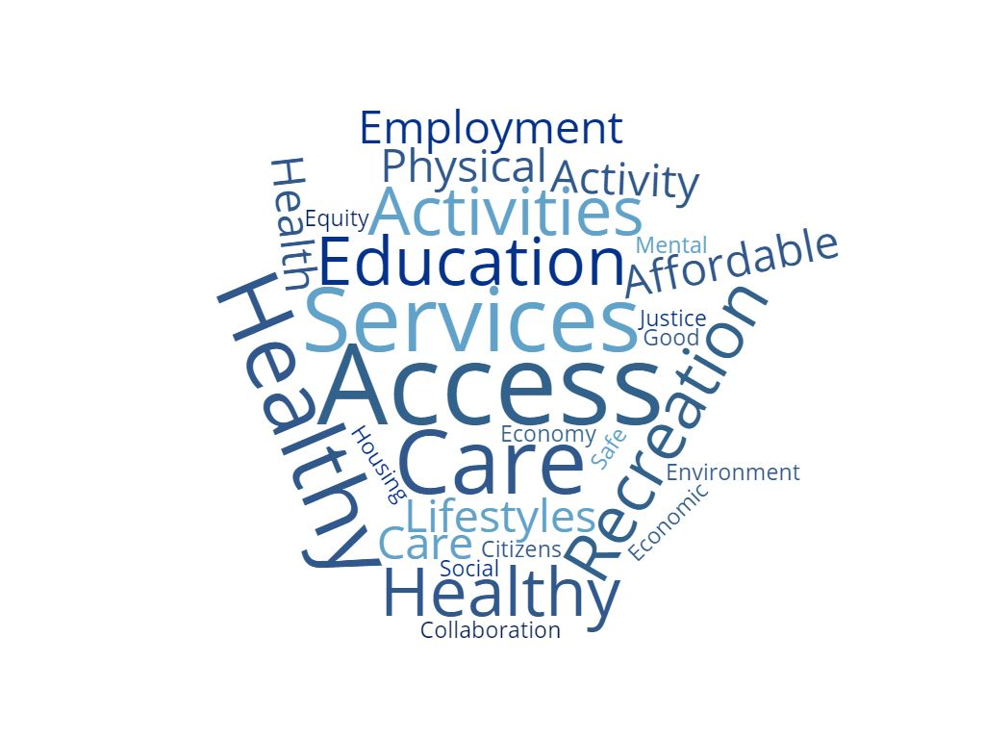
Elements of a Healthy Community
In the online survey, key informants were asked to list characteristics of a healthy community. They were also asked to select the health issues or behaviors that they feel are the most critical to address collaboratively in their own community over the next three years or more. Follow-up questions asked them to describe which contributors to progress and impediments of progress exist for these issues, as well as the likelihood that collaborative effort could make a positive change for these issues.
You can make a word cloud from your survey results using a free tool like www.wordclouds.com. Contact us if you need assistance.
When key informants were asked to describe what elements they felt contributed to a health community in our county, they reported:
- Theme 1
- Theme 2
- Theme 3
- Theme 4
This information may come from your key informant survey findings, focus groups, or other primary data collected during your process.
You could add photos to this page, more text to this page, or whatever else you find that you want to use to illustrate the results your community has in mind when we talk about ‘community health’. The image is an example of a word cloud created using www.wordclouds.com.
During our collaborative planning efforts and next steps, we will further explore these concepts and the results our community has in mind.

CHAPTER 4 – SOCIAL & ECONOMIC FACTORS

Relates to Accreditation Activity 1.1.c. (Describe socioeconomic, educational & environment factors that affect health)

You may want to include information about why these factors are important to include in understanding health. Brief information included below is from the County Health Rankings website at http://www.countyhealthrankings.org/our-approach/health-factors. Socioeconomic factors are also included in the CDC’s Community Health Improvement Navigator infographic and details. http://www.cdc.gov/chinav/resources/index.html (CDC, 2015)

As described by Healthy People 2020, economic stability, education, health and healthcare, neighborhood and built environment, and social community and context are five important domains of social determinants of health. These factors are strongly correlated with individual health. People with higher incomes, more years of education, and a healthy and safe environment to live in have better health outcomes and generally have longer life expectancies. Although these factors affect health independently, they also have interactive effects on each other and thus on health. For example, people in poverty are more likely to engage in risky health behaviors, and they are also less likely to have affordable housing. In turn, families with difficulties in paying rent and utilities are more likely to report barriers to accessing health care, higher use of the emergency department, and more hospitalizations.

Income & Poverty
“Income provides economic resources that shape choices about housing, education, child care, food, medical care, and more. Wealth, the accumulation of savings and assets, helps cushion and protect us in times of economic distress. As income and wealth increase or decrease, so does health” (County Health Rankings, 2018).
- Median household income
- Median family income
- Per capita income
- Poverty rate trend
- Poverty rate by age comparison
- Poverty rate by race comparison
- Food and nutrition services participation
- Free and reduced-price school meals

Employment
“Employment provides income and, often, benefits that can support healthy lifestyle choices. Unemployment and under employment limit these choices, and negatively affect both quality of life and health overall. The economic condition of a community and an individual’s level of educational attainment both play important roles in shaping employment opportunities” (County Health Rankings, 2018).
- Sector employment information and weekly wages
- Unemployment rate

Education
“Better educated individuals live longer, healthier lives than those with less education, and their children are more likely to thrive. This is true even when factors like income are taken into account” (County Health Rankings, 2018).
- Educational attainment
- School enrollments
- Drop-out and Graduation rates
- Other educational indicators (disciplinary actions, educational achievement, math & reading proficiency levels, preschool enrollment/waitlists and facilities with five-star ratings)

Community Safety
“Injuries through accidents or violence are the third leading cause of death in the United States, and the leading cause for those between the ages of 1 and 44. Accidents and violence affect health and quality of life in the short and long-term, for those both directly and indirectly affected, and living in unsafe neighborhoods can impact health in a multitude of ways” (County Health Rankings, 2018).
- Crime rates
- Sexual assault and domestic violence
- Juvenile justice
- Child abuse
- School violence

Housing
“The housing options and transit systems that shape our communities’ built environments affect where we live and how we get from place to place. The choices we make about housing and transportation, and the opportunities underlying these choices, also affect our health” (County Health Rankings, 2018).
- Housing units spending more than 30% of household income on housing (rented and owned units)
- Median gross rent and median monthly owner costs
- Housing adequacy
- Other housing indicators (obtained from local county questions on community health survey)

Family & Social Support
“People with greater social support, less isolation, and greater interpersonal trust live longer and healthier lives than those who are socially isolated. Neighborhoods richer in social capital provide residents with greater access to support and resources than those with less social capital” (County Health Rankings, 2018).
- “Always/Usually” get needed social/emotional support

In addition, counties that participated in the key informant survey have some information from their respondents related to social determinants of health (Adverse Childhood Experiences (ACEs), Access to Health Care Services, Early Childhood Education, Food Insecurity, Housing, Interpersonal Violence (IPV) and Transportation) that you may want to include here or elsewhere in the report.


CHAPTER 5 – HEALTH DATA FINDINGS SUMMARY

Include Primary, Secondary and Trend Data for Accreditation Activity 1.1.d, 1.1.e and 1.1.f (Assemble/analyze secondary data to describe community health status, Collect/analyze primary data to describe community health status, Compile/analyze trend data to describe changes in community health status and factors affecting health)

Counties should add data as preferred to best meet the needs of their health assessment process and product. Your community should also insert analysis and interpretation of data within each of these data sections that helps the reader understand the significance of the information you are presenting. You may also choose to integrate information from your health resource inventory process on the community assets that are addressing (or available to address) related needs.
If you get stuck inserting any of the data tables, graphs, etc. from WNC Healthy Impact regional data products – please let us know.

Likely, the majority of data included in your CHA will be information that you include to show and describe your selection of priority health issues (this template has a Chapter placeholder for each priority area). This “Chapter 5 - Health Data Findings Summary” section is intended to serve as a placeholder for giving an overall review of the health status in your county. Note that population characteristics, socioeconomic, and environmental factors have separate sections within this document.

Mortality
- Description and table on leading causes of death
- Life expectancy
- Other key information re: causes of death in your community and related disparities that were observed and how they have changed
Health Status & Behaviors (Include morbidity and health behavior data)
- Overall Health Status
- Pregnancy and Births or Maternal/Infant Health
- Secondary and Survey Data: Chronic Disease (including cardiovascular disease and cancer)
- Injury & Violence (including falls and motor vehicle accidents and injuries)
- Substance Use (opioids and opioid prescribers)
- Survey Data: Mental Health
- Oral Health
Clinical Care & Access (Include health resources data)
- Health Professionals
- Aging of the Health Workforce
- Licensed Facilities
- Uninsured Population
- Survey Data: Healthcare Access
- Medicaid
- Mental Health Services
At Risk Populations
- Primary and chronic disease needs by uninsured, low-income, and minority groups


CHAPTER 6 – PHYSICAL ENVIRONMENT
You may want to include information about why these factors are important to include in understanding health within their community. Physical environment is discussed on the County Health Rankings website at http://www.countyhealthrankings.org/our-approach/health-factors if this is information that you want to include. Physical environment is also included in the CDC’s Community Health Improvement Navigator infographic and details. http://www.cdc.gov/chinav/resources/index.html. Please feel free to add categories if you have data you want to include here for the natural or built environment are not listed below.

Air & Water Quality
“Clean air and safe water are prerequisites for health. Poor air or water quality can be particularly detrimental to vulnerable populations such as the very young, the elderly, and those with chronic health conditions. Clean air and water support healthy brain and body function, growth, and development. Air pollutants such as fine particulate matter, ground-level ozone, sulfur oxides, nitrogen oxides, carbon monoxide, and greenhouse gases can harm our health and the environment. Excess nitrogen and phosphorus run-off, medicines, chemicals, lead, and pesticides in water also pose threats to well-being and quality of life” (County Health Rankings, 2018).
- Primary air pollutants
- Unhealthy days
- Community Water Systems (proportion of population served by CWSs)

Can also be a formatting placeholder for indoor air quality data – e.g., survey or other data on second hand smoke exposure or other indoor air quality conditions or measures.

Access to Healthy Food & Places
“Food security exists when all people, at all times, have physical, social and economic access to sufficient, safe and nutritious food to meet their dietary needs and food preferences for an active and healthy life (Food and Agriculture Organization, 2006). The environments where we live, learn, work, and play affect our access to healthy food and opportunities for physical activity which, along with genetic factors and personal choices, shape our health and our risk of being overweight and obese. As of 2013, 29 million Americans lived in a food desert, without access to affordable, healthy food. Those with lower education levels, already at-risk for poor health outcomes, frequently live in food deserts” (County Health Rankings, 2018).
- Markets/stores/restaurants are located in county (change over time and ratio per 1,000)
- Number of farmer’s markets and grocery stores
- No car or low access to a grocery store
- Fast food restaurants


CHAPTER 7- HEALTH RESOURCES

Health Resources
Relates to Accreditation Activity 1.1.i (Identify existing and needed health resources)

Process
Briefly describe the process used to review health resources available to meet needs in your community. If you used the 2-1-1 datasets or review process that WNC Healthy Impact provided, you can mention that here. Clarify (if appropriate) that your CHA team reviewed the information and reported back any gaps to 2-1-1, so that community tool (2-1-1) continues to serve as the updated resource list accessible via phone and web 24/7 – instead of your team compiling a printed directory. You may link to the reference guide, but you do not need to include the full guide in the Appendix.
You may have some data in your key informant survey that helps illustrate key informant perception of this issue as well. Consider including a representative quote.

Findings
Describe general findings about health-related services in your community. You may want to give a general sense of what is available, where community strengths are perceived, etc. In addition, you may want to cover some specific resources within the priority area sections of this document.

Resource Gaps
Based on local review of available resources and collaborative discussions around general availability of services (or those specifically related to prioritized needs), include a brief narrative about resources that are needed but are currently lacking. Also mention how these resources impact the health of community members. To view the WNC Healthy Impact 211 Resource List Instructions and Gap Analysis document go here.


CHAPTER 8 – IDENTIFICATION OF HEALTH PRIORITIES

Health Priority Identification
Relates to Accreditation Activity 1.1.k (Identify leading community health problems)
If you would prefer to refer to these as “Issues” rather than “Priorities” simply send Kathy Dail a variance email requesting approval: Kathy.dail@dhhs.nc.gov.

Process
Counties should modify this above description to fit their actual process and provide more detail about the process that was used for data review and deciding on a “short list” to present for prioritization.
Every three years we pause our work to improve community health so that we may step back and take a fresh look at all of the current data from our county that reflects the health of our community. We then use this information to help us assess how well we’re doing, and what actions we need to take moving forward.
Beginning in Month, 2018, our team spent time understanding the data and uncovering what issues were affecting the most people in our community. We also interviewed community leaders to find out what they’re most concerned about. To identify the significant health issues in our community, our key partners (see a full list in the Executive Summary) reviewed data and discussed the facts and circumstances of our community.

We used the following criteria to identify significant health issues:
- Data reflects a concerning trend related to size or severity
- Significant disparities exist
- Issue surfaced as a high community concern
- County data deviates notably from the region, state or benchmark

Once our team made sense of the data, we presented key health issues to a wide range of partners and community members. The participants used the information we presented to score each issue, and then vote for their top areas of concern. Some of the factors they considered were how much the issue impacts our community, how relevant the issue is to multiple health concerns, and how feasible it is for our community to make progress on this issue.
This process, often called health issue prioritization, is an opportunity for various community stakeholders, such as [the hospital, health department, and other examples,] to agree on which health issues and results we can all contribute to, which increases the likelihood that we’ll make a difference in the lives of people in our community.
Identified Issues [or Indicators]
Hospitals need this “short list” included for their CHNA report requirements.
When deciding whether to refer to these as “issues” or “indicators,” use the word that best describes your “short list”; Issue if you combined related data or indicator if you used specific indicators for your “short list”.
During the above process, the [name of your group] identified the following health issues or indicators:

- Insert name of issue 1: with a one sentence description about what that is/means

- Insert name of issue 2: with a one sentence description about what that is/means

- Insert name of issue 3: with a one sentence description about what that is/means

- Insert name of issue 4: with a one sentence description about what that is/means

- Insert name of issue 5: with a one sentence description about what that is/means

- Insert name of issue 6: with a one sentence description about what that is/means

- Insert name of issue 7: with a one sentence description about what that is/means

- Insert name of issue 8: with a one sentence description about what that is/means

- Insert name of issue 9: with a one sentence description about what that is/means

- Insert name of issue 10: with a one sentence description about what that is/means

Priority Health Issue Identification

Process
[In this section you will want to clarify how data was shared with your partners/community for review, the prioritization method(s) used for setting priorities, and the criteria that you used.]

During our group process, the following criteria were applied to the issues listed above to select priority health issues of focus for our community over the next three years: This is true if you used “Tool D” from the WNCHI Prioritization training. If you used a different method or a modified version of the tool, you may not have used 3 criteria – be sure to update as appropriate for your community

- Criteria 1 – Relevant – How important is this issue? (Urgency to solve problem; community concern; Focus on equity; Linked to other important issues)
- Criteria 2 – Impactful – What will we get out of addressing this issue? (Availability of solutions/proven strategies; Builds on or enhances current work; Significant consequences of not addressing issue now)
- Criteria 3 – Feasible – Can we adequately address this issue? (Availability of resources (staff, community partners, time, money, equipment) to address the issue; Political capacity/will; Community/social acceptability; Appropriate socio-culturally; Can identify easy, short-term wins)

Participants used a modified Hanlon method [if you used “Tool D”] to rate the priorities using the criteria listed above. Then dot-voting and multi-voting [only include multi-voting if you shrunk the list and voted again] techniques were used to narrow to the top 3 [change to number of priorities selected] priority health issues.

Identified Priorities
The following priority health issues are the final community-wide priorities for our county that were selected through the process described above: Reminder: this section should be updated to reflect the number that your community has selected. Per DPH Consolidated Agreement FY19, you must select and include narrative on a minimum of 2 priorities.

- Priority 1 – and why it was selected
- Priority 2 – and why it was selected
- Priority 3 – and why it was selected

PRIORITY ISSUE #1

This section is formatted to follow the Data Summary handout that you have completed during your prioritization process. If so, you may pull directly from that resource.

Insert brief narrative on the priority health issue identified, including the community’s experience with working together to address this – i.e., has been a priority in prior CHAs or not, and the progress that has or has not been made to the desired degree. Is there a specific reason why this one was chosen? Already working on it, and not making the progress yet that is satisfactory? Not yet “turned the curve” or reached your community’s desired result? Or is this a brand new priority area for your county? Why is this priority issue so important to your community?
Placeholder image to the left – insert one the helps communicate vision for success, or delete it. Don’t forget to cite the photo source in the “Works Cited – Photography Credits” section.

What Do the Numbers Say?
While you present the priority issue – also explain why issue and data are important, what the data means. You can use graphs and tables as well to help illustrate points, but you will want to give descriptive information here in addition to graphs. Whenever you include data or reference to numbers, you also describe/list the source of the data. You may include data in the appendix, but it is not required to be there – just be sure to reference the source.

Health Indicators
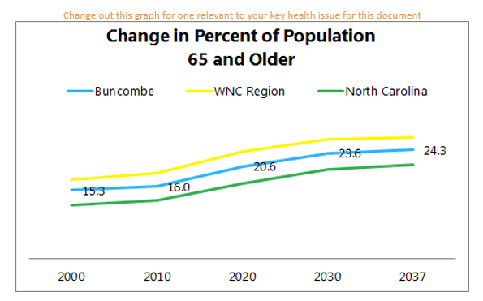
- Include a headline population data indicator from the WNC Healthy Impact data workbook, community health survey or other sources to help illustrate the trend/curve of key importance in understanding this health issue.
- Narrative on the analysis and interpretation of the data presented should be included, as well as any additional text and reference to other data that you reviewed (that is not being shown in a table of figure).
  - You may include morbidity data, mortality data, demographic trends, or other relevant data to help explain why this was chosen.

What Did the Community Say?
- Use the Key Informant Survey and any listening session results to share themes and quotes that illustrate:
  - What’s helping?
  - What’s hurting?

What Else Do We Know?
- Insert additional graphs from the survey – phone or key-informant, or quotes from primary data that help illustrate what is involved in selection of this priority health issue.
- Include additional analysis and interpretation, and any additional information you would like to insert that describes the “story behind the curve” (i.e. what is helping this issue? What is hurting this issue?
- Insert anything additional you know about those who seem to be most adversely impacted/experiencing this health issue. You may be able to use additional secondary data gathered locally to help illustrate this if not available on the core dataset, maps, etc.

What is Already Happening?
- Insert information about the services available in your community, and/or existing programs that are in place to address the issue – or to talk about specific service/resource gaps that have been identified through the assessment process/gathering and reviewing your health resources inventory.

What Change Do We Want to See?
- Choose a community priority result – RBA, and headline indicators – the most important curves you are/ will be monitoring.

To add additional priorities, copy and paste text from Priority Issue #1. You must include at least 2 priorities.


CHAPTER 9 - NEXT STEPS

Collaborative Planning
Collaborative planning with hospitals and other community partners will result in the creation of a community-wide plan that outlines what will be aligned, supported and/or implemented to address the priority health issues identified through this assessment process.
Use this text box to highlight an inspiring call to action quote, or some key next steps that you would like for your community to take.

Insert relevant next step information as preferred based on your local process.

Sharing Findings
Relates to Accreditation Activity 1.3
Include relevant details related to dissemination of findings/plans for sharing CHA results and where the document will be placed, and data presented. “The local health department shall disseminate results of the most recent community
health assessment and “State of the County’s Health” report to the local health department’s
stakeholders, community partners and the general population.
Documentation: Evidence of most recent CHA dissemination efforts by at least two different methods directed to stakeholders/ community partners AND the general population.”

Where to Access this Report
Information here from your dissemination plan about where the report will be located, in person and online.
- WNC Health Network website
- Your website
- Local library

For More Information and to Get Involved
Include your website and information about how to plug in to the local process.

WORKS CITED

Include all citations here. Click here for a link to DPH guidelines on documentation and authorship. Citations below are included using APA, 6th edition.

Citation Chart: Easy-to-use cross-walk chart of MLA, APA and Chicago Manual of Style (CMOS) citations.

To cite data using APA in works cited use the following format:

Author/Owner (Year). Title of Data. [Data Type, i.e. Data File, Dataset]. Available/Retrieved from url - link.
- Use “Available from” if the url takes you to a webpage where you can access the data
- Use “Retrieved from” if the url takes you straight to the data source
- Use “Unpublished data” if you are citing local data that is not available to the public

Example: ABC Health Department. (2018). 2018 ABC County Community Health Local Survey. [Data File]. Unpublished data.
Note: Focus group/listening session data does not need to belong in works cited due to confidentiality. For more information about communicating the results of focus group/listening sessions click here.
To cite data sources throughout the CHA document text use the following format:
(Last Name of Author/Owner of Data, Year).

CDC.(2018). CDC Community Health Improvement Navigator. Retrieved from www.cdc.gov/chinav

County Health Rankings. (2018). Health Factors. Retrieved from http://www.countyhealthrankings.org/explore-health-rankings/what-and-why-we-rank/health-factors.

Office of Disease Prevention and Health Promotion. (2018). Healthy People 2020. Retrieved from https://www.healthypeople.gov/2020/topics-objectives/topic/social-determinants-health/interventions-resources/early-childhood-0.

WNC Health Network. (2018). 2018 WNC Healthy Impact Community Health Survey: Data Workbook. [Data set]. Available from https://www.wnchn.org/partner-resources/. The in-text citation for 2018 WNC Healthy Impact Community Health Survey data is (WNC Health Network, 2018).

PHOTOGRAPHY CREDITS

Include any photography credits here. In the report template, all photos should be credited:

Photos used on the cover and in headers from www.pexels.com; accessed October, 2018.

All WNC landscape photos used in the headers courtesy of Patrick Williams, Ecocline Photography.

Consider contacting your local newspaper and Chamber of Commerce to access more photos from your community. Reach out to WNC Health Network if you need help accessing more photos from your county.

APPENDICES

Appendix A – Data Collection Methods & Limitations

Note to counties: Appendix A is included for all counties in this template so that data collection methodology can be included. Others listed here are just guides and should be modified to reflect what you decide to include in your final product.

Appendix B – Data Presentation
- Data Presentation Slides (PDF of slides)

Appendix C – County Maps (PDF of slides or other preferred presentation, may decide not to include these if you have inserted maps of interest within your document)

Appendix D – Survey Findings
- WNC Healthy Impact Survey Instrument
- Community Health Survey Results

Appendix E – Key-Informant Survey Findings (insert findings as applicable and preferred. You may have already integrated what you wanted to include throughout the report)

APPENDIX A - DATA COLLECTION METHODS & LIMITATIONS
Please note: counties should add content to this section to align with the local data collection used in their health assessment process.

Secondary Data from Regional Core

Secondary Data Methodology
In order to learn about the specific factors affecting the health and quality of life of residents of WNC, the WNC Healthy Impact data workgroup and data consulting team identified and tapped numerous secondary data sources accessible in the public domain. For data on the demographic, economic and social characteristics of the region sources included: the US Census Bureau; Log Into North Carolina (LINC); NC Department of Health and Human Services; NC Office of State Budget and Management; NC Department of Commerce; Employment Security Commission of NC; UNC-CH Jordan Institute for Families; NC Department of Public Instruction; NC Department of Justice; NC Division of Medical Assistance; NC Department of Transportation; and the Cecil B. Sheps Center for Health Services Research. The WNC Healthy Impact data consultant team made every effort to obtain the most current data available at the time the report was prepared. It was not possible to continually update the data past a certain date; in most cases that end-point was August 2018.

The principal source of secondary health data for this report was the NC State Center for Health Statistics (NC SCHS), including its County Health Data Books, Behavioral Risk Factor Surveillance System, Vital Statistics unit, and Cancer Registry. Other health data sources included: NC Division of Public Health (DPH) Epidemiology Section; NC Division of Mental Health, Developmental Disabilities and Substance Abuse Services; the Centers for Disease Control and Prevention; National Center for Health Statistics; NC DPH Nutrition Services Branch; and NC DETECT.

Environmental data was gathered from sources including: US Environmental Protection Agency; US Department of Agriculture; and NC Department of Environment and Natural Resources.

Because in any CHA it is instructive to relate local data to similar data in other jurisdictions, throughout this report representative county data is compared to like data describing the 16-county region and the state of NC as a whole. The WNC regional comparison is used as “peer” for the purposes of this assessment. Where appropriate and available, trend data has been used to show changes in indicators over time.

It is important to note that this report contains data retrieved directly from sources in the public domain. In some cases the data is very current; in other cases, while it may be the most current available, it may be several years old. Note also that the names of organizations, facilities, geographic places, etc. presented in the tables and graphs in this report are quoted exactly as they appear in the source data. In some cases these names may not be those in current or local usage; nevertheless they are used so readers may track a particular piece of information directly back to the source.

Gaps in Available Information
Insert a general statement of any relevant information gaps that you feel limits the county’s ability to assess the community’s health needs.

WNC Healthy Impact Survey (Primary Data)

Survey Methodology
The 2018 WNC Healthy Impact Community Health Survey was conducted from March to June. The purpose of the survey was to collect primary data to supplement the secondary core dataset, allow individual counties in the region to collect data on specific issues of concern, and hear from community members about their concerns and priorities. The survey was conducted throughout the entire WNC Healthy Impact region, which includes the following 16 counties: Buncombe, Cherokee, Clay, Graham, Haywood, Henderson, Jackson, Macon, Madison, McDowell, Mitchell, Polk, Rutherford, Swain, Transylvania and Yancey.
The in-text citation for 2018 WNC Healthy Impact Community Health Survey data is (WNC Health Network, 2018).

Professional Research Consultants, Inc. (PRC) designed and implemented the survey methodology, which included a combination of telephone (both landline and cell phone) interviews, as well as an online survey. The survey methodology was designed to achieve a representative sample of the regional population that would allow for stratification by certain demographic characteristics, while also maximizing data collection timeliness and efficiency. Survey sampling and implementation methodology is described in greater detail below.

Survey Instrument
The survey instrument was developed by WNC Healthy Impact’s data workgroup, consulting team, and local partners, with assistance from PRC. Many of the questions were derived from the CDC Behavioral Risk Factor Surveillance System (BRFSS) and other validated public health surveys. Other questions were developed specifically by WNC Healthy Impact, with input from regional and local partners, to address particular issues of interest to communities in western North Carolina. Each county was given the opportunity to include three additional questions of particular interest to their county, which were asked only of their county’s residents.

[If your county had county-specific questions, include those here:]
The three additional county questions included in the 2018 survey were:
1)
2)
3)

Sampling Approach & Design
PRC designed the survey methodology to minimize sample bias and maximize representativeness by using best practice random-selection sampling techniques. They also used specific data analysis techniques, including poststratification, to further decrease sample bias and account for underrepresented groups or nonresponses in the population. Poststratification involves selecting demographic variables of interest within the population (here, gender, age, race, ethnicity, and poverty status) and then applying “weights” to the data to produce a sample which more closely matches the actual regional population for these characteristics. This technique preserves the integrity of each individual’s responses while improving overall representativeness. In order to determine WNC regional estimates, county responses were weighted in proportion to the actual population distribution to appropriately represent Western North Carolina as a whole. Since the sample design and quality control procedures used in the data collection ensure that the sample is representative, the findings may be generalized to the region with a high degree of confidence.

Survey Administration
PRC piloted the survey through 30 interviews across the region and consulted with WNC Health Network staff to resolve substantive issues before full implementation. PRC used trained, live interviewers and an automated computer-aided telephone interviewing system to administer the survey region-wide. Survey interviews were conducted primarily during evening and weekend hours, with some daytime weekday attempts. Interviewers made up to five call attempts per telephone number. Interviews were conducted in either English or Spanish, as preferred by respondents. The final sample included 29 percent cell phone-based survey respondents and 71 percent landline-based survey respondents. Including cell phone numbers in the sampling algorithm allowed better representation of demographic segments that might otherwise be under sampled in a landline-only model.

PRC also worked with a third-party provider to identify and invite potential respondents for an online survey for a small proportion (20%) of the sample population. The online survey was identical to the telephone survey instrument and allowed better sampling of younger and more urban demographic segments.

About the [insert county name] Sample

Size: The total regional sample size was 3,265 individuals age 18 and older, with [insert county-specific survey total] from our county. PRC conducted all analysis of the final, raw dataset.

Sampling Error: For our county-level findings, the maximum error rate at the 95% confidence level is [insert county-specific error rate]. You can find your county’s error rate in the methods section of your county-specific survey PowerPoint slides.

Expected Error Ranges for a Sample of [insert county-specific survey total]
Respondents at the 95 Percent Level of Confidence

Note: The "response rate" (the percentage of a population giving a particular response) determines the error rate associated with that response. A "95 percent level of confidence" indicates that responses would fall within the expected error range on 95 out of 100 trials.

Examples:
- If 10% of a sample of 200 respondents answered a certain question with a "yes," it can be asserted that between 5.8% and 14.2% (10% ± 4.2%) of the total population would offer this response.
- If 50% of respondents said "yes," one could be certain with a 95 percent level of confidence that between 43.1% and 56.9% (50% ± 6.9%) of the total population would respond "yes" if asked this question.

Characteristics: The following chart outlines the characteristics of the survey sample for our county by key demographic variables, compared to actual population characteristics from census data. Note that the sample consists solely of area residents age 18 and older.

Insert county-specific “population and sample characteristics” slide from your local PowerPoint slide set.

Benchmark Data
This is an optional section that you may choose to include. and modified to your county benchmarks. If included, add any benchmarks you are using (region/peer, state, national, Healthy People 2020).

North Carolina Risk Factor Data
Statewide risk factor data are provided where available as an additional benchmark against which to compare local survey findings; these data are reported in the most recent BRFSS (Behavioral Risk Factor Surveillance System) Prevalence and Trend Data published by the Centers for Disease Control and Prevention and the US Department of Health & Human Services.

Nationwide Risk Factor Data
Nationwide risk factor data, which are also provided in comparison charts where available, are taken from the 2017 PRC National Health Survey; the methodological approach for the national study is identical to that employed in this assessment, and these data may be generalized to the US population with a high degree of confidence.

Healthy People 2020
Healthy People provides science-based, 10-year national objectives for improving the health of all Americans. The Healthy People initiative is grounded in the principle that setting national objectives and monitoring progress can motivate action. For three decades, Healthy People has established benchmarks and monitored progress over time in order to:
- Encourage collaborations across sectors.
- Guide individuals toward making informed health decisions.
- Measure the impact of prevention activities.

Healthy People 2020 is the product of an extensive stakeholder feedback process that is unparalleled in government and health. It integrates input from public health and prevention experts, a wide range of federal, state and local government officials, a consortium of more than 2,000 organizations, and perhaps most importantly, the public. More than 8,000 comments were considered in drafting a comprehensive set of Healthy People 2020 objectives.

Information Gaps
While this assessment is quite comprehensive, it cannot measure all possible aspects of health in the community, nor can it adequately represent all possible populations of interest. It must be recognized that these information gaps might in some ways limit the ability to assess all of the community’s health needs.

For example, certain population groups (such as the homeless, institutionalized persons, or those who only speak a language other than English or Spanish) are not represented in the survey data. Other population groups (for example, pregnant women, lesbian/gay/bisexual/transgender residents, undocumented residents, and members of certain racial/ethnic or immigrant groups) might not be identifiable or might not be represented in numbers sufficient for independent analyses.

In terms of content, this assessment was designed to provide a comprehensive and broad picture of the health of the overall community. However, there are certainly a great number of medical conditions that are not specifically addressed.

Online Key Informant Survey (Primary Data)

Online Survey Methodology

Purpose and Survey Administration
WNC Healthy Impact, with support from PRC, implemented an Online Key Informant Survey to solicit input from local leaders and stakeholders who have a broad interest in the health of the community. WNC Healthy Impact shared with PRC a list of recommended participants, including those from our county. This list included names and contact information for physicians, public health representatives, other health professionals, social service providers, and a variety of other community leaders. Potential participants were chosen because of their ability to identify primary concerns of the populations with whom they work, as well as of the community overall.
Contact Jo Bradley, jo.bradley@wnchn.org, if you need this information to complete the following table.

Key informants were contacted through an email that introduced the purpose of the survey and provided a link to take the survey online. Reminder emails were sent as needed to increase participation.

Online Survey instrument
The survey provided respondents the opportunity to identify critical health issues in their community, the feasibility of collaborative efforts around health issues, and what is helping/hurting their community’s ability to make progress on health issues.

Participation
In all, insert number community stakeholders took part in the Online Key Informant Survey for our county, as outlined below: [FILL IN YOUR LOCALLY SPECIFIC INFO]
Local Online Key Informant Survey Participation
Key Informant Type | Number Invited | Number Participating
Community Leader
Other Health Provider
Physician
Public Health Representative
Social Services Provider

Through this process, input was gathered from several individuals whose organizations work with low-income, minority populations, or other medically underserved populations.

Online Survey Limitations
The Online Key Informant Survey was designed to gather input from participants regarding their opinions and perceptions of the health of the residents in the area. Thus, these findings are based on perceptions, not facts.

To collect this data, purposive sampling (a type of non-probability sampling which targets a specific group of people) was used. Unlike the random sampling technique employed in the telephone survey, the purpose is not to make generalizations or statistical inferences from the sample to the entire population, but to gather in-depth insights into health issues from a group of individuals with a specific perspective.

Local Survey Data or Listening Sessions (if applicable)
[Include details on additional primary data collection at the local level if applicable]

Data Definitions
Reports of this type customarily employ a range of technical terms, some of which may be unfamiliar to many readers. Health data, which composes a large proportion of the information included in this report, employs a series of very specific terms which are important to interpreting the significance of the data. While these technical health data terms are defined in the report at the appropriate time, there are some data caveats that should be applied from the onset.

Error
First, readers should note that there is some error associated with every health data source. Surveillance systems for communicable diseases and cancer diagnoses, for instance, rely on reports submitted by health care facilities across the state and are likely to miss a small number of cases, and mortality statistics are dependent on the primary cause of death listed on death certificates without consideration of co-occurring conditions.

Age-adjusting
Secondly, since much of the information included in this report relies on mortality data, it is important to recognize that many factors can affect the risk of death, including race, gender, occupation, education and income. The most significant factor is age, because an individual’s risk of death inevitably increases with age. As a population ages, its collective risk of death increases; therefore, an older population will automatically have a higher overall death rate just because of its age distribution. At any one time some communities have higher proportions of “young” people, and other communities have a higher proportion of “old” people. In order to compare mortality data from one community with the same kind of data from another, it is necessary first to control for differences in the age composition of the communities being compared. This is accomplished by age-adjusting the data.

Age-adjustment is a statistical manipulation usually performed by the professionals responsible for collecting and cataloging health data, such as the staff of the NC State Center for Health Statistics (NC SCHS). It is not necessary to understand the nuances of age-adjustment to use this report. Suffice it to know that age-adjusted data are preferred for comparing most health data from one population or community to another and have been used in this report whenever available.

Rates
Thirdly, it is most useful to use rates of occurrence to compare data. A rate converts a raw count of events (deaths, births, disease or accident occurrences, etc.) in a target population to a ratio representing the number of same events in a standard population, which removes the variability associated with the size of the sample. Each rate has its own standard denominator that must be specified (e.g., 1,000 women, 100,000 persons, 10,000 people in a particular age group, etc.) for that rate.

While rates help make data comparable, it should be noted that small numbers of events tend to yield rates that are highly unstable, since a small change in the raw count may translate to a large change in rate. To overcome rate instability, another convention typically used in the presentation of health statistics is data aggregation, which involves combining like data gathered over a multi-year period, usually three or five years. The practice of presenting data that are aggregated avoids the instability typically associated with using highly variable year-by-year data, especially for measures consisting of relatively few cases or events. The calculation is performed by dividing the sum number of cases or deaths in a population due to a particular cause over a period of years by the sum of the population size for each of the years in the same period.

Health data for multiple years or multiple aggregate periods is included in this report wherever possible. Sometimes, however, even aggregating data is not sufficient, so the NC SCHS recommends that rates based on fewer than 20 events—whether covering an aggregate period or not—be considered unstable. In fact, in some of its data sets the NC SCHS no longer calculates rates based on fewer than 20 events. To be sure that unstable data do not become the basis for local decision-making, this report will highlight and discuss primarily rates based on 20 or more events in a five-year aggregate period, or 10 or more events in a single year. Where exceptions occur, the text will highlight the potential instability of the rate being discussed.

Regional arithmetic mean
Fourthly, sometimes in order to develop a representative regional composite figure from sixteen separate county measures the consultants calculated a regional arithmetic mean by summing the available individual county measures and dividing by the number of counties providing those measures. It must be noted that when regional arithmetic means are calculated from rates the mean is not the same as a true average rate but rather an approximation of it. This is because most rates used in this report are age adjusted, and the regional mean cannot be properly age-adjusted.

Describing difference and change
Fifthly, in describing differences in data of the same type from two populations or locations, or changes over time in the same kind of data from one population or location—both of which appear frequently in this report—it is useful to apply the concept of percent difference or change. While it is always possible to describe difference or change by the simple subtraction of a smaller number from a larger number, the result often is inadequate for describing and understanding the scope or significance of the difference or change. Converting the amount of difference or change to a percent takes into account the relative size of the numbers that are changing in a way that simple subtraction does not, and makes it easier to grasp the meaning of the change.

For example, there may be a rate of for a type of event (e.g., death) that is one number one year and another number five years later. Suppose the earlier figure is 12.0 and the latter figure is 18.0. The simple mathematical difference between these rates is 6.0. Suppose also there is another set of rates that are 212.0 in one year and 218.0 five years later. The simple mathematical difference between these rates also is 6.0. But are these same simple numerical differences really of the same significance in both instances? In the first example, converting the 6 point difference to a percent yields a relative change factor of 50%; that is, the smaller number increased by half, a large fraction. In the second example, converting the 6 point difference to a percent yields a relative change factor of 2.8%; that is, the smaller number increased by a relatively small fraction. In these examples the application of percent makes it very clear that the difference in the first example is of far greater degree than the difference in the second example. This document uses percentage almost exclusively to describe and highlight degrees of difference and change, both positive (e.g., increase, larger than, etc.) and negative (e.g., decrease, smaller than, etc.).

Data limitations
Some data that is used in this report may have inherent limitations, due to the sample size, its geographic focus, or its being out-of-date, for example, but it is used nevertheless because there is no better alternative. Whenever this kind of data is used, it will be accompanied by a warning about its limitations.

Additional Header Photos (cut and paste; delete when you have what you need):











































