2013
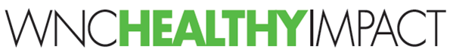

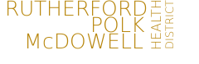
Polk County
Community Health Improvement Plan
CHIP
2013 POLK COUNTY
COMMUNITY HEALTH IMPROVEMENT PLAN (CHIP)

July 2013

Acknowledgements
This document was developed by Polk County, in partnership with St. Luke’s Hospital and the Polk, Fit, Fresh & Friendly Coalition as part of a local community health assessment process. We would like to thank several agencies and individuals for their contributions and support in conducting this health assessment:

Linda Greensfelder, Polk Fit Fresh and Friendly Chairperson, Jimmi Buell, Family and Consumer Sciences Polk County Extension, Ellen Lawson and Kris Edwards, Nurse-Family Partnership, Mary Smith, Joann O’Sullivan, Community Transformation Grant Program, Kathy Woodham, St. Luke’s Hospital, Basil Savitsky ARP Prevention Services, Jimmy Hines, Marjorie Vestal, Rachel Ross, Becky Koone, Rutherford Polk McDowell District Health Department.

This CHIP format draws heavily on the work of the Wisconsin Association of Local Health Departments and Boards (WALHDAB), particularly their Template Implementation Plan, as well as actual examples from Bexar County, Texas. This product was also informed by many other organizations, which can be found in the reference section at the end of this document.

Our collaborative action planning process and community health improvement plan (CHIP) product were also supported by the technical assistance and tools available through our participation in WNC Healthy Impact, a partnership between hospitals and health departments in western North Carolina to improve community health.

Please contact Jimmy Hines, Health Director, Rutherford Polk McDowell Health District (jhines@rpmhd.org), if you have any questions or would like to discuss more about how to get involved in moving forward the strategies outlined in this community health improvement plan (CHIP).

Table of Contents
Acknowledgements 2
Table of Contents 3
Executive Summary 5
General Review of Data and Trends 5
Leading Causes of Death 6
Gender Disparities in Lung Cancer Mortality 8
Teen Substance Abuse 9
Smoking During Preganancy 10
Diabetes 10
Summarized Action Plan 11
Monitoring and Accountability 11
Chapter 1 - Introduction 12
What is a Community Health Improvement Plan (CHIP)? 12
How to Use this CHIP 12
Connection to the 2012 Community Health Assessment (CHA) 13
WNC Healthy Impact 13
Community Transformation Grant Program 13
Chapter 2 – Community Health Assessment Process 14
Chapter 3 - Priority One: Reducing Diabetes 15
Situational Analysis 15
Spotlight on Success: Growing Cycle Bike-to-Farm Tour 17
Partners 18
Community Objectives 19
Strategy 1 – Increase Access to Fresh Fruit and Vegetables 20
Action Plan 20
Strategy 2 – Increase Physical Activity 21
Action Plan 21
Strategy 3 – Increase Breastfeeding 22
Action Plan 22
Strategy 4 - Diabetes Education, Management & Prevention 24
Action Plan 24
Chapter 4 – Priority Two:Reduce Subtance Abuse & Tobacco Use 25
Situational Analysis 25
Spotlight on Success 26
Community Objectives 27
Strategy 1 – Adopt Policy for Smokefree College Campus 27
Action Plan 28
Strategy 2 – Smoking Cessation Referrals 29
Action Plan 29
Strategy 3 – Promote Quit Line 30
Action Plan 30
Strategy 4 – Increase Community Capacity for Prevention 31
Action Plan 31
Chapter 5 – Next Steps 32
References 33
Glossary of Terms 34

Executive Summary

Overview of CHIP Purpose and Process
The Community Health Improvement Plan (CHIP) is built upon relevant data from our Community Health Assessment as well as opportunities for improvement presented by community partners. Following is a summary of health related data for Polk County (2012).

List of Health Priorities

In 2008 the following Priorities were chosen:

- Access to mental health and substance abuse services
- Access to healthcare for the uninsured
- Prevention
- Obesity
- Education

In 2012 the following Priorities were chosen:

- Reduce Chronic Disease (Diabetes) through Healthy Living, Physical activity, Nutrition
- Access to Care
- Tobacco, Substance Abuse

General Review of Data and Trends

Population
According to data from the 2010 US Census, the total population of Polk County is 20,510. In Polk County, as region-wide and statewide, there is a higher proportion of females than males (52.1% vs. 47.9%).

Table 1. Overall Population and Distribution, by Gender (2010)
Geography | Total Population (2010) | # Males | % Males | # Females | % Females
Polk County | 20,510 | 13,341 | 48.6 | 14,103 | 51.4
Regional Total | 759,727 | 368,826 | 48.5 | 390,901 | 51.5
State Total | 9,535,483 | 4,645,492 | 48.7 | 4,889,991 | 51.3

Older Adult Population Growth Trend
The age 65-and-older segment of the population represents a larger proportion of the overall population in Polk County and WNC than in the state as a whole. In terms of future health resource planning, it will be important to understand how this segment of the population, a group that utilizes health care services at a higher rate than other age groups, is going to change in the coming years.

Calculated from the figures in Table 6, the percent increase anticipated for each age group in Polk County between 2010 and 2030 is 24.0% for the 65-74 age group, 53.2% for the 75-84 age group, and 20.9% for the 85+ age group.

Table 6. Population Age 65 and Older (2010 through 2030)
Geography | 2010 Census Data |  |  |  |  | 2020 (Projected) |  |  |  | 2030 (Projected)
Geography | Total% Age 65 and Older | % Age 65-74* | % Age 75-84 | % Age 85+ |  | % Age 65 and Older | % Age 65-74 | % Age 75-84 | % Age 85+ | % Age 65 and Older | % Age 65-74 | % Age 75-84 | % Age 85+ *
Polk County | 24.3 | 12.1 | 7.9 | 4.3 |  | 29.8 | 15.8 | 9.5 | 4.5 | 32.3 | 15.0 | 12.1 | 5.2
Regional Total | 19.0 | 10.4 | 6.1 | 2.5 |  | 23.5 | 13.2 | 7.4 | 2.9 | 25.7 | 12.9 | 9.3 | 3.5
State Total | 12.9 | 7.3 | 4.1 | 1.5 |  | 16.6 | 9.9 | 4.9 | 1.8 | 19.3 | 10.6 | 61.8 | 2.2

Leading Causes of Death
The leading causes of death in Polk County are cancer, heart disease and chronic lung respiratory disease. Leading causes of death differ in rank order from the comparable lists for WNC or NC, most notably in a higher county placement for cancer.

Since total cancer is a very significant cause of death, it is useful to examine patterns in the development of new cases of cancer in the county.

Table 28. Rank of Cause-Specific Mortality Rates for the Fifteen Leading Causes of Death
(Five-Year Aggregate, 2006-2010)
Leading Cause of Death | Polk County |  | WNC Mean |  | NC
Leading Cause of Death | Rank | Rate | Rank | Rate | Rank | Rate
Heart Disease | 2 | 161.7 | 1 | 194.4 | 1 | 184.9
Total Cancer | 1 | 167.2 | 2 | 180.3 | 2 | 183.1
Chronic Lower Respiratory Disease | 3 | 43.4 | 3 | 51.1 | 4 | 46.4
Cerebrovascular Disease | 5 | 38.3 | 4 | 44.0 | 3 | 47.8
All Other Unintentional Injuries | 4 | 38.9 | 5 | 42.9 | 5 | 28.6
Alzheimer’s Disease | 6 | 32.2 | 6 | 30.7 | 6 | 28.5
Diabetes Mellitus | 7 | 20.6 | 7 | 19.6 | 7 | 22.5

Heart Disease Mortality
Heart disease is an abnormal organic condition of the heart or of the heart and circulation. It is also a major cause of disability. The most common cause of heart disease, coronary artery disease, is a narrowing or blockage of the coronary arteries, the blood vessels that supply blood to the heart itself. This is the major reason people have heart attacks. Heart disease was the second leading cause of death in Polk County in the 2006-2010 aggregate period.

Heart Disease Mortality Rate, Deaths per 100,000 Population
Five-Year Aggregates (2002-2006 through 2006-2010)
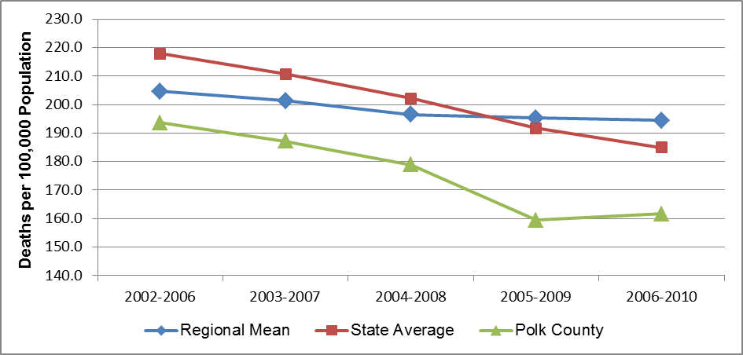

Further subdivision of heart disease mortality data reveals a striking gender disparity. From these data it is clear that Polk County males have had a higher heart disease mortality rate than females for the past decade, with the difference as high as 103%.

Gender Disparities in Heart Disease Mortality, Polk County
(Five-Year Aggregates, 2002-2006 through 2006-2010)
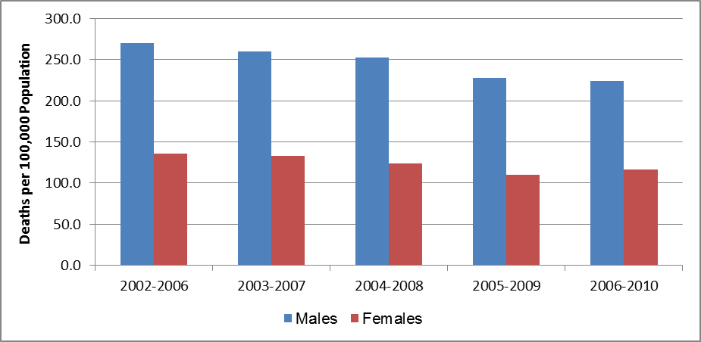

Lung Cancer
From these data it appears that lung cancer incidence in Polk County increased a dramatic 108.2% (from 30.6 to 63.7) between 1999-2003 and 2005-2009. Since lung cancer mortality is already on the rise in the region, the increase in the incidence rate may portend additional lung cancer mortality in the future.

Lung Cancer Incidence, New Cases per 100,000 Population
(Five-Year Aggregates, 1999-2003 through 2005-2009)
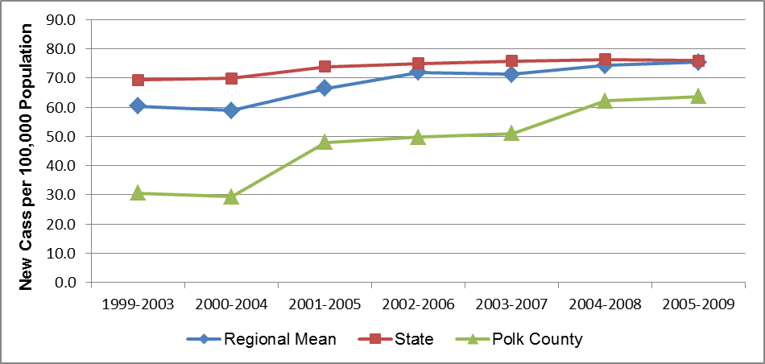

Gender Disparities in Lung Cancer Mortality
From this data it is clear that males experience disproportionately higher lung cancer mortality than females, with the lung cancer mortality rate among men from 2.3 to 2.9 times the rate among women over the period cited.

Gender Disparities in Lung Cancer Mortality, Polk County
(Five-Year Aggregates, 2002-2006 through 2006-2010)
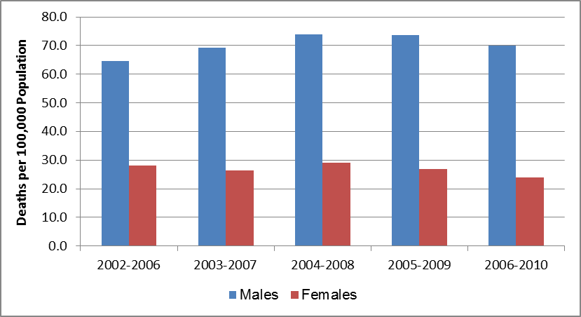

Tobacco
Polk County has a higher rate of smoking than our region, our state and our country. According to the graph below, 21.4% of the Polk population is currently smoking.

Tobacco use is the single most preventable cause of death and disease in the United States. Each year, approximately 443,000 Americans die from tobacco-related illnesses. For every person who dies from tobacco use, 20 more people suffer with at least one serious tobacco-related illness. In addition, tobacco use costs the US $193 billion annually in direct medical expenses and lost productivity. Preventing tobacco use and helping tobacco users quit can improve the health and quality of life for Americans of all ages. People who stop smoking greatly reduce their risk of disease and premature death. Benefits are greater for people who stop at earlier ages, but quitting tobacco use is beneficial at any age.

Current Smokers (WNC Healthy Impact Survey)
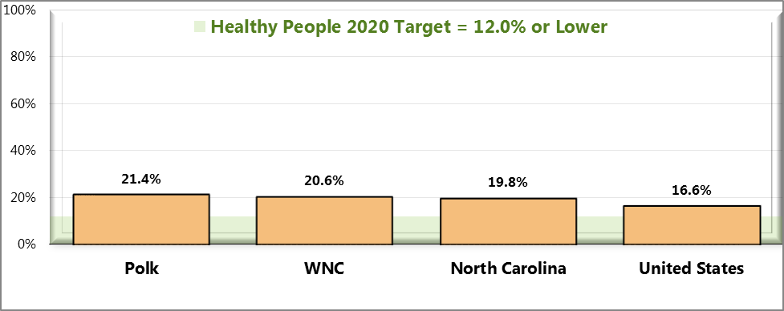
Sources: ● 2012 PRC Community Health Survey, Professional Research Consultants, Inc. [Item 86] 2011 PRC National Health Survey, Professional Research Consultants, Inc.● Behavioral Risk Factor Surveillance System Survey Data. Atlanta, Georgia. United States Department of Health and Human Services, Centers for Disease Control and Prevention (CDC): 2010 North Carolina data. US Department of Health and Human Services. Healthy People 2020. December 2010. http://www.healthypeople.gov [Objective TU-1.1]
Notes: ● Asked of all respondents.
● Includes regular and occasional smokers (every day and some days).

Teen Substance Abuse
How many teens are using drugs in Western North Carolina?

Percentage of Students Who Have Ever Used During Their Lifetime

Grades Prescription Drugs Marijuana Inhalants Cocaine Methamphetamines
9 21.1 15.5 19.0 7.0 3.8
10 24.1 17.1 14.3 6.9 3.
11 30.3 19.0 12.0 8.4 4.7
12 27.4 21.5 11.3 8.7 4.3

Percentage of Students Who Used in the Past 30 Days
Grades Alcohol Binge Alcohol Smoked Cigarettes Marijuana
9 29.1 15.7 17.0 15.5
10 30.2 22.0 21.9 17.1
11 41.0 23.0 23.4 19.0
12 42.5 29.0 26.1 21.5
Source: Western North Carolina High School Drug Use (YRBS 2009)

Figure 67. Currently Use Smokeless Tobacco Products (WNC Healthy Impact Survey)
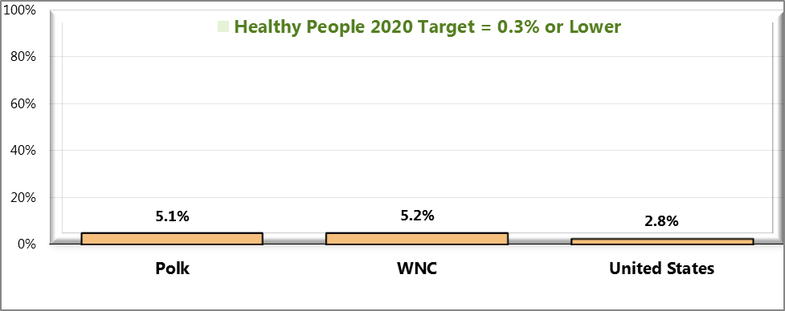
Sources: ● 2012 PRC Community Health Survey, Professional Research Consultants, Inc. [Item 43]
● 2011 PRC National Health Survey, Professional Research Consultants, Inc.
● US Department of Health and Human Services. Healthy People 2020. December 2010. http://www.healthypeople.gov [Objective TU-1.2]
Notes: ● Asked of all respondents.
● Includes regular and occasional users (every day and some days).

Smoking During Pregnancy
Smoking during pregnancy is an unhealthy behavior that may have negative effects on both the mother and the fetus. Smoking can lead to fetal and newborn death, and contribute to low birth weight and pre-term delivery. In pregnant women, smoking can increase the rate of placental problems, and contribute to premature rupture of membranes and heavy bleeding during delivery (March of Dimes, 2010).

Table below shows the number and percent of births resulting from pregnancies in which the mother smoked during the prenatal period - 13.8% in Polk County for the period of 2005 – 2009. The corresponding target for Healthy North Carolina’s 2020 is 6.8% by 2020.

Births to Mothers Who Smoked During the Prenatal Period
(Five-Year Aggregates, 2001-2005 through 2005-2009)
Geography | 2001-2005 |  | 2002-2006 |  | 2003-2007 |  | 2004-2008 |  | 2005-2009
Geography | # | % | # | % | # | % | # | % | # | %
Polk County | 129 | 15.2 | 120 | 14.8 | 116 | 14.5 | 104 | 13.3 | 108 | 13.8
Regional Total | 7,496 | 22.4 | 7,442 | 22.1 | 7,361 | 21.7 | 7,106 | 21.2 | 6,919 | 20.6
State Total | 76,712 | 12.9 | 74,901 | 12.4 | 73,887 | 11.9 | 72,513 | 11.5 | 70,529 | 11.0

Diabetes
Diabetes is a disease in which the body’s blood glucose levels are too high due to problems with insulin production and/or utilization. Over time, having too much glucose in the blood can damage the eyes, kidneys, and nerves. Diabetes can also lead to heart disease, stroke and even the need to remove a limb (US National Library of Medicine).

Diabetes was the seventh leading cause of death in Polk County in the 2006-2010 period. Overweight/obesity and being older are risk factors for diabetes.

Diabetes Mellitus Mortality Rate, Deaths per 100,000 Population
(Five-Year Aggregates, 2002-2006 through 2006-2010)
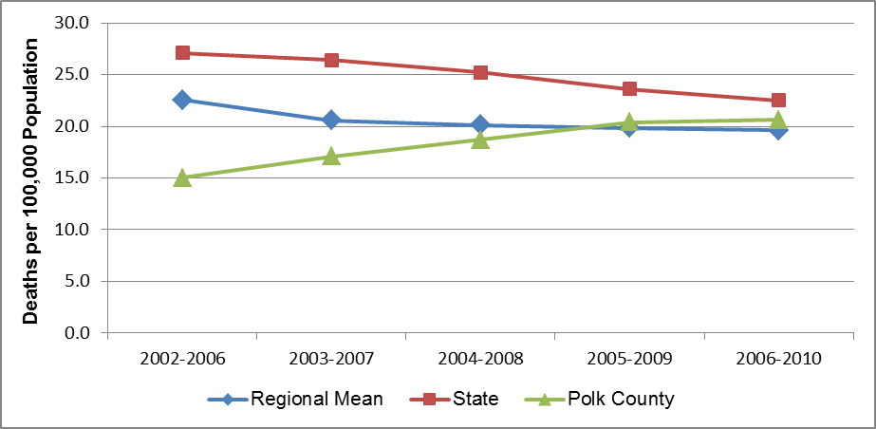
Note: There is some instability in the regional mean rates because each includes one or more unstable county rate.

Summarized Action Plan
Key strategies to address chronic disease especially diabetes are: increasing consumption of fresh fruits and vegetables, increasing opportunities to be physically active, increasing participation in diabetes management programs and education.

Strategies to prevent substance abuse including tobacco use include: policies for smoke-free government building and community campuses, increased training and education about tobacco and other drugs in Polk public schools and among WIC and Health Department clients, improved smoking cessation programs and referrals.

Monitoring and Accountability
The Rutherford Polk McDowell District Health Department (RPMHD) and the Polk Fit Fresh and Friendly Health Coalition serve as organizing bodies for ensuring accountability. Programs will be monitored by the agencies administering the programs. RPMHD will monitor the action plans for this CHIP and convene community collaboratives and stakeholders to address any gaps that could occur.

Chapter 1 - Introduction

What is a Community Health Improvement Plan (CHIP)?
A Community Health Improvement Plan, or CHIP, is an action-oriented strategic plan outlining the priority health issues for a defined community, and how these issues will be addressed, including strategies and measures, to ultimately improve the health of the community. CHIPs are created through a community-wide, collaborative action planning process that engages partners and organizations to develop, support, and implement the plan. A CHIP is intended to serve as a vision for the health of the community and a framework for organizations to use in leveraging resources, engaging partners, and identifying their own priorities and strategies for community health improvement.

This CHIP is intended to help focus and solidify each of our key partner agency’s commitment to improving the health of the community in specific areas. The goal is that through sustained, focused effort on this overarching framework, a wide range of public health partners and stakeholders engaged in assessment, planning, and action will be able to document measured improvement on these key health issues over the coming years.

The next phase will involve broad implementation of the action plan details included in this CHIP, and monitoring/evaluation of the CHIP’s short-term and long-term outcomes and indicators.

This 2013 CHIP is focused on creating plans within a six month to three-year timeline. The community health improvement process is iterative and involves continuous monitoring; we plan to release an annual update of this document in December 2013, and again in December 2014. The next community health assessment will be conducted in 2015.

How to Use this CHIP
This CHIP is designed to be a broad, strategic framework for community health, and will be a “living” document that will be modified and adjusted as conditions, resources, and external environmental factors change. It has been developed and written in a way that engages multiple voices and multiple perspectives. We are working towards creating a unified effort that helps improve the health and quality of life for all people who live, work, and play in our county.

We encourage you to review the priorities and goals, reflect on the suggested intervention strategies, and consider how you can join this call to action: individually, within your organizations, and collectively as a community. To get involved or for questions about the purpose of this document, please contact Jimmy Hines, Health Director, jhines@rpmhd.org, www.RPMHD.org or Marjorie Vestal, marjorie.vestal@gmail.com.

Connection to the 2012 Community Health Assessment (CHA)
Community health assessment (CHA) is the foundation for improving and promoting the health of a community. CHA, as a process and product, is a key step in the continuous community health improvement process. The role of CHA is to identify factors that affect the health of a population and determine the availability of resources within the county to adequately address these factors.

The 2012 Polk County CHA process and products were designed to provide a rich set of data for our county and its partners to use in identifying major health concerns and issues. The information collected through this process, and the priorities identified, were considered in setting the priorities for our county, which are included in this CHIP.

WNC Healthy Impact
WNC Healthy Impact is a partnership between hospitals and health departments, and their partners, in western North Carolina to improve community health. As part of a larger, and continuous, community health improvement process, these partners are collaborating to conduct community health (needs) assessments across western North Carolina. See www.WNCHealthyImpact.com for more details about the purpose and participants of this regional effort. The regional work of WNC Healthy Impact is supported by a steering committee, workgroups, local agency representatives, and a public health/data consulting team.

Community Transformation Grant Program
The Centers for Disease Control and Prevention (CDC) continues its long-standing dedication to improving the health and wellness of all Americans through the Community Transformation Grant (CTG) Program.

CTG will design and implement community-level programs that prevent chronic diseases such as cancer, diabetes, and heart disease. In Polk, the CTGP commits to increasing signage for Farmer’s Markets and offering support for smoke-free policies.

Chapter 2 – Community Health Assessment Process

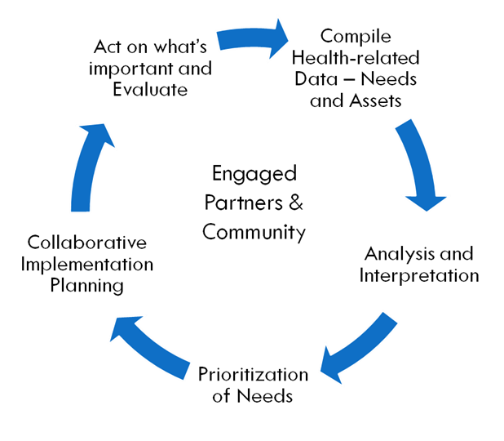
Community health assessment (CHA) is the foundation for improving and promoting the health of county residents. Community-health assessment is a key step in the continuous community health improvement process. The role of CHA is to identify factors that affect the health of a population and determine the availability of resources within the county to adequately address these factors.

A community health assessment (CHA), which refers both to a process and a document, investigates and describes the current health status of the community, what has changed since a recent past assessment, and what still needs to change to improve the health of the community. The process involves the collection and analysis of a large range of secondary data, including demographic, socioeconomic and health statistics, environmental data, as well as primary data such as personal self-reports and public opinion collected by survey, listening sessions, or other methods. The document is a summary of all the available evidence and serves as a resource until the next assessment. Together they provide a basis for prioritizing the community’s health needs, and for planning to meet those needs.

Community Engagement
In the random-sample survey that was administered in our county as part of this community health assessment, 200 community members completed a questionnaire regarding their health status, health behaviors, interactions with clinical care services, support for certain health-related policies, and factors that impact their quality of life. In addition, the Polk Fresh, Fit and Friendly Coalition, St. Luke’s Hospital and the Rutherford Polk McDowell Board of Health were involved in:

Local data review and analysis, prioritization of Health Issues, promoting and organizing the Health Forum to present CHA data to the public and to facilitate the choosing of priorities. These groups will continue to work as a team to create and follow through on Community Health Improvement Plans (CHIPs) throughout the next four years.

Prioritization Process & Criteria
Why Walk???

Walking has tremendous health benefits.

Find a quiet road to explore, walking can be a central component of your fitness routine.

Try for 30 minutes each day

What can walking do for you?
- Improve health of heart and lungs
- Burn body fat
- Calories are burned faster
- Help control appetite
- Increase energy
- Help relieve stress
- Elevate mood
- Slow aging
- Reduce cholesterol
- Lower blood pressure
- Strengthen
- Reduce stiffness in joints

Check out the Polk Walking Paths and Trails Map: http://www.polkfitfreshandfriendly.org/uploads/1/0/8/7/10875927/mapfinal.pdf

A Community Health Forum was held at Isothermal Community College, Polk Campus, on January 17, 2013. The Polk County Community at large was presented with the CHA information contained in this report. Breakout sessions were held to get community input in the following areas:
Chronic Disease including: Diabetes, High Blood Pressure, Obesity, High Cholesterol, Healthy Eating and Active Living, Substance Abuse including Tobacco, Economy and Health, Access to Care. Moving forward, Community partners realized that “Economy and Health” did not have a leader and therefore could not be addressed at this time.

Chapter 3 – Priority One: Reduce Diabetes Through A Comprehensive Approach

Situational Analysis
Our data shows Polk County suffers from many conditions that are largely preventable: heart disease, lung diseases, obesity and overweight, and diabetes. Our CHIP is designed to promote the adoption of healthy lifestyle changes.

While we have chosen to focus on diabetes reduction, we see that our strategies will also result in a reduction in obesity, heart disease, stroke, lung disease and more.

A variety of settings for health interventions will allow us to achieve a collective impact in reaching our goals. We see the benefit of working with individuals, groups, families and institutions to reach our goal.

Working across the life span, we will work to encourage breastfeeding. The health effects of breastfeeding infants are well documented. Breastfeeding decreases many risks, including childhood overweight and obesity. Children who are not breastfed are more likely to be overweight and obese than those who are breastfed.

Polk Fit Action Team has created a Walking Paths and Trails Map to promote active lifestyles. Our plan includes expanding the reach of the map and integrating it into medical and community settings.

Through enhancing farmers markets, we intend to increase consumption of fresh local fruits and vegetables.

With policy level work, we will increase smoke-free community college campuses thus reducing the harmful effects of secondhand smoke. Connecting people to needed resources for health improvements is a key to our success.

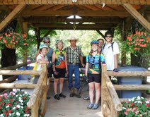
Spotlight on Success: Growing Cycle Bike-to-Farm Tour

With over 300 farms in this 200-square-mile county, agriculture is a thriving part of the Polk economy. In addition to Christmas trees and hay and corn for animal consumption, Polk County farmers produce soybeans, sweet potatoes and a wide variety of small yield food crops. Dairy, beef, and pork are also a mainstay of the county’s agricultural sector. Polk County agriculture centers on small family farms (under 50 acres), many of them organic. Driving down any scenic back road in the Foothills, farms dominate the landscape, contributing to the area’s tourism economy with their scenic beauty.

Despite the wealth of farm products available in the county, nutrition in Polk County remains poor. Currently, only 11 percent of the adult population receives the recommended daily allowance of fruits and vegetables. Research indicates a strong link between low consumption of fruits and vegetables and the development of diabetes, which continues to rise in Polk County. In addressing diabetes in Polk County, one strategy adopted by the health department is increasing visits to local farmer’s markets. The Polk County office of the North Carolina Cooperative Extension Service is a partner in this strategy.

The Extension Service is uniquely positioned to help promote fresh produce consumption because of its relationships with local farmers. In addition to its work providing training for farmers, the Extension Service has long emphasized the connection between agriculture/gardening and health through its Healthy Cooking classes and other programs aimed at integrating agriculture into family and community life. But physical activity is also a key pillar in a healthy lifestyle. In strategizing on how to integrate it with nutrition programs, Polk County Extension agent Jimmi Buell hit upon an idea: connecting physical activity to fresh produce through one of the region’s most popular sports: road biking.

While several Polk County farms participate in Appalachian Sustainable Agriculture Project (ASAP)’s annual farm tour (designed to introduce the public to the farmers who grow their food), Buell⎯an avid biker⎯saw the potential to take the tour idea even further. Instead of driving from farm to farm, tour participants could bike the roughly 10 miles between each farm, through rolling hills past some of the county’s most scenic landscapes. At each stop, there would be an opportunity to sample fresh produce, meet the farmers, and participate in the life of the farm, learning something about farm production during their stop. During its pilot year, the tour was held in the conjunction with ASAP’s tour. The first official Growing Cycle Tour was held in 2012.

The 2013 Growing Cycle Tour begins at the Parker-Binns Winery and makes stops at two farmer’s markets, four farms and an additional winery along the way. The 37-mile itinerary is not strenuous, but because of the hills, would be challenging for someone with no biking experience, says Buell. The farms on the tour offer a range of products from pasture-raised rabbits and chickens to cheese, grass-fed heritage turkeys, and raspberries. Goat and bison farms produce dairy products and meat. Chardonnay, merlot and cabernet sauvignon wines are bottled at the Tour’s vineyard. The Tour ends with a farm-to-table meal made with ingredients from the farms, including pizza made in the winery’s brick oven, topped with pesto made onsite and peach ice cream made from local orchard peaches.

The 2012 Growing Cycle Tour had 25 participants and this year’s tour is expected to sell out. It’s a bike tour, yes, says Buell, but mostly it’s a “foodie tour,” introducing the surprisingly diverse array of farm products grown in this small Western North Carolina county.

Buell herself took up riding as a way to lose weight and get fit. She hopes that the tour will change the eating habits of those who participate and raise awareness about the links between nutrition, physical activity and wellness. The added benefit of the tour is that it helps build community, introducing local bike enthusiasts to the farmers who grow their food. Polk County’s farms make it more beautiful and have the potential to make it a healthier, too. The Growing Cycle Farm Tour is a step toward combining the county’s most valuable assets to benefit the health of its residents.

Partners
Addressing diabetes is complex and will require the collaborative planning, action, and coordination of multiple partners in our community. The following partner agencies and organizations are engaged in efforts to improve healthy lifestyles in our community.

Organizations: | Primary Focus or Function | Website or Contact Information
RPMHD | Breastfeeding Counseling, WIC | www.rpmhd.org Becky Koone (828) 223-3900
Mill Spring Agricultural Development Center | agricultural development, farmland preservation, education, community service and business development. | http://www.nc-mountains.org/links/346
NC Cooperative Extension | Healthy Cooking Classes, Bike to Farm Tour, more | Jimmi Buell  Extension Agent, Family and Consumer Sciences, http://polk.ces.ncsu.edu  jimmi_buell@ncsu.edu  (828) 894-8218
St. Luke’s Hospital | Diabetes Case Management, Healthy Menu Options in Cafeteria | http://www.saintlukeshospital.com
Polk Wellness Center | Integrated Care, Diabetes Education | http://polkwellness.org/index.html
PF3 | Support for Healthy Lifestyles | http://www.polkfitfreshandfriendly.org/index.html
Polk Community Foundation | Grant funding to increase participation at farmers markets including low income | http://polkccf.org/
Community Transformation Grant | Access to Farmer’s Markets, T.A. for EBT expansion, marketing materials | http://www.cdc.gov/communitytransformation
Polk Fit Action Team | Trail Maps. Website. Active Living by Design. | http://www.polkfitfreshandfriendly.org/uploads/1/0/8/7/10875927/mapfinal.pdf  http://www.activelivingbydesign.org
Polk County Farms | Farm Markets, Events | http://www.polkcountyfarms.org/home.html

Priority One: Reducing Diabetes
Action Plan

Vision of Impact

We envision a mountain community working together to make healthy choices easier by improving access to physical activity and healthy food options where community members live, learn, work, and play.

Community Objectives  Reduce Diabetes | Baseline/Indicator Source
1. By December 2015, reduce the percentage of adults with diabetes by .5% each year for 3 years. (per 100,000 population) | Current: 11.3% (2012 CHA)  Target 12/15: 9.7%
Related Healthy NC 2020 Objective: By December 2020, reduce the percentage of adults with diabetes (per 100,000 population) to | Target 2020: 8.6% (BRFSS)
2. By December 2015, increase percentage of adults consuming recommended daily servings of fruits and vegetables from 11.4% to 15% | Current: 11.4% (2012 CHA)  Target: 12/15: 15%
Related Healthy NC 2020 Objective: Increase the percentage of adults who report they consume fruits and vegetables five or more times per day | BRFSS  [2020 Target: 29.3%]

Strategy 1 – Increase Access to Fresh Fruit and Vegetables

Goal: Reduce Diabetes .5% per year by increasing consumption of Fresh Fruits and Vegetables.

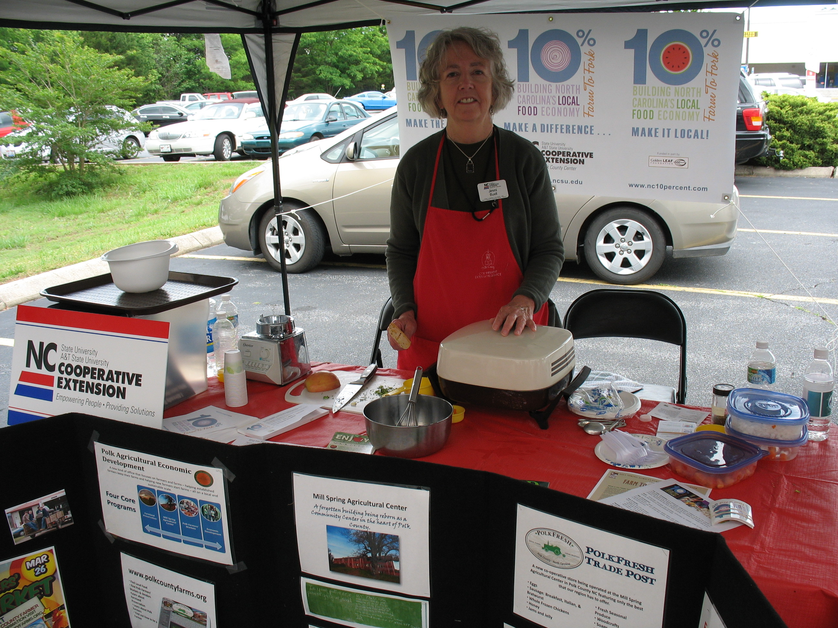
Strategy Background
Source: State Indicator Report on Fruits and Vegetables 2009. Centers for Disease Control and Prevention. www.fruitsandveggiesmatter.gov/indicatorreport
Evidence Base: North Carolina’s Plan to Address Obesity
Type of Change: community, policy

Partner Agencies
Lead: Polk Agricultural Development Center – Farmers Markets
Collaborating: Community Transformation Grant Project, NC Cooperative Extension
Supporting: All members of the PF3 Health Coalition

Strategy Objective #1:
Example: By December 2014, increase the number of visitors to local Farmers Markets.

Indicator: A .5% increase over 2013 visitors as measured by Farmers Market

Action Plan
Activity  (what is being done?) | Resources Needed  (who? how much?) | Anticipated Result  (what will happen?) | Result Verification  (how will you know?) | Target Date  (by when?)
Cooperative Extension does cooking demos | Staff time | Increase knowledge of how to prepare local fresh produce | Verbal feedback | Sept 2013
Increased signage | CTG providing funding for signs | More awareness of farmers markets | Signs in place, direct feedback from visitors to farmers markets | By September 2013
CTG to develop photovoice project to help tell story of need for change. | staff time and volunteers; photo equipment and supplies | Photovoice display to use with stakeholder communication | Review of deliverable | By December 2015

Strategy Objective #2: Increase fruit and vegetable consumption in Polk county through increasing sales at Farmers Markets.

Indicator: Volume of sales of fruits and vegetables at Farmers Markets.

Action Plan
Activity  (what?) | Resources Needed  (who? how much?) | Anticipated Result  (what will happen?) | Result Verification  (how will you know?) | Target Date  (by when?)
Increased Signage at Farmers Markets | CTG Staff time | More Awareness, more patronage | Sales records | 12/13
EBT capacity, Mill Spring Ag Center | Funds for operation, staff time to manage, bookkeeping | Increased sales from EBT | Sales records | 12/15
Incentives to use EBT | Funds to purchase incentives, staff to coordinate | Increased sales from EBT | Sales records | 12/15
Cooperative Extension gives incentives to spend with vendors | Staff time, funds to purchase incentives | Increased sales | Coupons turned in | 6/13  6/14
Cooperative Extension and Mill Spring Ag Center sponsor Farm Tour | Staff time, partnering farms | Produce sales, new customers for farmers | Sales records | 6/13  6/14

Strategy 2 – Increase Physical Activity
Goal: Reduce diabetes through increasing opportunities to be physically active.

Strategy Background:

Sources: Families Eating Smart and Moving More http://www.eatsmartmovemorenc.com/FamiliesESMM/FamiliesESMM.html
http://www.polkfitfreshandfriendly.org/uploads/1/0/8/7/10875927/mapfinal.pdf

Evidence Base: Environmental and Policy Approaches to Increase Physical Activity: Creation of or Enhanced Access to Places for Physical Activity Combined with Informational Outreach Activitieswww.thecommunityguide.org/pa/environmental-policy/improvingaccess.html

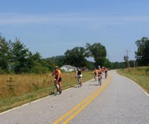

Partner Agencies

Lead:Community Transformation Grant Program

Collaborating:PF3 Health Coalition

Supporting:Cooperative Extension

Strategy Objective #1: By December 2014, Update, Print, Promote and Distribute Trail Map

Indicator:Number of Maps Distributed to Stakeholders

Action Plan
Activity  (what?) | Resources Needed  (who? how much?) | Anticipated Result  (what will happen?) | Result Verification  (how will you know?) | Target Date  (by when?)
Convene Stakeholders to gain input to Map updates | CTG Staff time, Partners time | Input gained for map updates | Minutes from meetings | October 2013
Update Trail Maps | Volunteer time PF3 members, CTG staff time | Trail maps will include new messages, updated addresses | Verify new copy of map | December 2013
Print Maps | Budget $1000 | Maps printed | Maps printed | December 2013
Distribute to Partners | Volunteer time PF3 members, CTG staff time | Maps Distributed to 6 locations | Partners verify receipt of Maps | March 2014
Partners Distribute to target population | Partners staff time | Maps given to target population | Partners track distribution to clients/the public | December 2014
Partners promote Maps on line/websites | Partners staff time | Maps promoted | Verify link to map on websites | December 2015

Strategy 3 – Increase Breastfeeding

Goal: Reduce Diabetes by Increasing Breastfeeding Initiations

Rationale: The health effects of breastfeeding infants are well documented. Breastfeeding decreases many risks, including childhood overweight and obesity. Children who are not breastfed are more likely to be overweight and obese than those who are breastfed.

Strategy Background
Source: Breastfeeding Report Card 2012, United States.
Evidence Base: www.cdc.gov/brastfeeding/data/reportcard2.htm.
Type of Change: Individual, Family. Likely to address disparities.

Partner Agencies
Lead: Rutherford Polk McDowell District Health Department
Collaborating: St. Luke’s Hospital
Supporting: NC Cooperative Extension, Polk Wellness

Strategy Objective #1: By December 31, 2015, the proportion of North Carolina infants who are breastfed will increase to 75 % and the proportion of infants who are breastfed for at least six months will increase to 50%.

Indicator: Number breastfed. www.cdc.gov/brastfeeding/data/reportcard2.htm. North Carolina’s Obesity Prevention Plan Objective 3B.

Activity  (what?) | Resources Needed  (who? how much?) | Anticipated Result  (what will happen?) | Result Verification  (how will you know?) | Target Date  (by when?)
Increasing percentage of WIC mothers breastfeeding | Peer counselor Staff training and staff time, | More promotion, more evidence based programming and education | Training attendance records, staff time records | December 2013  December 2014
Increased collective impact | RPMHD task force participation increase, including clinicians | More communication and education | More clinician involvement, attendance records | December 2015
Increase Lactation Consulting in medical settings | Medical staff training and promotion, flyers, website, referral system | Increased awareness of risks of not breastfeeding and benefits of | Attendance records, referral system records | December 2015
Events to promote world Breastfeeding Week | Promotional materials, volunteer time | Increase awareness of peer counseling program | More referrals to peer counseling, number of contacts made, number reached through media | August 30, 2013
Breastfeeding support group | Staff, space for meetings | Mothers will attend and gain support | Mothers will attend | December 2015

Strategy 4 - Diabetes Education, Management & Prevention

Goal: Reduce Percentage of Diabetes by .5% per year

Strategy Background
Source: NC’s Plan to Address Obesity
Evidence Base: Healthy North Carolina 2020: A Better State of Health
Type of Change: individual, family, community

Partner Agencies
Lead: Polk Wellness Center
Collaborating: St. Luke’s Hospital, NC Cooperative Extension
Supporting: Polk Fit Action Team

Strategy Objective #1: Increase Diabetes Education and Self-management
Indicator: Number of classes offered in Polk by partners, number attending

Action Plan
Activity  (what?) | Resources Needed  (who? how much?) | Anticipated Result  (what will happen?) | Result Verification  (how will you know?) | Target Date  (by when?)
Diabetes Self-management Education Programs | Staff Time – Polk Wellness, St. Luke’s, NC Cooperative Ext. | Self-management will increase among target population | 2015 Community Health Survey | 12/15
Home Demonstrations and plant exchanges in African American Homes/neighborhoods | NC Cooperative Ext. staff time, trained volunteers to do home demonstrations | Plant exchanges and information gained about growing food | Verbal feedback from participants | 8/13
Increase number of Healthy Cooking and food preservation Classes and Demos | Staff time NC Cooperative Extension | Gain knowledge of healthy food preparation and food preservation | Record number of classes and number attendees | 6/13, 8/1/13, 6/14, 6/15
Healthier Menu Options at Hospital | Staff time St. Luke’s kitchen. | Increased nutrition, reduced diabetes risks | Evaluations from patients and staff | 12/13

Chapter 4 – Priority Two: Reduce Substance Abuse and Tobacco Use

Situational Analysis

Substance use and abuse are major contributors to death and disability in North Carolina. Addiction to drugs is a chronic health problem. People who suffer from abuse or dependence are at risk for premature death, comorbid health conditions, injuries and disability.
Focusing prevention planning in high risk and low protection areas could be especially beneficial.

Therefore, prevention of misuse and abuse of substances is critical. In Polk County, we have seen that substance abuse creates difficulties for families and our community. Reducing illicit drug use will also help to reduce crime and motor vehicle crashes and fatalities.

A Communities That Care Survey was conducted at Polk High School in 2008. There is a plan to repeat that survey or another survey to update the data on knowledge, behaviors and attitudes of alcohol and tobacco and other drug use.
By becoming more involved with their communities, young people are more likely to develop healthy norms that reduce the risk of involvement in antisocial behavior.

Polk CTC Survey
2008

From Communities That Care Survey in 2008:

Polk County High School students recorded lifetime prevalence-of-use rates for alcohol (51.5%), cigarettes (31.7%), smokeless tobacco (20.4%) and marijuana (18.8%). Other lifetime prevalence rates ranged from 0.5% for LSD/Psychedelics to 6.9% for inhalants.

There was no reported lifetime methamphetamine or heroin use. The rate of illicit drug use excluding marijuana is summarized by the indicator “any illicit drug (other than marijuana),” with 10.0% of surveyed students reporting use of these drugs in their lifetimes.

Polk County High School students reported the highest past-30-day prevalence-of- use rates for alcohol (23.6%), cigarettes (14.4%), smokeless tobacco (9.0%) and marijuana (8.4%).

Tobacco Use

Tobacco use is the single most preventable cause of death and disease in the United States. Each year, approximately 443,000 Americans die from tobacco-related illnesses. For every person who dies from tobacco use, 20 more people suffer with at least one serious tobacco-related illness. In addition, tobacco use costs the US $193 billion annually in direct medical expenses and lost productivity. Preventing tobacco use and helping tobacco users quit can improve the health and quality of life for Americans of all ages. People who stop smoking greatly reduce their risk of disease and premature death. Benefits are greater for people who stop at earlier ages, but quitting tobacco use is beneficial at any age.

Spotlight on Success

ARP Prevention Services

The likelihood of becoming involved with drugs and other risky behaviors grows with the presence of risk factors (e.g., perception that drugs aren’t harmful) and decreases with the presence of protective factors (e.g., parental support). The earlier the intervention through education and support, the less likely a child will turn to drugs and alcohol. For those who have already begun using, outpatient treatment can be key to avoiding the downward spiral that so often leads to crisis.

ARP Prevention Services works with schools, human service organizations, businesses and communities to provide technical and programming assistance to reduce risk factors and increase protective factors. This leads to overall physical, mental/emotional and spiritual wellness.

Priority Two – Reduce Substance Abuse and Tobacco Use Action Plan

Vision of Impact

We envision a community where healthy and life-enhancing behaviors are the norm.

Community Objectives  Reducing smoking rates will improve health outcomes and extend life expectancy. | Baseline/Indicator Source  NC IOM  Healthy NC 2020
1. By December 2015, decrease the number of adults who are current smokers from 21.4% to 19.9% | 2012 Healthy Impact Survey: 21.4%
Related Healthy NC 2020 Objective: Decrease the number of adults who are current smokers. | NC 2020 target: 15%
2. By December 2015, decrease the percentage of high school students reporting lifetime cigarette smoking from 31.7% to 25%. | Communities that Care Survey Polk 2008 – 25%  NC 2020 target: 15%
Community Objectives
Prevent and reduce rates of drug addiction and misuse of illicit drugs.
3. Reduce the percentage of individuals’ aged 12 and older reporting any illicit drug use in the past 30 days.  Related Healthy NC 2020 Objective: Reduce the percentage of individuals’ aged 12 and older reporting any illicit drug use in the past 30 days. | Current in NC State: 7.8%  NC 2020 Target: 6.6%

Strategy 1 – Adopt Policy for Smokefree College Campus

Goal: Reduce percentage of current smokers

Strategy Background
Source:www.surgeongeneral.gov/library/secondhandsmoke/factsheets/factsheet4html.
Evidence Base: Office of the Surgeon General. The health consequences of involuntary exposure to tobacco smoke
Type of Change: Policy

Partner Agencies
Lead: Isothermal Community College
Collaborating: Community Transformation Grant Program
Supporting: Rutherford Polk McDowell Health District

Strategy Objective #1: By December 2014, develop a student led movement leading to new policy.
Indicator: Draft of Policy for Board consideration

Action Plan
Activity  (what?) | Resources Needed  (who? how much?) | Anticipated Result  (what will happen?) | Result Verification  (how will you know?) | Target Date  (by when?)
Teen tobacco cessation facilitator training | CTG staff time, volunteers | Facilitators will be trained | Training attendance records | 9/13
Find and educate allies | CTG staff time, volunteers | Allies will join efforts | Contacts list | 12/14
Provide resources on how to quit, posters on quitting | CTG staff time, volunteers | Educational materials and Posters will be displayed | Verify placement on campus | 12/14
Make a communication plan | CTG staff time, volunteers | Plan in place | Verify plan | 12/14
Plan signage for campus | CTG staff time, volunteers | Order signs | Signs delivered and ready to erect | 12/14
Make an implementation plan | CTG staff time, volunteers | Plan in place | Verify plan | 12/14
Make an enforcement plan | CTG staff time, volunteers | Plan in place | Verify plan | 12/14

Strategy Objective #2: By December 2014, gain support for Smoke-free Policy from College Board of Directors

Indicator: New smoke-free campus policy accepted

Action Plan
Activity  (what?) | Resources Needed  (who? how much?) | Anticipated Result  (what will happen?) | Result Verification  (how will you know?) | Target Date  (by when?)
Gain approval to present plan for 100% Tobacco Free campus to Trustees | RPMHD staff time, Board Trustees time | Approval | Approval verified | 12/14
Work with ICC staff to further develop plan | RPMHD and CTG staff time | Plan improved and ready | Verify plan | 12/14
Organize advisory committee | CTG staff time, volunteers | Find and educate allies | List of Committee members | 12/14
Draft Policy | RPMHD and CTG staff time | Policy will be drafted | Verify | 12/14
Final Plan Acceptance | RPMHD staff time, Board Trustees time | Policy will be accepted | Policy on record at ICC – Polk | 12/15

Strategy 2 – Smoking Cessation Referrals

Goal: Reduce percentage of current smokers and pregnant women who smoke

Strategy Background
Source:http://www.uspreventiveservicestaskforce.org/uspstf/uspstbac2.htm#supporting
Evidence Base: US Preventive Services Task Force
Type of Change: Individual, Family

Partner Agencies
Lead: St. Luke’s Hospital
Collaborating: Rutherford Polk McDowell Health District, WIC, NFP Programs
Supporting: Community Transformation Grant Program

Strategy Objective #1: Screen & Refer smoking clients to local cessation services

Indicator: Number of smoking clients referred, number of classes offered locally

Action Plan
Activity  (what?) | Resources Needed  (who? how much?) | Anticipated Result  (what will happen?) | Result Verification  (how will you know?) | Target Date  (by when?)
NFP creates awareness of smoking risks | Staff time, educational material | Client motivated to enroll in class | Enrollment record, self-report | 12/13, 12/14, 12/15
NFP makes referral to local program | Staff time, local cessation classes | Client enrolled | Enrollment record | 12/14, 12/14
Client attends classes | Transportation, affordable fee structure | Client attends and completes program | Enrollment records | 12/14
Client reduces cigarette use | Staff time, incentives, Good programs | Client reduces use | Self-report and ETO report | 12/14
NFP follows up with client | Staff time | Improved birth outcomes | ETO and NFP quarterly reports | 12/14

Strategy 3 – Promote NC Quit Line

Goal: Reduce percentage of current smokers and pregnant women who smoke

Strategy Background
Source:www.thecommunityguide.org/tobacco/cessation/providerreminderedu.html
Evidence Base: CDC Increasing tobacco use cessation
Type of Change: Community, individual

Partner Agencies
Lead: Rutherford Polk McDowell Health District
Collaborating: St. Luke’s Hospital, Polk Wellness Center
Supporting: Community Transformation Program

Strategy Objective #1:By December 2015, launch countywide campaign to create awareness of Quit Line and smoking cessation classes.

Indicator: Number of partners involved in Quit Line and smoking cessation promotion will increase by 1 community partner per year.

Action Plan
Activity  (what?) | Resources Needed  (who? how much?) | Anticipated Result  (what will happen?) | Result Verification  (how will you know?) | Target Date  (by when?)
Nurse Family Partners will refer smokers to quit line | Staff time | Smokers will use Quit line | Self-report | December 2013
WIC counselors will refer smokers to quit line | Staff time | Smokers will use Quit line | Self-report | December 2013
Physicians will refer smokers to quit line | Staff time | Smokers will use Quit line | Self-report | December 2013
NFP includes smoking cessation info on calendar | Staff time | Increased awareness of smoking cessation resources | Calendar | December 2014

Strategy 4 – Increase Community Capacity for Prevention

Strategy Background
Goal: Reduce illicit drug use. Reduce underage drinking.
Source:www.samhsa.gov/about/siDocs/introduction.pdf
Evidence Base: NIDA InfoFacts: treatment approaches for drug addiction
Type of Change: Community, individual

Partner Agencies

Action Plan
Activity  (what?) | Resources Needed  (who? how much?) | Anticipated Result  (what will happen?) | Result Verification  (how will you know?) | Target Date  (by when?)
Deliver Developmental Assets Training to Polk School system, | ARP staff time, school staff time | School staff will gain prevention skills and common prevention language. | Attendance records and evaluations, select members will serve as communicators within community | March 2014
Deliver Dev. Assets training to Parks and Rec., Youth services Organization | Youth Organizations leaders time, ARP staff time | Youth leaders will gain prevention skills and common prevention language, | Attendance records and evaluations, select members will serve as communicators within community | March 2014
Deliver Dev. Assets training to Ministerial Alliance | ARP staff time, minister’s time | Ministers will receive training & will gain prevention skills and common prevention language, , | Attendance records and evaluations, select members will serve as communicators within community | March 2014
Develop community action team to work with new prevention language and skills together | ARP Staff time, partners time | Partners will improve prevention skills, share information and practice new common language | Action Team meeting attendance records and minutes | December 12-15
Lead: ARP Prevention Services
Collaborating: Polk County Schools, Ministerial Alliance, Parks and Recreation, 4-H clubs
Supporting: Rutherford Polk McDowell Health, Community Transformation Program

Strategy Objective #1: By December 2015, enhancement of protective factors through increasing training and communication among community partners.

Indicator: Number of partnering agencies receiving training in substance abuse prevention will increase by one community partnering agency per year.

Chapter 5 – Next Steps

We will continue to work with a wide range of community partners to modify this Community Health Improvement Plan (CHIP) in the months and years ahead in Polk County. This CHIP will be used by partner organizations to complete agency specific reporting of roles and responsibilities (e.g., our health department and local hospitals), as well as informing agency strategic plans across the county where appropriate.

This CHIP will be widely disseminated electronically to partner organizations and used as a community roadmap to monitor and evaluate our collective efforts.

Dissemination of this CHIP will also include making it publicly available on the Rutherford Polk McDowell District Health Department website (www.rpmhd.org), the WNC Healthy Impact website (www.WNCHealthyImpact.com) and local libraries.

Moving forward, the CHIP report will be updated to provide the framework for the annual State of the County’s Health Report, which will be submitted and made publicly available in December 2013.

References

NACCHO’s CHA/CHIP Resource Center http://www.naccho.org/topics/infrastructure/CHAIP/index.cfm

Wisconsin Association of Local Health Departments and Boards http://www.walhdab.org/NewCHIPPResources.htm

NC Division of Public Health Community Health Assessment Resource Site
http://publichealth.nc.gov/lhd/cha/resources.htm

Template Implementation Plan v 1.0; 6/2012. Wisconsin CHIPP Infrastructure Improvement Project *Revised 7/2012 for NACCHO CHA/CHIP Project

NC DPH Community Health Assessment Guide Book http://publichealth.nc.gov/lhd/cha/docs/guidebook/CHA-GuideBookUpdatedDecember15-2011.pdf

Connecticut DPH Guide and Template for Comprehensive Health Improvement Planning http://www.ct.gov/dph/lib/dph/state_health_planning/planning_guide_v2-1_2009.pdf

Bexar County CHIP http://www.bcchip.org/#!home/mainPage

Sedgwick County CHIP
http://www.sedgwickcounty.org/healthdept/communityhealthpriorities_2010.pdf

Kane County CHIP Executive Summary http://kanehealth.com/chip.htm

Kane County full CHIP http://kanehealth.com/chip.htm

[Counties: insert additional details used in determining EBIs, researching the issues, etc.]

Glossary of Terms
Vision of Impact | Describe the impact that the work of the CHIP will have in the identified health priorities in your county at the end of three years. In other words, what does success look like in 2016?
Community Objective | Description of what the collaborative action team wants to accomplish by addressing the specific health priority.
Strategy | Also known as interventions or approaches which will address priority health issues.
Goal | The impact of the work you anticipate for a specific strategy
Strategy Objectives | Description of what is to be achieved or the specific change expected to occur within a specific time frame. Objectives should be SMART (Specific, Measurable, Achievable, Realistic, & Time Specific). Can have more than one objective for each strategy and related goal.
Indicators | Measurements used to determine whether the objectives were met. They answer the question: how will I know if the objective was accomplished?
Activities | Key components of the strategy needed to achieve the objective for the strategy.
Resources Needed | Description of what your community will need (staff time, materials, resources, etc.) to implement the specific activity.
Results | Also ‘impacts, outputs, and outcomes’. It’s what happens as a result of the completion of specific activities.
Result Verification | How you will know that results have been achieved for specific activities.
Target Date | The date results will be verified.
Lead | An organization in this role commits to seeing that the issue is addressed. It would take responsibility for developing the resources needed to advance the issue such as a detailed plan. It would focus on the day-to-day and long-range tasks of moving the goal forward. Organizations in a lead role would ask others to assist with specific tasks.
Collaborating | An organization in this role commits to significant help in advancing the issue. For example, it might assist with planning, assembling data, or developing policy options. It would participate regularly in developing strategy to advance the goal.
Supporting | An organization in this role commits to help with specific circumscribed tasks when asked. These tasks might include attending meetings or writing letters of support to move the goal forward.

In some guidance documents, including National Public Health Accreditation standards, the CHIP includes details on the priority setting process. However, in the state of North Carolina, Local Health Department Community Health Assessment process and product includes the priority setting process, and the CHIP here is intended to document efforts involved in action planning that follow the collaborative setting of priorities in each county.

