|  |  |  |
| --- | --- | --- |
| Haywood County Community Health Assessment | March 1  2013 | |
|  | |
| ***“Promoting Healthy Lifestyles & A Safe Environment”*** | |

**Haywood County Community Health Assessment**

March 2013

# Acknowledgements

This document was developed by Haywood County Health Department, in partnership with MedWest Hospital as part of a local community health assessment process. We would like to thank several agencies and individuals for their contributions and support in conducting this health assessment:

Healthy Haywood Steering Committee

* Martha Teater – Chair and Mental Health Professional
* Paul Turner – NC Spit Tobacco
* Michelle Matthews – Department of Social Services

Healthy Haywood Health Action Team Chairs

* Scot Worley – Haywood County Recreation and Parks
* Tray Shapiro – REACH of Haywood
* Patti Tiberi – Smoky Mountain Center

MedWest Haywood Hospital

* Kathy Keogh – Health Promotion Coordinator (through Oct 2012), actively engaged in the assessment process. Future collaboration will continue with MedWest Haywood on the planning and implementation phases when hospital staff transitions and reassignments are determined and finalized.

Health Department

* Carmine Rocco – Director
* Kathy Keogh – Nursing Director
* Steffie Duginske – Health Educator
* Anita Wilkins – Health Educator

Our community health assessment process and products were also supported by technical assistance, financial support, and collaboration as part of WNC Healthy Impact, a partnership between hospitals and health departments in western North Carolina to improve community health. [www.WNCHealthyImpact.com](http://www.WNCHealthyImpact.com)

Table of Contents

Acknowledgements 2

Executive Summary 7

Overview of CHA Purpose and Process 7

List of Health Priorities 7

List of Health Priorities (continued) 13

General Review of Data and Trends 14

Next Steps 15

Chapter 1 - Introduction 15

Purpose of Community Health Assessment (CHA) 15

Definition of Community 16

WNC Healthy Impact 16

Data Collection Process 17

Core Dataset Collection 17

Criteria for selecting “highlights” 17

Additional Local Data 17

Definitions & Data Interpretation Guidance 18

Community Engagement 18

Priority Setting 18

Chapter 2 – Demographic and Socioeconomic Parameters 19

Location and Geography 19

History 19

Population 21

Current Population (Stratified by Gender, Age, and Race/Ethnicity) 21

Population Growth Trend 22

Older Adult Population Growth Trend 23

Composition of Families with Children 23

Military Veteran Population 24

Education 25

Educational Attainment 25

Drop-Out Rate Trend 26

Current High School Graduation Rate 26

Income 27

Median Household and Family Income 27

Population in Poverty 27

Housing Costs 29

Employment and Unemployment 30

Employment 30

Crime 33

Chapter 3 – Health Status and Health Outcome Parameters 35

Health Rankings 35

America’s Health Rankings 35

County Health Rankings 35

Pregnancy and Birth Data 37

Pregnancy Rate 37

Pregnancy Risk Factors 40

Birth Outcomes 41

Abortion 43

Mortality Data 45

Leading Causes of Death 45

Life Expectancy 82

Morbidity Data 83

Self-Reported Health Status 83

Disability and Limitations in Physical Activity 83

Diabetes 85

Obesity 86

Injuries 91

Communicable Disease 94

Chapter 4 – Health Behaviors 96

Physical Activity 96

Diet and Nutrition 99

Substance Use/Abuse 101

Illicit Drugs 101

Alcohol 102

Tobacco 104

Health Information 106

Chapter 5 – Clinical Care Parameters 107

Medical Care Access 107

Self-Reported Access 107

Health Care Providers 109

Uninsured Population 112

Medicaid Eligibility 113

Screening and Prevention 114

Diabetes 114

Hypertension 116

Cholesterol 118

Healthcare Utilization 120

Routine Medical Care 120

Emergency Department Utilization 121

Inpatient Hospitalizations 123

Dental Services 125

Utilization of Dental Services by the Medicaid Population 125

Dental Screening Results among Children 126

Utilization of Preventive Dental Care 126

Mental Health 127

Mental Health Service Utilization Trends 128

Poor Mental Health Days 129

Access to Mental Health Services 130

Advance Directives 132

Care-giving 133

Chapter 6 – Physical Environment 136

Air Quality 136

Outdoor Air Quality 136

Toxic Chemical Releases 138

Indoor Air Quality 139

Drinking Water 142

Radon 142

Built Environment 143

Access to Farmers’ Markets and Grocery Stores 143

Access to Fast Food Restaurants 145

Access to Recreational Facilities 145

Chapter 7 – Quality of Life 148

Perception of County 148

Social and Emotional Support 150

Satisfaction with Life 151

Chapter 8 - Healthcare & Health Promotion Resources 152

Health Resources 152

Resource Gaps 152

Chapter 9 - Health Priorities & Next Steps 155

Prioritization Process & Criteria 155

Priority Health Issues 156

List of Health Priorities (continued) 160

Next Steps 160

References 161

Appendices 164

Appendix A - Data Collection Methods & Limitations 165

Secondary Data 165

Secondary Data Methodology 165

Data Definitions 166

Data limitations 168

Gaps in Available Information 168

WNC Healthy Impact Survey (Primary Data) 168

Survey Methodology 168

Benchmark Data 171

Survey Administration 172

Information Gaps 173

Health Resource Inventory 174

Appendix B - Community Health Survey Instrument 175

Appendix C - Health Resource Inventory 177

# Executive Summary

Overview of CHA Purpose and Process

Community health assessment (CHA) is the foundation for improving and promoting the health of county residents. **Community health assessment is a key step in the continuous community health improvement process**. The role of CHA is to identify factors that affect the health of a population and determine the availability of resources within the county to adequately address these factors.

List of Health Priorities

*The following is a description of the priorities and progress from previous CHA in 2008.*

* The Top 10 Health Priorities determined in **2008** are listed below in order from highest to lowest rating. Note there is a tie for number 3.

|  |
| --- |
| 1. Overweight/Poor Nutrition |
| 2. Cardiovascular Disease |
| 3. Substance Abuse  (Drugs/Alcohol/Tobacco) |
| 3. Cancer |
| 4. Mental Health |
| 5. Diabetes |
| 6. Lack of Access to Care |
| 7. Asthma & Lung Problems |
| 8. Dental Health |
| 9. STDs, AIDS, Communicable Disease |

**2008 CHA Progress**

Below is a list of the three health focus areas, along with the interventions that were addressed. There were some interventions that were not able to be completed for various reasons. The amount of accomplished vs. incomplete goals is listed along with a narrative of highlights from each team.

Healthy Living Action Team – 8 out of 13 interventions were addressed.

The eight interventions addressed are:

1. **Fitness Challenge** – program designed to offer participants the opportunity to exercise at various centers while also leaning more about proper nutrition through the Healthy Taste of Haywood.
2. **Healthy Tips and Opps/ Healthy Articles** – Monthly newsletter focusing on healthy fitness and nutrition tips and opportunities.
3. **Fitness Finder** – a resource directory for all fitness opportunities within the county.
4. **Inspiration of the Month** – a program created to showcase outstanding people in the community who influence others to aspire to be healthy.
5. **Family Fun Day** – an afternoon health fair event with free swimming for anyone in the community.
6. **Distribute Healthy Recipes** – an effort to improve nutrition to WIC families through sampling and distributing healthy recipes.
7. **Support Breastfeeding** – an effort to promote breastfeeding to WIC mothers by providing nursing covers.
8. **Support the Power of Pink** – a race dedicated to raising money to provide mammograms for women in need.

The five interventions not addressed are:

1. Pilot “Walk to School” program with at least one school in Haywood County.
2. Promote healthy food choice program to faith communities in Haywood County.
3. Expand community gardens to reach populations in need, low income areas, and the senior population.
4. Support/pilot “Think Your Drink” [water bottles] in Haywood County Schools to promote the importance of keeping hydrated with a healthy beverage like water.
5. Pilot a “Supper at School” event. Parents/guardians would be invited to eat a school meal to educate and inform them about school lunch offerings, school lunch funding, and the challenges and goals of improving the school lunch program.

The most successful intervention has consistently proven to be the Fitness Challenge. Over the course of 2009-2012, this program reached 9434 people, raising $94,340. A large amount of funds earned from this program went back into the community to improve fitness and nutrition. Another success that came from the Fitness Challenge was the addition of an event within the event: The Healthy Taste of Haywood. The Healthy Taste of Haywood is designed to demonstrate that it is possible to make healthy choices when dining out and grocery shopping in Haywood County. A few years into the event, farmers from the local tailgate markets began participating as vendors along with area restaurants.

An unexpected and positive surprise has been the success of the “Healthy Tips and Opps” newsletter. This newsletter has been published to an online Fitness Challenge database of nearly 4000 people, as well as in the local newspaper (print and online) every month for nearly two years, thanks to the support of a dedicated volunteer.

The Fitness Finder was printed and distributed to 2000 people over the course of the 4 year span.

Healthy Haywood’s partnership role in the Power of Pink was primarily in support of MedWest- Haywood Hospital’s leadership role, but we are proud to have been a part of this successful project. The following chart shows the funds raised by Power of Pink events since its origin, along with the number of women who have benefited from receiving free mammograms, biopsies, or other surgical procedures through this annual community fund-raising event.

|  |  |  |  |  |  |  |
| --- | --- | --- | --- | --- | --- | --- |
| **Year** | **Gross** | **Expenses** | **Net** | **# of Procedures** | **# of Women** |  |
|  |  |  |  |  |  |  |
| 2007 | 17,550.05 | 10,144.67 | 7,405.38 | 0 | 0.00 |  |
| 2008 | 18,846.97 | 6579.01 | 12,267.96 | 42 | 41 |  |
| 2009 | 21,811.19 | 5482.01 | 16,329.18 | 148 | 129 |  |
| 2010 | 21,129.31 | 7498.63 | 13,630.68 | 257 | 203 |  |
| 2011 | 18,896.34 | 9759.03 | 9,137.31 | 198 | 167 |  |
| 2012 | 17,200.00 | 5773.81 | 11,426.19 | 161 | 130 |  |
|  |  |  |  |  |  |  |
| **Total** | 115,433.86 | 45,237.16 | 70,196.70 | 806 | 670 |  |

Substance Abuse Action Team – 10 out of 11 interventions were addressed.

The ten interventions addressed are:

1. **Provide Lunch & Learn** to law enforcement, probation officers, nurses, school reps and churches who offer addiction-focused programs.
2. Provide evidence-based **substance abuse prevention programs to youth.**
3. **TATU (Teens Against Tobacco Use):** High School students will teach tobacco education classes to 5th grade students.
4. Host **Healthy Living Mini Camps** to provide substance abuse prevention education.
5. Support community efforts to establish a new **Suboxone Treatment**.
6. Provide **Merchant Education** to local businesses on the laws regarding alcohol and tobacco, and show support to those merchants currently adhering to the laws.
7. Create a **Substance Use** **Resource list** of all substance abuse support interventions, and distribute to the community in print and website form.
8. Coordinate dialogue to promote the recognition and **recording of more accurate and thorough data** about the scope of substance abuse disorders in Haywood County.
9. Develop a policy to administer **Alternative to Suspension (ATS)** program for student who get caught using tobacco and Not On Tobacco (NOT) for students who voluntarily want to quit.
10. Provide **Community forum** to increase awareness and provide education about various substance abuse topics.

The one intervention not addressed is:

1. TABU 21: Provide peer-taught alcohol education programs to after school groups, summer camps, and driver education classes.

By far, the most successful work of this team was the creation of the Prescription for Safety Coalition, a team dedicated to addressing prescription drug abuse within the county. This concern came through discussion among Healthy Haywood’s Substance Abuse Action Team, and falls under the Lunch & Learn and Community Forum intervention. Under the direction and coordination of Healthy Haywood and key stakeholders in the community, the coalition divided into 6 community teams:

* + Law enforcement
  + Concerned citizens
  + School system
  + Faith community
  + Mental health and substance abuse professionals
  + Medical community

Many achievements came from this structure, including the installation of permanent pill drop boxes located at three of the four police departments, Medsafe lock boxes that were purchased and made available to the community, thousands of educational flyers printed and distributed through local pharmacies, creation of a video for educational purposes, and the revision of an emergency procedure with the result of the reduction of the amount of narcotics that can be prescribed upon an emergency room visit. This list highlights some of the team’s successes. After the coalition’s first active year, the decision was made to re-structure and shift to population teams that included moms and babies, youth, adults and seniors. This new structure did not produce as many achievements and lost momentum, so the hope is for the coalition to go back to the original team structure and begin work again.

TATU (Teens Against Tobacco Use) is a comprehensive tobacco prevention program designed to train high school students to teach their peers and younger students about the dangers of tobacco use. The TATU students, accompanied by a TATU-trained health educator, went into every Haywood County elementary school to reach every 5th grade student, as well as presenting to a variety after–school programs. This initiative reached approximately 700 students every year until the health promotion funding was cut from the state budget in 2011.

A Substance Abuse Resource Guide was also created and updated within the time between the previous and current CHA. The creation and distribution of this guide was a collaborative effort by all members of the present Substance Abuse Health Action Team. Healthy Haywood posted the Substance Abuse Resource Guide on the website, and provided further distribution by offering print versions at health promotion events.

Mental Health Action Team – 7 out of 8 interventions addressed.

The seven interventions addressed are:

1. Implement evidenced-based screening tools **(Healthy Ideas)** for depression in various populations, and make referrals.
2. Provide and distribute **anxiety and depression awareness** information to schools to educate **youth.**
3. Promote a Mental Health Awareness campaign throughout the community by publishing **healthy articles.**
4. Provide resources to enable outreach for the **faith-based community** regarding **mental health issues.**
5. Set up **booths for mental health** at various health fairs.
6. Coordinate **workshop,** open to the community, on a mental health topic.
7. Provide **education and resources** to the homeless shelter staff and volunteers as well as to the **homeless community** who access the shelter.

The one intervention not addressed is:

1. Provide a community discussion about providing resources [education and tools] for families of divorce through the legal system.

One of this team’s greatest achievements has been to regularly provide the community with healthy articles on a variety of mental health topics. The team was able to include a variety of community perspectives through these articles, while the content helped address the stigma that often goes along with mental health needs.

A “Holiday Recovery” workshop was coordinated by the team to address the stress that often accompanies the holidays. Along with a health fair, the primary focus of this event was a series of stress-release education presenters ranging from a laughter therapist to a yoga instructor to a psychologist from the hospital, all of whom delivered lectures, Q & A sessions and hands-on activities. The team made every effort to provide attendees with healthy snacks to show that maintaining one’s mental health is better balanced through a holistic approach that includes good nutrition and a healthy body.

This team also made great strides in looking at the needs of the homeless community by connecting with a local church group that has been providing shelter to the homeless community. The team coordinated many presentations on site at the homeless shelter. These presentations covered a variety of topics including mental health resources, job placement, and substance abuse, along with a program offering a perspective of hope from a formerly homeless individual with mental health needs. These efforts sparked the development of the homelessness resource guide to support those who work with the homeless community.

List of Health Priorities (continued)

*The following is a list of priority areas selected based on the 2012 CHA*

The following top 10 Health Priorities determined in **2012** are presented in order from highest to lowest rating. Note there is a tie for number 6.

|  |
| --- |
| 1. Substance Abuse |
| 1. Physical Activity & Nutrition |
| 1. Chronic Disease |
| 1. Social Determinants of Health/ Access to Care |
| 1. Mental Health |
| 1. Unintentional Injury |
| 6. Maternal/Infant Health/  Unintended Pregnancy |
| 1. Dental Health |
| 1. Communicable Disease |
| 1. Environmental Health |

General Review of Data and Trends

* Key data and trends provided support to determine the 2012 priorities
  + Substance abuse has risen to the top, taking the lead over fitness and nutrition (previously the key health issue for 10+ years).
    - Strong community support exists within the substance abuse field, law enforcement, education, faith community, health care, and the community at large to address this priority.
  + Chronic disease still remains an overlapping health concern among many.
  + Access to care has become a higher priority, moving from #6 in 2008 to #4 in 2012.
  + Haywood County ranked 64 out of 100 in the County Health Rankings report. Morbidity ranked 74, and physical environment [air quality] ranked 79.
  + Heart disease, cancer, chronic lower respiratory disease, cerebrovascular disease, and unintentional injuries are the top five leading causes of death in Haywood County, as well as in the WNC region and NC state.
* Mental health and suicide are emerging issues when compared with other counties. While the prioritized ranking remains unchanged from the 2008 list, it warrants concern and exploration. Mortality due to suicide was approximately the same as the WNC region but it was 37-48% higher than the state rate between 2002 and 2010. See figure below.

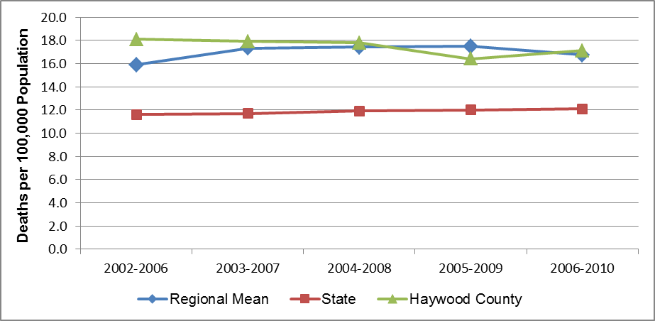

* Underserved populations are certainly more at risk. With health concerns such as prescription drug abuse, all populations are affected. However, data shows males within the ages of 20-40 to be most at risk. In terms of fitness and nutrition, those with transportation challenges, less access to care, and socioeconomic disadvantages have a far more difficult time finding the physical and financial means to achieve healthier eating and exercise.

Next Steps

* Plans to disseminate the findings of the CHA results include Facebook postings, websites (including Haywood County government and Healthy Haywood), and a press release to two local newspapers. Presentations may also be made to key groups and organizations such as the Board of Health, Haywood County School Board, Cooperative Extension, and local Kiwanis and Rotary Clubs.
* Plans to collaborate with agencies, interested community members, and key stakeholders around action planning are underway. First, a presentation about the CHA process and findings, along with top three health priority recommendations, will be given to the Board of Health in February. Potential actions and implementation strategies to accomplish these goals will also be discussed at the next Healthy Haywood partnership meeting with Medwest Haywood Hospital. Lead agencies to help achieve the determined goals will be identified at that time.

# Chapter 1 - Introduction

## Purpose of Community Health Assessment (CHA)

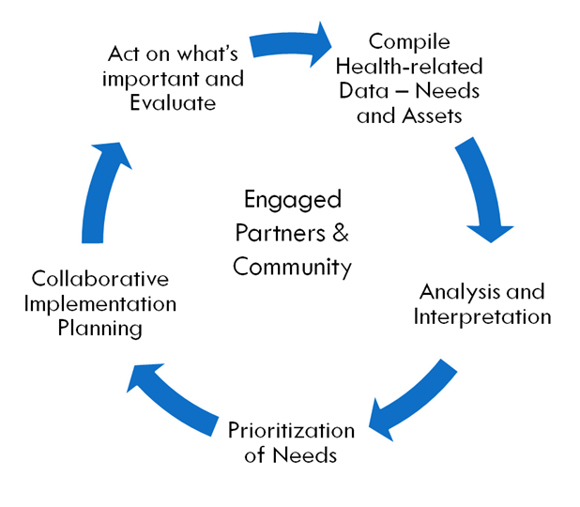Community health assessment (CHA) is the foundation for improving and promoting the health of county residents. **Community-health assessment is a key step in the** **continuous** **community health improvement process**. The role of CHA is to identify factors that affect the health of a population and determine the availability of resources within the county to adequately address these factors.

A community health assessment (CHA), which refers both to a process and a document, investigates and describes the current health status of the community, what has changed since a recent past assessment, and what still needs to change to improve the health of the community. The *process* involves the collection and analysis of a large range of secondary data, including demographic, socioeconomic and health statistics, environmental data, as well as primary data such as personal self-reports and public opinion collected by survey, listening sessions, or other methods. The *document* is a summary of all the available evidence and serves as a resource until the next assessment. Together they provide a basis for prioritizing the community’s health needs, and for planning to meet those needs.

Because it is good evidence-based public health practice, local health departments (LHDs) across North Carolina (NC) are required to conduct a comprehensive community health assessment at least every four years. It is required of public health departments in the consolidated agreement between the NC Division of Public Health and local public health departments. Furthermore, it is required for local public health department accreditation through the NC Local Health Department Accreditation Board (G.S. § 130A-34.1). As part of the Affordable Care Act, non-profit hospitals are also now required to conduct a community health (needs) assessment at least every three years.

The local health department usually conducts the CHA as part (and usually the leader) of a team composed of representatives from a broad range of health and human service and other organizations within the community. Community partners and residents are part this process as well.

### Definition of Community

Community is defined as "county" for the purposes of the North Carolina Community Health Assessment Process. In western North Carolina, hospitals define their community as one or more counties for this process. Haywood County is included in MedWest Haywood hospital’s community for the purposes of community health improvement and investment, and as such MedWest Haywood Hospital was a key partner in this local level assessment process.

## 

## WNC Healthy Impact

WNC Healthy Impact is a partnership between hospitals and health departments in North Carolina to improve community health. As part of a larger, and continuous, community health improvement process, these partners are collaborating to conduct community health (needs) assessments across western North Carolina. See [www.WNCHealthyImpact.com](http://www.WNCHealthyImpact.com) for more details about the purpose and participants of this region-wide effort. The regional work of WNC Healthy Impact is supported by a steering committee, workgroups, local agency representatives, and a public health/data consulting team. In addition, for this data collection phase of our regional efforts, a survey vendor (PRC – Professional Research Consultants, Inc.) was hired to administer a region-wide telephone survey. Various partners, coalitions, and community members are also engaged at the local level. The template for this CHA report, a core set of secondary and survey (primary) data, and analysis support, were made available through this collaborative regional effort.

## 

## Data Collection Process

### 

### ****Core Dataset Collection****

As part of WNC Healthy Impact, a regional data workgroup of public health and hospital representatives and regional partners, with support from the consulting team, made recommendations to the steering committee on the data approach and content used to help inform regional data collection. The core regional dataset was informed by stakeholder data needs, guidelines, and requirements. From data collected as part of this core dataset, the consulting team compiled secondary (existing) data and new survey findings for each county in the 16-county region. This assessment includes data integrated from the secondary data efforts as well as the community health survey for ourcounty. See Appendix A for details on the data collection methodology.

### 

### Criteria for selecting “highlights”

The body of assessment data supporting this document is wide-ranging and complex. In order to develop a summary of major findings, the consultant team applied three key criteria to nominate data for inclusion in this report. The data described in this report was selected because:

* County statistics deviate in significant ways from WNC regional data or NC statistics;
* County trend data show significant change—positive or negative—over time; or
* County data demonstrate noteworthy age, gender, or racial disparities.

Supplementary to this report is the *WNC Healthy Impact Secondary Data Workbook* (*Data Workbook*) that contains complete county-level data as well as the state and regional averages and totals described here. Data contained in the *Data Workbook* is thoroughly referenced as to source. Readers should consult the *Data Workbook* to review all of the secondary data comprising the regional summaries.

Unless specifically noted otherwise, all tables, graphs and figures presented in this report were derived directly from spreadsheets in the *Data Workbook* or survey data reported by the survey vendor (PRC).

### 

### Additional Local Data

Determination of available health-related resources and facilities took place through discussion among hospital, health department, and community stakeholders as well as a review of 2-1-1 data. When the three key health topics were determined in 2008, each team identified the need for a resource list for their particular health topic. Note also that each resource guide is revisited periodically to make edits to new and changing resources which prompted the need to identify and possibly address any gaps in resources.

When looking at 2012 priorities, community stakeholders were asked very simply what resources they felt were currently lacking in Haywood County. (See Chapter 8 Resource Gaps for a list of comments). As the teams begin to meet, these comments will be taken into consideration when choosing goals and action plans.

See Appendix C for a list of the healthcare and health promotion resources and facilities available in Haywood County to respond to the health needs of the community. This resource list addresses specific identified needs to include substance abuse, mental health, prescription use and abuse, homelessness, developmental disabilities, aging, and fitness.

## 

## Definitions & Data Interpretation Guidance

Reports of this type customarily employ a range of technical terms, some of which may be unfamiliar to many readers. This report defines technical terms within the section where each term is first encountered.

Health data, which composes a large proportion of the information included in this report, employs a series of very specific terms which are important to interpreting the significance of the data. While these technical health data terms are defined in the report at the appropriate time, there are some data caveats that should be applied from the onset. See Appendix A for additional details and definitions.

## 

## Community Engagement

In the random-sample survey that was administered in our county as part of this community health assessment, 200 community members completed a questionnaire regarding their health status, health behaviors, interactions with clinical care services, support for certain health-related policies, and factors that impact their quality of life. In addition, community members and partners in our county were involved in:

* Workgroups with WNC Healthy Impact; specifically secondary data workgroup, communication workgroup, and the steering committee.
* Meetings were held between the Haywood County Health Educators and the MedWest Health representative to assist with local data interpretation, prioritization of needs, and completion of the health resource inventory.
* Input regarding perceived resource gaps was obtained from key community stakeholders
* Key community stakeholders participated in the prioritization process in October 2012.

## 

## Priority Setting

Details on our county’s priority setting process and outcomes are included in Chapter 9 of this document.

# Chapter 2 – Demographic and Socioeconomic Parameters

## Location and Geography

With a 546 square mile radius and population of about 60,000, Haywood County is the third largest county in western North Carolina after Buncombe and Henderson counties. Haywood is centrally located in the Southeast region of the U.S. and easily accessible from most places by either automobile or plane. Haywood County is located 20 minutes from west Asheville, NC and 20 minutes east of Cherokee, NC. The Blue Ridge Parkway winds its way around the area, with Haywood County boasting four entrances to this scenic byway and its many hiking, viewing, and picnic spots. The most famous natural attraction in the area is the Great Smoky Mountains. Haywood County is home to part of the Great Smoky Mountains National Park, the most visited National Park in the U.S. Fourteen peaks in the Great Smoky Mountains soar to elevations of at least 6,000 feet [more than any east of the Mississippi River], and the county is one of the highest east of the Rockies, with a mean elevation of 3,600 feet. The most notable mountain peak is Cold Mountain at 6,030 feet – the basis for the award winning, best selling novel by Charles Frazier and the ensuing 2003 major motion picture. The Nantahala National Forest is North Carolina’s largest national forest, with 516,000 acres spanning from Waynesville to area towns of Murphy, Fontana, and Cashiers. It is also home to the Nantahala River Gorge, a nine mile stretch of the Nantahala River that offers a haven for whitewater rafters. Haywood County’s lakes, numerous creeks, streams, and the Pigeon River all originate from its own watershed of headwaters in the high mountains of the county.

## 

## History, Tradition, & Industry

First established in 1808, Haywood County was named for John Haywood, North Carolina Treasurer from 1878 to 1827. The area has recently been designated a Blue Ridge Heritage area and is well known for its creativity in arts and crafts. The award winning, volunteer-based community theater, “The Haywood Arts Regional Theatre” (or HART) promotes the performing arts among local youth as well as adults. The annual Folkmoot Festival features performances by international dancers and is an attraction for local residents and tourists. Free public dances featuring local folk dances occur regularly during the summer months in public parks and streets. With the number of tourists and vacation homes, there is a significant seasonal population change in Haywood County. However, it has not yet been possible to quantify the population change.

Haywood Community College has more than 50 curricular programs, including the only fish and game wildlife program in North Carolina, and a student population of more than 2,000 students.

Evergreen Packaging Group, located in Canton, is Haywood’s largest employer. Haywood County Schools is the second largest employer, and MedWest Haywood, the local hospital, is the third largest employer in Haywood County. MedWest is affiliated with Carolinas HealthCare System, one of the leading health care providers in the Southeast. The county has a strong support system for small business with the combined efforts of a small business incubator and the Small Business Center at Haywood Community College’s High Technology Center.

Haywood County is also home to Lake Junaluska Assembly, a camp and conference center for the Southeastern Jurisdiction for the United Methodist Church in the United States. Lake Junaluska is also the headquarters of the World Methodist Council, the consultative body that links almost all churches in the Methodist tradition.

Population

Understanding the growth patterns and age, gender and racial/ethnic distribution of the population in Haywood County will be keys in planning the allocation of health care resources for the county in both the near and long term.

### Current Population (Stratified by Gender, Age, and Race/Ethnicity)

According to data from the 2010 US Census, the total population of Haywood County is 59,036. In Haywood County, as region-wide and statewide, there are a slightly higher proportion of females than males (51.7% vs. 48.3%).

Table 1. Overall Population and Distribution, by Gender (2010)

|  |  |  |  |  |  |
| --- | --- | --- | --- | --- | --- |
| **Geography** | **Total Population (2010)** | **# Males** | **% Males** | **# Females** | **% Females** |
|
|
|  |  |  |  |  |  |
| Haywood County | 59,036 | 28,502 | 48.3 | 30,534 | 51.7 |
| Regional Total | 759,727 | 368,826 | 48.5 | 390,901 | 51.5 |
| State Total | 9,535,483 | 4,645,492 | 48.7 | 4,889,991 | 51.3 |
|  |  |  |  |  |  |

In Haywood County 21.0% of the population is in the 65-and-older age group, compared to 19.0% region-wide and 12.9% statewide (Table 2). The median age in Haywood County is 45.6, while the regional mean median age is 44.7 years and the state median age is 37.4 years.

Table 2. Median Age and Population Distribution, by Age Group (2010)

|  |  |  |  |  |  |  |  |  |  |
| --- | --- | --- | --- | --- | --- | --- | --- | --- | --- |
| **Geography** | **Median Age** | **# Under 5 Years Old** | **% Under 5 Years Old** | **# 5-19 Years Old** | **% 5-19 Years Old** | **# 20 - 64 Years Old** | **% 20 - 64 Years Old** | **# 65 Years and Older** | **% 65 Years and Older** |
|  |  |  |  |  |  |  |  |  |  |
| Haywood County | 45.6 | 2,905 | 4.9 | 9,899 | 16.8 | 33,816 | 57.3 | 12,416 | 21.0 |
| Regional Total | 44.7 | 40,927 | 5.4 | 132,291 | 17.4 | 441,901 | 58.2 | 144,608 | 19.0 |
| State Total | 37.4 | 632,040 | 6.6 | 1,926,640 | 20.2 | 5,742,724 | 60.2 | 1,234,079 | 12.9 |
|  |  |  |  |  |  |  |  |  |  |

In terms of racial and ethnic diversity, Haywood County is less diverse than WNC or than NC as a whole. In Haywood County the population is 95.5% white/Caucasian and 4.5% non-white. Region-wide, the population is 89.3% white/Caucasian and 11.7% non-white. Statewide, the comparable figures are 68.5% white and 31.5% non-white (Table 3). The proportion of the population that self-identifies as Hispanic or Latino of any race is 3.4% in Haywood County, 5.4% region-wide, and 8.4% statewide (Table 3). The predominant minorities in Haywood County are those identifying as “some other race” (1.4%).

The racial and ethnic diversity within the 16 counties that compose the region is quite varied, and readers should consult the *Data Workbook* to understand those differences.

Table 3. Population Distribution, by Racial/Ethnic Groups,

as Percent of Overall Population (2010)

|  |  |  |  |  |  |  |  |  |
| --- | --- | --- | --- | --- | --- | --- | --- | --- |
| **Geography** | **White** | **Black or African American** | **American Indian, Alaskan Native** | **Asian** | **Native Hawaiian, Other Pacific Islander** | **Some Other Race** | **Two or More Races** | **Hispanic or Latino (of any race)** |
|  |  |  |  |  |  |  |  |  |
| Haywood County | 95.5 | 1.1 | 0.5 | 0.4 | 0.0 | 1.4 | 1.1 | 3.4 |
| Regional Total | 89.3 | 4.2 | 1.5 | 0.7 | 0.1 | 2.5 | 1.8 | 5.4 |
| State Total | 68.5 | 21.5 | 1.3 | 2.2 | 0.1 | 4.3 | 2.2 | 8.4 |
|  |  |  |  |  |  |  |  |  |

### Population Growth Trend

Between the 2000 and 2010 US Censuses the population of Haywood County grew by 8.5% and the population of WNC grew by 13.0% (Table 4). The rate of growth in the county is projected to increase slightly over the next 10 years, to 8.8% before slowing to 8.0% in the decade following that. These future county decadal growth rates are smaller than the figures projected for WNC and for NC as a whole over the same period.

Table 4. Decadal Population Growth Rate (2000 to 2030)

|  |  |  |  |  |
| --- | --- | --- | --- | --- |
| **Geography** | **% Total Population Growth** | | | |
| **2000 to 2010** | **2010 to 2020** | **2020 to 2030** | **2000 to 2030** |
|  |  |  |  |  |
| Haywood County | 8.5 | 8.8 | 8.0 | 28.4 |
| Regional Total | 13.0 | 11.6 | 9.6 | 38.2 |
| State Total | 15.6 | 11.3 | 9.6 | 44.5 |
|  |  |  |  |  |

The growth rate of a population is a function of emigration and death rates on the negative side, and immigration and birth rates on the positive side.As illustrated by the data in Table 5, the birth rate in Haywood County, lower than the comparable mean WNC and NC birth rates remained steady at around 10.1% every period between 2002-2006 and 2006-2010 (Table 5). Region-wide the birth rate was stable at around 10.8 for several years before falling recently to 10.5. Statewide, the birth rate, stable for several years around 14.2, fell recently to 13.8.

Table 5. Birth Rate, Five 5-Year Aggregate Period (2002-2006 through 2006-2010)

|  |  |  |  |  |  |
| --- | --- | --- | --- | --- | --- |
| **Geography** | **2002-2006** | **2003-2007** | **2004-2008** | **2005-2009** | **2006-2010** |
|  |  |  |  |  |  |
| Haywood County | 10.1 | 10.2 | 10.1 | 10.2 | 10.0 |
| Regional Arithmetic Mean | 10.8 | 10.8 | 10.8 | 10.7 | 10.5 |
| State Total | 14.2 | 14.2 | 14.2 | 14.1 | 13.8 |
|  |  |  |  |  |  |

### Older Adult Population Growth Trend

As noted previously, the age 65-and-older segment of the population in Haywood County represents a smaller proportion of the overall population than in WNC, but a larger proportion than in the state as a whole. In terms of future health resource planning, it will be important to understand how this segment of the population, a group that utilizes health care services at a higher rate than other age groups, is going to change in the coming years. Table 6 presents the decadal growth trend for the age 65-and-older population, further stratified into smaller age groups, for the decades from 2010 through 2030. These data illustrate how the population age 65-and-older in the county is going to increase over the coming two decades. Calculated from the figures in Table 6, the percent increase anticipated for each age group in Haywood County between 2010 and 2030 is 23.7% for the 65-74 age group, 48.5% for the 75-84 age group, and 60.0% for the 85+ age group. In WNC as a whole, the 65-74 age group is projected to grow by 24.0%, the 75-84 age group by 52.5%, and the 85+ age group by 40.0% over the same period of time.

Table 6. Population Age 65 and Older (2010 through 2030)

|  |  |  |  |  |  |  |  |  |  |  |  |  |  |
| --- | --- | --- | --- | --- | --- | --- | --- | --- | --- | --- | --- | --- | --- |
| **Geography** | **2010 Census Data** | | | |  | **2020 (Projected)** | | | | **2030 (Projected)** | | | |
| ***Total% Age 65 and Older*** | ***% Age 65-74\**** | ***% Age 75-84*** | ***% Age 85+*** | | **% Age 65 and Older** | **% Age 65-74** | **% Age 75-84** | **% Age 85+** | **% Age 65 and Older** | **% Age 65-74** | **% Age 75-84** | **% Age 85+ \*** |
|  |  |  |  |  | |  |  |  |  |  |  |  |  |
| Haywood County | 21.0 | 11.8 | 6.8 | 2.5 | | 25.9 | 14.2 | 8.5 | 3.2 | 28.8 | 14.6 | 10.1 | 4.0 |
| Regional Total | 19.0 | 10.4 | 6.1 | 2.5 | | 23.5 | 13.2 | 7.4 | 2.9 | 25.7 | 12.9 | 9.3 | 3.5 |
| State Total | 12.9 | 7.3 | 4.1 | 1.5 | | 16.6 | 9.9 | 4.9 | 1.8 | 19.3 | 10.6 | 61.8 | 2.2 |
|  |  |  |  |  | |  |  |  |  |  |  |  |  |

### 

### Composition of Families with Children

Data in Table 7 illustrates that the percentage of households with children headed by a married couple is slightly smaller in Haywood County (17.1%) than in WNC (17.2%) and smaller than the comparable figure for NC as a whole (20.1%).

Table 7. Composition of Family Households, 5-Year Estimate (2006-2010)

|  |  |  |  |  |  |  |  |
| --- | --- | --- | --- | --- | --- | --- | --- |
| **Geography** | **Family Composition** | | | | | | |
| **# Total Households\*** | **Family Household** Headed by Married Couple (with children under 18 years)** | | **Family Household Headed by Male (with children under 18 years)** | | **Family Household Headed by Female (with children under 18 years)** | |
| **Est. #** | **%** | **Est. #** | **%** | **Est. #** | **%** |
|  |  |  |  |  |  |  |  |
| Haywood County | 26,445 | 4,509 | 17.1 | 427 | 1.6 | 1,357 | 5.1 |
| Regional Total | 318,280 | 54,822 | 17.2 | 5,322 | 1.7 | 17,134 | 5.4 |
| State Total | 3,626,179 | 729,708 | 20.1 | 78,051 | 2.2 | 282,131 | 7.8 |
|  |  |  |  |  |  |  |  |

* A household includes all the people who occupy a housing unit. The occupants may be a single family, one person living alone, two or more families living together, or any other group of related or unrelated people who share living arrangements.

** A family consists of a householder and one or more other people living in the same household who are related to the householder by birth, marriage, or adoption. All people in a household who are related to the householder are regarded as members of his or her family. A family household may contain people not related to the householder, but those people are not included as part of the householder's family in tabulations.

*** Family composition percentages are based on total number of households. Numerator is number of family households (headed by male, female or married couple) with children under 18 years; denominator is total number of households.

In Haywood County, 46.2% of grandparents living with their minor grandchildren also are the party responsible for their grandchildren’s care. In WNC as in NC as a whole, the comparable figure is about 51% (Table 8).

Table 8. Grandparents Responsible for Grandchildren, 5-Year Estimate (2006-2010)

|  |  |  |  |
| --- | --- | --- | --- |
| **Geography** | **Family Composition** | | |
| **# Grandparents Living with Own Grandchildren (<18 Years)\*** | **Grandparent Responsible for Grandchildren (under 18 years)** | |
| **Est. #** | **%** |
|  |  |  |  |
| Haywood County | 1,064 | 492 | 46.2 |
| Regional Total | 13,470 | 6,971 | 51.8 |
| State Total | 187,626 | 95,027 | 50.6 |
|  |  |  |  |

* Grandparents responsible for grandchildren - data on grandparents as caregivers were derived from American Community Survey questions. Data were collected on whether a grandchild lives with a grandparent in the household, whether the grandparent has responsibility for the basic needs of the grandchild, and the duration of that responsibility. Responsibility of basic needs determines if the grandparent is financially responsible for food, shelter, clothing, day care, etc., for any or all grandchildren living in the household. Percent is derived with the number of grandparents responsible for grandchildren (under 18 years) as the numerator and number of grandparents living with own grandchildren (under 18 years) as the denominator.

### Military Veteran Population

Military veterans compose a higher proportion of the total civilian population in Haywood County than in either NC or the US as a whole. Calculating from figures in Table 9, veterans make up 14.4% of the civilian population in Haywood County, compared to 12.4% in the WNC region, 10.8% statewide, and 9.9% nationally. In Haywood County, approximately 46% of the veteran population is 65 years of age or older; the comparable proportions are 49% for the WNC mean, 36% for NC statewide, and 40% nationwide.

Table 9. Population of Military Veterans, 5-Year Estimate (2006-2010)

|  |  |  |  |  |  |  |  |  |
| --- | --- | --- | --- | --- | --- | --- | --- | --- |
| **Geography** | **Civilian Population 18 years and over** | | | **% Veterans by Age** | | | | |
| **Total** | **Veterans** | **Nonveterans** | **18 to 34 years** | **35 to 54 years** | **55 to 64 years** | **65 to 74 years** | **75 years and over** |
|
|  |  |  |  |  |  |  |  |  |
| Haywood County | 46,945 | 6,773 | 40,172 | 4.9 | 22.4 | 27.1 | 22.6 | 22.9 |
| Regional Total | 593,603 | 73,783 | 519,820 | n/a | n/a | n/a | n/a | n/a |
| Regional Arithmetic Mean | n/a | n/a | n/a | 3.6 | 19.3 | 28.1 | 24.1 | 24.9 |
| State Total | 6,947,547 | 747,052 | 6,200,495 | 8.7 | 30.0 | 25.7 | 17.9 | 17.8 |
| National Total | 228,808,831 | 22,652,496 | 206,156,335 | 7.8 | 26.3 | 25.4 | 19.0 | 21.4 |
|  |  |  |  |  |  |  |  |  |

## Education

It is helpful to understand the level of education of the general population, and with what frequency current students stay in school and eventually graduate.

### Educational Attainment

Table 10 provides data on the proportion of the population age 25 and older with one of three levels of educational attainment: high school or equivalent, some college, and a bachelor’s degree or higher. In these terms, in 2006-2010, Haywood County had a 3% lower proportion than WNC as a whole of residents age 25 or older possessing a high school diploma or its equivalent (31.3% vs. 32.2%), and an approximately 11% higher proportion than NC as a whole (31.3% vs. 28.2%). The county had a slightly higher proportion of persons age 25 and older with some college (21.5%) than the region (20.5%) or the state (20.9%). At the bachelor’s and greater level, the proportional attainment in the county (20.6%) was 2% higher than the comparable mean regional figure (20.2%) but 21% lower than the statewide figure (26.1%).

Table 10. Educational Attainment of Population Age 25 and Older,

Two 5-Year Estimates (2005-2009 and 2006-2010)

|  |  |  |  |  |  |  |  |  |
| --- | --- | --- | --- | --- | --- | --- | --- | --- |
| **Geography** | **2005-2009** | | | | **2006-2010** | | | |
| **Total Population Age 25 Years and Older** | **% High School Graduation Rate (Includes equivalency)** | **% Some College** | **% Bachelor's Degree or Higher** | **Total Population Age 25 Years and Older** | **% High School Graduation Rate (Includes equivalency)** | **% Some College** | **% Bachelor's Degree or Higher** |
|  |  |  |  |  |  |  |  |  |
| Haywood County | 41,247 | 31.6 | 21.2 | 20.3 | 42,828 | 31.3 | 21.5 | 20.6 |
| Regional Total | 511,076 | n/a | n/a | n/a | 532,838 | n/a | n/a | n/a |
| Regional Arithmetic Mean | 31,942 | 32.2 | 19.6 | 19.9 | 33,302 | 32.2 | 20.5 | 20.2 |
| State Total | 5,940,248 | 28.6 | 20.4 | 25.8 | 6,121,611 | 28.2 | 20.9 | 26.1 |
|  |  |  |  |  |  |  |  |  |

### Drop-Out Rate Trend

There are 17 school districts in the WNC region, two in Buncombe County (Buncombe County Schools and Asheville City Schools) plus one in each of the other 15 counties. Table 11 displays the high school drop-out rates for Haywood County as well as a mean drop-out rate for the WNC region and an average rate for NC. The drop-out rate fell each school year from 2008-2009 through 2010-2011 in all the jurisdictions shown in the table. The drop-out rate in Haywood County was higher than the comparable mean WNC and NC rates in SY2007-2008 but lower than both after that date.

Table 11. High School Drop-Out Numbers and Rates (SY2006-2007 through SY2010-2011)

|  |  |  |  |  |  |  |  |  |  |  |
| --- | --- | --- | --- | --- | --- | --- | --- | --- | --- | --- |
| **Geography** | **SY2006-2007** | | **SY2007-2008** | | **SY2008-2009** | | **SY2009-2010** | | **SY2010-2011** | |
| **#** | **Rate** | **#** | **Rate** | **#** | **Rate** | **#** | **Rate** | **#** | **Rate** |
|  |  |  |  |  |  |  |  |  |  |  |
| Haywood County Schools | 154 | 6.05 | 158 | 6.23 | 98 | 3.96 | 81 | 3.26 | 68 | 2.76 |
| Regional Total | 1,756 | n/a | 1,651 | n/a | 1,385 | n/a | 1,129 | n/a | 1,019 | n/a |
| Regional Arithmetic Mean | n/a | 5.66 | n/a | 5.58 | n/a | 4.51 | n/a | 3.61 | n/a | 3.36 |
| State Total | 23,550 | 5.27 | 22,434 | 4.97 | 19,184 | 4.27 | 16,804 | 3.75 | 15,342 | 3.43 |
|  |  |  |  |  |  |  |  |  |  |  |

### Current High School Graduation Rate

The four-year cohort graduation rates for subpopulations of 9th graders entering high school in SY2007-2008 and graduating in SY2010-2011 are presented in Table 12. Region-wide, the mean graduation rates for all subpopulations exceeded the comparable rates for NC as a whole. The overall graduation rate in Haywood County (79.3%) was higher than the comparable rates for WNC (78.8%) or NC (77.9%). The graduation rate for the population of economically disadvantaged students in Haywood County Schools (71.4%) was 7.9 points lower than the corresponding overall graduation rate and lower than the comparable rate for disadvantaged students in WNC (72.0%). The graduation rate for students with limited English proficiency in Haywood County (40.0%) is significantly lower than the comparable rate region-wide (57.2%) or statewide (48.1%).

Table 12. 4-Year Cohort High School Graduation Rate

SY2007-2008 Entering 9th Graders Graduating in SY2010-2011 or Earlier

|  |  |  |  |  |  |  |
| --- | --- | --- | --- | --- | --- | --- |
| **Geography** | **Total Number of Students** | **% Students Graduating** | | | | |
| **All Students** | **Males** | **Females** | **Economically Disadvantaged** | **Limited English Proficiency** |
|  |  |  |  |  |  |  |
| Haywood County Schools | 622 | 79.3 | 74.8 | 84.2 | 71.4 | 40.0 |
| Regional Total | 7,545 | 78.8 | 75.2 | 82.5 | 72.0 | 57.2 |
| State Total | 110,377 | 77.9 | 73.8 | 82.2 | 71.2 | 48.1 |
|  |  |  |  |  |  |  |

## Income

There are several income measures that can be used to compare the economic well-being of communities, among them median household income, and median family income.

### Median Household and Family Income

As calculated from the most recent estimate (2006-2010) displayed in Table 13, the median *household* income in Haywood County was $41,377, compared to a mean WNC median household income of $37,815, a difference of $3,562 *more* in Haywood County. The median household income in Haywood County was more than $4,100 *lower* than the comparable state average in both periods shown in Table 13, but the gap narrowed by $1,200 from 2005-2009 to 2006-2010.

As calculated from the most recent estimate (2006-2010), the median *family* income in Haywood County was $51,595, compared to a mean WNC median family income of $47,608, a difference of $3,087 *more* in Haywood County. The median family income in Haywood County was more than $4,000 *lower* than the comparable state average for both periods cited in Table 13, and the shortfall grew by $501 between 2005-2009 and 2006-2010.

Table 13. Median Household and Median Family Income

5-Year Estimates (2005-2009 and 200-2010)

|  |  |  |  |  |  |  |  |  |
| --- | --- | --- | --- | --- | --- | --- | --- | --- |
| **Geography** | **2005-2009** | | | | **2006-2010** | | | |
| **Median Household Income\*** | | **Median Family Income\*\*** | | **Median Household Income** | | **Median Family Income** | |
| **$** | **$ Difference from State** | **$** | **$ Difference from State** | **$** | **$ Difference from State** | **$** | **$ Difference from State** |
|
|  |  |  |  |  |  |  |  |  |
| Haywood County | 39,676 | -5,393 | 51,473 | -4,056 | 41,377 | -4,193 | 51,596 | -4,557 |
| Regional Arithmetic Mean | 37,107 | -7,962 | 46,578 | -8,951 | 37,815 | -7,756 | 47,608 | -8,545 |
| State Total | 45,069 | n/a | 55,529 | n/a | 45,570 | n/a | 56,153 | n/a |
|  |  |  |  |  |  |  |  |  |

* Median household income is the incomes of all the people 15 years of age or older living in the same household (i.e., occupying the same housing unit) regardless of relationship. For example, two roommates sharing an apartment would be a household, but not a family.

** Median family income is the income of all the people 15 years of age or older living in the same household who are related through either marriage or bloodline. For example, in the case of a married couple who rent out a room in their house to a non-relative, the household would include all three people, but the family would be just the couple.

### Population in Poverty

The *poverty rate* is the percent of the population (both individuals and families) whose money income (which includes job earnings, unemployment compensation, social security income, public assistance, pension/retirement, royalties, child support, etc.) is below a federally established threshold. (This is the “100%-level” figure.)

Table 14 shows the estimated annual poverty rate for two five year periods: 2005-2009 and 2006-2010. The table also presents an estimate for the number of persons living below 200% of the Federal poverty rate, since this figure is often used as a threshold for determining eligibility for government services. The data in this table describe an overall rate, representing the entire population in each geographic entity. As subsequent data will show, poverty may have a strong age component that is not detectable in these numbers.

The 100%-level poverty rate in Haywood County was 12.7% in the 2005-2009 period, and fell to 12.3% in the 2006-2010 period; this change represents a decrease of 3.1% in the percent of persons living in poverty. In both periods cited, the poverty rate in Haywood County was lower than the comparable rates in both WNC and NC. As calculated from figures in Table 14, the 200%-level poverty rate in Haywood County was 34.8% in the 2005-2009 period and fell to 34.5% in the 2006-2010 period, a decrease of 0.9%. In WNC the 200% poverty rate was 36.6% in the 2005-2009 period and rose to 37.3% in the 2006-2010 period, an increase of 1.9%. Statewide, the 100%-level poverty rate rose from 15.1% to 15.5% (an increase of 2.6%) and the 200%-level poverty rate rose from 35.0% to 35.6% (an increase of 1.7%) over the same time frame.

Table 14. Population in Poverty, All Ages

5-Year Estimates (2005-2009 and 2006-2010)

|  |  |  |  |  |  |  |  |  |
| --- | --- | --- | --- | --- | --- | --- | --- | --- |
| **Geography** | **2005-2009** | | | | **2006-2010** | | | |
| **Population Estimate** | **# Below Poverty Level** | **% Below Poverty Level** | **# Below 200% Federal Poverty Level** | **Population Estimate** | **# Below Poverty Level** | **% Below Poverty Level** | **# Below 200% Federal Poverty Level** |
|  |  |  |  |  |  |  |  |  |
| Haywood County | 55,503 | 7,025 | 12.7 | 19,335 | 57,509 | 7,053 | 12.3 | 19,843 |
| Regional Total | 697,685 | 103,966 | 14.9 | 255,556 | 726,827 | 113,990 | 15.7 | 271,215 |
| State Total | 8,768,580 | 1,320,816 | 15.1 | 3,066,957 | 9,013,443 | 1,399,945 | 15.5 | 3,208,471 |
|  |  |  |  |  |  |  |  |  |

Table 15 presents similar data focusing this time exclusively on children under the age of 18. From these data it is apparent that children suffer disproportionately from poverty. In Haywood County the 2005-2009 poverty rate for young persons (18.9%) was 48.8% higher than the overall rate (12.7%), and the 2006-2010 poverty rate for young people (18.2%) was 48.0% higher than the overall rate (12.3%). Childhood poverty increased in both WNC and NC between the 2005-2009 and 2006-2010 periods, rising by 5.2% in WNC and 3.8% statewide. During this same interval, childhood poverty in Haywood County creased 3.7%.

Table 15. Population in Poverty, Under Age 18

5-Year Estimates (2005-2009 and 2006-2010)

|  |  |  |  |  |  |  |
| --- | --- | --- | --- | --- | --- | --- |
| **Geography** | **2005-2009** | | | **2006-2010** | | |
| **Population Estimate** | **# Below Poverty Level** | **% Below Poverty Level** | **Population Estimate** | **# Below Poverty Level** | **% Below Poverty Level** |
|
|  |  |  |  |  |  |  |
| Haywood County | 11,253 | 2,131 | 18.9 | 11,348 | 2,067 | 18.2 |
| Regional Total | 146,592 | 31,196 | 21.3 | 149,649 | 33,486 | 22.4 |
| State Total | 2,173,508 | 452,280 | 20.8 | 2,205,704 | 476,790 | 21.6 |
|  |  |  |  |  |  |  |

### Housing Costs

Because the cost of housing is a major component of the overall cost of living for individuals and families it merits close examination. Table 16 presents housing costs as a percent of total household income, specifically the percent of housing units—both rented and mortgaged—for which the cost exceeds 30% of household income.

In Haywood County, the percentage of *rental* housing units costing more than 30% of household income was 40.9% in the 2005-2009 period and 39.3% in the 2006-2010 period, a decrease of 4%. In WNC, the comparable percentage was 38.9% in the 2005-2009 period and 40.5% in the 2006-2010 period, an increase of 4%. These percentages correspond to state figures of 43.0% and 44.0%, respectively, with a state-level increase of only 2%. The percent of *mortgaged* housing units in Haywood County costing more than 30% of household income was 31.3% in 2005-2009 and 31.8% in 2006-2010, an increase of 2%. Comparable figures for mortgaged housing units in WNC stood at 33.0% in 2005-2009 and 32.6% in 2006-2010, a decrease of 1%. These percentages compare to state figures of 31.4% and 31.7% in the same periods, and a state-level increase of not quite 1%. From these data it appears that in Haywood County, WNC and NC as a whole a higher proportion of renters than mortgage holders spend 30% or more of household income on housing costs.

Table 16. Estimated Housing Units Spending >30% Household Income on Housing

5-Year Estimates (2005-2009 and 2006-2010)

|  |  |  |  |  |  |  |  |  |
| --- | --- | --- | --- | --- | --- | --- | --- | --- |
| **Geography** | **Renter Occupied Units** | | | | **Mortgaged Housing Units** | | | |
| **2005-2009** | | **2006-2010** | | **2005-2009** | | **2006-2010** | |
| **Total Units** | **% Units Spending >30%** | **Total Units** | **% Units Spending >30%** | **Total Units** | **% Units Spending >30%** | **Total Units** | **% Units Spending >30%** |
|  |  |  |  |  |  |  |  |  |
| Haywood County | 6,055 | 40.9 | 6,566 | 39.3 | 9,915 | 31.3 | 10,617 | 31.8 |
| Regional Total | 82,441 | 38.9 | 86,022 | 40.5 | 122,383 | 33.0 | 132,668 | 32.6 |
| State Total | 1,131,480 | 43.0 | 1,157,690 | 44.0 | 1,634,410 | 31.4 | 1,688,790 | 31.7 |
|  |  |  |  |  |  |  |  |  |

Note: The percent of renter-occupied units spending greater than 30% of household income on rental housing was derived by dividing the number of renter-occupied units spending >30% on gross rent by the total renter-occupied units. Gross rent is defined as the amount of the contract rent plus the estimated average monthly cost of utilities (electricity, gas, and water and sewer) and fuels (oil, coal, kerosene, wood, etc.) if these are paid for by the renter (or paid for the renter by someone else). Gross rent is intended to eliminate differentials which result from varying practices with respect to the inclusion of utilities and fuels as part of the rental payment.

## Employment and Unemployment

The following definitions will be useful in understanding the data in this section.

* *Labor force* – includes all persons over the age of 16 who, during the week, are employed, unemployed or in the armed services.
* *Civilian labor force* – excludes the Armed Forces from the labor force equation.
* *Unemployed* – civilians not currently employed but are available for work and have actively looked for a job within the four weeks prior to the date of analysis; also, laid-off civilians waiting to be called back to their jobs, as well as those who will be starting new jobs in the next 30 days.
* *Unemployment rate* – calculated by dividing the number of unemployed persons by the number of people in the civilian labor force.

### Employment

Table 17 summarizes employment by sector. In Haywood County the five sectors employing the greatest proportions of the workforce are, in descending order: (1) Retail Trade (16.68%), (2) Health Care and Social Assistance (16.39%), (3) Manufacturing (13.41%), (4) Accommodation and Food Service (12.25%), and (5) Educational Services (10.05%). In WNC, the five leading employment sectors are: (1) Health Care and Social Assistance (18.52%), (2) Retail Trade (13.86%), (3) Accommodation and Food Services (11.43%), (4) Manufacturing (11.28%) and (5) Educational Services (9.19%). Statewide the comparably ordered list is composed of: (1) Health Care and Social Assistance (14.45%), (2) Retail Trade (11.66%), (3) Manufacturing (11.33%), (4) Educational Services (9.58%) and (5) Accommodation and Food Services (8.95%). The county, WNC and NC lists are quite similar, with variations in WNC stemming from its relative lack of manufacturing jobs and the regionally greater significance of the tourism industry, represented by the Accommodations and Food Service sector.

Table 17. Insured Employment by Sector, Annual Summary (2011)

|  |  |  |  |  |
| --- | --- | --- | --- | --- |
| **Sector** | **Haywood County** | | **WNC** | **NC** |
| **Avg. No. Employed** | **% Total Employment in Sector\*\*** | **% Total Employment in Sector\*\*** | **% Total Employment in Sector\*\*** |
|  |  |  |  |  |
| Agriculture, Forestry, Fishing & Hunting | 52 | 0.32 | 0.58 | 0.74 |
| Mining | * | n/a | 0.24 | 0.08 |
| Utilities | 77 | 0.47 | 0.36 | 0.35 |
| Construction | 788 | 4.84 | 4.75 | 4.53 |
| Manufacturing | 2,183 | 13.41 | 11.28 | 11.33 |
| Wholesale Trade | 263 | 1.62 | 2.35 | 4.38 |
| Retail Trade | 2,715 | 16.68 | 13.86 | 11.66 |
| Transportation & Warehousing | 178 | 1.09 | 2.53 | 3.27 |
| Information | 128 | 0.79 | 1.35 | 1.82 |
| Finance & Insurance | 410 | 2.52 | 2.25 | 3.88 |
| Real Estate & Rental & Leasing | 150 | 0.92 | 0.93 | 1.23 |
| Professional, Scientific & Technical Services | 519 | 3.19 | 3.32 | 4.96 |
| Management of Companies & Enterprises | * | n/a | 0.49 | 2.01 |
| Administrative & Waste Services | 573 | 3.52 | 4.90 | 6.53 |
| Educational Services | 1,636 | 10.05 | 9.19 | 9.58 |
| Health Care & Social Assistance | 2,668 | 16.39 | 18.52 | 14.45 |
| Arts, Entertainment & Recreation | 304 | 1.87 | 1.73 | 1.58 |
| Accommodation & Food Services | 1,993 | 12.25 | 11.43 | 8.95 |
| Public Administration | 1,183 | 7.27 | 7.18 | 6.18 |
| Other Services | 455 | 2.80 | 2.76 | 2.49 |
| Unclassified | * | n/a | 0.00 | n/a |
| TOTAL ALL SECTORS | 16,275 | 100.00 | 100.00 | 100.00 |

Table 18 summarizes the annual average wage paid to employees in the various sectors.

Data in Table 18 reveal that overall the annual wage per employee in Haywood County ($33,105) is $961 higher than the comparable figure for employees region-wide ($32,144) but $13,667 lower than the average annual wage statewide ($46,772).

Table 18. Insured Wages by Sector, Annual Summary (2011)

|  |  |  |  |
| --- | --- | --- | --- |
| **Sector** | **Average Annual Wage per Employee** | | |
| **Haywood County** | **WNC** | **NC** |
|  |  |  |  |
| Agriculture, Forestry, Fishing & Hunting | $21,748 | $23,145 | $28,752 |
| Mining | n/a | 41,662 | 45,828 |
| Utilities | 50,364 | 72,196 | 76,552 |
| Construction | 29,252 | 31,190 | 41,316 |
| Manufacturing | 49,561 | 38,443 | 52,613 |
| Wholesale Trade | 35,978 | 36,182 | 61,194 |
| Retail Trade | 23,128 | 22,109 | 24,650 |
| Transportation & Warehousing | 43,665 | 39,117 | 43,400 |
| Information | 47,519 | 38,682 | 63,833 |
| Finance & Insurance | 41,765 | 42,881 | 75,088 |
| Real Estate & Rental & Leasing | 21,416 | 24,051 | 38,476 |
| Professional, Scientific & Technical Services | 43,732 | 36,584 | 66,951 |
| Management of Companies & Enterprises | n/a | 43,518 | 88,763 |
| Administrative & Waste Services | 23,054 | 25,753 | 30,258 |
| Educational Services | 31,613 | 32,604 | 39,787 |
| Health Care & Social Assistance | 39,112 | 32,843 | 42,811 |
| Arts, Entertainment & Recreation | 21,554 | 20,936 | 28,474 |
| Accommodation & Food Services | 12,878 | 14,424 | 14,877 |
| Public Administration | 35,336 | 33,818 | 43,641 |
| Other Services | 24,207 | 24,660 | 28,182 |
| Unclassified | n/a | 12,056 | n/a |
| TOTAL ALL SECTORS | $33,105 | $32,144 | $46,772 |

#### Unemployment

Table 19 summarizes the annual unemployment rate for 2007 through 2011. From these data it appears that the unemployment rate in Haywood County was lower than comparable figures for both WNC and NC as a whole throughout the period from 2007-2011.

Table 19. Unemployment Rate as Percent of Workforce,

(2007 through 2011)

|  |  |  |  |  |  |
| --- | --- | --- | --- | --- | --- |
| **Geography** | **Annual Average** | | | | |
| **2007** | **2008** | **2009** | **2010** | **2011** |
|
|  |  |  |  |  |  |
| Haywood County | 4.0 | 5.6 | 9.7 | 10.0 | 9.9 |
| Regional Arithmetic Mean | 4.9 | 6.8 | 11.8 | 11.8 | 11.5 |
| State Total | 4.8 | 6.3 | 10.5 | 10.9 | 10.5 |
|  |  |  |  |  |  |

## Crime

Tables 20-22 present annual crime rates for Haywood County, WNC and the state of NC for the 10 years from 2001 through 2010. Table 20 summarizes the “index crime rate”, which is the sum of the violent crime rate (murder, forcible rape, robbery, and aggravated assault) *plus* the property crime rate (burglary, larceny, arson, and motor vehicle theft). Table 21 summarizes violent crime, and Table 22 summarizes property crime.

Data in Table 20 indicate that the index crime rate in Haywood County was higher than the mean WNC index crime rate but lower than the state rate in all years cited in the table. The mean index crime rate in WNC was far lower than the comparable state rate for every year during the decade covered in the table. There is not enough information available from the data source to interpret annual variations in these rates.

Table 20. Index Crime Rate (2001-2010)

|  |  |  |  |  |  |  |  |  |  |  |
| --- | --- | --- | --- | --- | --- | --- | --- | --- | --- | --- |
| **Geography** | **Index Crimes per 100,000 Population** | | | | | | | | | |
| **2001** | **2002** | **2003** | **2004** | **2005** | **2006** | **2007** | **2008** | **2009** | **2010** |
|
|  |  |  |  |  |  |  |  |  |  |  |
| Haywood County | 2,516.0 | 2,489.2 | 2,756.1 | 3,022.1 | 3,120.5 | 3,291.8 | 3,185.6 | 3,268.4 | 2,733.4 | 3,041.6 |
| Regional Arithmetic Mean | 2,163.4 | 2,294.3 | 2,413.8 | 2,656.0 | 2,648.1 | 2,536.4 | 2,688.3 | 2,703.4 | 2,502.2 | 2,426.4 |
| State Total | 5,005.2 | 4,792.6 | 4,711.8 | 4,641.7 | 4,622.9 | 4,654.4 | 4,658.6 | 4,581.0 | 4,191.2 | 3,955.7 |
|  |  |  |  |  |  |  |  |  |  |  |

Table 21 separates the violent crime rate from the overall index crime rate for the same period cited above. As with overall index crime, the violent crime rate in Haywood County was, with one exception, higher than the comparable mean WNC rate but lower than the state rate for the period from 2001 through 2010. In 2007, the Haywood County violent crime rate was lower than both the mean WNC and NC rates. The mean violent crime rate in WNC was significantly lower than the rate for NC as a whole throughout the period cited in the table. According to data from the NC SCHS, there were a total of 148 homicides in the 16 WNC counties during the five-year period from 2006 through 2010, seven of them in Haywood County (*Data Workbook*).

Table 21. Violent Crime Rate (2001-2010)

|  |  |  |  |  |  |  |  |  |  |  |
| --- | --- | --- | --- | --- | --- | --- | --- | --- | --- | --- |
| **Geography** | **Violent Crimes per 100,000 Population** | | | | | | | | | |
| **2001** | **2002** | **2003** | **2004** | **2005** | **2006** | **2007** | **2008** | **2009** | **2010** |
|
|  |  |  |  |  |  |  |  |  |  |  |
| Haywood County | 265.6 | 208.8 | 228.6 | 265.1 | 265.5 | 270.3 | 263.0 | 298.1 | 246.9 | 272.3 |
| Regional Arithmetic Mean | 181.5 | 194.4 | 200.4 | 198.5 | 232.9 | 221.9 | 274.4 | 190.7 | 224.4 | 258.6 |
| State Total | 503.8 | 475.3 | 454.7 | 460.9 | 478.6 | 483.5 | 480.5 | 477.0 | 417.1 | 374.4 |
|  |  |  |  |  |  |  |  |  |  |  |

Table 22 separates the property crime rate from the overall index crime rate for the same period cited above. Comparing these figures to the index crime rate, it is clear that the majority of all index crime committed is property crime. In keeping with the pattern noted for index crime, the property crime rates for Haywood County were higher than the comparable mean WNC and NC rates for the period from 2001-2005 and again in 2008. The mean property crime rate for WNC was significantly lower than the comparable rate for NC as a whole from 2001 to 2010.

|  |  |  |  |  |  |  |  |  |  |  |
| --- | --- | --- | --- | --- | --- | --- | --- | --- | --- | --- |
| **Geography** | **Property Crimes per 100,000 Population** | | | | | | | | | |
| **2001** | **2002** | **2003** | **2004** | **2005** | **2006** | **2007** | **2008** | **2009** | **2010** |
|
|  |  |  |  |  |  |  |  |  |  |  |
| Haywood County | 2,250.4 | 2,280.4 | 2,527.5 | 2,757.0 | 2,855.0 | 3,021.5 | 2,922.6 | 2,970.3 | 2,486.5 | 2,769.4 |
| Regional Arithmetic Mean | 1,981.9 | 2,093.9 | 2,215.2 | 2,423.1 | 2,410.3 | 2,298.7 | 2,468.3 | 2,494.0 | 2,262.1 | 2,228.4 |
| State Total | 4,501.4 | 4,317.3 | 4,257.1 | 4,180.7 | 4,144.3 | 4,170.9 | 4,178.1 | 4,103.9 | 3,774.1 | 3,581.4 |
|  |  |  |  |  |  |  |  |  |  |  |

Table 22. Property Crime Rate (2001-2010)

# Chapter 3 – Health Status and Health Outcome Parameters

## Health Rankings

### America’s Health Rankings

Each year for 20 years, America’s Health Rankings™*,* a project of United Health Foundation, has tracked the health of the nation and provided a comprehensive perspective on how the nation—and each state—measures up. America’s Health Rankings is the longest running state-by-state analysis of health in the US (United Health Foundation, 2011).

America’s Health Rankings are based on several kinds of measures, including *determinates* (socioeconomic and behavioral factors and standards of care that underlay health and well-being) and *outcomes* (measures of morbidity, mortality, and other health conditions). Together, the determinates and outcomes help calculate an overall rank. Table 23 shows where NC stood in the 2011 rankings relative to the “best” and “worst” states (where 1=”best”). *When comparing county or regional health data with data for the state as a whole it is necessary to keep in mind that NC ranks 32nd overall, just outside the bottom third of the 50 US states.*

Table 23. State Rank of North Carolina in America’s Health Rankings (2011)

|  |  |  |  |
| --- | --- | --- | --- |
| **Geography** | **National Rank (Out of 50)** | | |
| **Overall** | **Determinates** | **Outcomes** |
| **Vermont** | 1 | 1 | 5 |
| **North Carolina** | 32 | 31 | 38 |
| **Mississippi** | 50 | 48 | 50 |

Source: United Health Foundation, 2011. *America’s Health Rankings*. Available at: http://www.americashealthrankings.org/mediacenter/mediacenter2.aspx

### County Health Rankings

Building on the work of America's Health Rankings, the Robert Wood Johnson Foundation, collaborating with the University of Wisconsin Population Health Institute, supports a project to develop health rankings for the counties in all 50 states.

Each state’s counties are ranked according to health outcomes and the multiple health factors that determine a county’s health. Each county receives a summary rank for its health outcomes and health factors, and also for four different specific types of health factors: health behaviors, clinical care, social and economic factors, and the physical environment.

Below is a list of the parameters considered in each of the health outcome and health factor categories:

|  |  |
| --- | --- |
| **Health Outcomes –** Mortality | **Social and Economic Factors** |
| **Premature death** | High school graduation |
| Morbidity | Some college |
| Poor or fair health | Unemployment |
| Poor physical health days | Children in poverty |
| Poor mental health days | Inadequate social support |
| Low birthweight | Children in single-parent households |
| **Health Factors** | Violent crime rate |
| Health Behaviors | **Physical Environment** |
| Adult smoking | Air pollution – particulate matter days |
| Adult obesity | Air pollution – ozone days |
| Physical inactivity | Access to recreational facilities |
| Excessive drinking | Limited access to healthy foods |
| Motor vehicle death rate | Fast food restaurants |
| Sexually transmitted infections |  |
| Teen birth rate |  |
| Clinical Care |  |
| Uninsured |  |
| Primary care physicians |  |
| Preventable hospital stays |  |
| Diabetic screening |  |
| Mammography screening |  |

Table 24 presents the health outcome and health factor rankings for Haywood County.

Table 24. County Health Rankings via MATCH (2012)

|  |  |  |  |  |  |  |  |
| --- | --- | --- | --- | --- | --- | --- | --- |
| **Geography** | **County Rank (Out of 100)1** | | | | | | |
| **Health Outcomes** | | **Health Factors** | | | | **Overall Rank** |
| **Mortality** | **Morbidity** | **Health Behaviors** | **Clinical Care** | **Social & Economic Factors** | **Physical Environment** |
| Haywood County | 53 | 71 | 29 | 26 | 20 | 79 | 64 |

Source: *County Health Rankings and Roadmaps, 2012*. Available at http://www.countyhealthrankings.org/app/north-carolina/2012/rankings/outcomes/overall

## 

## Pregnancy and Birth Data

### Pregnancy Rate

The following definitions and statistical conventions will be helpful in understanding the data on pregnancy:

* Reproductive age = 15-44
* Total pregnancies = live births + induced abortions + fetal death at >20 weeks gestation
* Pregnancy rate = number of pregnancies per 1,000 women of reproductive age
* Fertility rate = number of live births per 1,000 women of reproductive age
* Abortion rate = number of induced abortions per 1,000 women of reproductive age

The NC SCHS stratifies much of the pregnancy-related data it maintains into two age groups: ages 15-44 (all women of reproductive age) and ages 15-19 (“teens”). Figures 1 and 2 present pregnancy rate data for ages 15-44 and 15-19, respectively. Note that regional rates are presented as *arithmetic means* (sums of individual county rates divided by the number of county rates). These means are approximations of true regional rates, which NC SCHS does not compute.

Data in Figure 1 illustrate that the pregnancy rate for women ages 15-44 in Haywood County has been lower than the comparable state rate and approximately the same as the mean WNC rate throughout the period cited. The pregnancy rates in all three jurisdictions decreased between 2006 and 2010, by 3.5% in Haywood County, by 11.6% in WNC, and by 9.9% in NC. The 2010 pregnancy rate was 61.3 in Haywood County, 62.7 in WNC, and 76.4 in NC.

Figure 1 – Pregnancy Rate Ages 15-44, Pregnancies per 1,000 Women

(Single Years, 2006-2010)

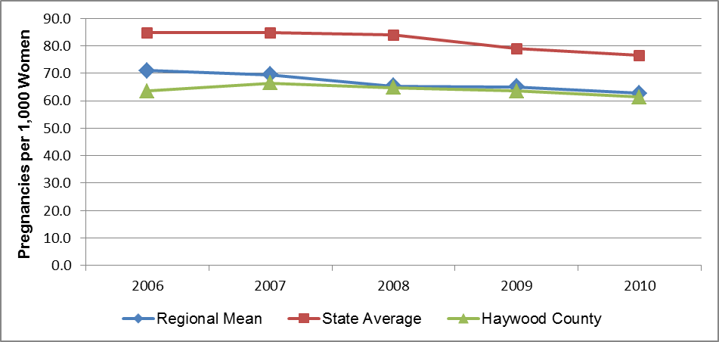

The minority population in Haywood County is large enough to permit calculation of pregnancy rates stratified by race and ethnicity. Table 25 presents pregnancy rates for the 14-55 year age group for 2010. In Haywood County in 2010 the highest pregnancy rate was among Hispanic women (113.1), followed by African-American non-Hispanic women (94.7) and Other non-Hispanic women (67.2). Note, however, that the rates for African American women and Other women are unstable, since they are based on small numbers of events. In WNC, the mean pregnancy rate was highest among Hispanic women (111.8), followed by Other non-Hispanic women (89.4), and white non-Hispanic women (58.9).

Table 25. Pregnancy Rate, Ages 15-44, by Race,

Pregnancies per 1,000 Women

(2010)

|  |  |  |  |  |  |  |  |  |  |  |  |  |  |  |  |
| --- | --- | --- | --- | --- | --- | --- | --- | --- | --- | --- | --- | --- | --- | --- | --- |
| **County** | **Total** | | | **White Non-Hispanic** | | | **African American Non-Hispanic** | | | **Other Non-Hispanic** | | | **Hispanic** | | |
| **#** | **Rate** | **#** | | **Rate** | **#** | | **Rate** | **#** | | **Rate** | **#** | | **Rate** |
|  |  |  |  | |  |  | |  |  | |  |  | |  |
| Haywood County | 596 | 61.3 | 534 | | 58.6 | 9 | | **94.7** | 8 | | **67.2** | 45 | | 113.1 |
| Regional Total | 8,630 | n/a | 6,835 | | n/a | 490 | | n/a | 336 | | n/a | 962 | | n/a |
| Regional Arithmetic Mean | 539 | 62.7 | 427 | | 58.9 | 31 | | *47.3* | 21 | | *89.4* | 60 | | *111.8* |
| State Total | 148,922 | 76.4 | 78,671 | | 65.6 | 40,836 | | 86.1 | 7,288 | | 84.5 | 21,573 | | 114.0 |
|  |  |  |  | |  |  | |  |  | |  |  | |  |

Note: There is some instability in the regional mean rates because each includes one or more unstable county rate.

Data in Figure 2 illustrates that the pregnancy rate for teens (ages 15-19) in Haywood County was lower than the comparable mean WNC and NC rates over most of the period cited. Note that the teen pregnancy rate in all three jurisdictions decreased between 2006 and 2009, by 35.1% in Haywood County, by 22.9% in WNC, and by 21.2% in NC. The 2010 teen pregnancy rate was 41.9 in Haywood County, 46.3 in WNC, and 49.7 in NC.

Figure 2 – Pregnancy Rate Ages 15-19, Pregnancies per 1,000 Women

(Single Years, 2006-2010)

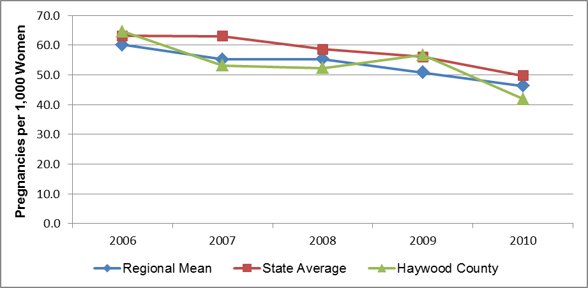

Note: There is some instability in the regional mean rates because each includes one or more unstable county rate.

The minority population in Haywood County is large enough to permit calculation of teen pregnancy rates stratified by race and ethnicity. Table 26 presents pregnancy rates for the 14-19 year age group for 2010. While there were pregnancies among minority teens In Haywood County in 2010, all the rates are unstable due to small numbers of events. In WNC, the mean teen pregnancy rate was highest among Hispanic teens (73.0), followed by African-American non-Hispanic teens (72.2), and other non-Hispanic teens (50.3).

Table 26. Pregnancy Rate, Ages 15-19, by Race,

Pregnancies per 1,000 Women

(2010)

|  |  |  |  |  |  |  |  |  |  |  |  |  |  |  |  |
| --- | --- | --- | --- | --- | --- | --- | --- | --- | --- | --- | --- | --- | --- | --- | --- |
| **County** | **Total** | | | **White Non-Hispanic** | | | **African American Non-Hispanic** | | | **Other Non-Hispanic** | | | **Hispanic** | | |
| **#** | **Rate** | **#** | | **Rate** | **#** | | **Rate** | **#** | | **Rate** | **#** | | **Rate** |
|  |  |  |  | |  |  | |  |  | |  |  | |  |
| Haywood County | 68 | 41.9 | 61 | | 40.2 | 1 | | **58.8** | 2 | | **117.6** | 4 | | **55.6** |
| Regional Total | 990 | n/a | 740 | | n/a | 86 | | n/a | 51 | | n/a | 113 | | n/a |
| Regional Arithmetic Mean | 62 | 46.3 | 46 | | *42.2* | 5 | | *72.2* | 3 | | *50.3* | 7 | | *73.0* |
| State Total | 15,957 | 49.7 | 6,525 | | 34.4 | 6,292 | | 70.2 | 609 | | 48.9 | 2,456 | | 82.7 |
|  |  |  |  | |  |  | |  |  | |  |  | |  |

a– A figure in ***bold italics*** indicates an unstable rate based on a small number of events

Note: There is some instability in the regional mean rates because each includes one or more unstable county rate.

### Pregnancy Risk Factors

Smoking During Pregnancy

Smoking during pregnancy is an unhealthy behavior that may have negative effects on both the mother and the fetus. Smoking can lead to fetal and newborn death, and contribute to low birth weight and pre-term delivery. In pregnant women, smoking can increase the rate of placental problems, and contribute to premature rupture of membranes and heavy bleeding during delivery (March of Dimes, 2012).

Table 27 presents data on the number and percent of births resulting from pregnancies in which the mother smoked during the prenatal period. The percentage frequency of smoking during pregnancy in Haywood County was higher than the comparable mean percentage for WNC as well as the percentage statewide in all of the time periods cited in the table. Note that the WNC means were significantly higher than the comparable percentages statewide in all of the time periods cited in the table. The frequency of smoking during pregnancy in Haywood County, WNC and NC all improved over the period cited, by 4.3% in Haywood County, by 8.0% in WNC, and by 14.78% in NC.

Table 27. Births to Mothers Who Smoked During the Prenatal Period

(Five-Year Aggregates, 2001-2005 through 2005-2009)

|  |  |  |  |  |  |  |  |  |  |  |
| --- | --- | --- | --- | --- | --- | --- | --- | --- | --- | --- |
| **Geography** | **2001-2005** | | **2002-2006** | | **2003-2007** | | **2004-2008** | | **2005-2009** | |
| # | % | # | % | **#** | **%** | **#** | **%** | **#** | **%** |
|
|  |  |  |  |  |  |  |  |  |  |  |
| Haywood County | 685 | 24.3 | 674 | 23.7 | 688 | 24.0 | 673 | 23.5 | 676 | 23.2 |
| Regional Total | 7,496 | 22.4 | 7,442 | 22.1 | 7,361 | 21.7 | 7,106 | 21.2 | 6,919 | 20.6 |
| State Total | 76,712 | 12.9 | 74,901 | 12.4 | 73,887 | 11.9 | 72,513 | 11.5 | 70,529 | 11.0 |
|  |  |  |  |  |  |  |  |  |  |  |

Late or No Prenatal Care

Good pre-conception health and early prenatal care can help assure women the healthiest pregnancies and best birth outcomes possible. Access to prenatal care is particularly important during the first three months of pregnancy (March of Dimes, 2012).

Table 28 shows data summarizing utilization of prenatal care during the first three months of pregnancy. The percent of births in Haywood County that included early prenatal care was higher than both the mean figure for WNC as well as the total for NC as a whole for the entire period cited. The prenatal care frequency in Haywood County has fallen gradually over time, as have the frequencies in the other two jurisdictions. Overall, the Haywood County percentage fell from 91.3% in 2001-2005 to 89.2% in 2005-2009, a decrease of 2.3%. Among Haywood County minority groups, African-Americans utilize early prenatal care at a frequency of 83.3%, and Native Americans at a frequency of 66.7% (*Data Workbook*).

The frequency of early prenatal care utilization was higher in WNC than in the state as a whole for every period noted in the figure, but the percentages for both the region and the state decreased over the period cited, by 2.7% in WNC and by 1.7% in NC. Among minority groups statewide, Native Americans utilize early prenatal care at a frequency of 77.1%, and African Americans at a frequency of 75.2% (*Data Workbook*).

Table 28. Births to Mothers Receiving Prenatal Care During the First Trimester

(Five-Year Aggregates, 2001-2005 through 2005-2009)

|  |  |  |  |  |  |  |  |  |  |  |
| --- | --- | --- | --- | --- | --- | --- | --- | --- | --- | --- |
| **Geography** | **2001-2005** | | **2002-2006** | | **2003-2007** | | **2004-2008** | | **2005-2009** | |
| **#** | **%** | **#** | **%** | **#** | **%** | **#** | **%** | **#** | **%** |
|  |  |  |  |  |  |  |  |  |  |  |
| Haywood County | 2,579 | 91.3 | 2,559 | 89.9 | 2,580 | 89.9 | 2,558 | 89.3 | 2,605 | 89.2 |
| Regional Total | 35,375 | 89.3 | 35,799 | 89.0 | 36,433 | 88.9 | 36,806 | 88.0 | 37,049 | 86.9 |
| State Total | 497,895 | 83.5 | 503,331 | 83.0 | 510,954 | 82.5 | 519,098 | 82.1 | 524,902 | 82.1 |
|  |  |  |  |  |  |  |  |  |  |  |

### Birth Outcomes

#### Low Birth Weight

Low birth weight can result in serious health problems in newborns (e.g., respiratory distress, bleeding in the brain, and heart, intestinal and eye problems), and cause lasting disabilities (mental retardation, cerebral palsy, and vision and hearing loss) or even death (March of Dimes, 2012).

Table 29 summarizes data on the number and percent of low birth weight (< 2500 grams or 5.5 pounds) births. (Note that NC SCHS also maintains data on *very* low birth weight [<1500 grams or 3.3 pounds] births. There are so few very low birth weight births in WNC that county rates are too unstable to calculate a stable regional mean.) In WNC, the percentage of low-birth weight births was lower than the comparable percentage for NC as a whole in each of the aggregate periods cited in the table. Further, the percentages were relatively static in both jurisdictions during the entire period.

In Haywood County over the time span 2002-2006 through 2006-2010, the percentage of low birth weight births rose 4.2% overall, from 9.6 to 10.0, and the county percentage was consistently higher than comparable figures for the region and the state.

The frequency of *very* low birth weight births also increased in Haywood County, from 1.6% in 2002-2006 to 1.8% in 2006-2010 (*Data Workbook*).

Table 29. Low-Weight Births (Five-Year Aggregates, 2002-2006 through 2006-2010)

|  |  |  |  |  |  |  |  |  |  |  |
| --- | --- | --- | --- | --- | --- | --- | --- | --- | --- | --- |
| **Geography** | **2002-2006** | | **2003-2007** | | **2004-2008** | | **2005-2009** | | **2006-2010** | |
| **#** | **%** | **#** | **%** | **#** | **%** | **#** | **%** | **#** | **%** |
|  |  |  |  |  |  |  |  |  |  |  |
| Haywood County | 272 | 9.6 | 287 | 10.0 | 289 | 10.1 | 277 | 9.5 | 285 | 10.0 |
| Regional Total | 3,447 | 8.2 | 3,473 | 8.4 | 3,467 | 8.3 | 3,434 | 8,2 | 3,373 | 8.2 |
| State Total | 54,991 | 9.1 | 56,541 | 9.1 | 57,823 | 9.1 | 58,461 | 9.1 | 58,260 | 9.1 |
|  |  |  |  |  |  |  |  |  |  |  |

#### Infant Mortality

Infant mortality is the number of deaths of infants under one year of age per 1,000 live births. Figure 3 presents infant mortality data for WNC and the state. When interpreting this data it is important to remember that the infant mortality rate for NC as a whole is among the highest (i.e., worst) in the US, ranking 46th out of 50 according to the 2011 *America’s Health Rankings*, cited previously.

The state’s infant mortality rate recently has begun to decrease; after hovering near 8.5 for several years, it was 7.9 in the most recent aggregate period (2006-2010). The mean infant mortality rate for WNC has been lower than the state rate, and appears to be trending in the right direction; the mean WNC infant mortality rate was 7.0 in the 2006-2010 aggregate period. The infant mortality rate for Haywood County was lower than (or equal to) the comparable mean WNC and NC rates throughout the period cited, and did not improve over the past several years; the county rate in the 2002-2006 period and the 2006-2010 period were identical: 7.0.

Figure 3. Infant Mortality Rate, Infant Deaths per 1,000 Live Births

(Five-Year Aggregates, 2002-2006 through 2006-2010)

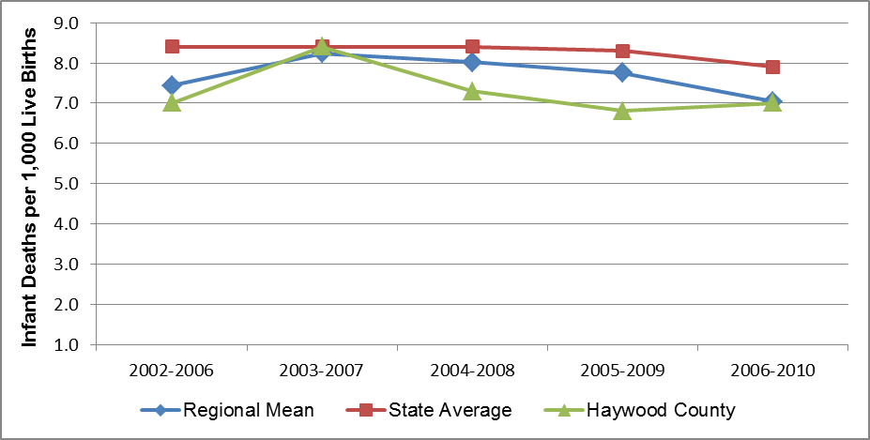

Note: There is some instability in the regional mean rates because each includes one or more unstable county rates.

There is a strong racial component to infant mortality in NC. Statewide in 2006-2010, the infant mortality rate among non-Hispanic African Americans (14.7) was *two and one-half times* the comparable rate among non-Hispanic whites (5.9). In Haywood County during the same interval, the infant mortality rate among non-Hispanic African Americans (11.7) also was two and one-half times the comparable rate among non-Hispanic whites (4.7). Infant deaths in other minority groups in Haywood County were below the threshold for calculating stable rates. Statewide in 2006-2010 the infant mortality rate among non-Hispanic other races was 6.3, and the rate among Hispanics was 5.8 (*Data Workbook*).

### Abortion

Figures 4 and 5 depict abortion rates for Haywood County, the region, and the state. Data in Figure 4 show that the mean abortion rate in WNC for women ages 15-44 was less than half the abortion rate for the state as a whole, and that the rate in both jurisdictions fell over the time period cited in the figure, by 24.3% in WNC and by 16.5% in NC. In 2010 the abortion rate was 5.6 in WNC and 13.2 in NC.

The abortion rate in Haywood County fluctuated around the mean WNC rate throughout the period cited. From 2006 through 2010 the abortion rate for this age group in Haywood County decreased 4.3%, from 7.0 to 6.7.

Figure 4. Pregnancies Ending in Abortion, Ages 15-44, per 1,000 Population

(Single Years, 2006-2010)

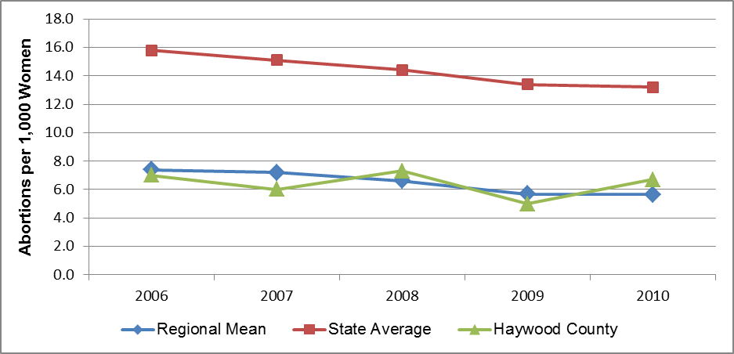

Note: There is some instability in the regional mean rates because each includes one or more unstable county rates.

Data in Figure 5 show that the mean abortion rate in WNC for teens ages 15-19 was slightly more than half the teen abortion rate for the state as a whole for the first three years cited in the figure and less than half the state rate in the most recent two years. The rate in both jurisdictions fell over the time period cited in the figure, by 45.8% in WNC and by 24.1% in NC. The teen abortion rate in Haywood County fluctuated around the regional rate throughout the period cited. Between 2006 and 2010 the teen abortion rate in Haywood County fell from 9.7 to 3.7, a decrease of 61.9%. It should be noted that the 2010 teen abortion rate for the county was unstable since it was based on fewer than 10 events (n=6).

Figure 5. Pregnancies Ending in Abortion, Age 15-19, per 1,000 Population

(Single Years, 2006-2010)

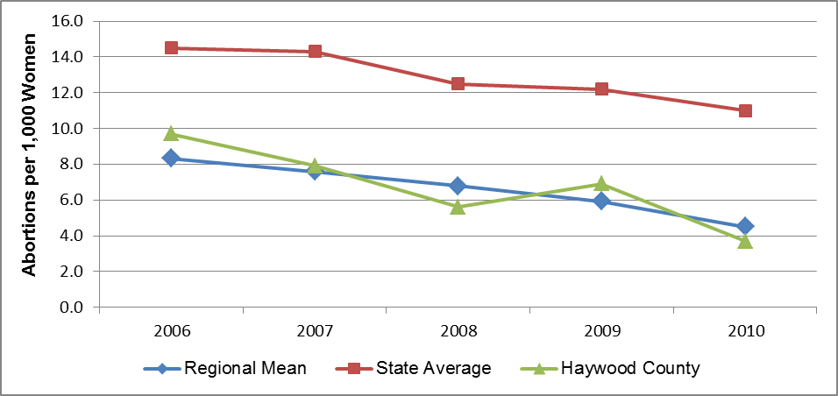

Note: There is some instability in the regional mean rates because each includes one or more unstable county rate.

## Mortality Data

This section describes mortality for the 15 leading causes of death, as well as mortality due to four major site-specific cancers. The list of topics and the accompanying data is derived from the NC SCHS *County Health Databook*. Unless otherwise noted, the numerical data are age-adjusted and represent overlapping five-year aggregate periods.

### Leading Causes of Death

Table 30 compares the mean rank order of the 15 leading causes of death in Haywood County, WNC and NC for the five-year aggregate period 2006-2010. (The causes of death are listed in descending rank order for WNC.) From this data it appears that chronic lower respiratory disease, pneumonia and influenza, motor vehicle injury and suicide rank higher as causes of death in WNC than in the state as a whole. Conversely, cerebrovascular disease, kidney disease, and septicemia rank lower as causes of death regionally than statewide.

The leading causes of death in Haywood County differ in rank order from the comparable lists for WNC or NC, most notably in a higher county placement for pneumonia and influenza, unintentional motor vehicle injuries, and suicide. The Haywood County mortality rate for pneumonia and influenza (20.4) exceeded both the WNC rate (19.1) and NC rate (18.6), the county rate for unintentional motor vehicle injury mortality (19.5) exceeded both the WNC and NC rates (both 16.7), and the Haywood County mortality rate for suicide (17.1) was 2.4% higher than the mean WNC rate (16.7) and 41.3% higher than the NC rate (12.1) Other differences in mortality statistics will be covered as each cause of death is discussed separately below. It should be noted from the onset, however, that for some causes of death (e.g., conditions ranked 14 and 15 below) there may not be stable county mortality rates, due to small numbers of deaths. Some unstable data will be presented in this document, but always accompanied by cautions regarding its use.

Table 30. Rank of Cause-Specific Mortality Rates for the Fifteen Leading Causes of Death

(Five-Year Aggregate, 2006-2010)

|  |  |  |  |  |  |  |
| --- | --- | --- | --- | --- | --- | --- |
| **Leading Cause of Death** | **Haywood County** | | **WNC Mean** | | **NC** | |
| **Rank** | **Rate** | **Rank** | **Rate** | **Rank** | **Rate** |
|  |  |  |  |  |  |  |
| Heart Disease | 1 | 194.1 | 1 | 194.4 | 1 | 184.9 |
| Total Cancer | 2 | 173.8 | 2 | 180.3 | 2 | 183.1 |
| Chronic Lower Respiratory Disease | 3 | 47.1 | 3 | 51.1 | 4 | 46.4 |
| Cerebrovascular Disease | 4 | 45.0 | 4 | 44.0 | 3 | 47.8 |
| All Other Unintentional Injuries | 5 | 38.1 | 5 | 42.9 | 5 | 28.6 |
| Alzheimer’s Disease | 8 | 19.0 | 6 | 30.7 | 6 | 28.5 |
| Diabetes Mellitus | 10 | 16.2 | 7 | 19.6 | 7 | 22.5 |
| Pneumonia and Influenza | 6 | 20.4 | 8 | 19.1 | 9 | 18.6 |
| Unintentional Motor Vehicle Injuries | 7 | 19.5 | 9 | 16.7 | 10 | 16.7 |
| Suicide | 9 | 17.1 | 10 | 16.7 | 12 | 12.1 |
| Nephritis, Nephrotic Syndrome & Nephrosis | 12 | 13.5 | 11 | 16.2 | 8 | 18.9 |
| Septicemia | 13 | 10.4 | 12 | 13.4 | 11 | 13.7 |
| Chronic Liver Disease & Cirrhosis | 11 | 13.7 | 13 | 13.2 | 13 | 9.1 |
| Homicide | 14 | n/a | 14 | n/a | 14 | 6.6 |
| Acquired Immune Deficiency Syndrome | 15 | n/a | 15 | n/a | 15 | 5.4 |

It should be noted that the rank order of leading causes of death varies somewhat among the 16 counties in WNC. Further, in 2005-2009 and 2006-2010 the NC SCHS did not release mortality rates for some causes of death in several counties (including Haywood) because the number of deaths fell below the Center’s threshold of 20 per five-year aggregate period. The mean WNC ranking displayed in Table 30 includes only stable rates presented in the *Data Workbook*.

Each age group tends to have its own leading causes of death. Table 31 lists the three leading causes of death by age group for the five-year aggregate period from 2006-2010. (Note that for this purpose it is important to use *non*-age adjusted death rates.) The WNC rankings were developed by a qualitative examination of the individual ranking lists for each of the counties in the region.

Causes of death in all age groups in Haywood County are similar to those noted for WNC and NC as a whole.

Table 31. Leading Causes of Death by Age Group

Unadjusted Death Rates per 100,000 Population

(Five-Year Aggregate, 2006-2010)

|  |  |  |  |  |
| --- | --- | --- | --- | --- |
| **Age Group** | **Rank** | **Leading Cause of Death** | | |
| **Haywood County** | **WNC** | **NC** |
| **00-19** | **1** | Perinatal conditions | Perinatal conditions | Perinatal conditions |
|  | **2** | Motor vehicle injuries | Motor vehicle injuries | Congenital abnormalities |
|  | **3** | Other unintentional injuries | Congenital abnormalities | Motor vehicle injuries |
|  |  |  | Other unintentional injuries |  |
| **20-39** | **1** | Other unintentional injuries | Other unintentional injuries | Motor vehicle injuries |
|  | **2** | Suicide | Motor vehicle injuries | Other unintentional injuries |
|  | **3** | Motor vehicle injuries | Suicide | Suicide |
| **40-64** | **1** | Cancer – all sites | Cancer – all sites | Cancer – all sites |
|  | **2** | Heart disease | Heart disease | Heart disease |
|  | **3** | Other unintentional injuries | Other unintentional injuries | Other unintentional injuries |
| **65-84** | **1** | Cancer – all sites | Cancer – all sites | Cancer – all sites |
|  | **2** | Heart disease | Heart disease | Heart disease |
|  | **3** | Chronic lower respiratory disease | Chronic lower respiratory disease | Chronic lower respiratory disease |
| **85+** | **1** | Heart disease | Heart disease | Heart disease |
|  | **2** | Cancer – all sites | Cancer – all sites | Cancer – all sites |
|  | **3** | Cerebrovascular disease | Alzheimer’s disease | Cerebrovascular disease |

The following section examines in greater detail each of the causes of death listed in Table 30, in the order of highest mean WNC rank to lowest, beginning with heart disease.

#### Heart Disease Mortality

Heart disease is an abnormal organic condition of the heart or of the heart and circulation. Heart disease is the number one killer in the U.S. It is also a major cause of disability. The most common cause of heart disease, coronary artery disease, is a narrowing or blockage of the coronary arteries, the blood vessels that supply blood to the heart itself. This is the major reason people have heart attacks. Other kinds of heart problems may happen to the valves in the heart, or the heart may not pump well and cause heart failure (US National Library of Medicine).

In the 2006-2010 aggregate period heart disease was the leading cause of death in Haywood County, WNC and NC (Table 30, cited previously). Figure 6 presents heart disease mortality trend data. This graph illustrates that the heart disease mortality rate in Haywood County was higher than the comparable mean rate for WNC throughout the period cited until the last data point. The graph also illustrates that the heart disease mortality rate in Haywood County fell from 210.2 in the 2002-2006 aggregate period to 194.1 in the 2006-2010 aggregate period, a decrease of 7.7%. Over the same interval the NC heart disease mortality rate fell from 217.9 for the 2002-2006 aggregate period to 184.9 for the 2006-2010 aggregate period, a decrease of 15.1%. The mean WNC rate, which for the first three periods cited was below the state rate, surpassed the state rate and leveled during the two most recent periods. For the 2002-2006 period the mean WNC heart disease mortality rate was 204.6; by the 2006-2010 period it had fallen to 194.4, a decrease of 4.9%.

Figure 6. Heart Disease Mortality Rate, Deaths per 100,000 Population

Five-Year Aggregates (2002-2006 through 2006-2010)

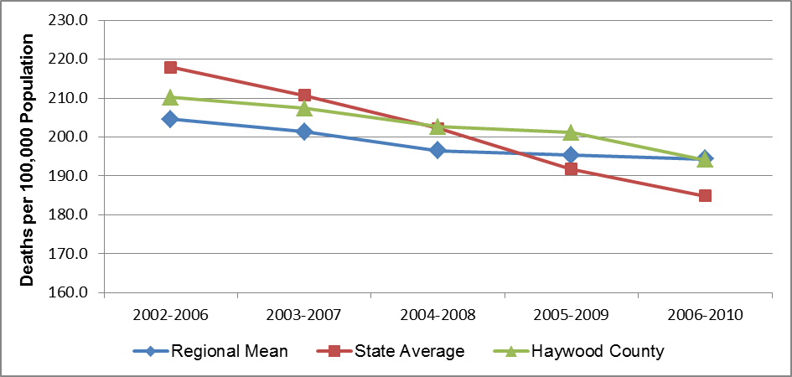

Further subdivision of heart disease mortality data reveals a striking gender disparity. Figure 7 plots heart disease mortality rates for Haywood County, stratified by gender. From these data it is clear that Haywood County males have had a higher heart disease mortality rate than females for the past decade, with the difference as high as 54%. This trend data also shows an apparent 11.0% decrease in the heart disease mortality rate among county males (from 258.6 to 230.2) and a corresponding 1.8% decrease in the rate among county females (from 168.1 to 165.0) from the beginning of the entire period cited to the end. In the last aggregate period, the heart disease mortality rate for Haywood County males was 39.5% higher than the comparable rate for females.

Figure 7. Gender Disparities in Heart Disease Mortality, Haywood County

(Five-Year Aggregates, 2002-2006 through 2006-2010)

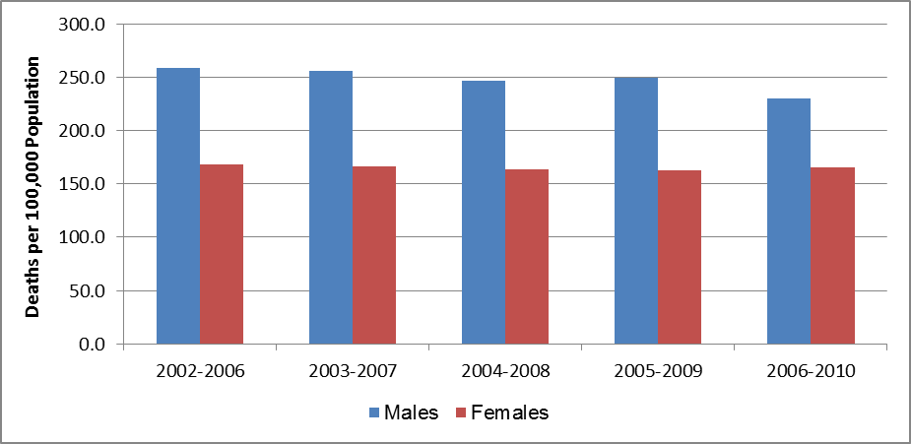

Only four of the 16 counties in WNC (Buncombe, Jackson, Rutherford and Swain) had large enough minority populations to yield stable heart disease mortality rates for minority populations, so it is not possible to calculate stable mean region-wide rate for minorities. At the state level, heart disease mortality demonstrates significant racial disparity, with the minority rate higher than the non-minority rate. For example, statewide in 2006-2010 the heart disease mortality rate among non-Hispanic African American males (285.8) was almost 23% higher than the comparable rate among non-Hispanic white males (233.0), and the rate among non-Hispanic African American females (175.7) was 25% higher than the rate among non-Hispanic white females (140.9). The comparable rates among Other non-Hispanics were 148.7 for males and 102.7 for females. Hispanics had the lowest heart disease mortality rates, 55.7 for males and 36.9 for females (*Data Workbook*).

#### Total Cancer Mortality

Cancer is a term for diseases in which abnormal cells divide without control and can invade nearby tissues. Cancer cells also can spread to other parts of the body through the blood and lymph systems. If the disease remains unchecked, it can result in death (National Cancer Institute).

Taken together, cancers of all types compose the second leading cause of death in WNC and NC but the first leading cause of death in Haywood County in 2006-2010 (Table 30, cited previously).

Figure 8 presents mortality trend data for total cancer. This graph illustrates how over the period cited the total cancer death rate in Haywood County has fallen, from 187.6 in the 2002-2006 aggregate period to 173.8 in the 2006-2010, a decrease of 7.4%. The total cancer mortality rate in the county was below the NC rate throughout the period cited.

This graph also illustrates how over the period cited the total cancer death rate decreased at the state level, and the comparable mean regional rate fluctuated some but changed little in the net. Statewide, mortality attributable to all cancers decreased 6.8% over the period covered in the graph, from 196.4 in 2002-2006 to 183.1 in 2006-2010. In WNC the mean total cancer mortality rate decreased 0.6%, from 181.5 in 2002-2006 to 180.3 in 2006-2010. Nevertheless, the mean regional rate was lower than the comparable state rate in each of the periods cited in Figure 8, although the gap has narrowed.

Figure 8. Total Cancer Mortality Rate, Deaths per 100,000 Population

(Five-Year Aggregates, 2002-2006 through 2006-2010)

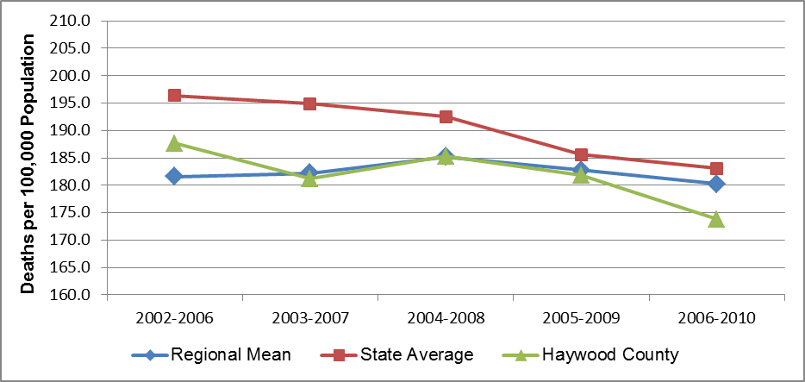

Like heart disease mortality, total cancer mortality demonstrates a gender disparity. Figure 9 plots total cancer mortality rates for Haywood County, stratified by gender. From these data it is clear that males had and continue to have a higher total cancer mortality rate than females for the past decade. Total cancer mortality rates among both males and females in Haywood County appear to be falling. In the most recent aggregate period (2006-2010) the total cancer mortality rate for Haywood County males (215.3) was 49.5% higher than the comparable rate for females (144.0).

Figure 9. Gender Disparities in Total Cancer Mortality, Haywood County

(Five-Year Aggregates, 2002-2006 through 2006-2010)

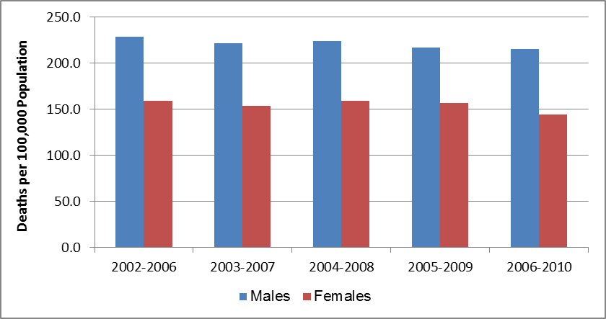

Regionally, only four of the 16 counties in WNC (Buncombe, Jackson, Rutherford and Swain) had large enough minority populations to yield stable total cancer mortality rates, so it is not possible to calculate stable mean region-wide rates for minority populations. At the state level, total cancer mortality demonstrates significant racial disparity, with the minority rates higher than non-minority rates. For example, statewide in 2006-2010 the total cancer mortality rate among non-Hispanic African American males (302.9) was 35% higher than the comparable rate among non-Hispanic white males (224.6), and the rate among non-Hispanic African American females (166.6) was 12% higher than the rate among non-Hispanic white females (149.3). The comparable total cancer mortality rates for Other non-Hispanics were 145.7 for males and 103.2 for females. Hispanics had the lowest total cancer mortality rates, 66.0 for males and 61.2 for females (*Data Workbook*).

Since total cancer is a very significant cause of death, it is useful to examine patterns in the development of new cases of cancer in the county. The statistic important to understanding the growth of a health problem is *incidence*. Incidence is the population-based rate at which new cases of a disease occur and are diagnosed. It is calculated by dividing the number of newly diagnosed cases of a disease or condition during a given period by the population size during that period. Typically, the resulting value is multiplied by 100,000 and is expressed as cases per 100,000; sometimes the multiplier is a smaller number, such as 10,000 or 1,000. Cancer incidence rates were obtained from the NC Cancer Registry, which collects data on newly diagnosed cases from NC clinics and hospitals as well as on NC residents whose cancers were diagnosed at medical facilities in bordering states.

Figure 10 graphs the incidence rates for total cancer for seven five-year aggregate periods. From this data it appears that the incidence rate for total cancer increased in Haywood County, WNC and NC between 1999-2003 and 2005-2009. In Haywood County, the total cancer incidence rate rose from 397.8 at the beginningk of the period cited to 513.4 at the end, an increase of 29.1%. For most of the period cited the county total cancer incidence rate was between the WNC and NC rates; in the last three aggregate periods, the county rate surpassed both the WNC and NC rates.

While both state and mean WNC total cancer incidence rates increased over the period cited in the graph, the slope of increase for WNC is greater than that for the state as a whole. The NC rate rose from 444.0 in 1999-2003 to 500.1 in 2005-2009, a 12.6% increase. The mean total cancer incidence rate in WNC rose from 374.5 in 1999-2003 to 503.8 in 2005-2009, an increase of 35%. Further, the regional incidence rate for total cancer, which for years had been below the comparable NC rate, surpassed the state rate for the first time in the 2005-2009 period.

Figure 10. Total Cancer Incidence Rate, New Cases per 100,000 Population

(Five-Year Aggregates, 1999-2003 through 2005-2009)

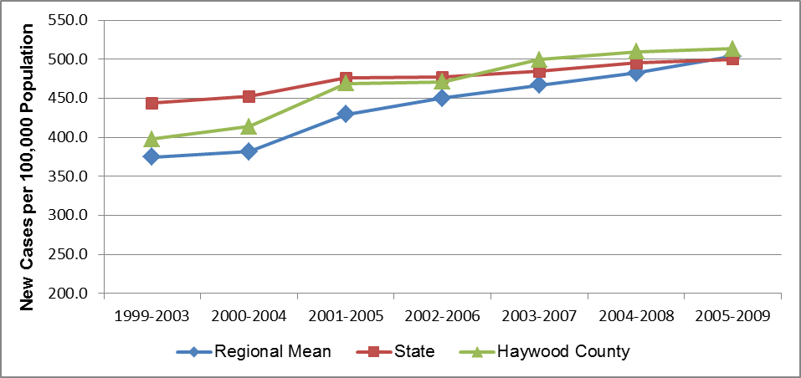

To this point the discussion of cancer mortality and incidence has focused on figures for total cancer. In Haywood County, as throughout both WNC and the state of NC, there are four site-specific cancers that cause most cancer deaths: breast cancer, colon cancer, lung cancer, and prostate cancer. Table 32 summarizes the age-adjusted mortality rates for the four site-specific cancers for the 2006-2010 aggregate period. In Haywood County, the mortality rate for lung cancer (56.3) was higher than the comparable rates for WNC (54.7) and NC (55.9). The county mortality rate for breast cancer (23.7) was below the mean WNC rate (24.3) but above the NC rate (23.4). The county mortality rates for prostate cancer and colon cancer both were below the comparable mean WNC and NC rates. In Haywood County lung cancer was the site-specific cancer with the highest mortality rate, followed by breast cancer, prostate cancer, and colon cancer. In WNC, lung cancer was the site-specific cancer with the highest mortality, followed by breast cancer, prostate cancer, and colon cancer.

Table 32. Age-Adjusted Mortality Rates for Major Site-Specific Cancers (2006-2010)

|  |  |  |  |  |
| --- | --- | --- | --- | --- |
| **Geography** | **Deaths per 100,000 Population** | | | |
| **Lung Cancer** | **Breast Cancer** | **Prostate Cancer** | **Colon Cancer** |
|  |  |  |  |  |
| **Haywood County** | 56.3 | 23.7 | 19.2 | 14.3 |
| **Regional Mean** | 54.7 | 24.3 | 22.9 | 16.6 |
| **State** | 55.9 | 23.4 | 25,5 | 16,0 |

Multi-year mortality rate trends for these four site-specific cancers will be presented subsequently, as each cancer type is discussed separately.

Table 33 summarizes the age-adjusted incidence rates for these four site-specific cancers for the 2005-2009 aggregate period. From this data it appears that in Haywood County, as in WNC, breast cancer was the site-specific cancer with the highest incidence, followed by prostate cancer, lung cancer, and colon cancer. The Haywood County incidence rates for breast cancer and lung cancer were above the comparable mean WNC rates and NC rates; the county incidence rate for prostate cancer was above the mean WNC rate, but below the NC rate. The county incidence rate for colon cancer was lower than in the other two jurisdictions. Multi-year incidence rate trends for these four site-specific cancers will be presented subsequently, as each cancer type is discussed separately.

Table 33. Age-Adjusted Incidence Rates for Major Site-Specific Cancers (2005-2009)

|  |  |  |  |  |
| --- | --- | --- | --- | --- |
| **Geography** | **New Cases per 100,000 Population** | | | |
| **Breast Cancer** | **Prostate Cancer** | **Lung Cancer** | **Colon Cancer** |
|  |  |  |  |  |
| **Haywood County** | 158.7 | 154.4 | 77.0 | 39.1 |
| **Regional Mean** | 154.0 | 139.2 | 75.4 | 46.0 |
| **State** | 154.5 | 158.3 | 75.9 | 45.5 |

#### Lung Cancer Mortality

Lung cancer was the leading cause of cancer mortality in Haywood County in 2006-2010 (Table 32, cited above). Figure 11 plots lung cancer mortality rates for several aggregate periods. This data reveals that the lung cancer mortality rate in Haywood County was higher than mean WNC and NC rates for the entire period cited in the graph, and that the rates in all three jurisdictions fell from the beginning of the period to the end. The lung cancer mortality rate in Haywood County fell from 51.8 for 2002-2006 to 56.3 for 2006-2010, a decrease of 8.9%. Statewide the lung cancer mortality rate fell from 59.8 for 2002-2006 to 55.9 for 2006-2010, a 6.5% decrease over the period. The comparable mean WNC rate fluctuated somewhat but was essentially the same at the end of the period (54.7) as at the beginning (54.2).

Figure 11. Lung Cancer Mortality Rate, Deaths per 100,000 Population

(Five-Year Aggregates, 2002-2006 through 2006-2010)

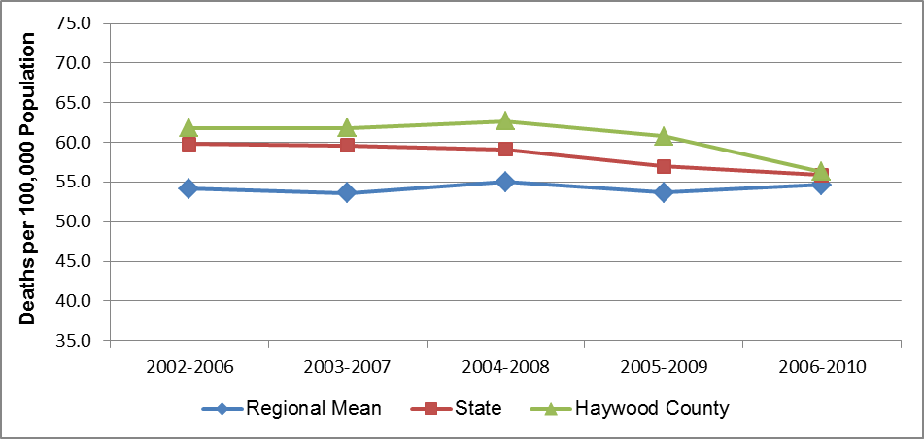

Figure 12 presents gender-stratified Haywood County lung cancer mortality rates for several aggregate periods. From this data it is clear that males experience disproportionately higher lung cancer mortality than females, with the lung cancer mortality rate among men from 36%-49% higher than the rate among women over the period cited.

Figure 12. Gender Disparities in Lung Cancer Mortality, Haywood County

(Five-Year Aggregates, 2002-2006 through 2006-2010)

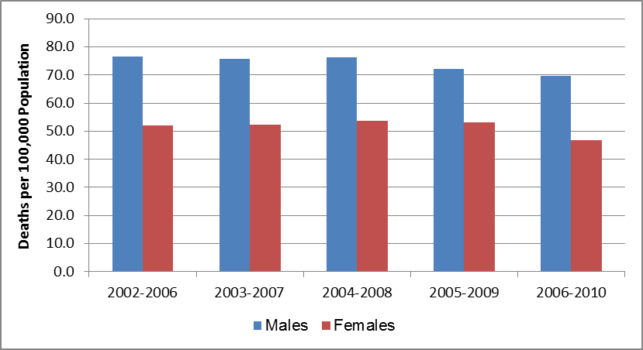

Regionally, only one of the 16 counties in WNC (Buncombe) had large enough minority populations to yield stable minority lung cancer mortality rates, so it is not possible to calculate stable mean region-wide rates for minorities. Statewide, lung cancer mortality rates demonstrate racial disparity. For example, statewide in 2006-2010 the lung cancer mortality rate among African American non-Hispanic males (90.9) was 19% higher than the comparable rate among white non-Hispanic males (76.1); however, the rate among African American non-Hispanic females (32.7) was 25% lower than the rate among white non-Hispanic females (43.7). The comparable rates among “Other” non-Hispanics were 47.2 for males and 24.6 for females. Hispanic males and females had the lowest lung cancer mortality rates, 12.7 and 8.6, respectively (*Data Workbook*).

Since lung cancer is a significant cause of mortality in Haywood County, it is instructive to examine the trend of development of new lung cancer cases over time. Figure 13 depicts the seven-year trend of lung cancer incidence.

Lung cancer incidence in Haywood County increased 17.6% (from 65.5 to 77.0) between 1999-2003 and 2005-2009. The mean lung cancer incidence rate in WNC increased 25.0% from the 1999-2003 aggregate period (60.3) to the 2005-2009 aggregate period (75.4), while the statewide lung cancer incidence rate increased by 9.5% (from 69.3 to 75.9) over the same time frame. Since lung cancer mortality is already on the rise in the region, the increase in the incidence rate may portend additional lung cancer mortality in the future.

Figure 13. Lung Cancer Incidence, New Cases per 100,000 Population

(Five-Year Aggregates, 1999-2003 through 2005-2009)

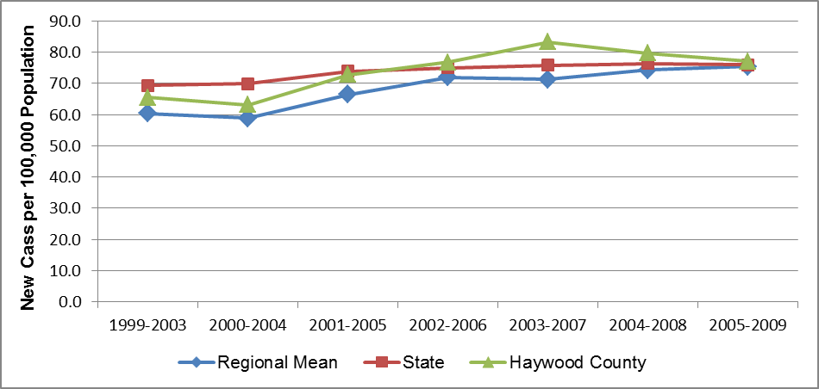

#### Breast Cancer Mortality

Breast cancer was the second leading cause of cancer death in Haywood County in 2006-2010 (Table 32, cited previously). Data in Figure 14 demonstrate that the breast cancer mortality rates in WNC changed little, increasing from 23.8 in 2002-2006 to 24.0 in 2006-2010 (0.8% overall). In Haywood County, the breast cancer mortality rate displayed volatility in varying both above and below the WNC and NC rates, but decreased 10.6% overall, falling from 26.5 to 23.7 over the same period. At the state level, the breast cancer mortality rate fell over the period cited, from a high of 25.5 deaths per 100,000 women in 2002-2006 to a low of 23.2 in 2006-2010, a decrease of 9.0%.

Figure 14. Breast Cancer Mortality Rate, Deaths per 100,000 Women

(Five-Year Aggregates, 2002-2006 through 2006-2010)

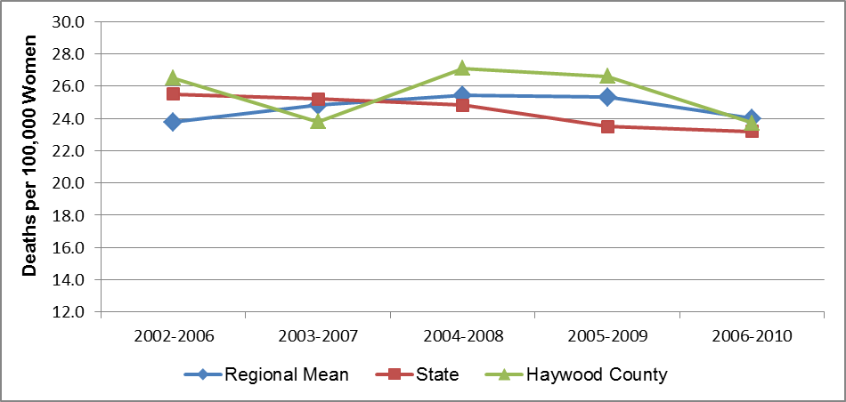

Note: There is some instability in the regional mean rates because each includes one or more unstable county rate.

In WNC, none of the 16 counties, including Haywood, had large enough minority populations to yield stable breast cancer mortality rates for any minority group. At the state level, minority breast cancer mortality rates are higher than the non-minority rates. For example, statewide in 2006-2010 the breast cancer mortality rate among non-Hispanic African American women (30.7) was 40% higher than the comparable rate among non-Hispanic white women (21.9), and the rate among “Other” non-Hispanic women (11.7) was less than half the rate among non-Hispanic white women. The rate among Hispanic women (6.7) was far lower than the rate in any other population (*Data Workbook*).

Figure 15 demonstrates that the breast cancer incidence rate has been increasing in all three jurisdictions over the past several years. In Haywood County, the breast cancer incidence rate rose from 135.2 new cases per 100,000 women in the 1999-2003 aggregate period to 158.7 in the 2005-2009 aggregate period, an increase of 17.4%. In WNC, the mean breast cancer incidence rate rose from 121.3 in the 1999-2003 aggregate period to 154.0 in the 2005-2009 aggregate period, an increase of 27.0%. At the state level, breast cancer incidence rate rose from 147.3 to 154.5 over the same period, an increase of approximately 5%.

Figure 15. Breast Cancer Incidence, New Cases per 100,000 Women

(Five-Year Aggregates, 1999-2003 through 2005-2009)

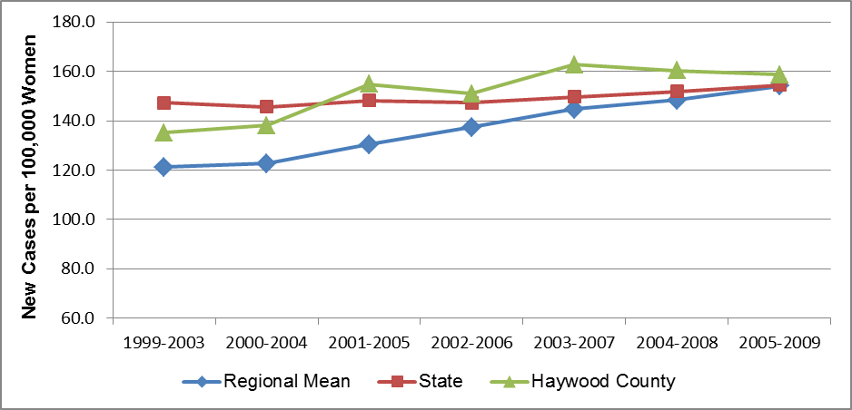

#### Prostate Cancer Mortality

Prostate cancer was the third leading cause of cancer deaths in Haywood County in 2006-2010 (Table 32, cited previously). Figure 16 plots the prostate cancer mortality trend for several aggregate periods. Statewide, prostate cancer mortality demonstrates a slight downward trend, with the 2006-2010 rate (25.5) approximately 12% lower than the comparable rate in 2002-2006 (29.1). In WNC, there has been fluctuation but little net decrease in the mean prostate cancer mortality rate over the period cited in the graph (23.0 the first aggregate period; 22.9 the last aggregate period). In Haywood County, the prostate cancer mortality rate fell significantly over the period cited, from 27.7 for 2002-2006 to 19.2 for 2006-2010, a decrease of 30.7%.

Figure 16. Prostate Cancer Mortality Rate, Deaths per 100,000 Men

(Five-Year Aggregates, 2002-2006 through 2006-2010)

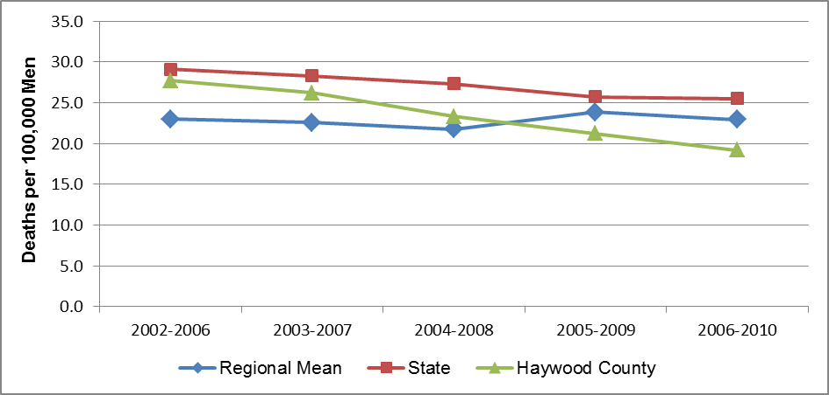

Note: There is some instability in the regional mean rates because each includes one or more unstable county rate.

In WNC, none of the 16 counties (including Haywood County) had large enough minority populations to yield stable prostate cancer mortality rates for any minority group. Statewide, there is a significant racial disparity in prostate cancer mortality. For 2006-2010 in NC as a whole the prostate cancer mortality rate among non-Hispanic African American males (59.4) was *three times* the rate for either non-Hispanic white males (20.4) or “Other” non-Hispanic males (18.2). The prostate cancer mortality rate for Hispanic males (9.5) was the lowest of any minority group in NC (*Data Workbook*).

Prostate cancer incidence statewide has remained relatively stable in recent years, increasing by 4.1%, from 152.0 to 158.3, in the period from 1999-2003 through 2005-2009 (Figure 17). Over the same span of time, the mean prostate cancer incidence rate in WNC rose from 110.7 new cases per 100,000 men in the 1999-2003 period to 139.2 in 2005-2009 period, a total increase of 25.7%, or over six times the statewide percentage increase. In Haywood County, the prostate cancer incidence rate fell between the mean WNC and NC rates throughout most of the period cited, rising from 114.9 to 154.4 over the same period, an overall increase of 34.4%

Figure 17. Prostate Cancer Incidence, New Cases per 100,000 Men

(Five-Year Aggregates, 1999-2003 through 2005-2009)

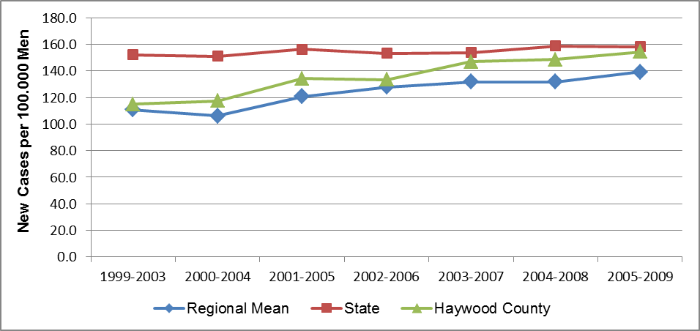

Note: There is some instability in the regional mean rates because each includes one or more unstable county rate.

#### Colorectal Cancer Mortality

Cancer of the colon, rectum and anus (collectively “colorectal” cancer) caused the fourth largest mortality rate among the major site-specific cancers in Haywood County in 2006-2010 (Table 32, cited previously). Figure 18 plots the colorectal cancer mortality rate trend for several aggregate periods. The colorectal cancer mortality rate in Haywood County fell from 16.2 in the 2002-2006 aggregate period to 14.3 in the 2006-2010 aggregate period, a decrease of 11.7%. As seen for a number of other cancers, the state colorectal cancer mortality rate has fallen steadily in recent years, from a high of 18.2 in the 2002-2006 period to a low of 16.0 in the 2006-2010 period, a rate decrease of 12.1%. In WNC, the mean colorectal cancer mortality rate fluctuated considerably, possibly due to a high proportion of unstable county rates, but was the same at the end of the period cited as at the beginning (16.6).

Figure 18. Colorectal Cancer Mortality Rate, Deaths per 100,000 Population

(Five-Year Aggregates, 2002-2006 through 2006-2010)

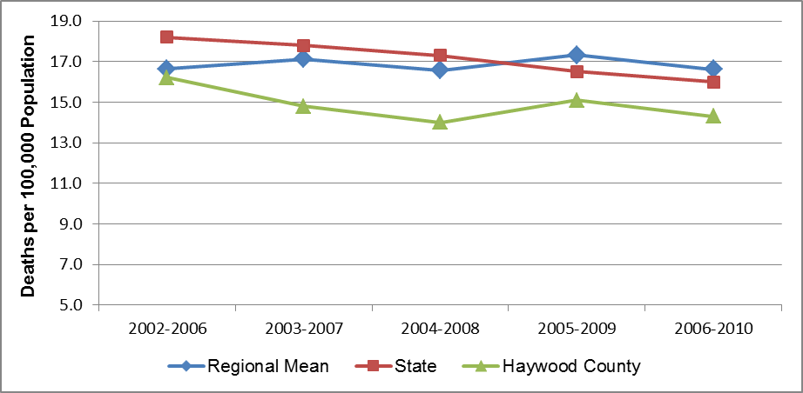

Note: There is some instability in the regional mean rates because each includes one or more unstable county rate.

As shown in Figure 19, the colorectal cancer mortality rate differed between males and females in Haywood County, with the rate for males higher than the rate for females. It is important to note that the colorectal cancer mortality rates among males appeared to be decreasing while the corresponding rate among females appeared to be increasing. Because of these shifts, the colorectal cancer mortality rate among men in Haywood County, once 58% higher than the rate among females, was only 4.3% higher in the 2006-2010 aggregate period. In the 2006-2010 period, the colorectal cancer mortality rate among females was 14.2; the comparable rate among males was 14.8.

Figure 19. Gender Disparities in Colorectal Cancer Mortality, Haywood County

(Five-Year Aggregates, 2002-2006 through 2006-2010)

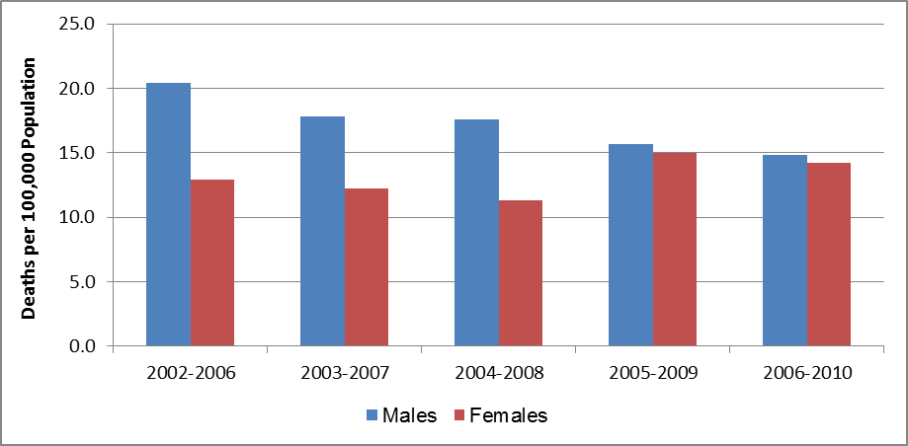

In WNC, none of the 16 counties (including Haywood County) had large enough minority populations to yield stable colorectal cancer mortality rates for any minority group, so it is not possible to calculate stable mean region-wide colorectal cancer mortality rates for minorities. Statewide, colorectal cancer mortality rates demonstrate some racial disparities. In the 2006-2010 aggregate period, the colorectal cancer mortality rate among African American non-Hispanic males (29.0) was 58% higher than the comparable rate among white non-Hispanic males (18.4) and over three times the rate among Other non-Hispanic males (9.0). Statewide in the same period the colorectal cancer mortality rate was 18.5 for African American non-Hispanic females, 12.4 for white non-Hispanic females, and 9.9 for Other non-Hispanic females. Statewide, the colorectal cancer mortality rates were lowest for Hispanic males (7.4) and Hispanic females (5.4) (*Data Workbook*).

From data in Figure 20 it is apparent that the incidence rate for colorectal cancer in Haywood County fluctuated over the full period cited, from a low of 39.2 to a high of 45.9, and back to a low of 39.1, meaning there was little net difference from the first aggregate period to the last. Throughout the period cited, however, the county rate was lower than the mean WNC and NC rates. The mean WNC colorectal cancer incidence rate has been, until recently, following a different trend than the comparable state rate. In the 1999-2003 aggregate period, the mean colorectal cancer incidence rate in WNC (42.2) was 12% lower than the comparable state rate (48.2). By the 2005-2009 aggregate period, the state colorectal cancer rate had fallen to 45.5 (a decrease of over 5%), but the mean WNC rate had risen to 46.0 (an increase of 9%).

Figure 20. Colorectal Cancer Incidence, New Cases per 100,000 Population

(Five-Year Aggregates, 1999-2003 through 2005-2009)

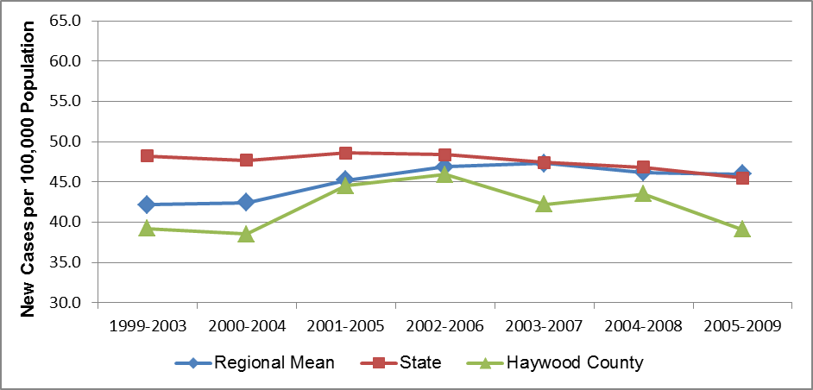

#### Chronic Lower Respiratory Disease (CLRD) Mortality

Chronic lower respiratory disease (CLRD) is composed of three major diseases, chronic bronchitis, emphysema, and asthma, all of which are characterized by shortness of breath caused by airway obstruction and sometimes lung tissue destruction. The obstruction is irreversible in chronic bronchitis and emphysema, reversible in asthma. Before 1999, CLRD was called chronic obstructive pulmonary disease (COPD). Some in the field still use the designation COPD, but limit it to mean chronic bronchitis and emphysema only. In the United States, tobacco use is a key factor in the development and progression of CLRD/COPD, but exposure to air pollutants in the home and workplace, genetic factors, and respiratory infections also play a role (West Virginia Health Statistics Center, 2006).

CLRD/COPD was the third leading cause of death in WNC and in Haywood County for the 2006-2010 aggregate period (Table 30, cited previously).

Figure 21 plots CLRD mortality rates for five aggregate periods. The CLRD mortality rate was relatively stable in Haywood County, WNC and NC for the overall period from 2002-2006 through 2006-2010. WNC had the highest rates of the three jurisdictions over the entire period, and NC had the lowest. The data also shows that CLRD mortality has been and remains higher in WNC than in the state as a whole. The mean WNC CLRD mortality rate ranged from 5% to 10% higher than NC rate throughout the period cited in Figure 21. Neither the NC nor the mean WNC CLRD mortality rates improved significantly over the period, but the CLRD mortality rate in Haywood County fell 8.4% over the same time span. In 2006-2010, CLRD mortality rates were 47.1 in Haywood County, 46.4 in NC, and 51.1 in WNC.

Figure 21. CLRD Mortality Rate, Deaths per 100,000 Population

(Five-Year Aggregates, 2002-2006 through 2006-2010)

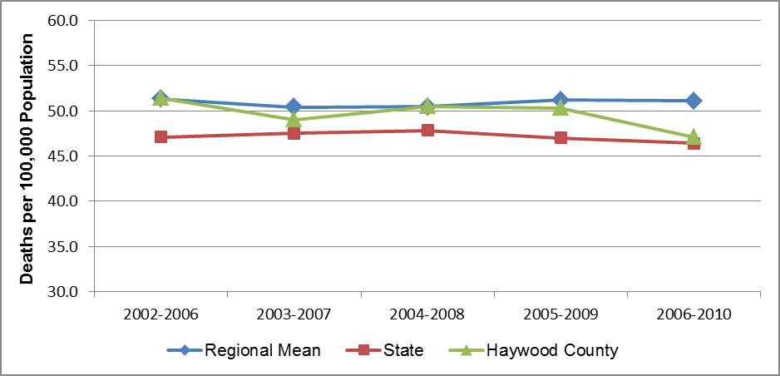

Figure 22 shows how in Haywood County the CLRD mortality rate among males exceeded the comparable rate among females over the past decade. However, the gender gap is closing: the CLRD mortality difference between men and women in Haywood County, which was 62% in the 2002-2006 period, was 8% in the 2006-2010 period, as the mortality rate among males decreased 26.0% (from 67.3 to 49.8) over the interval, and the rate among females increased 11.1% (from 41.6 to 46.2).

Figure 22. Gender Disparities in CLRD Mortality, Haywood County

(Five-Year Aggregates, 2002-2006 through 2006-2010)

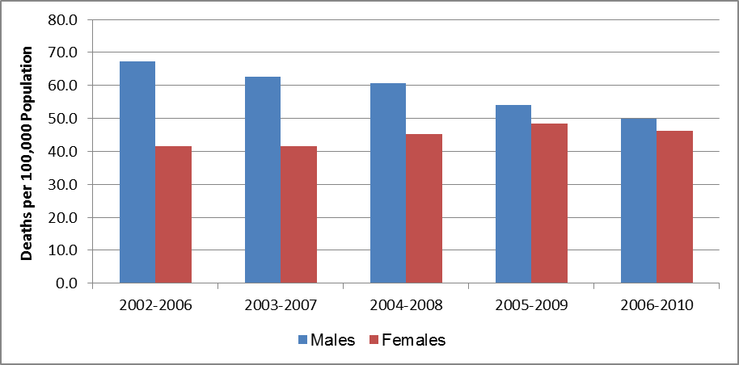

In WNC, none of the 16 counties, including Haywood, had large enough minority populations to yield stable CLRD mortality rates for any minority group, so it is not possible to calculate a stable mean region-wide CLRD mortality rates for minorities. At the state level for the 2006-2010 aggregate period, the CLRD mortality rate was highest among non-Hispanic white males (58.7), followed by non-Hispanic white females (46.4), non-Hispanic African American males (45.1), Other non-Hispanic males (27.4), non-Hispanic females (21.1), and Other non-Hispanic females (15.6). CLRD mortality rates among Hispanic males and females are much lower (6.8 and 7.5, respectively) (*Data Workbook*).

#### Cerebrovascular Disease (Stroke) Mortality

Cerebrovascular disease describes the physiological conditions that lead to stroke. Strokes happen when blood flow to the brain stops and brain cells begin to die. There are two types of stroke. Ischemic stroke (the more common type) is caused by a blood clot that blocks or plugs a blood vessel in the brain. The other kind, called hemorrhagic stroke, is caused by a blood vessel that breaks and bleeds into the brain (US National Library of Medicine).

Cerebrovascular disease was the fourth leading cause of death in both Haywood County and WNC in the 2006-2010 aggregate period (Table 30, cited previously). Figure 23 plots stroke mortality rates for several aggregate periods. The stroke mortality rates for Haywood County, WNC and NC all decreased over the period cited in the graph; the rate improvement was smallest in Haywood County. The rate fell 3.6% in Haywood County (from 46.7 to 45.0), 17.4% in WNC (from 53.3 to 44.9) and 21.8% in NC (from 61.1 to 47.8).

Figure 23. Cerebrovascular Disease Mortality Rate, Deaths per 100,000 Population

(Five-Year Aggregates, 2002-2006 through 2006-2010)

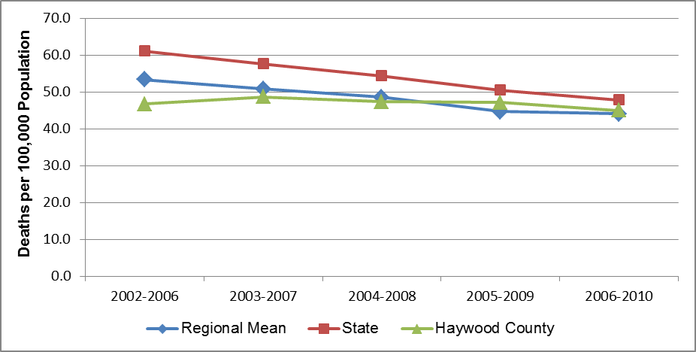

Stroke is one cause of death for which there is little gender disparity in the WNC region (*Data Workbook*). As the data in Figure 24 show, the same would appear to be the case recently in Haywood County, but that was not always the case. In the first three periods cited in the figure, the stroke mortality rate for males was from 29% to 48% higher than the rate for females. The stroke mortality rate for men appears to have decreased, while the rate for women appears to have increased. In Haywood County in the 2006-2010 aggregate period, the stroke mortality rate for women was 42.2, and the rate for men was 48.5 (14.9% higher).

Figure 24. Gender Disparities in Cerebrovascular Disease Mortality,

Haywood County

(Five-Year Aggregates, 2002-2006 through 2006-2010)

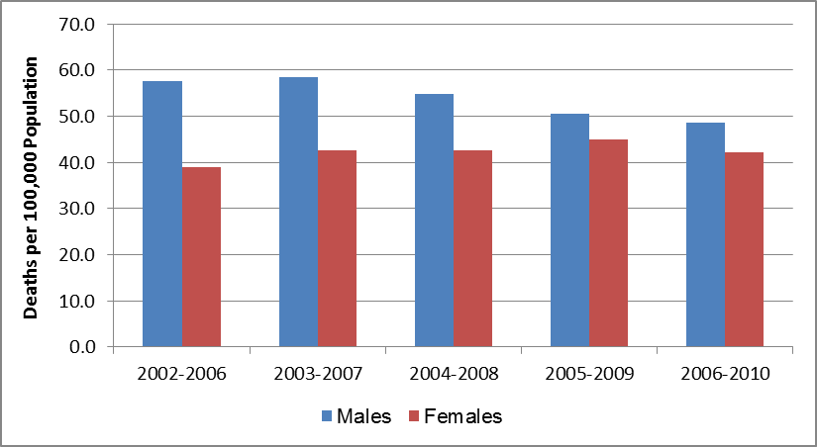

No county in WNC had large enough minority populations to yield stable cerebrovascular disease mortality rates for any minority group, so it is not possible to calculate stable mean region-wide cerebrovascular disease mortality rates for minorities. At the state level stroke mortality demonstrates a significant racial disparity. Statewide in the 2006-2010 aggregate period African American non-Hispanic males and females had the highest stroke mortality rates, 71.4 and 60.1, respectively. The comparable rate for non-Hispanic white males was 44.9, and the rate for non-Hispanic white females was 43.6, and the rate for Other non-Hispanic males was 39.6 and the rate for Other non-Hispanic females was 30.0. The Hispanic population had the lowest stroke mortality rates statewide over the same period, 13.1 among males and 15.2 among females (*Data Workbook*).

#### Non-Motor Vehicle Injury Mortality (“All Other Injuries Mortality”)

Mortality due to injuries *not* involving motor vehicles is the fifth leading cause of death in WNC and Haywood County in the 2006-2010 aggregate period (Table 30, cited previously). This “all other injuries” category includes death without purposeful intent due to poisoning, falls, burns, choking, animal bites, drowning, and occupational or recreational injuries. (Death due to injury involving motor vehicles is a separate cause of death and will be covered subsequently.)

Figure 25 plots the trend in mortality due to all other injuries for five aggregate periods. Throughout most of the period cited, the non-motor vehicle injury mortality rate in Haywood County exceeded the comparable state figure, but was lower than the mean WNC rate. While the state rate increased 5.9% (from 27.0 to 28.6) over the entire span cited, the mean WNC rate rose 12.3% from the first period (38.2) to the last (42.9). Over the same span, the comparable rate in Haywood County was rather static, falling 1.0%, from 38.5 to 38.1.

Figure 25. All Other Unintentional Injury Mortality Rate, Deaths per 100,000 Population

(Five-Year Aggregates, 2002-2006 through 2006-2010)

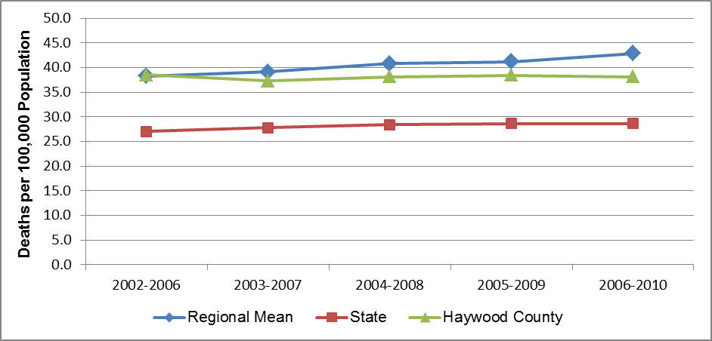

Note: There is some instability in the regional mean rates because each includes one or more unstable county rate.

As in other leading causes of death, non-motor vehicle injury mortality in Haywood County demonstrates a strong, but changing gender disparity (Figure 26). In each of the periods cited, the mortality rate among males was higher than the comparable rate among females, but the gap narrowed significantly as the rate for men decreased 27.3% (from 59.8 to 43.5) and the rate for women increased 51.1% (from 22.5 to 34.0) over the whole period cited. In Haywood County in 2002-2006 the all other injuries mortality rate for males was 2.7 times the rate for females; in 2006-2010 the rate for males was 28% higher than the rate for females.

Figure 26. Gender Disparities in All Other Unintentional Injury Mortality,

Haywood County

(Five-Year Aggregates, 2002-2006 through 2006-2010)

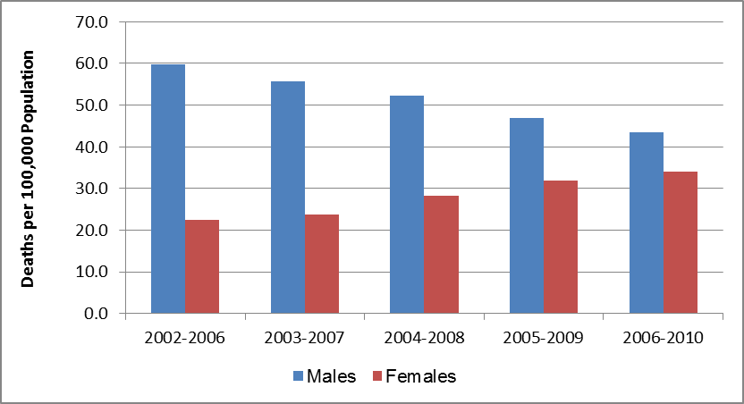

In WNC, none of the 16 counties had large enough minority populations to yield stable all other injury mortality rates for any minority group, so it is not possible to calculate stable mean region-wide rates for minorities. At the state level for 2006-2010, mortality rates attributable to non-motor vehicle injury are higher among males of each race/ethnicity than females. All other injury mortality rates are highest among non-Hispanic white males (42.2), non-Hispanic African American males (31.7), Other non-Hispanic males (25.6) and Hispanic males (15.0). Comparable rates for females are 23.0 for non-Hispanic white females, 13.1 for non-Hispanic African American females, 12.5 for Other non-Hispanic females, and 6.2 for Hispanic females (*Data Workbook*).

#### Alzheimer’s Disease Mortality

Alzheimer’s disease is a progressive neurodegenerative disease affecting mental abilities including memory, cognition and language. Alzheimer’s disease is characterized by memory loss and dementia. The risk of developing Alzheimer’s disease increases with age (e.g., almost half of those 85 years and older suffer from Alzheimer’s disease). Early-onset Alzheimer’s has been shown to be genetic in origin, but a relationship between genetics and the late-onset form of the disease has not been demonstrated. No other definitive causes have been identified (National Institute on Aging).

Alzheimer’s disease was the sixth leading cause of death in WNC but the eighth leading cause of death in Haywood County for the aggregate period 2006-2010 (Table 30, cited previously).

Figure 27 plots Alzheimer’s disease mortality rates over several aggregate periods. The Alzheimer’s disease mortality rate in Haywood County was below both the mean regional mortality rate and the statewide mortality rate over the period cited in the figure. The county rate fell 18.5% over the period cited, from 23.3 to 19.0. The mean Alzheimer’s disease mortality rate in WNC was higher than the comparable state rate throughout the span of time cited in Figure 27, despite the fact that the data used are all age-adjusted. Note, however, that NC SCHS made the age-adjustment calculations on the basis of the 2000 US Census, and as we have seen, the “elderly” population in WNC has grown considerably since 2000. It should be noted that the difference between the WNC and NC rates may look different once the 2010 Census becomes the basis of the age adjustment. In the 2006-2010 aggregate period the Alzheimer’s disease mortality rate was 19.0 in Haywood County, 30.7 in WNC, and 28.5 in NC.

Figure 27. Alzheimer’s Disease Mortality Rate, Deaths per 100,000 Population

(Five-Year Aggregates, 2002-2006 through 2006-2010)

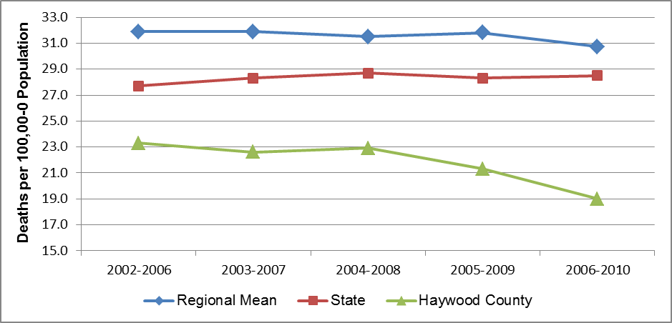

Note: There is some instability in the regional mean rates because each includes one or more unstable county rate.

Alzheimer’s disease mortality has a strong gender component, with mortality rates traditionally much higher among women than among men. In WNC, for example, the mean Alzheimer’s disease mortality rate among women was from 51% to 62% higher than the rate among men over the past decade (*Data Workbook*). Figure 28 plots gender-stratified data for Alzheimer’s disease mortality in Haywood County that demonstrated variability. The rate for females was higher than the rate for males in the first two aggregate periods; the opposite was the case in the last three aggregate periods. The Alzheimer’s disease mortality rate among Haywood County women appeared to decrease steadily, while the comparable rate for men increased for two periods before falling in the last three periods. In the 2006-2010 aggregate period the Alzheimer’s disease mortality rate for Haywood County females was 17.9 and the rate for males was 20.3.

Figure 28. Gender Disparities in Alzheimer’s Disease Mortality, Haywood County

(Five-Year Aggregates, 2002-2006 through 2006-2010)

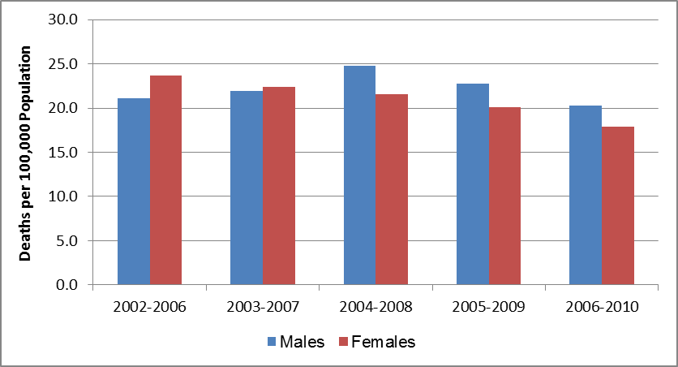

In WNC, none of the 16 counties had large enough minority populations to yield stable Alzheimer’s disease mortality rates for any minority group, so it is not possible to calculate stable mean region-wide rates for minorities. Statewide, the disparity in Alzheimer’s disease mortality may be more gender-based than race-based. In NC as a whole in the 2006-2010 aggregate period, the Alzheimer’s disease mortality rate for white non-Hispanic females was 32.5, compared to 23.3 for white, non-Hispanic males; the rate for African American non-Hispanic females was 27.6 compared to 20.9 for African American non-Hispanic males; and the rate for Other non-Hispanic females was 21.1 compared to 17.3 for Other non-Hispanic males. The Alzheimer’s disease mortality rate for Hispanic females was 9.7; due to a small number of events, the NC SCHS did not release a comparable rate for Hispanic males (*Data Workbook*).

#### Diabetes Mellitus Mortality

Diabetes is a disease in which the body’s blood glucose levels are too high due to problems with insulin production and/or utilization. Insulin is a hormone that helps the glucose get to cells where it is used to produce energy. With type 1 diabetes, the body does not make insulin. With type 2 diabetes, the more common type, the body does not make or use insulin well. Without enough insulin, glucose stays in the blood. Over time, having too much glucose in the blood can damage the eyes, kidneys, and nerves. Diabetes can also lead to heart disease, stroke and even the need to remove a limb (US National Library of Medicine).

Diabetes was the seventh leading cause of death in WNC, but the tenth leading cause of death in Haywood County in the 2006-2010 aggregate period (Table 30, cited previously).

Figure 29 plots trend data for diabetes mortality for several aggregate periods. According to data in Figure 29, the diabetes mortality rate in Haywood County was below both the mean WNC and NC rates for the duration of the period cited. The mean diabetes mortality rate in WNC is and has been lower than the state rate. Statewide, the diabetes mortality rate fell from 27.1 to 22.5 (17.0%) over the period cited in the figure. Region-wide, the mean diabetes mortality rate fell from 22.6 to 19.6 (13.3%) over the same period. In Haywood County the diabetes mortality rate declined 17.8% from the beginning of the period cited (19.7) to the end (16.2).

Figure 29. Diabetes Mellitus Mortality Rate, Deaths per 100,000 Population

(Five-Year Aggregates, 2002-2006 through 2006-2010)

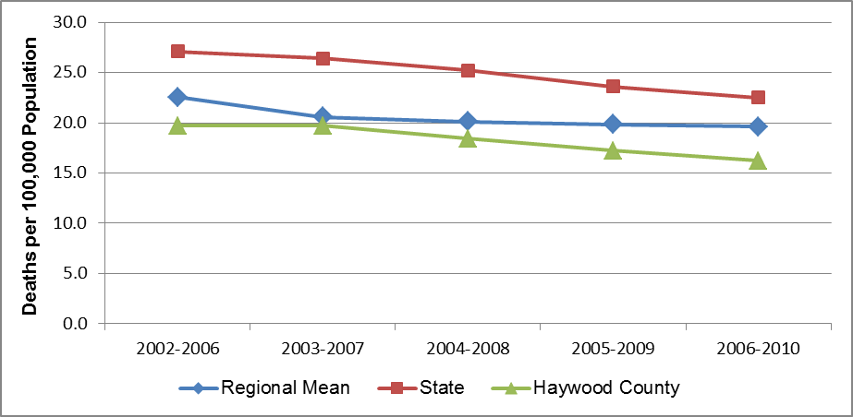

Note: There is some instability in the regional mean rates because each includes one or more unstable county rate.

Figure 30 plots gender-stratified diabetes mortality rates for Haywood County, where diabetes mortality demonstrates a significant and changing gender disparity. From this data it would appear that the difference in diabetes mortality between men and women is narrowing as the rate for males is decreasing at a faster pace than is the rate for females. Over the period cited in Figure 30 the diabetes mortality rate among Haywood County males fell from 24.1 to 17.5, a decrease of 27.4%. At the same time, the diabetes mortality rate among county females fell from 15.6 to 14.0, a decrease of 10.3%.

Figure 30. Gender Disparities in Diabetes Mellitus Mortality, Haywood County

(Five-Year Aggregates, 2002-2006 through 2006-2010)

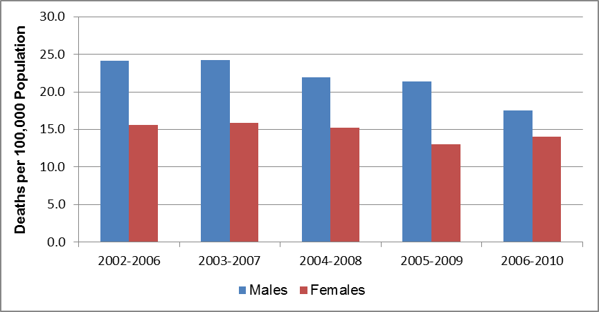

In WNC, none of the 16 counties had large enough minority populations to yield stable diabetes mortality rates for any minority group, so it is not possible to calculate stable mean region-wide rates for minorities. Statewide, diabetes mortality demonstrates significant racial disparities. At the state level in the 2006-2010 aggregate period, the highest diabetes mortality rates were observed among African American non-Hispanic males and females, with rates of 51.3 and 42.5, respectively. The next highest rates occurred among Other non-Hispanic persons, both male and female, with rates of 25.0 and 25.5, respectively. The diabetes mortality rate during this period for white non-Hispanics was 22.2 for males and 14.4 for females. The lowest diabetes mortality was observed in the Hispanic population, with a rate of 11.2 for men and 7.1 for women (*Data Workbook*).

#### Pneumonia and Influenza Mortality

Pneumonia and influenza are diseases of the lungs. Pneumonia is an inflammation of the lungs caused by either bacteria or viruses. Bacterial pneumonia is the most common and serious form of pneumonia, and among individuals with suppressed immune systems, it may follow influenza or the common cold. Influenza (the “flu”) is a contagious infection of the throat, mouth and lungs caused by an airborne virus (US National Library of Medicine).

The joint mortality category pneumonia and influenza was the eighth leading cause of death in WNC but the sixth leading cause of death in Haywood County for the period 2006-2010 (Table 30, cited previously).

Figure 31 plots the mortality trend for pneumonia and influenza for several aggregate periods. From this data it is apparent that the mean mortality rate in WNC closely paralleled the comparable NC rate throughout the period cited. Both the regional and state mortality rates for this cause of death decreased in the net over the period. The mean WNC rate decreased from 23.8 to 19.1 (19.7%) and the comparable NC rate decreased from 22.5 to 18.6 (17.3%). A corresponding decrease in pneumonia/influenza mortality in Haywood County was somewhat more dramatic, falling 29.2%, from 28.8 in 2002-2006 to 20.4 in 2006-2010. The county rate was above both the comparable WNC and NC rates throughout the period shown in the figure.

Figure 31. Pneumonia and Influenza Mortality Rate, Deaths per 100,000 Population

(Five-Year Aggregates, 2002-2006 through 2006-2010)

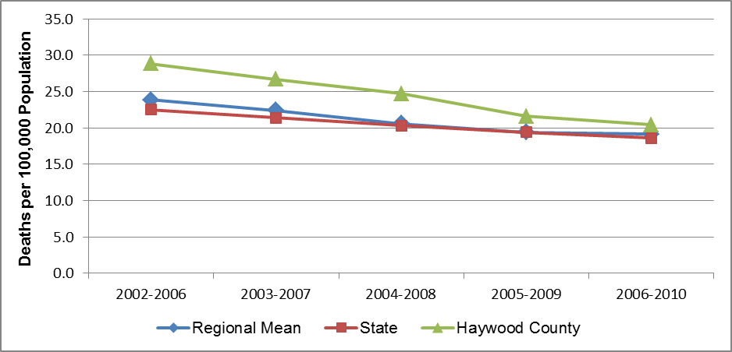

Note: There is some instability in the regional mean rates because each includes one or more unstable county rate.

Figure 32 plots gender-stratified pneumonia/influenza mortality rates for Haywood County for several aggregate periods. According to data displayed in the figure, females in the county had higher pneumonia/influenza mortality rates than males over the period cited, even as the rates among both males and females fell substantially. The rate among county males fell 35.5% from 28.7 to 18.5, and the rate among county females fell 27.9% from 29.4 to 21.2. In the 2006-2010 period the pneumonia/influenza mortality rate among Haywood County females was 14.6% higher than the comparable rate among county females.

Figure 32. Gender Disparities in Pneumonia/Influenza Mortality, Haywood County

(Five-Year Aggregates, 2002-2006 through 2006-2010)

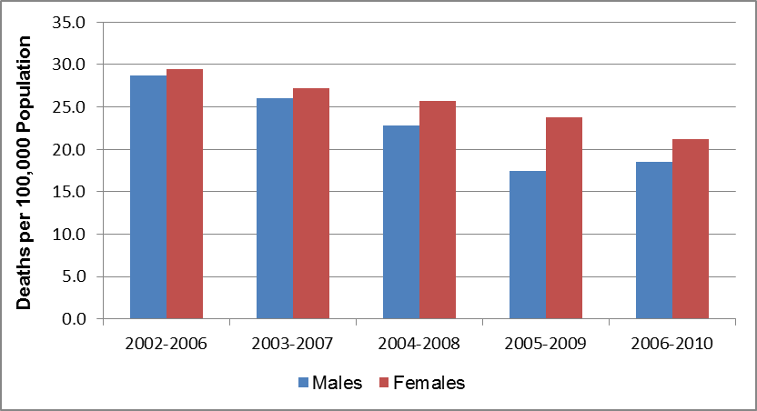

In WNC, none of the 16 counties had large enough minority populations to yield stable pneumonia/influenza mortality rates for any minority group, so it is not possible to calculate stable mean region-wide rates for minorities. At the state level pneumonia and influenza mortality rates demonstrate moderate racial disparities. Statewide in the 2006-2010 aggregate period the highest pneumonia/influenza mortality rate (24.1) occurred among African American non-Hispanic males, followed in order by white non-Hispanic males (21.5), white non-Hispanic females (17.3), African American non-Hispanic females (15.8), other non-Hispanic males (11.1), and other non-Hispanic females (9.0). The Hispanic population, both male and female, experienced the lowest pneumonia and influenza mortality rates, 5.8 and 7.1, respectively (*Data Workbook*).

#### Unintentional Motor Vehicle Injury (UMVI) Mortality

Death due to injuries incurred in unintentional motor vehicle crashes was the ninth leading cause of death in WNC and the seventh leading cause of death in Haywood County in the 2006-2010 aggregate period (Table 30, cited previously).

Figure 33 plots UMVI mortality rates over several aggregate periods. From this data it appears that the mortality rate attributable to UMVI in Haywood County was higher than both the mean WNC and NC rates in all but the first aggregate period shown in the figure. UMVI mortality rates fell in WNC and NC over the period cited in the figure. In WNC, the mean UMVI mortality rate fell 20.1%, from 20.9 to 16.7, and in NC the rate fell 12.5%, from 19.1 to 16.7. Less overall change was apparent in Haywood County, where the rate fell from 19.7 in the 2002-2006 aggregate period to 19.5 in the 2006-2010 aggregate period. The major rate decrease in the county occurred mid-course, when the rate fell from 21.9 in 2004-2008 to 20.4 in the 2005-2009 period, a decrease of 6.8%.

Figure 33. Unintentional Motor Vehicle Injury Mortality Rate

Deaths per 100,000 Population

(Five-Year Aggregates, 2002-2006 through 2006-2010)

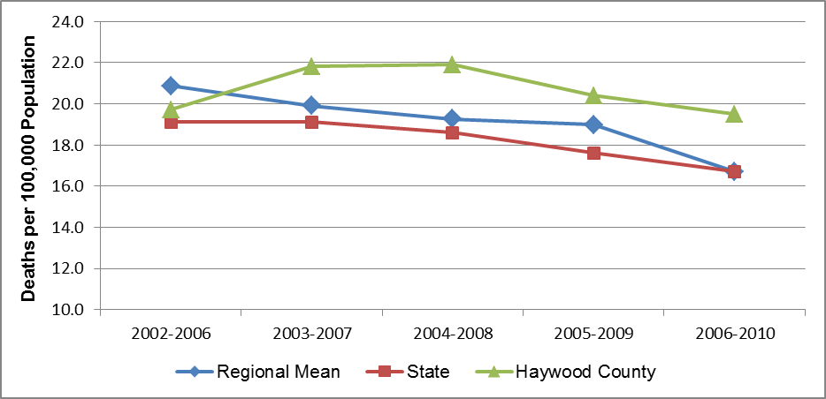

Note: There is some instability in the regional mean rates because each includes one or more unstable county rate.

Figure 34 plots UMVI mortality differences between WNC men and women in Haywood County for several aggregate periods. From this data it seems that UMVI mortality among Haywood County males was from 2.1 to 2.3 times the comparable rate among females over the period cited. Note, however, that the first rate cited for females is technically unstable, and the NC SCHS did not release rates for county females in the last two aggregate periods due to below-threshold numbers of deaths. The UMVI mortality rate among Haywood County males increased 8.0% (from 28.6 to 30.9) over the period shown.

Figure 34. Gender Disparities in Unintentional Motor Vehicle Injury Mortality

Haywood County

(Five-Year Aggregates, 2002-2006 through 2006-2010)

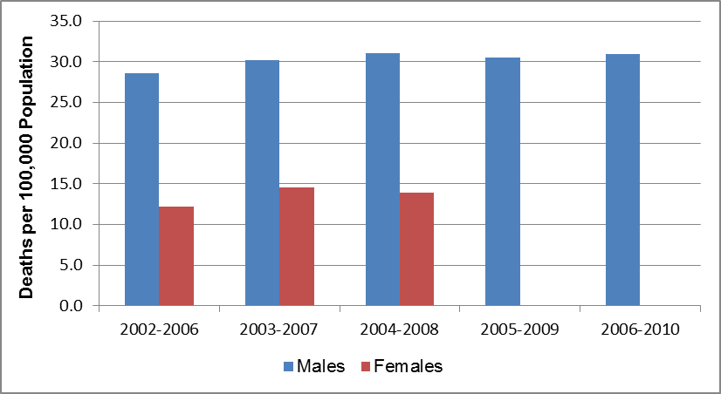

In WNC, none of the 16 counties, including Haywood County, had large enough minority populations to yield stable UMVI mortality rates for any minority group, so it is not possible to calculate stable mean region-wide rates for minorities. Statewide, disparities in UMVI mortality appear more gender-based than racially-based. At the state level in 2006-2010, the highest UMVI mortality rates all occurred among males with the following rates, in decreasing order: 27.1 for African American non-Hispanic males, 24.2 for non-Hispanic males of other races, and 23.6 for both white non-Hispanic males and Hispanic males. Among women statewide the highest rates were noted among non-Hispanic females of other races (10.4), followed by white non-Hispanic females (9.9), African American non-Hispanic females (7.9) and Hispanic females (7.3) (*Data Workbook*).

#### Suicide Mortality

Suicide was the tenth leading cause of death in WNC and the ninth leading cause of death in Haywood County for the 2006-2010 aggregate period (Table 30, cited previously).

Figure 35 plots suicide mortality rates for several aggregate periods. From these data it appears that in Haywood County mortality due to suicide was approximately the same as in the WNC region, but higher than in NC as a whole. The mean suicide mortality rate in WNC ranged from 37% to 48% higher than the state rate over the period cited in Figure 35. The suicide mortality rates in Haywood County, WNC and NC changed slightly over the period cited. Rates in WNC and NC increased 5.0% and 4.3%, respectively; the comparable rate in Haywood County fell 5.5% over the same period, from 18.1 to 17.1.

Figure 35. Suicide Mortality Rate, Deaths per 100,000 Population

(Five-Year Aggregates, 2002-2006 through 2006-2010)



Note: There is some instability in the regional mean rates because each includes one or more unstable county rate.

Suicide mortality in Haywood County demonstrated a very pronounced gender disparity. From data in Figure 36 it is apparent that over the span of years cited in the figure, the suicide mortality rate for county males was five to seven times the comparable rate for county females. It should be noted, however, that all the rates for females were either unstable, or were not released by NC SCHS because the number of suicide deaths among females fell below the threshold for calculating a stable rate. In 2004-2008 the suicide mortality rate for Haywood County males was 32.9; the comparable rate for females was 4.7.

Figure 36. Gender Disparities in Suicide Mortality, Haywood County

(Five-Year Aggregates, 2002-2006 through 2006-2010)

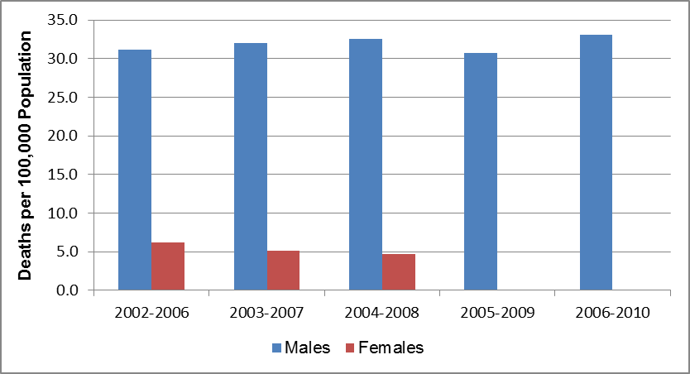

In WNC, none of the 16 counties, including Haywood County, had large enough minority populations to yield stable suicide mortality rates for any minority group, so it is not possible to calculate stable mean region-wide rates for minorities. At the state level, suicide mortality demonstrates a racial disparity as well as a gender disparity. Statewide in the 2006-2010 aggregate period the highest suicide mortality rates occurred among white non-Hispanic males (23.9) followed by other non-Hispanic males (10.8), African American non-Hispanic males (8.6) and Hispanic males (7.4). Among females, the highest suicide mortality rates occurred among white non-Hispanic females (6.7) followed by other non-Hispanic females (4.7), Hispanic females (1.7) and African American non-Hispanic females (1.5) (*Data Workbook*).

#### Nephritis, Nephrotic Syndrome and Nephrosis (Kidney Disease) Mortality

*Nephritis* refers to inflammation of the kidney, which causes impaired kidney function. Nephritis can be due to a variety of causes, including kidney disease, autoimmune disease, and infection. *Nephrotic syndrome* refers to a group of symptoms that include protein in the urine, low blood protein levels, high cholesterol levels, high triglyceride levels, and swelling. *Nephrosis* refers to any degenerative disease of the kidney tubules, the tiny canals that make up much of the substance of the kidney. Nephrosis can be caused by kidney disease, or it may be a complication of another disorder, particularly diabetes (MedineNet.com, March 2012; PubMed Health, 2011).

Kidney disease was the eleventh leading cause of death in WNC, but the twelfth leading cause of death in Haywood County for the 2006-2010 aggregate period (Table 30, cited previously).

Figure 37 plots kidney disease mortality over several aggregate periods. This data shows that the mean kidney disease mortality rate in WNC was below the comparable figure for NC as a whole, and that the mortality rate in Haywood County was approximately the same as or below the mean WNC rate for the last four aggregate periods displayed in the figure. Between the 2002-2006 aggregate period and the 2006-2010 aggregate period the mean regional kidney disease mortality rate climbed from 14.4 to 16.2 (12.5%), and the NC rate increased slightly, from 18.2 to 18.9 (3.8%). In Haywood County the kidney disease mortality rate fell from 15.7 to 13.5 (14.0%).

Figure 37. Kidney Disease Mortality Rate, Deaths per 100,000 Population

(Five-Year Aggregates, 2002-2006 through 2006-2010)

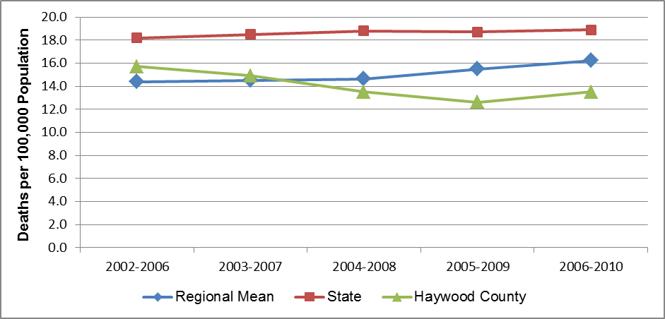

Note: There is some instability in the regional mean rates because each includes one or more unstable county rate.

Figure 38 displays mean gender-stratified kidney disease mortality data for Haywood County. The data presented in Figure 38 displayed considerable variability. Throughout the period cited, the kidney disease mortality rate among Haywood County men was from 6% to 51% higher than the comparable rate among county women. While the kidney disease mortality rate among county females fell 34.7% overall (from 15.9 to 11.8), the comparable rate for males rose, fell, and then rose again with no clear pattern.

Figure 38. Gender Disparities in Kidney Disease Mortality, Haywood County

(Five-Year Aggregates, 2002-2006 through 2006-2010)

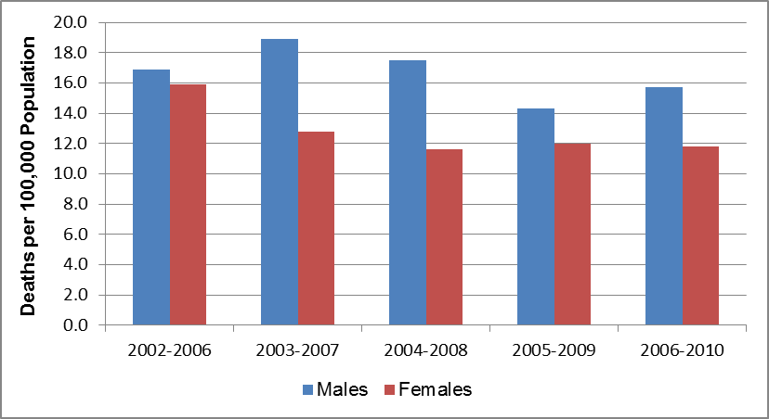

In WNC, none of the 16 counties had large enough minority populations to yield stable kidney disease mortality rates for any minority group, so it is not possible to calculate stable mean region-wide rates for minorities. Statewide for 2006-2010 kidney disease mortality rates demonstrate both racial and gender disparities. Men of all racial groups suffer kidney disease mortality at rates higher than their female counterparts in the same racial group, and non-Hispanic African Americans of either gender have the highest kidney disease mortality rates among their gender group. For instance, kidney disease mortality among non-Hispanic African American males in this period was 42.4, compared to 19.7 among non-Hispanic white males, 18.0 among other non-Hispanic males, and 7.1 among Hispanic males. Similarly, the kidney disease mortality rate among non-Hispanic African American females was 34.6, followed by 15.3 among other non-Hispanic females, 12.5 among non-Hispanic white females, and 5.4 among Hispanic females (*Data Workbook*).

#### Septicemia Mortality

Septicemia is a rapidly progressing infection resulting from the presence of bacteria in the blood. The disease often arises from other infections throughout the body, such as meningitis, burns, and wound infections. Septicemia can lead to septic shock in which case low blood pressure and low blood flow cause organ failure (US National Library of Medicine). While septicemia can be community-acquired, some cases are acquired by patients hospitalized initially for other conditions; these are referred to as nosocomial infections. Sepsis is now a preferred term for septicemia, but NC SCHS continues to use the older term.

Septicemia was the twelfth leading cause of death in WNC and the thirteenth leading cause of death in Haywood County for the aggregate period 2006-2010 (Table 30, cited previously).

Figure 39 plots septicemia mortality data for several aggregate periods. This data shows that the mean WNC septicemia mortality rate fluctuated over the period cited in approaching the state rate, while the state rate decreased 4.9%, from 14.1 to 13.7. Fluctuation at the WNC-level may be attributed partly to unstable regional mean rates. In Haywood County from the 2002-2006 aggregate period to the 2006-2010 aggregate period, the septicemia mortality rate fell 211.9%, from 11.8 to 10.4. Throughout the period cited in the figure the Haywood County septicemia mortality rate was below both the WNC and NC rates.

Figure 39. Septicemia Mortality Rate, Deaths per 100,000 Population

(Five-Year Aggregates, 2002-2006 through 2006-2010)

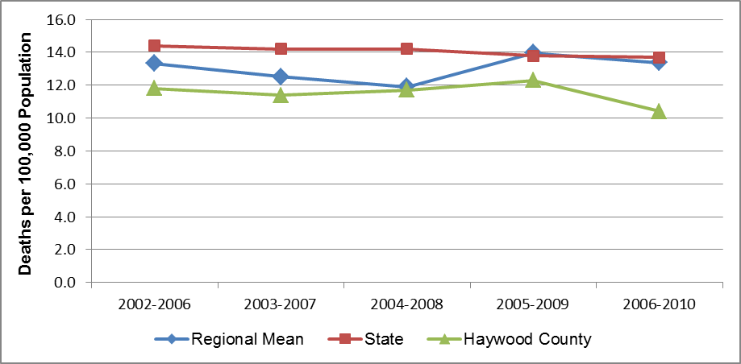

Note: There is some instability in the regional mean rates because each includes one or more unstable county rate.

Gender-stratified septicemia mortality rates are plotted for Haywood County in Figure 40. Septicemia mortality in Haywood County was from 31% to 61% higher among males than females over the period cited. The septicemia mortality rate for county females did not demonstrate a clear pattern of change, but was 17.1% lower in 2006-2010 (8.7) than in 2002-2006 (10.5). The comparable rate for county males rose over most of the aggregate periods cited, but fell dramatically in the 2006-2010 period to a point (12.7) that was 21.6% lower than the rate in the 2005-2009 period.

Figure 40. Gender Disparities in Septicemia Mortality, Haywood County

(Five-Year Aggregates, 2002-2006 through 2006-2010)

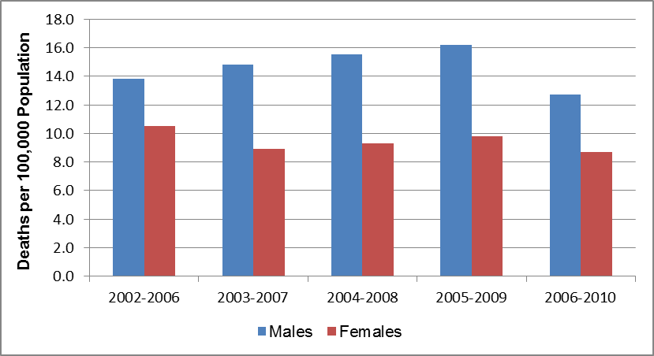

In WNC, none of the 16 counties, including Haywood County, had large enough minority populations to yield stable septicemia mortality rates for any minority group, so it is not possible to calculate stable mean region-wide rates for minorities. At the state level, where the calculation of stable septicemia mortality rates is possible, mortality is highest among African American non-Hispanics, both male and female. Statewide the septicemia mortality rate for African American non-Hispanic males in the 2002-2010 aggregate period was 23.7; for females of the same population group the rate was 18.8. For white non-Hispanic males the comparable rate was 13.7; for white non-Hispanic females the rate was 11.5. Among other non-Hispanic males the septicemia mortality rate was 10.6; among other non-Hispanic females the rate was 7.6. The lowest septicemia mortality rates occurred among Hispanics; for males the rate was 5.3, and for females, 4.9 (*Data Workbook*).

#### Chronic Liver Disease and Cirrhosis Mortality

Chronic liver disease describes an ongoing disturbance of liver function that causes illness. Liver disease, also referred to as hepatic disease, is a broad term that covers all the potential problems that cause the liver to fail to perform its designated functions. Usually, more than 75% or three quarters of liver tissue needs to be affected before decrease in function occurs. Cirrhosis is a term that describes permanent scarring of the liver. In cirrhosis, the normal liver cells are replaced by scar tissue that cannot perform any liver function (MedicineNet.com, June 2012).

Chronic liver disease and cirrhosis was the thirteenth leading cause of death in WNC and the eleventh leading cause of death in Haywood County in the 2006-2010 aggregate period (Table 30, cited previously).

Figure 41 plots mortality data for liver disease over several aggregate periods. This data shows that the liver disease mortality rate in Haywood County was higher than the comparable NC rate, and approximately equal to or lower than the mean WNC rate throughout the period cited. The mean WNC rate exceeded the state rate throughout the period cited. It also appears that the regional and Haywood County rates have risen over the period cited. In WNC, the mean chronic liver disease mortality rate rose from 10.0 for 2002-2006 to 13.2 for 2006-2010, an increase of 32.0%. In Haywood County, the comparable rise was from 10.0 to 13.7, a 37.0% increase. Throughout this period the state liver disease mortality rate has been stable at or near 9.1.

Figure 41. Chronic Liver Disease and Cirrhosis Mortality Rate

Deaths per 100,000 Population

(Five-Year Aggregates, 2002-2006 through 2006-2010)

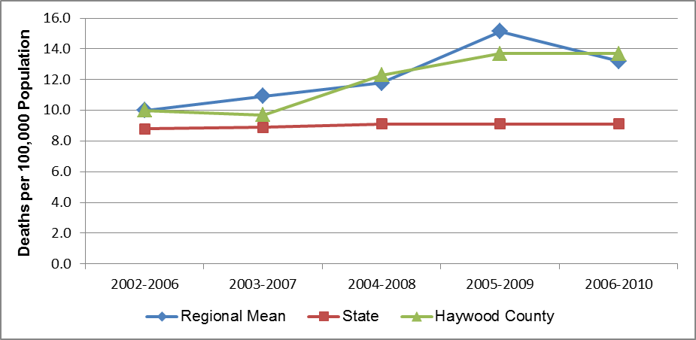

Note: There is some instability in the regional mean rates because each includes one or more unstable county rate.

Gender-stratified data presented in Figure 42 reveals a strong gender-based disparity in liver disease mortality rates in Haywood County. This gender-stratified data for several aggregate periods shows that mean liver disease mortality rates among Haywood County men ranged from 2.0 to 2.9 times the comparable rates among Haywood County women. It should be noted, however, that the rates for females represented in the figure were either unstable or assigned a value of “zero” to signify that the NC SCHS did not release a rate for county females in that period. Over the span of time depicted in the figure, the rate among county males rose 61.3% (from 13.7 to 22.1).

Figure 42. Gender Disparities in Chronic Liver Disease and Cirrhosis Mortality,

Haywood County

(Five-Year Aggregates, 2002-2006 through 2006-2010)

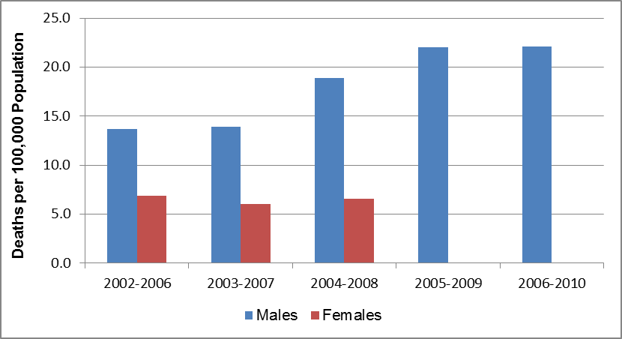

In WNC, none of the 16 counties, including Haywood County, had large enough minority populations to yield stable chronic liver disease/cirrhosis mortality rates for any minority group, so it is not possible to calculate stable mean region-wide rates for minorities. At the state level, liver disease mortality rates demonstrate some differences among racial groups but a consistent trend of higher mortality rates among men than women. For example, the liver disease mortality rate is highest among white non-Hispanic men (13.8), followed by African American non-Hispanic men (11.2). The liver disease mortality rates among other non-Hispanic men was 7.5, and the rate among Hispanic men was 6.8. Liver disease mortality rates among females were highest for white non-Hispanic women (6.0), followed by other non-Hispanic women (5.2), and African American women non-Hispanic women (5.1). There were too few liver disease deaths among Hispanic women statewide to calculate a stable rate (*Data Workbook*).

#### Homicide Mortality

Death by homicide was the fourteenth leading cause of death in WNC and Haywood County for the 2006-2010 aggregate period (Table 30, cited previously).

Figure 43 plots the homicide mortality rate trend over several aggregate periods. From this data it is apparent that homicide mortality rate in Haywood County was lower than comparable rates for both WNC and NC as a whole throughout the period cited. The homicide mortality rate fell in WNC and NC over the period cited, from 6.1 to 4.1 (32.8%) in WNC, and from 7.2 to 6.6 (8.3%) in NC. All the rates shown for Haywood County are either unstable, or “zero” to signify that the NC SCHS did not release a county mortality rate in that period.

Figure 43. Homicide Mortality Rate, Deaths per 100,000 Population

(Five-Year Aggregates, 2002-2006 through 2006-2010)

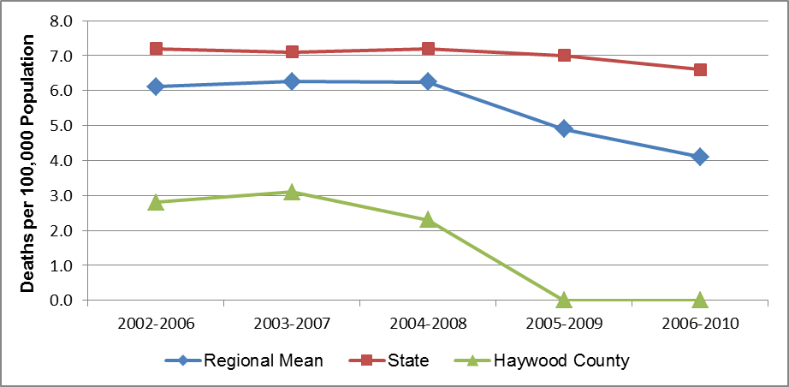

Note: There is some instability in the regional mean rates because each includes one or more unstable county rate.

According to gender-stratified data presented in Figure 44, the homicide mortality rate among Haywood County males was approximately 1.7 to 2.3 times the rate among Haywood County females. It should be noted, however, that the rates displayed in the figure are all unstable, and that NC SCHS did not compute homicide mortality rates for county males or females in the last two aggregate periods due to small numbers of events.

Figure 44. Gender Disparities in Homicide Mortality, Haywood County

(Five-Year Aggregates, 2002-2006 through 2004-2008)

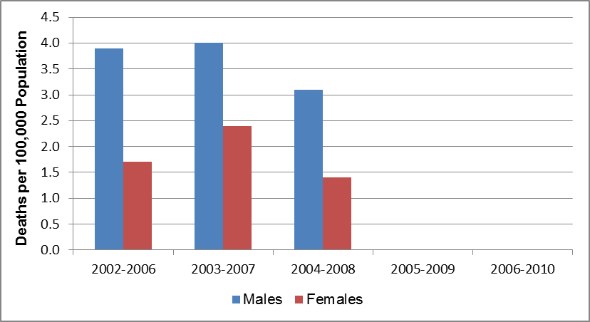

In WNC, none of the 16 counties, including Haywood County, had large enough minority populations to yield stable homicide mortality rates for any minority group, so it is not possible to calculate stable mean region-wide rates for minorities. At the state level homicide mortality demonstrates strong racial and gender disparities. In NC for the 2006-2010 aggregate period the highest homicide mortality rates were among African American non-Hispanic males (25.6), and Hispanic males and other non-Hispanic males (13.0). The next highest homicide mortality rate occurred among African American non-Hispanic females (5.2), followed by white, non-Hispanic males (4.6), other non-Hispanic females (3.4), Hispanic females (2.6), and white non-Hispanic females (2.2) (*Data Workbook*).

#### Acquired Immune Deficiency Syndrome (AIDS) Mortality

The human immunodeficiency virus (HIV) is the virus that causes AIDS. HIV attacks the immune system by destroying CD4 positive (CD4+) T cells, a type of white blood cell that is vital to fighting off infection. The destruction of these cells leaves people infected with HIV vulnerable to other infections, diseases and other complications. The acquired immunodeficiency syndrome (AIDS) is the final stage of HIV infection. A person infected with HIV is diagnosed with AIDS when he or she has one or more opportunistic infections, such as pneumonia or tuberculosis, and has a dangerously low number of CD4+ T cells (less than 200 cells per cubic millimeter of blood) (National Institutes of Health, 2012).

AIDS was the fifteenth leading cause of death in WNC for the aggregate period 2006-2010 (Table 30, cited previously).

Because of small numbers of AIDS deaths across WNC, AIDS mortality rates are unstable or non-existent in 15 of the 16 counties in the region. A stable rate is available only for Buncombe County; hence it is not possible to plot meaningful regional AIDS mortality data.

Even at the state level it is not possible to calculate a stable AIDS mortality rate for several minority population groups. Using the stable NC rates available, it is apparent that non-Hispanic African Americans suffered mortality attributable to AIDS at rates much higher than did other groups. For example, in the 2006-2010 aggregate period, the AIDS mortality rate for African American non-Hispanic men (20.2) was almost 12 times the rate among white non-Hispanic men (1.7), and the rate among African American non-Hispanic women (9.8) was almost 25 times the rate among white non-Hispanic women (0.4). The AIDS mortality rate among Hispanic men statewide during this period was 4.1; rates were not released for any other minority group because of below-threshold numbers of AIDS deaths (*Data Workbook*).

## Life Expectancy

*Life expectancy* is the average number of additional years that someone at a given age would be expected to live if current mortality conditions remained constant throughout their lifetime. As the above data has demonstrated, there are many factors, from the prenatal period through the senior years, which can affect life expectancy. Table 34 presents a fairly recent summary of life expectancy for Haywood County, WNC, and NC as a whole. From this data it appears that females born in Haywood County in the period cited could expect to live 4.8 years longer than males born at the same time. Similarly, females born in WNC in the period cited in the table could expect to live 5.5 years longer on average than males born under the same parameters. African Americans born in Haywood County at the same time could expect to live a 3.9 year *longer* lifespan than their white counterparts; in WNC African Americans could expect to live a 3.3 year *shorter* lifespan than their white counterparts. Life expectancy overall in Haywood County (77.3 years) is the same as in the state as a whole, and 0.3 years longer the mean lifespan in WNC.

Table 34. Life Expectancy at Birth (2006-2008)

|  |  |  |  |  |  |
| --- | --- | --- | --- | --- | --- |
| **Geography** | **Overall** | **Gender** | | **Race** | |
| **Male** | **Female** | **White** | **African American** |
|  |  |  |  |  |  |
| Haywood County | 77.3 | 74.8 | 79.6 | 77.2 | 81.1 |
| Regional Arithmetic Mean | 77.0 | 74.3 | 79.8 | 77.3 | 74.0 |
| State Total | 77.3 | 74.5 | 80.0 | 78.1 | 73.8 |
|  |  |  |  |  |  |

## Morbidity Data

*Morbidity* as used in this report refers generally to the current presence of injury, sickness or disease (and sometimes the symptoms and/or disability resulting from those conditions) in the living population. In this report disability, diabetes, obesity, injury, communicable disease (including sexually-transmitted infections) and mental health conditions are the topics covered under morbidity.

The parameter most frequently used to describe the current extent of any condition of morbidity in a population is *prevalence*. Prevalence is the number of existing cases of a disease or health condition in a population at a defined point in time or during a period. Prevalence usually is expressed as a proportion, not a rate, and often represents an estimate rather than a direct count.

### Self-Reported Health Status

Survey respondents were asked, “Would you say that in general your health is excellent, very good, good, fair, or poor?”

Figure 45. Self-Reported Health Status (WNC Healthy Impact Survey)

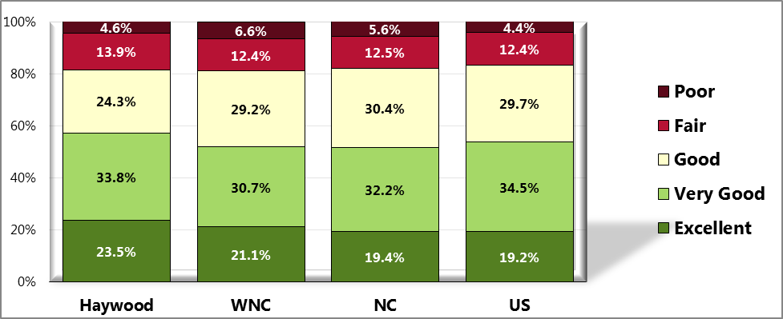

Sources: ● 2012 PRC Community Health Survey, Professional Research Consultants, Inc. [Item 12]

● Behavioral Risk Factor Surveillance System Survey Data. Atlanta, Georgia. United States Department of Health and Human Services, Centers for Disease Control and Prevention (CDC): 2010 North Carolina data.

● 2011 PRC National Health Survey, Professional Research Consultants, Inc.

Notes: ● Asked of all respondents.

### Disability and Limitations in Physical Activity

An individual can get a disabling impairment or chronic condition at any point in life. Compared with people without disabilities, people with disabilities are more likely to (DHHS, 2010):

* Experience difficulties or delays in getting the health care they need.
* Not have had an annual dental visit.
* Not have had a mammogram in past 2 years.
* Not have had a Pap test within the past 3 years.
* Not engage in fitness activities.
* Use tobacco.
* Be overweight or obese.
* Have high blood pressure.
* Experience symptoms of psychological distress.
* Receive less social-emotional support.
* Have lower employment rates.

Survey respondents were asked, “Are you limited in any way in any activities because of physical, mental or emotional problems?” Those who responded, “yes,” were then asked to name the major impairment or health problem that limits them. Due to small county-level sample sizes, only regional data is shown for the latter question.

Figure 46. Limited in Activities in Some Way

Due to Physical, Mental or Emotional Problem (WNC Healthy Impact Survey)

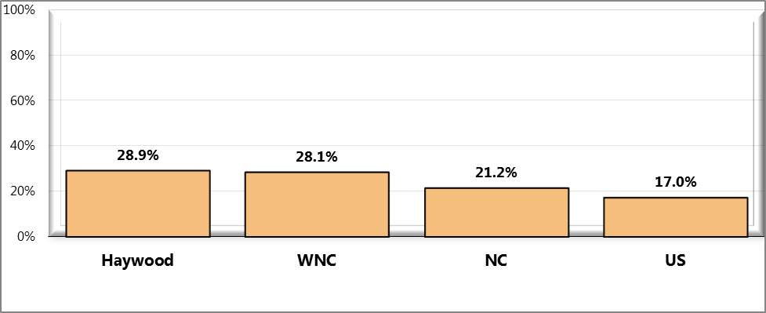

Sources: ● 2012 PRC Community Health Survey, Professional Research Consultants, Inc. [Item 67]

● Behavioral Risk Factor Surveillance System Survey Data. Atlanta, Georgia. United States Department of Health and Human Services, Centers for Disease Control and Prevention (CDC): 2010 North Carolina data.

● 2011 PRC National Health Survey, Professional Research Consultants, Inc.

Notes: ● Asked of all respondents

Table 35. Type of Problem That Limits Activities (WNC Healthy Impact Survey)

(Among Those Reporting Activity Limitations)

(Western North Carolina, 2012)

|  |  |  |  |  |  |  |  |  |
| --- | --- | --- | --- | --- | --- | --- | --- | --- |
|  | **Arthritis/ Rheumatism** | **Back/Neck Problem** | **Difficulty Walking** | **Fracture/Bone/ Joint Injury** | **Heart Problem** | **Lung/Breathing Problem** | **Mental/ Depression** | **Other (<3%)** |
| Haywood | 6.1% | 20.9% | 6.2% | 18.7% | 4.7% | 5.7% | 0.0% | 37.7% |

### Diabetes

Table 36 presents trend data from the US Centers for Disease Control and Prevention (CDC) on the estimated prevalence of diagnosed diabetes in Haywood County and WNC. The prevalence of diagnosed diabetes and selected risk factors by county was estimated using data from CDC's Behavioral Risk Factor Surveillance System (BRFSS) and data from the U.S. Census Bureau's Population Estimates Program. Three years of data were used to improve the precision of the year-specific county-level estimates of diagnosed diabetes and selected risk factors.

From these data it appears that the estimated prevalence of diagnosed diabetes among adults in Haywood County rose from 8.1% in 2005 to 8.5% in 2009, an increase of 4.9%. Note, however, that in intervening years diabetes prevalence in the county was as high as 9.2%. In WNC the estimated mean percent prevalence of diagnosed diabetes among adults rose from 8.5% in 2005 to 9.0% in 2009, an increase of 5.9%.

|  |  |  |  |  |  |  |  |  |  |  |
| --- | --- | --- | --- | --- | --- | --- | --- | --- | --- | --- |
| **Geography** | **2005** | | **2006** | | **2007** | | **2008** | | **2009** | |
| **#** | **%** | **#** | **%** | **#** | **%** | **#** | **%** | **#** | **%** |
|
|  |  |  |  |  |  |  |  |  |  |  |
| Haywood County | 4,242 | 8.1 | 4,511 | 8.7 | 4,858 | 9.2 | 4,750 | 8.9 | 4,756 | 8.5 |
| Regional Total | 49,896 | - | 52,045 | - | 55,160 | - | 55,442 | - | 58,378 | - |
| Regional Arithmetic Mean | 3,119 | 8.5 | 3,253 | 8.7 | 3,448 | 8.9 | 3,465 | 8.8 | 3,649 | 9.0 |
|  |  |  |  |  |  |  |  |  |  |  |

Table 36. Estimate of Diagnosed Diabetes Among Adults Age 20 and Older (2005-2009)

In 2010, inpatient hospitalizations for diabetes among Haywood County residents totaled 63 cases, or 0.9% of all inpatient hospitalizations listed for the county. In the same year, there were 1,240 inpatient hospital cases associated with treatment of diabetes in WNC. This number of cases represented 1.6% of all hospitalizations in the region. Statewide, diabetes hospitalizations composed 1.9% of all hospitalizations in NC (*Data Workbook*).

### Obesity

Obesity is a problem throughout the population. However, among adults in the U.S., vast disparities in obesity exist. Within the U.S., the prevalence of obesity is highest for middle-aged people and for non-Hispanic black and Mexican American women. Among children and adolescents, the prevalence of obesity is highest among older and Mexican American children and non-Hispanic black girls. The association of income with obesity varies by age, gender, and race/ethnicity. Social and physical factors affecting diet and physical activity have an impact on weight. (DHHS, 2010).

Body Mass Index (BMI), which describes relative weight for height, is significantly correlated with total body fat content. The BMI should be used to assess overweight and obesity and to monitor changes in body weight. In addition, measurements of body weight alone can be used to determine efficacy of weight loss therapy. BMI is calculated as weight (kg)/height squared (m2). To estimate BMI using pounds and inches, use: [weight (pounds)/height squared (inches2)] x 703.

In this report, underweight is defined as a BMI of <18.5 kg/m2, normal is defined as a BMI of 18.5 to 24.9 kg/m2, overweight is defined as a BMI of 25.0 to 29.9 kg/m2 and obesity as a BMI ≥30 kg/m2. The rationale behind these definitions is based on epidemiological data that show increases in mortality with BMIs above 25 kg/m2. The increase in mortality, however, tends to be modest until a BMI of 30 kg/m2 is reached. For persons with a BMI ≥30 kg/m2, mortality rates from all causes, and especially from cardiovascular disease, are generally increased by 50 to 100 percent above that of persons with BMIs in the range of 20 to 25 kg/m2 (NIH, 1998)

#### Adult Obesity

Table 37 presents trend data from the CDC on the estimated prevalence of diagnosed adult obesity in Cherokee County and WNC. The prevalence of diagnosed obesity and selected risk factors by county was estimated using data from CDC's Behavioral Risk Factor Surveillance System (BRFSS) and data from the U.S. Census Bureau's Population Estimates Program. Three years of data were used to improve the precision of the year-specific county-level estimates of diagnosed diabetes and selected risk factors.

From these data it appears that the estimated prevalence of diagnosed obesity among adults in Haywood County rose overall from 24.6% in 2005 to 28.8% in 2009, an increase of 17.1%. The estimated mean prevalence of adult obesity in WNC increased annually throughout the period cited. Between 2005 and 2009 the estimated mean percent of the WNC population diagnosed as obese rose from 25.2% to 28.0%, a total increase of 11.1%.

Table 37. Estimate of Diagnosed Obesity Among Adults Age 20 and Older (2005-2009)

|  |  |  |  |  |  |  |  |  |  |  |
| --- | --- | --- | --- | --- | --- | --- | --- | --- | --- | --- |
| **Geography** | **2005** | | **2006** | | **2007** | | **2008** | | **2009** | |
| **#** | **%** | **#** | **%** | **#** | **%** | **#** | **%** | **#** | **%** |
|
|  |  |  |  |  |  |  |  |  |  |  |
| Haywood County | 10,750 | 24.6 | 11,950 | 27.4 | 12,430 | 28.8 | 12,640 | 29.3 | 12,509 | 28.8 |
| Regional Total | 128,908 | - | 136,661 | - | 139,114 | - | 143,681 | - | 148,403 | - |
| Regional Arithmetic Mean | 8,057 | 25.2 | 8,541 | 26.4 | 8,695 | 26.7 | 8,980 | 27.4 | 9,275 | 28.0 |
|  |  |  |  |  |  |  |  |  |  |  |

#### Based on self-reported heights and weights, the survey data below shows 2012 county and regional estimates of the prevalence of healthy weight, overweight, and obesity.

Figure 47. Healthy Weight (WNC Healthy Impact Survey)

(Percent of Adults With a Body Mass Index Between 18.5 and 24.9)

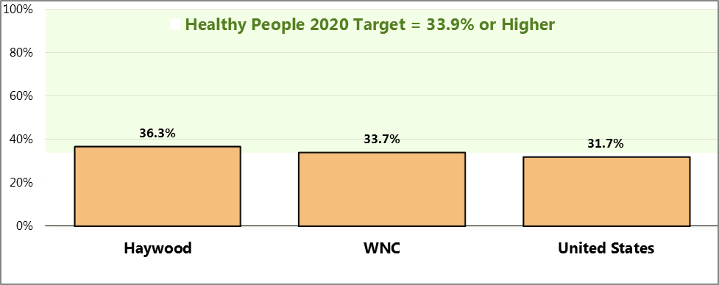

Sources: ● 2012 PRC Community Health Survey, Professional Research Consultants, Inc. [Item 85]

● 2011 PRC National Health Survey, Professional Research Consultants, Inc.

Notes: ● Based on reported heights and weights, asked of all respondents.

● US Department of Health and Human Services.  Healthy People 2020. December 2010.

http://www.healthypeople.gov Objective NWS-8]

● The definition of healthy weight is having a body mass index (BMI), a ratio of weight to height (kilograms divided by meters squared), between 18.5 and 24.9.

Figure 48. Prevalence of Total Overweight (WNC Healthy Impact Survey)

(Percent of Overweight or/Obese Adults; Body Mass Index of 25.0 or Higher)

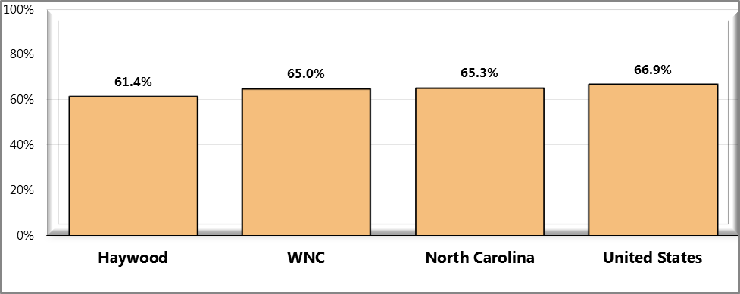

Sources: ● 2012 PRC Community Health Survey, Professional Research Consultants, Inc. [Item 85]

● 2011 PRC National Health Survey, Professional Research Consultants, Inc.

● Behavioral Risk Factor Surveillance System Survey Data. Atlanta, Georgia. United States Department of Health and

Human Services, Centers for Disease Control and Prevention (CDC): 2010 North Carolina data.

Notes: ● Based on reported heights and weights, asked of all respondents.

● The definition of overweight is having a body mass index (BMI), a ratio of weight to height (kilograms divided by meters squared), greater than or equal to 25.0, regardless of gender. The definition for obesity is a BMI greater than or equal to 30.0.

Figure 49. Prevalence of Obesity (WNC Healthy Impact Survey)

(Percent of Obese Adults; Body Mass Index of 30.0 or Higher)

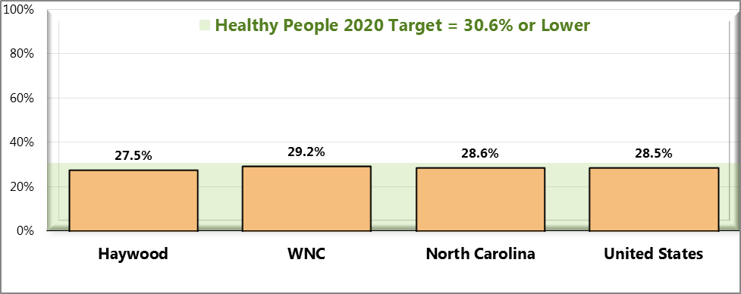

Sources: ● 2012 PRC Community Health Survey, Professional Research Consultants, Inc. [Item 85]

● 2011 PRC National Health Survey, Professional Research Consultants, Inc.

● US Department of Health and Human Services.  Healthy People 2020. December 2010. http://www.healthypeople.gov [Objective NWS-9]

● Behavioral Risk Factor Surveillance System Survey Data. Atlanta, Georgia. United States Department of Health and Human Services, Centers for Disease Control and Prevention (CDC): 2010 North Carolina data.

Notes: ● Based on reported heights and weights, asked of all respondents.

● The definition of obesity is having a body mass index (BMI), a ratio of weight to height (kilograms divided by meters squared), greater than or equal to 30.0, regardless of gender.

#### Childhood Obesity

The NC Healthy Weight Initiative, using the NC Nutrition and Physical Activity Surveillance System (NC NPASS), collects height and weight measurements from children seen in NC DPH-sponsored WIC and Child Health Clinics, as well as some school-based Health Centers (NC DHHS – Nutrition Services Branch, 2012). (Note that this data is not necessarily representative of the county-wide or region-wide population of children.) This data is used to calculate Body Mass Indices (BMIs) in order to gain some insight into the prevalence of childhood obesity.

BMI is a calculation relating weight to height by the following formula:

BMI = (weight in kilograms) / (height in meters)

For children, a BMI in the 95th percentile or above is considered “obese” (formerly defined as “overweight”), while BMIs that are between the 85th and 94th percentiles are considered “overweight” (formerly defined as “at risk for overweight”).

Tables 38, 39 and 40 present NC NPASS data for 2010 on children in three age groups: ages 2-4, ages 5-11, and ages 12-18.

From data presented in Table 38 it appears that the prevalence of healthy weight among 2-4 year-olds in Haywood County (60.9%) is lower than the comparable figures for either WNC (64.5%) or NC (63.5%). The prevalence of *overweight* among children ages 2-4 is higher in Haywood County (17.6%) than the mean for WNC (17.2%) or the figure for NC as a whole (16.1%). The prevalence of *obesity* in Haywood County 2-4 year-olds (16.5%) is higher than the mean prevalence in WNC (13.6%) and the prevalence in NC as a whole (15.6%). It must be noted that the regional means denoted in *italics* contain one or more county percentages that are unstable due to small numbers of children participating in the program.

Table 38. Prevalence of Obesity, Overweight, Healthy Weight and Underweight

Children 2 through 4 years

|  |  |  |  |  |  |  |  |  |  |  |
| --- | --- | --- | --- | --- | --- | --- | --- | --- | --- | --- |
| **Geography** | **Total** | **Underweight** | | **Healthy Weight** | | | **Overweight** | | **Obese** | |
| **<5th Percentile** | | **>5th to <85th Percentile** | | | **>85th to <95th Percentile** | | **>95th Percentile** | |
| # | **#** | **%** | | **#** | **%** | **#** | **%** | **#** | **%** |
|  |  |  |  | |  |  |  |  |  |  |
| Haywood County | 562 | 28 | 5.0 | | 342 | 60.9 | 99 | 17.6 | 93 | 16.5 |
| Regional Total | 6,814 | 316 | - | | 4,410 | - | 1,139 | - | 949 | - |
| Regional Arithmetic Mean | 426 | 20 | *4.8* | | 276 | 64.5 | 71 | *17.2* | 59 | *13.6* |
| State Total | 105,410 | 4,935 | 4.7 | | 66,975 | 63.5 | 17,022 | 16.1 | 16,478 | 15.6 |
|  |  |  |  | |  |  |  |  |  |  |

(2010)

From data presented in Table 39 it appears that the prevalence of children ages 5-11 with healthy weight in Haywood County (66.7%) is higher than the comparable figure for both WNC (63.4%) and NC (54.3%). The prevalence of *overweight* children ages 5-11 in Haywood County (14.1%) is lower than the comparable mean prevalence in WNC (14.3%) as well as the prevalence statewide (17.1%). The prevalence of *obesity* in this age group in Haywood County (17.9%) is lower than the comparable figure for WNC (19.4%) or the prevalence statewide (25.8%). It must be noted that the regional means denoted in *italics* contain one or more county percentages that are unstable due to small numbers of children participating in the program.

Table 39. Prevalence of Obesity, Overweight, Healthy Weight and Underweight

Children 5 through 11 years

|  |  |  |  |  |  |  |  |  |  |  |
| --- | --- | --- | --- | --- | --- | --- | --- | --- | --- | --- |
| **Geography** | **Total** | **Underweight** | | **Healthy Weight** | | | **Overweight** | | **Obese** | |
| **<5th Percentile** | | **>5th to <85th Percentile** | | | **>85th to <95th Percentile** | | **>95th Percentile** | |
| # | **#** | **%** | | **#** | **%** | **#** | **%** | **#** | **%** |
|  |  |  |  | |  |  |  |  |  |  |
| Haywood County | 78 | 1 | ***1.3*** | | 52 | 66.7 | 11 | 14.1 | 14 | 17.9 |
| Regional Total | 1,243 | 26 | - | | 721 | - | 208 | - | 288 | - |
| Regional Arithmetic Mean | 78 | 2 | *2.9* | | 45 | *63.4* | 13 | *14.3* | 18 | *19.4* |
| State Total | 12,633 | 353 | 2.8 | | 6,859 | 54.3 | 2,157 | 17.1 | 3,264 | 25.8 |
|  |  |  |  | |  |  |  |  |  |  |

(2010)

Note: Figures in ***bold italics*** signify unstable percentages based on small numbers of events

From data in Table 40 it appears that the prevalence of healthy weight children ages 12-18 is higher in Haywood County (64.7%) than in WNC (56.3%) or in NC (51.9%). Prevalence percentages for overweight or obese children in this age group in Haywood County are unstable because of small numbers of program participants. It must be noted that the regional means denoted in *italics* contain one or more county percentages that are unstable due to small numbers of children participating in the program.

Table 40. Prevalence of Obesity, Overweight, Healthy Weight and Underweight

Children 12 through 18 years

|  |  |  |  |  |  |  |  |  |  |  |
| --- | --- | --- | --- | --- | --- | --- | --- | --- | --- | --- |
| **Geography** | **Total** | **Underweight** | | **Healthy Weight** | | | **Overweight** | | **Obese** | |
| **<5th Percentile** | | **>5th to <85th Percentile** | | | **>85th to <95th Percentile** | | **>95th Percentile** | |
| # | **#** | **%** | | **#** | **%** | **#** | **%** | **#** | **%** |
|  |  |  |  | |  |  |  |  |  |  |
| Haywood County | 34 | 0 | ***0.0*** | | 22 | 64.7 | 7 | ***20.6*** | 5 | ***14.7*** |
| Regional Total | 1,348 | 13 | - | | 729 | - | 245 | - | 361 | - |
| Regional Arithmetic Mean | 84 | 1 | *1.0* | | 46 | *56.3* | 15 | *19.0* | 23 | *23.8* |
| State Total | 6,854 | 133 | 1.9 | | 3,560 | 51.9 | 1,241 | 18.1 | 1,920 | 28.0 |
|  |  |  |  | |  |  |  |  |  |  |

(2010)

Note: Figures in ***bold italics*** signify unstable percentages based on small numbers of events

For further details regarding this NC NPASS data, consult the *Data Workbook*.

### Injuries

#### Falls

There were 30 deaths due to falls in Haywood County in the period 2006-2010. In 2009 alone there were 10, nine of them in the over-65 age group (two in the 65-74 year age group, four in the 75-84 age group, and three in the 85-and-over age group) (*Data Workbook*).

Survey respondents were also asked how many times they have fallen in the past 12 months, and how many of these falls caused an injury. Data is shown below for adults age 65 and older. Due to small county-level sample sizes, fall-related injury data is provided at the regional level.

Figure 50. Number of Falls in the Past Year (WNC Healthy Impact Survey)

(Among Adults Age 65 and Older)

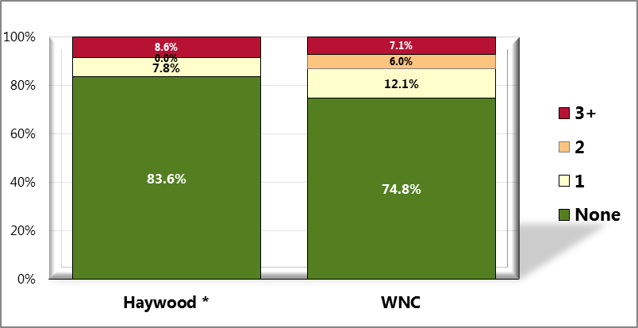

Sources: ● 2012 PRC Community Health Survey, Professional Research Consultants, Inc. [Item 40]

Notes: ● Asked of respondents age 65 and older.

* These counties have sample sizes deemed unreliable (n<50).

Figure 51. Sustained a Fall-Related Injury in the Past Year (WNC Healthy Impact Survey)

(Among Adults 65+ Who Have Fallen in the Past Year)

(Western North Carolina, 2012)

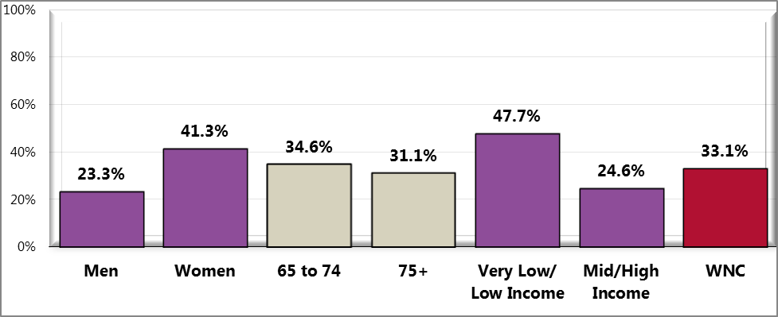

Sources: ● 2012 PRC Community Health Survey, Professional Research Consultants, Inc. [Item 41]

Notes: ● Asked of respondents age 65 and older who have fallen in the past year.

● Includes falls that caused respondent to limit his/her regular activities for at least a day or caused him/her to go see a

doctor.

● Hispanics can be of any race. Other race categories are non-Hispanic categorizations (e.g., “White” reflects non-

Hispanic White respondents).

● Income categories reflect respondent's household income as a ratio to the federal poverty level (FPL) for their

household size. “Low Income” includes households with incomes up to 200% of the federal poverty level; “Mid/High

Income” includes households with incomes at 200% or more of the federal poverty level.

#### Vehicle Crashes

The Highway Safety Research Center at the University of North Carolina at Chapel Hill tracks information about vehicle crashes across the state on an annual basis, including detail on the fraction of crashes that are alcohol-related. Table 41 presents trend data on vehicle crashes for the period from 2006 through 2010. The data presented for Haywood County demonstrated high variability, with the percentage of alcohol-related crashes sometimes above and sometimes below the percentage for WNC. However, the percentage of alcohol-related traffic crashes in the county was above the comparable state rate in every year cited in the table. The data in the table also shows that the percentage of alcohol-related vehicle crashes in WNC were higher than the comparable percentages for the state as a whole throughout the period cited, with the difference varying from 16% to 27% depending on the year.

|  |  |  |  |  |  |  |  |  |  |  |
| --- | --- | --- | --- | --- | --- | --- | --- | --- | --- | --- |
| **Geography** | **2006** | | **2007** | | **2008** | | **2009** | | **2010** | |
| **# Crashes** | **% Alcohol-Related** | **# Crashes** | **% Alcohol-Related** | **# Crashes** | **% Alcohol-Related** | **# Crashes** | **% Alcohol-Related** | **# Crashes** | **% Alcohol-Related** |
|
|  |  |  |  |  |  |  |  |  |  |  |
| Haywood County | 1,086 | 6.0 | 1,117 | 5.6 | 1,069 | 7.1 | 1,038 | 6.7 | 1,009 | 6.1 |
| Regional Total | 15,004 | 6.2 | 15,216 | 6.5 | 13,997 | 7.1 | 14,075 | 6.6 | 14,763 | 5.8 |
| State Total | 220,307 | 5.1 | 224,307 | 5.3 | 214,358 | 5.6 | 209,695 | 5.4 | 213,573 | 5.0 |
|  |  |  |  |  |  |  |  |  |  |  |

Table 41. Alcohol-Related Traffic Crashes (2006-2010)

Table 42 presents additional detail on the nature of vehicular crashes for a single year, 2010. In Haywood County 6.1% of *all* crashes were alcohol-related; although the following number may be unstable since it is based on only three events, 42.9% of the *fatal* crashes in the county (3 of 7) were alcohol-related. In both WNC and NC as a whole, the proportion of *all* crashes that were alcohol-related was less than 6%, but the proportion of *fatal* crashes that were alcohol-related was over 30%. It is noteworthy that the percentages of crashes that were alcohol-related were higher in WNC than in NC for every outcome category displayed in Table 42.

Table 42. Outcomes of Traffic Crashes (2010)

|  |  |  |  |  |  |  |  |  |
| --- | --- | --- | --- | --- | --- | --- | --- | --- |
| **Geography** | **Total Crashes** | | **Property Damage Only Crashes** | | **Non-Fatal Crashes** | | **Fatal Crashes** | |
| **# Reportable Crashes** | **% Alcohol-Related Crashes** | **# Reportable Crashes** | **% Alcohol-Related Crashes** | **# Reportable Crashes** | **% Alcohol-Related Crashes** | **# Reportable Crashes** | **% Alcohol-Related Crashes** |
|  |  |  |  |  |  |  |  |  |
| Haywood County | 1,009 | 6.1 | 653 | 4.3 | 349 | 8.9 | 7 | **42.9** |
| Regional Total | 14,763 | 5.8 | 9,469 | 4.0 | 5,192 | 8.3 | 102 | 36.3 |
| State Total | 213,573 | 5.0 | 143,211 | 3.4 | 69,138 | 7.8 | 1,224 | 32.4 |
|  |  |  |  |  |  |  |  |  |

#### Distracted Drivers

There is no comparable data for Haywood County, WNC or NC, but in the US as a whole in 2010, 3,092 people died and 416,000 were injured as a result of distracted driving (*Data Workbook*).

#### Workplace Injury

There is no comparable data for Haywood County, WNC or the US, but in NC as a whole, the mortality rate associated with work-related injury was 3.9 deaths per 100,000 full-time equivalent workers in 2008, and 3.3 in 2009 (*Data Workbook*).

#### Poisonings

For the five-year aggregate period 2006-2010 there were 43 unintentional poisoning deaths in Haywood County, with a corresponding age-adjusted mortality rate of 18.0 per 100,000 population. The comparable mean unintentional poisoning mortality rate for WNC was 23.1 over the same period.

### Communicable Disease

A communicable disease is a disease transmitted through direct contact with an infected individual or indirectly through a vector (Merriam-Webster.com). The topic of communicable diseases includes sexually transmitted infections (STIs). The STIs of greatest regional interest are chlamydia and gonorrhea. HIV/AIDS is sometimes grouped with STIs, since sexual contact is one mode of HIV transmission. While AIDS, as the final stage of HIV infection, was discussed previously among the leading causes of death, HIV is discussed here as a communicable disease.

**Chlamydia** is the most frequently reported bacterial STI in the US. It is estimated that there are approximately 2.8 million new cases of chlamydia in the US each year. Chlamydia cases frequently go undiagnosed and can cause serious problems in men and women, such as penile discharge and infertility respectively, as well as infections in newborn babies of infected mothers (CDC, 2012).

Figure 52 plots Chlamydia rates for several years. From this data it appears that chlamydia infection is less prevalent in Haywood County than in NC, and about as prevalent as in WNC. In WNC, the mean chlamydia infection rate, which varied between 136.9 and 241.5, was 57% to 66% lower than the comparable rate for NC as a whole for the time span cited. Chlamydia rates in both NC and WNC increased overall between 2007 and 2011, when the NC rate rose 67.2% (from 337.7 to 564.8) and the WNC rate rose 76.4% (from 136.9 to 241.5). In Haywood County over the same period the chlamydia infection rate increased 64.4%, from 141.2 to 232.1.

Figure 52. Chlamydia Rate, All Ages, Cases per 100,000 Population

(Five Single Years, 2007-2011)

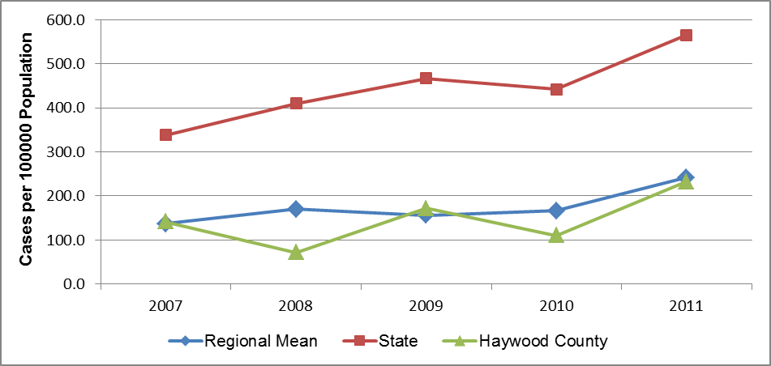

Note: There is some instability in the regional mean rates because each includes one or more unstable county rate.

**Gonorrhea** is the second most commonly reported bacterial STI in the US. The highest rates of gonorrhea have been found in African Americans, people 20 to 24 years of age, and women, respectively. In women, gonorrhea can spread into the uterus and fallopian tubes, resulting in pelvic inflammatory disease (PID). PID affects more than 1 million women in the US every year and can cause tubal pregnancy and infertility in as many as 10 percent of infected women. In addition, some health researchers think gonorrhea adds to the risk of getting HIV infection (CDC, 2012).

Figure 53 plots gonorrhea rates for several aggregate periods. From this data it appears that gonorrhea was far less prevalent in Haywood County than in NC as a whole, and less prevalent as well than in WNC. The mean gonorrhea rate in WNC was 72% to 82% lower than the state rate for the span of aggregate periods shown in Figure 53. It is noteworthy that as the state gonorrhea rate decreased 7.2% (from 182.0 to 168.9) over the period cited, the mean WNC gonorrhea rate increased 36.2% (from 33.7 to 45.9) in the same time span. In Haywood County the gonorrhea infection rate increased 33.6% over the period cited, rising from 12.8 to 17.1.

Figure 53. Gonorrhea Rate, Cases per 100,000 Population

(Five-Year Aggregates, 2002-2006 through 2006-2010)

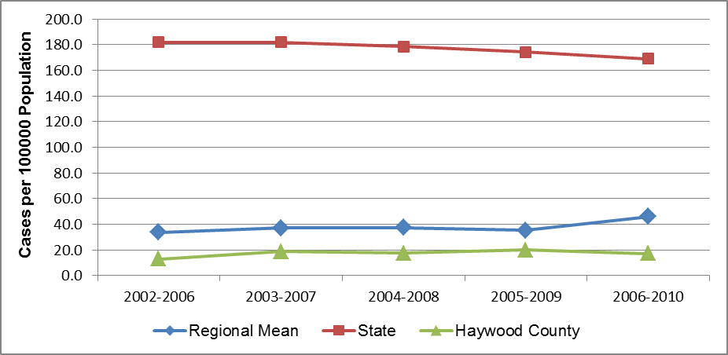

Note: There is some instability in the regional mean rates because each includes one or more unstable county rate.

**HIV infection**, an important communicable disease in some regions of NC, is a rare occurrence throughout most of WNC. Only one county in the region (Buncombe) has reported enough cases in some years to calculate a stable incidence rate. The total number of HIV cases in WNC in 2008 was 58; in 2009 the total was 46, and in 2010 the total was 40 (*Data Workbook).*

# Chapter 4 – Health Behaviors

## Physical Activity

Regular physical activity can improve the health and quality of life of Americans of all ages, regardless of the presence of a chronic disease or disability. Among adults and older adults, physical activity can lower the risk of: early death; coronary heart disease; stroke; high blood pressure; type 2 diabetes; breast and colon cancer; falls; and depression. Among children and adolescents, physical activity can: improve bone health; improve cardiorespiratory and muscular fitness; decrease levels of body fat; and reduce symptoms of depression. For people who are inactive, even small increases in physical activity are associated with health benefits.

Personal, social, economic, and environmental factors all play a role in physical activity levels among youth, adults, and older adults. Factors **positively** associated with adult physical activity include: postsecondary education; higher income; enjoyment of exercise; expectation of benefits; belief in ability to exercise (self-efficacy); history of activity in adulthood; social support from peers, family, or spouse; access to and satisfaction with facilities; enjoyable scenery; and safe neighborhoods. Factors **negatively** associated with adult physical activity include: advancing age; low income; lack of time; low motivation; rural residency; perception of great effort needed for exercise; overweight or obesity; perception of poor health; and being disabled. Older adults may have additional factors that keep them from being physically active, including lack of social support, lack of transportation to facilities, fear of injury, and cost of programs (DHHS, 2010).

Adults (age 18–64) should do 2 hours and 30 minutes a week of moderate-intensity, or 1 hour and 15 minutes (75 minutes) a week of vigorous-intensity aerobic physical activity, or an equivalent combination of moderate- and vigorous-intensity aerobic physical activity. Aerobic activity should be performed in episodes of at least 10 minutes, preferably spread throughout the week. Additional health benefits are provided by increasing to 5 hours (300 minutes) a week of moderate-intensity aerobic physical activity, or 2 hours and 30 minutes a week of vigorous-intensity physical activity, or an equivalent combination of both.

Older adults (age 65 and older) should follow the adult guidelines. If this is not possible due to limiting chronic conditions, older adults should be as physically active as their abilities allow. They should avoid inactivity. Older adults should do exercises that maintain or improve balance if they are at risk of falling.

For all individuals, some activity is better than none. Physical activity is safe for almost everyone, and the health benefits of physical activity far outweigh the risks (DHHS, 2008).

Figure 54. No Leisure-Time Physical Activity in the Past Month

(WNC Healthy Impact Survey)

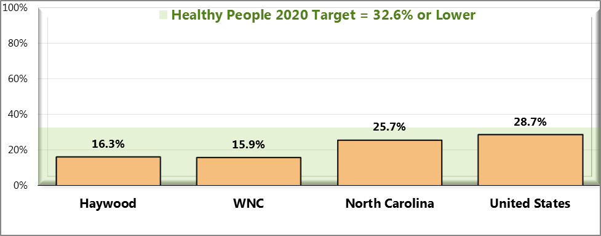

. Sources: ● 2012 PRC Community Health Survey, Professional Research Consultants, Inc. [Item 56]

● Behavioral Risk Factor Surveillance System Survey Data. Atlanta, Georgia. United States Department of Health and Human Services, Centers for Disease Control and Prevention (CDC): 2010 North Carolina data.

● 2011 PRC National Health Survey, Professional Research Consultants, Inc.

● US Department of Health and Human Services.  Healthy People 2020. December 2010. <http://www.healthypeople.gov> [Objective PA-1]

Notes: ● Asked of all respondents.

Figure 55. Meets Physical Activity Recommendations (WNC Healthy Impact Survey)

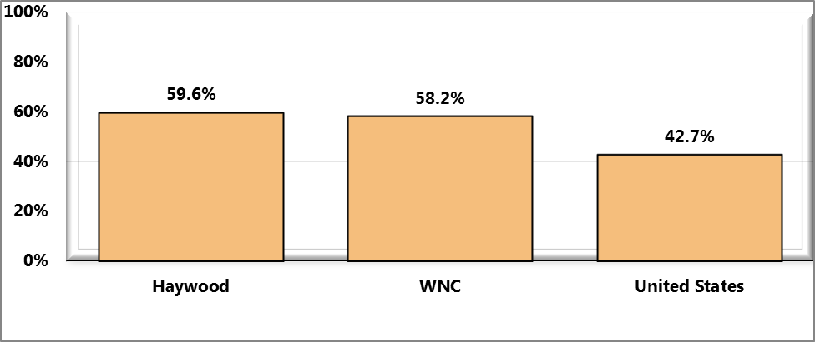

Sources: ● 2012 PRC Community Health Survey, Professional Research Consultants, Inc. [Item 80]

● 2011 PRC National Health Survey, Professional Research Consultants, Inc.

Notes: ● Asked of all respondents.

● In this case the term “meets physical activity recommendations” refers to participation in moderate physical activity (exercise that produces only light sweating or a slight to moderate increase in breathing or heart rate ) at least 5 times a week for 30 minutes at a time, and/or vigorous physical activity (activities that cause heavy sweating or large increases in breathing or heart rate) at least 3 times a week for 20 minutes at a time.

Figure 56. Moderate Physical Activity (WNC Healthy Impact Survey)

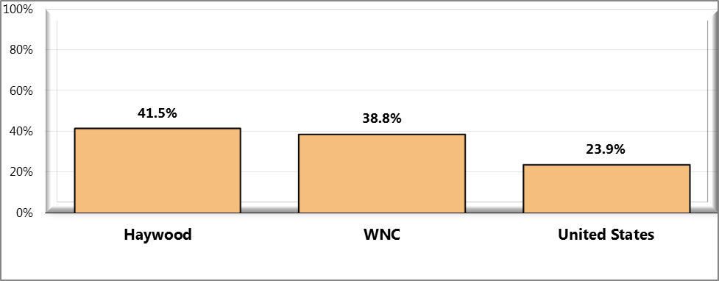

Sources: ● 2012 PRC Community Health Survey, Professional Research Consultants, Inc. [Item 81]

● 2011 PRC National Health Survey, Professional Research Consultants, Inc.

Notes: ● Asked of all respondents.

● Moderate Physical Activity: Takes part in exercise that produces only light sweating or a slight to moderate increase in breathing or heart rate at least 5 times per week for at least 30 minutes per time.

Figure 57. Vigorous Physical Activity (WNC Healthy Impact Survey)

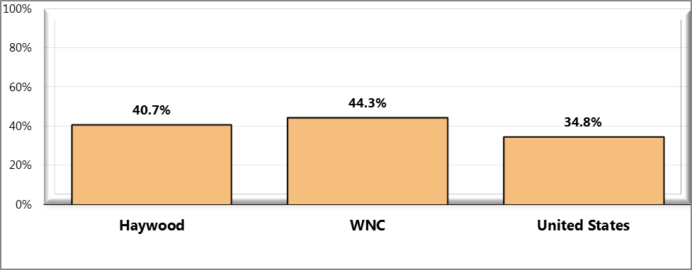

Sources: ● 2012 PRC Community Health Survey, Professional Research Consultants, Inc. [Item 82]

● 2011 PRC National Health Survey, Professional Research Consultants, Inc.

● Behavioral Risk Factor Surveillance System Survey Data. Atlanta, Georgia. United States Department of Health and

Human Services, Centers for Disease Control and Prevention (CDC): 2010 North Carolina data.

Notes: ● Asked of all respondents.

● Vigorous Physical Activity: Takes part in activities that cause heavy sweating or large increases in breathing or heart rate at least 3 times per week for at least 20 minutes per time.

Figure 58. Strengthening Physical Activity (WNC Healthy Impact Survey)

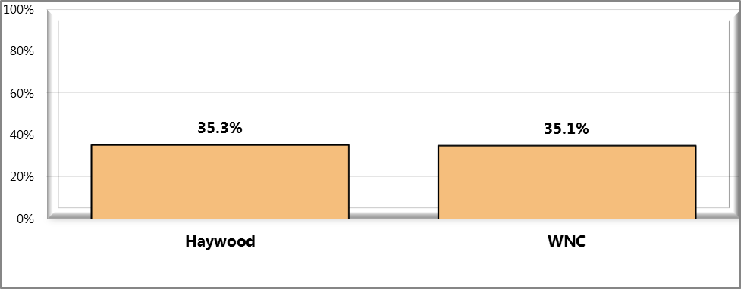

Sources: ● 2012 PRC Community Health Survey, Professional Research Consultants, Inc. [Item 83]

Notes: ● Asked of all respondents.

● Strengthening Physical Activity: Takes part in physical activities or exercises that strengthen muscles at least 2 times per week.

## Diet and Nutrition

Strong science exists supporting the health benefits of eating a healthful diet and maintaining a healthy body weight. Diet and body weight are related to health status. Good nutrition is important to the growth and development of children. A healthful diet also helps Americans reduce their risks for many health conditions, including: overweight and obesity; malnutrition; iron-deficiency anemia; heart disease; high blood pressure; dyslipidemia (poor lipid profiles); type 2 diabetes; osteoporosis; oral disease; constipation; diverticular disease; and some cancers. Efforts to change diet and weight should address individual behaviors, as well as the policies and environments that support these behaviors in settings such as schools, worksites, healthcare organizations, and communities.

**Social Determinants of Diet.** Social factors thought to influence diet include:

* Knowledge and attitudes
* Skills
* Social support
* Societal and cultural norms
* Food and agricultural policies
* Food assistance programs
* Economic price systems

**Physical Determinants of Diet.**

The places where people eat appear to influence their diet. For example, foods eaten away from home often have more calories and are of lower nutritional quality than foods prepared at home. Marketing also influences people’s—particularly children’s—food choices (DHHS, 2010).

More information is available elsewhere in this report about some of these determinants.

To measure fruit and vegetable consumption, survey respondents were asked how many one-cup servings of fruit and one-cup servings of vegetables (not counting lettuce salad or potatoes) they ate over the past week.

**Figure 59. Had an Average of Five or More Servings**

of Fruits/Vegetables per Day in the Past Week (WNC Healthy Impact Survey)

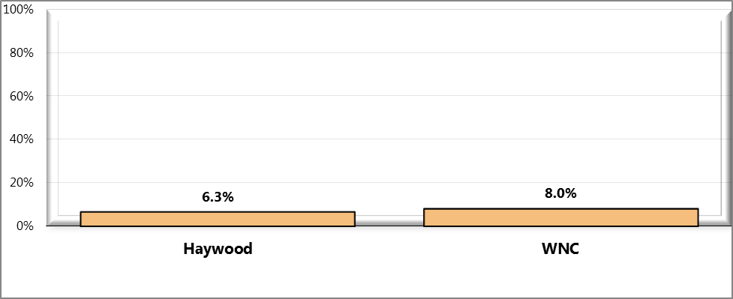

Sources: ● 2012 PRC Community Health Survey, Professional Research Consultants, Inc. [Item 79]

Notes: ● Asked of all respondents.

● For this issue, respondents were asked to recall their food intake during the previous week. Reflects 35 or more 1-cup servings of fruits and/or vegetables in the past week, excluding lettuce salad and potatoes.

Figure 60. Average Servings of Fruits/Vegetables in the Past Week

(WNC Healthy Impact Survey)

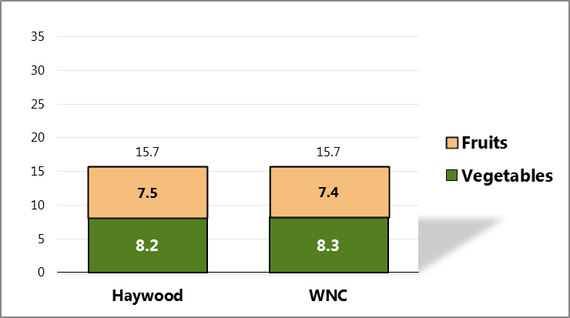

Sources: ● 2012 PRC Community Health Survey, Professional Research Consultants, Inc. [Items 53-54]

Notes: ● Asked of all respondents.

● For this issue, respondents were asked to recall their food intake during the previous week.

Reflects 35 or more 1-cup servings of fruits and/or vegetables in the past week, excluding lettuce

salad and potatoes.

## Substance Use/Abuse

Substance abuse refers to a set of related conditions associated with the consumption of mind- and behavior-altering substances that have negative behavioral and health outcomes. Social attitudes and political and legal responses to the consumption of alcohol and illicit drugs make substance abuse one of the most complex public health issues. In 2005, an estimated 22 million Americans struggled with a drug or alcohol problem. Almost 95% of people with substance use problems are considered unaware of their problem. Of those who recognize their problem, 273,000 have made an unsuccessful effort to obtain treatment. These estimates highlight the importance of increasing prevention efforts and improving access to treatment for substance abuse and co-occurring disorders. Substance abuse has a major impact on individuals, families, and communities. The effects of substance abuse are cumulative, significantly contributing to costly social, physical, mental, and public health problems (DHHS, 2010).

### Illicit Drugs

For the purposes of the survey, “illicit drug use” includes use of illegal substances or of prescription drugs taken without a physician’s order. It is important to note that as a self-reported measure – and because this indicator reflects potentially illegal behavior – it is reasonable to expect that it might be underreported, and that actual illicit drug use in the community is likely higher.

Figure 61. Illicit Drug Use in the Past Month (WNC Healthy Impact Survey)

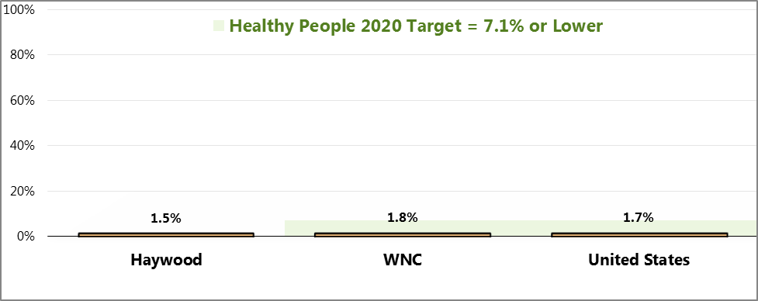

Sources: ● 2012 PRC Community Health Survey, Professional Research Consultants, Inc. [Item 52]

● 2011 PRC National Health Survey, Professional Research Consultants, Inc.

● US Department of Health and Human Services.  Healthy People 2020. December 2010. http://www.healthypeople.gov [Objective SA-13.3]

Notes: ● Asked of all respondents.

● Includes reported use of an illegal drug or of a prescription drug not prescribed to the respondent.

### Alcohol

“**Current drinkers**” include survey respondents who had at least one drink of alcohol in the month preceding the interview. For the purposes of this study, a “drink” is considered one can or bottle of beer, one glass of wine, one can or bottle of wine cooler, one cocktail, or one shot of liquor. “**Chronic drinkers**” include survey respondents reporting 60 or more drinks of alcohol in the month preceding the interview.

In this assessment, “**binge drinkers**” include adults who report drinking 5 or more alcoholic drinks on any single occasion during the past month. Note that state and national data reflect different thresholds for men (5+ drinks) and women (4+ drinks), so county and regional data is not directly comparable to state and national figures.

Figure 62. Current Drinkers (WNC Healthy Impact Survey)

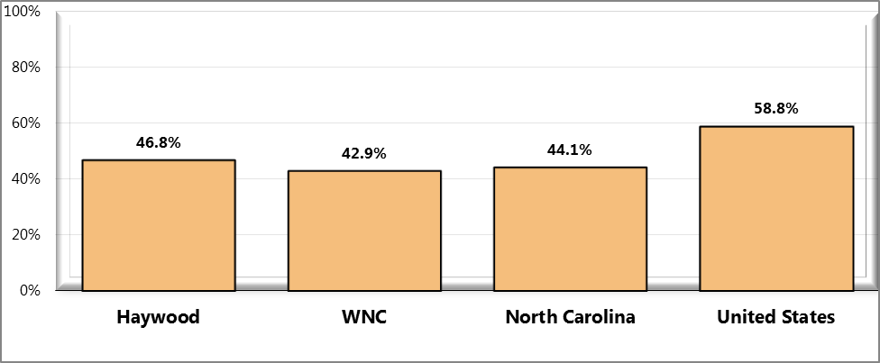

Sources: ● 2012 PRC Community Health Survey, Professional Research Consultants, Inc. [Item 88]

● Behavioral Risk Factor Surveillance System Survey Data. Atlanta, Georgia. United States Department of Health and Human Services, Centers for Disease Control and Prevention (CDC): 2010 North Carolina data.

● 2011 PRC National Health Survey, Professional Research Consultants, Inc.

Notes: ● Asked of all respondents.

● Current drinkers had at least one alcoholic drink in the past month.

Figure 63. Chronic Drinkers (WNC Healthy Impact Survey)

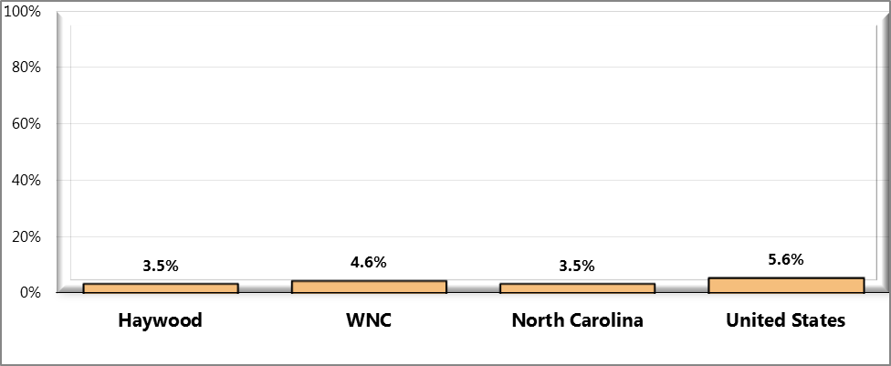

Sources: ● 2012 PRC Community Health Survey, Professional Research Consultants, Inc. [Item 89]

● Behavioral Risk Factor Surveillance System Survey Data. Atlanta, Georgia. United States Department of Health and Human Services, Centers for Disease Control

and Prevention (CDC): 2010 North Carolina data.

● 2011 PRC National Health Survey, Professional Research Consultants, Inc.

Notes: ● Asked of all respondents.

● Chronic drinkers are defined as having 60+ alcoholic drinks in the past month.

● *The state definition for chronic drinkers is males consuming 2+ drinks per day and females consuming 1+ drink per day in the past 30 days.

Figure 64. Binge Drinkers (WNC Healthy Impact Survey)

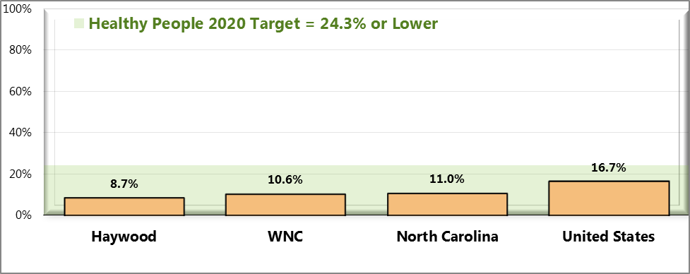

Sources: ● 2012 PRC Community Health Survey, Professional Research Consultants, Inc. [Item 90]

● Behavioral Risk Factor Surveillance System Survey Data. Atlanta, Georgia. United States Department of Health and Human Services, Centers for Disease Control and Prevention (CDC): 2010 North Carolina data.

● 2011 PRC National Health Survey, Professional Research Consultants, Inc.

● US Department of Health and Human Services.  Healthy People 2020. December 2010. http://www.healthypeople.gov [Objective SA-14.3]

Notes: ● Asked of all respondents.

● Binge drinkers are defined as those consuming 5+ alcoholic drinks on any one occasion in the past 30 days; * note

that state and national data reflect different thresholds for men (5+ drinks) and women (4+ drinks).

### Tobacco

Tobacco use is the single most preventable cause of death and disease in the United States. Each year, approximately 443,000 Americans die from tobacco-related illnesses. For every person who dies from tobacco use, 20 more people suffer with at least one serious tobacco-related illness. In addition, tobacco use costs the US $193 billion annually in direct medical expenses and lost productivity. Preventing tobacco use and helping tobacco users quit can improve the health and quality of life for Americans of all ages. People who stop smoking greatly reduce their risk of disease and premature death. Benefits are greater for people who stop at earlier ages, but quitting tobacco use is beneficial at any age.

Many factors influence tobacco use, disease, and mortality. Risk factors include race/ethnicity, age, education, and socioeconomic status. Significant disparities in tobacco use exist geographically; such disparities typically result from differences among states in smoke-free protections, tobacco prices, and program funding for tobacco prevention (DHHS, 2010).

Figure 65. Current Smokers (WNC Healthy Impact Survey)

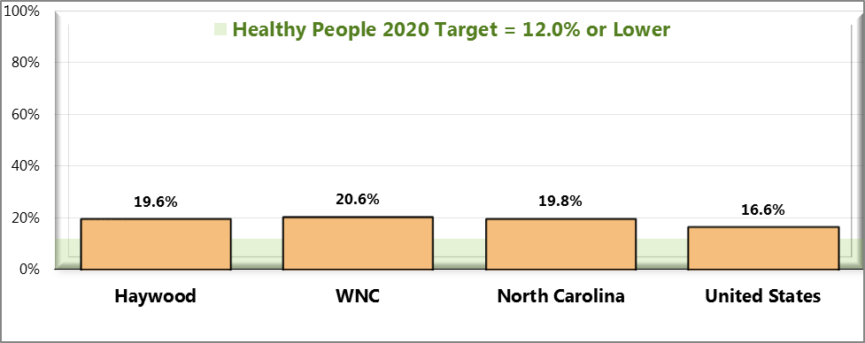

Sources: ● 2012 PRC Community Health Survey, Professional Research Consultants, Inc. [Item 86]

● 2011 PRC National Health Survey, Professional Research Consultants, Inc.

● Behavioral Risk Factor Surveillance System Survey Data. Atlanta, Georgia. United States Department of Health and Human Services, Centers for Disease Control and Prevention (CDC): 2010 North Carolina data.

● US Department of Health and Human Services.  Healthy People 2020. December 2010. http://www.healthypeople.gov [Objective TU-1.1]

Notes: ● Asked of all respondents.

● Includes regular and occasional smokers (every day and some days).

Figure 66. Currently Use Smokeless Tobacco Products (WNC Healthy Impact Survey)

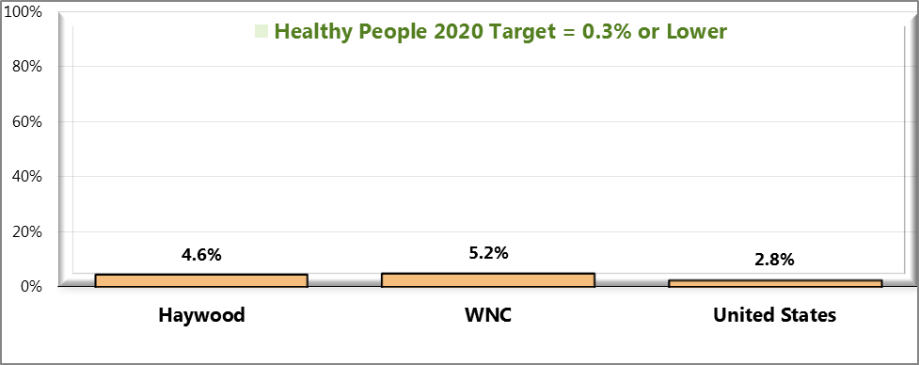

Sources: ● 2012 PRC Community Health Survey, Professional Research Consultants, Inc. [Item 43]

● 2011 PRC National Health Survey, Professional Research Consultants, Inc.

● US Department of Health and Human Services.  Healthy People 2020. December 2010. http://www.healthypeople.gov [Objective TU-1.2]

Notes: ● Asked of all respondents.

● Includes regular and occasional users (every day and some days).

Table 43. Top Three Resources Respondents

Would Go to for Help Quitting Tobacco (WNC Healthy Impact Survey)

|  |  |  |  |
| --- | --- | --- | --- |
|  | **Doctor** | **On My Own/Cold Turkey** | **Don’t Know** |
| Haywood | **✓** | **✓** | **✓** |
| WNC | **✓** | **✓** | **✓** |

Sources: ● 2012 PRC Community Health Survey, Professional Research Consultants, Inc. [Item 48]

Notes: ● Asked of all respondents.

## Health Information

Survey respondents were asked about where they get their healthcare information

Figure 67. Primary Source of Healthcare Information

(WNC Healthy Impact Survey)

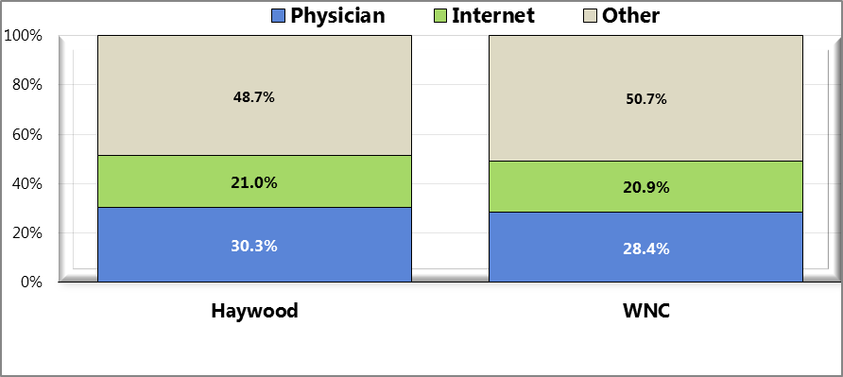

Sources: ● 2012 PRC Community Health Survey, Professional Research Consultants, Inc. [Item 11]

Notes: ● Asked of all respondents.

# Chapter 5 – Clinical Care Parameters

## Medical Care Access

Access to comprehensive, quality health care services is important for the achievement of health equity and for increasing the quality of a healthy life for everyone. It impacts: overall physical, social, and mental health status; prevention of disease and disability; detection and treatment of health conditions; quality of life; preventable death; and life expectancy.

Access to health services means the timely use of personal health services to achieve the best health outcomes. It requires three distinct steps: 1) gaining entry into the health care system; 2) accessing a health care location where needed services are provided; and 3) finding a health care provider with whom the patient can communicate and trust (DHHS, 2010).

### Self-Reported Access

Survey respondents were asked if there was a time in the past 12 months when they needed medical care, but could not get it. If they responded, “yes,” they were asked to name the main reason they could not get needed medical care. Due to small county-level sample sizes, the responses to the latter question are displayed at the regional-level, below.

Survey respondents were also asked to indicate their agreement with the following statement: “*Considering cost, quality, number of options and availability, there is good healthcare in my county*.”

Figure 68. Was Unable to Get Needed

Medical Care at Some Point in the Past Year

(WNC Healthy Impact Survey)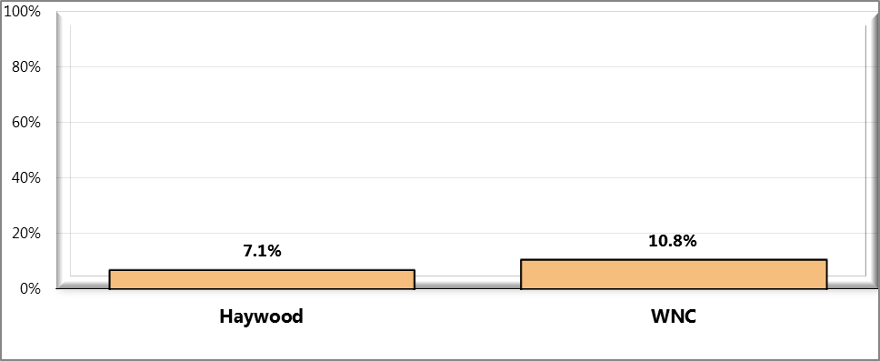

Sources: ● 2012 PRC Community Health Survey, Professional Research Consultants, Inc. [Item 13]

Notes: ● Asked of all respondents

Figure 69. Primary Reason for Inability to Get Needed Medical Care (WNC Healthy Impact)

(Adults Unable to Get Needed Medical Care at Some Point in the Past Year)

(Western North Carolina, 2012)

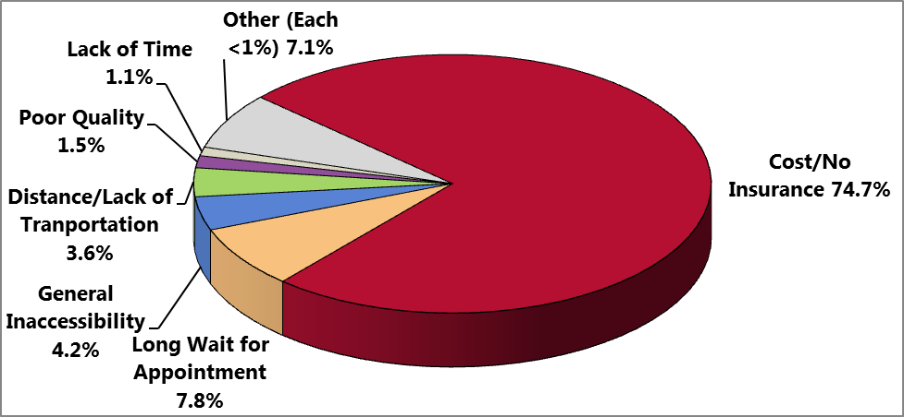

Sources: ● 2012 PRC Community Health Survey, Professional Research Consultants, Inc. [Item 14]

Notes: ● Asked of all respondents.

Figure 70. “Considering cost, quality, number of options

And availability, there is good health care in my county

(WNC Healthy Impact Survey)

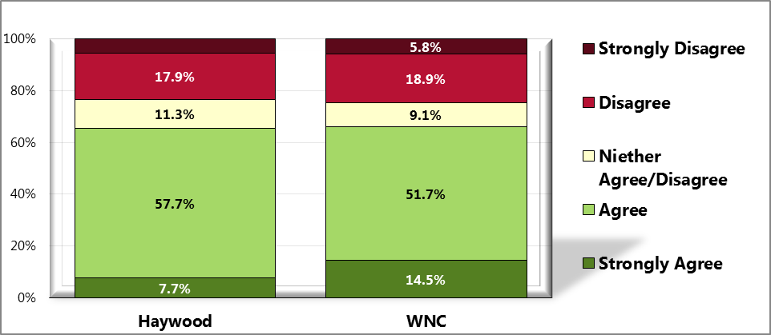

Sources: ● 2012 PRC Community Health Survey, Professional Research Consultants, Inc. [Item 7]

Notes: ● Asked of all respondents.

### Health Care Providers

#### Provider/Population Ratios

One way to judge the supply of health care providers in a jurisdiction is to calculate the ratio of the number of health professionals to the number of persons in the population of that jurisdiction. In NC, there is data on the ratio of active health professionals per 10,000 population calculated at the county level. Table 44 presents those data (which for simplicity’s sake will be referred to simply as the “ratio”) for Haywood County, WNC, the state as a whole, and the US for five key categories of health care professionals: physicians, primary care physicians, dentists, registered nurses, and pharmacists. The years covered are 2008 and 2010.

According to this data, in 2010 the ratios of professionals to population for Haywood County were higher than for both WNC and NC for dentists, and lower than for both for primary care physicians and registered nurses. The county ratios for physicians and pharmacists were higher than the comparable ratios for WNC but lower than the ratios for NC. It should be noted that the mean ratios for WNC are lower than the comparable state averages in every professional category listed in the table, and lower than the comparable national average in every professional category except primary care.

Table 44. Active Health Professionals per 10,000 Population (2008 and 2010)

|  |  |  |  |  |  |  |  |  |  |  |
| --- | --- | --- | --- | --- | --- | --- | --- | --- | --- | --- |
| **Geography** | **2008** | | | | | **2010** | | | | |
| **Phys** | **Primary Care Phys** | **Dents** | **RNs** | **Pharms** | **Phys** | **Primary Care Phys** | **Dents** | **RNs** | **Pharms** |
|
|  |  |  |  |  |  |  |  |  |  |  |
| Haywood County | 17.7 | 8.1 | 4.6 | 76.2 | 6.8 | 18.1 | 7.8 | 4.7 | 71.4 | 8.1 |
| Regional Average | 15.0 | 8.9 | 3.4 | 75.3 | 7.0 | 14.8 | 8.9 | 3.4 | 74.9 | 6.9 |
| State Average | 21.2 | 9.0 | 4.3 | 95.1 | 9.3 | 21.7 | 9.4 | 4.4 | 97.4 | 9.2 |
| National Average | 23.2* | 8.5* | 4.9 | 91.4 | 8.0 | 22.7** | 8.2** | 5.7 | 92.0 | 8.3 |
|  |  |  |  |  |  |  |  |  |  |  |

* Data are for 2006

** Data are for 2008

#### Providers by Specialty

Table 45 lists the number of active health care professionals in Haywood County and WNC, by specialty, for 2010. General practice is the only specialty missing from the county.

Table 45. Active Health Professionals in Haywood County and WNC, by Specialty (2010)

|  |  |  |
| --- | --- | --- |
| **Category of Professionals** | **Haywood County** | **WNC Total** |
|
|
|  |  |  |
| **Physicians** |  |  |
| Primary Care Physicians | 46 | 813 |
| *Family Practice* | 27 | 368 |
| *General Practice* | 0 | 10 |
| *Internal Medicine* | 10 | 240 |
| *Obstetrics/Gynecology* | 4 | 85 |
| *Pediatrics* | 5 | 110 |
| Other Specialties | 61 | 853 |
|  |  |  |
| **Dentists and Dental Hygienists** |  |  |
| Dentists | 28 | 342 |
| Dental Hygienists | 49 | 479 |
|  |  |  |
| **Nurses** |  |  |
| Registered Nurses | 422 | 7,981 |
| *Nurse Practitioners* | 15 | 316 |
| *Certified Nurse Midwives* | 2 | 28 |
| Licensed Practical Nurses | 113 | 1,854 |
|  |  |  |
| **Other Health Professionals** |  |  |
| Chiropractors | 14 | 192 |
| Occupational Therapists | 11 | 242 |
| Occupational Therapy Assistants | 11 | 99 |
| Optometrists | 6 | 84 |
| Pharmacists | 48 | 669 |
| Physical Therapists | 26 | 511 |
| Physical Therapy Assistants | 29 | 309 |
| Physician Assistants | 20 | 290 |
| Podiatrists | 4 | 24 |
| Practicing Psychologists | 5 | 201 |
| Psychological Assistants | 7 | 87 |
| Respiratory Therapists | 24 | 370 |
|  |  |  |

## Uninsured Population

Table 46 presents periodic two-year data on the proportion of the non-elderly population (ages 19-64) without health insurance of any kind. While there was a 21.0% increase in the percent of uninsured at the state level from 2006-2007, the mean percent of uninsured adults in WNC actually decreased from one biennial period to the next throughout the span of years shown in the table. In Haywood County the percent uninsured fell every period shown in the table, with an overall decrease of 10.4%.

Table 46. Estimated Percent Uninsured Adults, Ages 19-64

Biennial Periods (2006-2007, 2008-2009, and 2009-2010)

|  |  |  |  |
| --- | --- | --- | --- |
| **Geography** | **Percent Uninsured** | | |
| **2006-2007** | **2008-2009** | **2009-2010** |
|  |  |  |  |
| Haywood County | 22.2 | 21.8 | 19.9 |
| Regional Arithmetic Mean | 23.4 | 22.3 | 22.0 |
| State Total | 19.5 | 23.2 | 23.6 |
|  |  |  |  |

Table 47 shows the percent uninsured for one biennium (2009-2010) stratified by age. This data makes it clear that in Haywood County as well as in WNC and NC as a whole, insurance coverage is better for children, among whom the percentage uninsured is less than half the percentage uninsured among the 19-64 age group. For all age categories cited, the percent uninsured is approximately the same or lower in Haywood County than in WNC or NC.

Table 47. Estimated Percent Uninsured, All Ages

(2009-2010)

|  |  |  |  |
| --- | --- | --- | --- |
| **Geography** | **2009-2010** | | |
| **Children (0-18)** | **Adults (19-64)** | **Total (0-64)** |
|  |  |  |  |
| Haywood County | 9.1 | 19.9 | 17.1 |
| Regional Arithmetic Mean | 9.6 | 22.0 | 18.6 |
| State Total | 10.3 | 23.6 | 19.6 |
|  |  |  |  |

Survey data also provides county and regional estimates of health insurance coverage. Lack of health insurance coverage reflects respondents age 18 to 64 (thus, excluding the Medicare population) who have no type of insurance coverage for healthcare services – neither private insurance nor government-sponsored plans (e.g., Medicaid).

Figure 71. Lack of Healthcare Insurance Coverage (WNC Healthy Impact Survey)

(Among Adults 18-64)

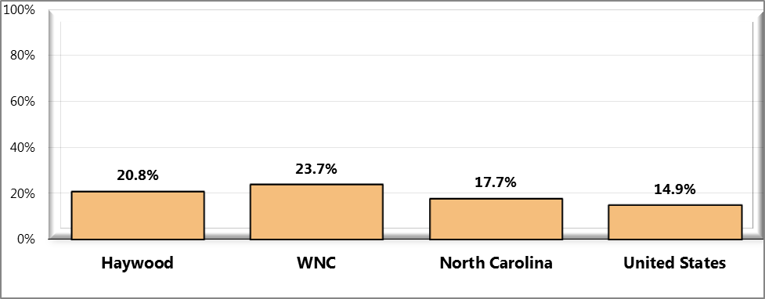

Sources: ● 2012 PRC Community Health Survey, Professional Research Consultants, Inc. [Item 125]

● Behavioral Risk Factor Surveillance System Survey Data. Atlanta, Georgia. United States Department of Health and Human Services, Centers for Disease Control and Prevention (CDC): 2010 North Carolina data.

● 2011 PRC National Health Survey, Professional Research Consultants, Inc.

● US Department of Health and Human Services.  Healthy People 2020. December 2010. http://www.healthypeople.gov [Objective AHS-1]

Notes: ● Reflects adults under the age of 65.

● Includes any type of insurance, such as traditional health insurance, prepaid plans such as HMOs, or government-sponsored coverage (e.g., Medicare, Medicaid, Indian Health Services, etc.).

## Medicaid Eligibility

Table 48 presents trend data on the number and percent of persons eligible for Medicaid for several state fiscal years. This data demonstrates that in Haywood County the number and percent of Medicaid-eligible persons rose annually every year cited in the table. The annual percent of Medicaid-eligible Haywood County residents was higher than the comparable figures for NC but lower than the figure for WNC in each year shown in the figure. With the exception of SFY2007, the mean percent of the WNC population eligible for Medicaid rose from one year to the next throughout the period cited in the table. Note that between SFY2006 and SFY2007 the number in WNC that were Medicaid-eligible rose even if the percentage did not. Further, the mean percent Medicaid-eligible in WNC exceeded the comparable percent eligible statewide for every period cited.

Table 48. Number and Percent of Population Medicaid-Eligible

(SFY2004 through SFY2008)

|  |  |  |  |  |  |  |  |  |  |  |  |  |
| --- | --- | --- | --- | --- | --- | --- | --- | --- | --- | --- | --- | --- |
| **Geography** | **SFY 2004** | | **SFY 2005** | | | **SFY 2006** | | **SFY 2007** | | | **SFY 2008** | |
| **#** | **%** | | **#** | **%** | **#** | **%** | | **#** | **%** | **#** | **%** |
|
|  |  |  | |  |  |  |  | |  |  |  |  |
| Haywood County | 10,874 | 19.48 | | 11,071 | 19.60 | 11,474 | 20.27 | | 11,580 | 20.44 | 11,722 | 20.55 |
| Regional Total | 128,727 | - | | 132,895 | - | 138,616 | - | | 139,891 | - | 142,606 | - |
| Regional Arithmetic Mean | 16,091 | 19.90 | | 16,612 | 20.21 | 17,327 | 20.75 | | 17,486 | 20.52 | 17,826 | 20.82 |
| State Total | 1,512,360 | 17.97 | | 1,563,751 | 18.31 | 1,602,645 | 18.46 | | 1,682,028 | 18.98 | 1,726,412 | 19.04 |
|  |  |  | |  |  |  |  | |  |  |  |  |

## Screening and Prevention

### 

### Diabetes

Diabetes mellitus occurs when the body cannot produce or respond appropriately to insulin. Insulin is a hormone that the body needs to absorb and use glucose (sugar) as fuel for the body’s cells. Without a properly functioning insulin signaling system, blood glucose levels become elevated and other metabolic abnormalities occur, leading to the development of serious, disabling complications. Many forms of diabetes exist; the three common types are Type 1, Type 2, and gestational diabetes.

Diabetes mellitus affects an estimated 23.6 million people in the United States and is the 7th leading cause of death. Diabetes mellitus:

* Lowers life expectancy by up to 15 years.
* Increases the risk of heart disease by 2 to 4 times.
* Is the leading cause of kidney failure, lower limb amputations, and adult-onset blindness.

People from minority populations are more frequently affected by type 2 diabetes. Minority groups constitute 25% of all adult patients with diabetes in the US and represent the majority of children and adolescents with type 2 diabetes. Lifestyle change has been proven effective in preventing or delaying the onset of type 2 diabetes in high-risk individuals (DHHS, 2010).

Figure 72. Tested for Diabetes in the Past Three Years (WNC Healthy Impact Survey)

(Among Adults Who Have Not Been Diagnosed With Diabetes)

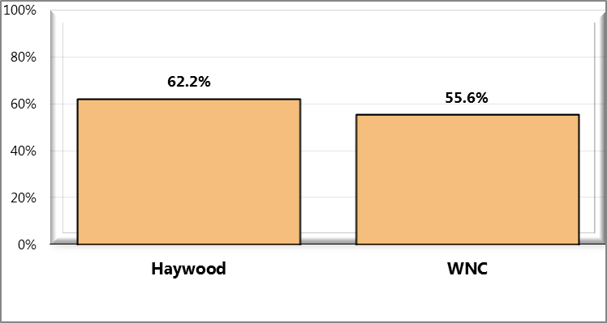

Sources: ● 2012 PRC Community Health Survey, Professional Research Consultants, Inc. [Item 19]

Notes: ● Asked of respondents who have never been diagnosed with diabetes; also includes women who have

only been diagnosed when pregnant.

Figure 73. Prevalence of Diabetes (Ever Diagnosed)

(WNC Healthy Impact Survey)

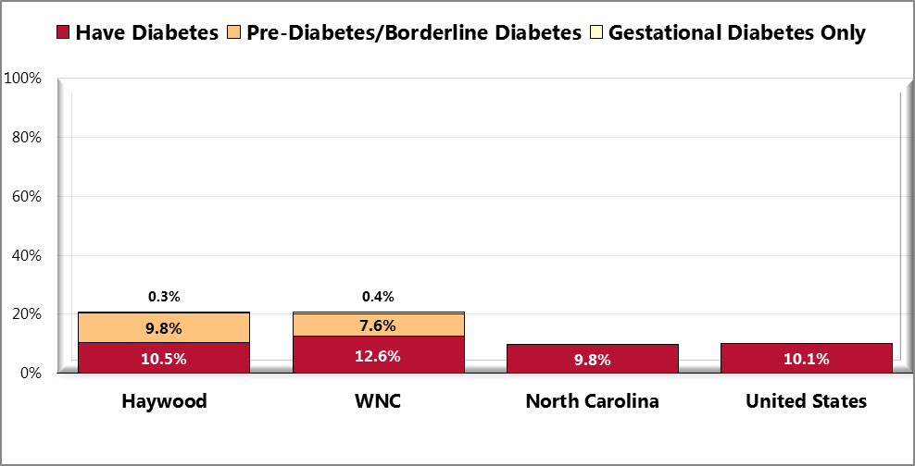

Sources: ● 2012 PRC Community Health Survey, Professional Research Consultants, Inc. [Item 78]

● 2011 PRC National Health Survey, Professional Research Consultants, Inc.

● Behavioral Risk Factor Surveillance System Survey Data. Atlanta, Georgia. United States Department of Health and Human Services, Centers for Disease Control and Prevention (CDC): 2010 North Carolina data.

Notes: ● Asked of all respondents.

● Local and national data exclude gestation diabetes (occurring only during pregnancy).

Figure 74. Taking Action to Control Diabetes or Prediabetes (WNC Healthy Impact Survey)

(Among Adults Diagnosed with Diabetes or Prediabetes/Borderline Diabetes)

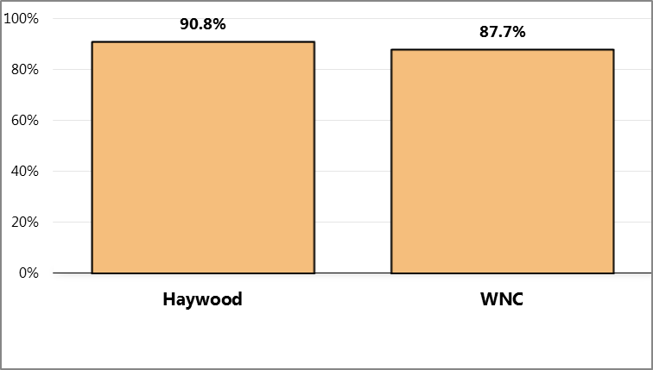

Sources: ● 2012 PRC Community Health Survey, Professional Research Consultants, Inc. [Item 21]

Notes: ● Asked of respondents who have been diagnosed with diabetes or prediabetes/borderline diabetes.

● In this case, the term “action” refers to taking natural or conventional medicines or supplements, diet

modification, or exercising.

### Hypertension

Controlling risk factors for heart disease and stroke remains a challenge. High blood pressure is still a major contributor to the national epidemic of cardiovascular disease. High blood pressure affects approximately 1 in 3 adults in the United States, and more than half of Americans with high blood pressure do not have it under control (DHHS, 2010).

Figure 75. Have Had Blood Pressure Checked in the Past Two Years

(WNC Healthy Impact Survey)

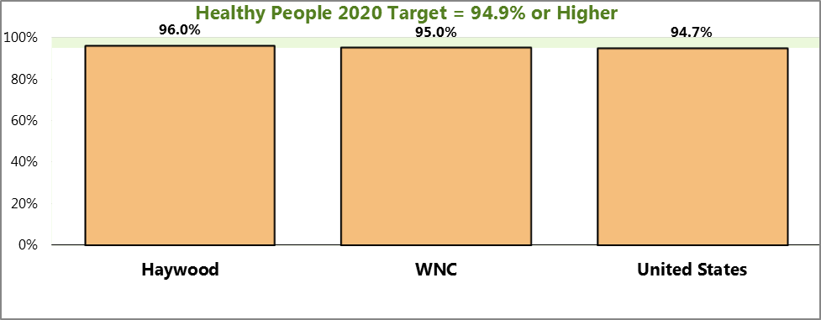

Sources: ● 2012 PRC Community Health Survey, Professional Research Consultants, Inc. [Item 24]

● 2011 PRC National Health Survey, Professional Research Consultants, Inc.

● US Department of Health and Human Services.  Healthy People 2020. December 2010. http://www.healthypeople.gov [Objective HDS-4]

Notes: ● Asked of all respondents.

Figure 76. Prevalence of High Blood Pressure (WNC Healthy Impact Survey)

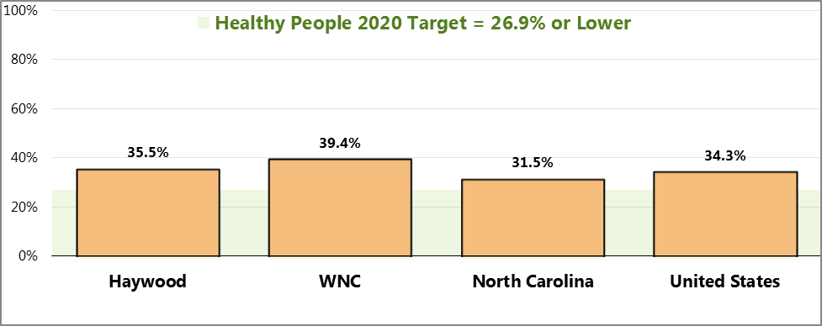

Sources: ● 2012 PRC Community Health Survey, Professional Research Consultants, Inc. [Item 76]

● Behavioral Risk Factor Surveillance System Survey Data. Atlanta, Georgia. United States Department of Health and Human Services, Centers for Disease Control and Prevention (CDC): 2009 North Carolina data.

● 2011 PRC National Health Survey, Professional Research Consultants, Inc.

● US Department of Health and Human Services.  Healthy People 2020. December 2010. http://www.healthypeople.gov [Objective HDS-5.1]

Notes: ● Asked of all respondents.

Figure 77. Taking Action to Control Hypertension (WNC Healthy Impact Survey)

(Among Adults with High Blood Pressure)

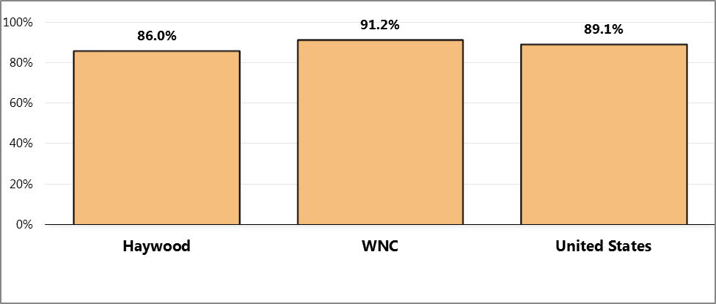

Sources: ● 2012 PRC Community Health Survey, Professional Research Consultants, Inc. [Item 23]

● 2011 PRC National Health Survey, Professional Research Consultants, Inc.

Notes: ● Asked of respondents who have been diagnosed with high blood pressure.

● In this case, the term “action” refers to medication, change in diet, and/or exercise.

### Cholesterol

Cholesterol is also a major contributor to the national epidemic of cardiovascular disease. Survey respondents were asked a series of questions about their blood cholesterol levels.

Figure 78. Have Had Blood Cholesterol Levels

Checked in the Past Five Years (WNC Healthy Impact Survey)

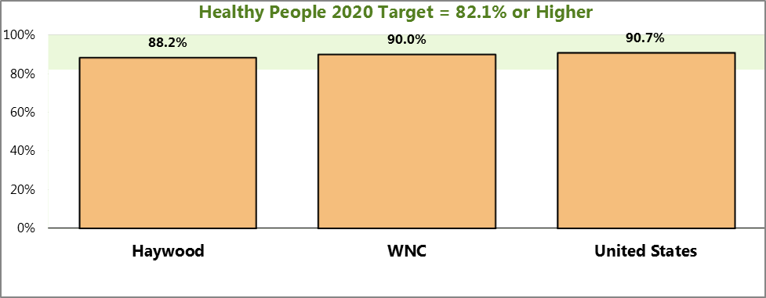

Sources: ● 2012 PRC Community Health Survey, Professional Research Consultants, Inc. [Item 27]

● 2011 PRC National Health Survey, Professional Research Consultants, Inc.

● US Department of Health and Human Services.  Healthy People 2020. December 2010. http://www.healthypeople.gov [Objective HDS-6]

Notes: ● Asked of all respondents.

Figure 79. Prevalence of High Blood Cholesterol (WNC Healthy Impact Survey)

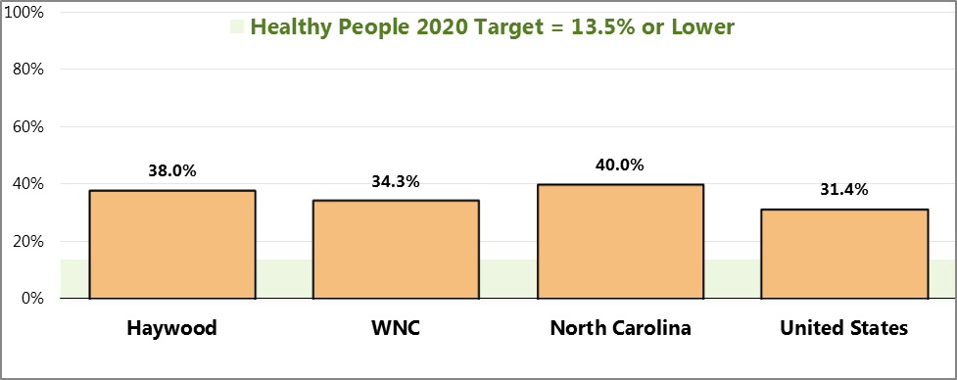

Sources: ● 2012 PRC Community Health Survey, Professional Research Consultants, Inc. [Item 77]

● Behavioral Risk Factor Surveillance System Survey Data. Atlanta, Georgia. United States Department of Health and Human Services, Centers for Disease Control and Prevention (CDC): 2009 North Carolina data.

● 2011 PRC National Health Survey, Professional Research Consultants, Inc.

● US Department of Health and Human Services.  Healthy People 2020. December 2010. http://www.healthypeople.gov [Objective HDS-7]

Notes: ● Asked of all respondents.

Figure 80. Taking Action to Control High Blood Cholesterol (WNC Healthy Impact Survey)

(Among Adults With High Blood Pressure)

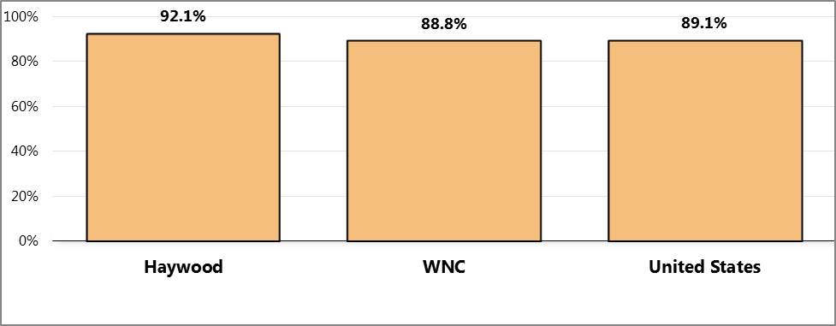

Sources: ● 2012 PRC Community Health Survey, Professional Research Consultants, Inc. [Item 26]

● 2011 PRC National Health Survey, Professional Research Consultants, Inc.

Notes: ● Asked of respondents who have been diagnosed with high blood cholesterol.

● In this case, the term “action” refers to medication, change in diet, and/or exercise.

## Healthcare Utilization

### Routine Medical Care

Improving health care services depends in part on ensuring that people have a usual and ongoing source of care. People with a usual source of care have better health outcomes and fewer disparities and costs. Having a primary care provider (PCP) as the usual source of care is especially important. PCPs can develop meaningful and sustained relationships with patients and provide integrated services while practicing in the context of family and community. Having a usual PCP is associated with:

* Greater patient trust in the provider
* Good patient-provider communication
* Increased likelihood that patients will receive appropriate care

Improving health care services includes increasing access to and use of evidence-based preventive services. Clinical preventive services are services that: **prevent** illness by detecting early warning signs or symptoms before they develop into a disease (primary prevention); or **detect** a disease at an earlier, and often more treatable, stage (secondary prevention) (DHHS, 2010).

Figure 81. Have One Person Thought of as

Respondent’s Personal Doctor or Health Care Provider

(WNC Healthy Impact Survey)

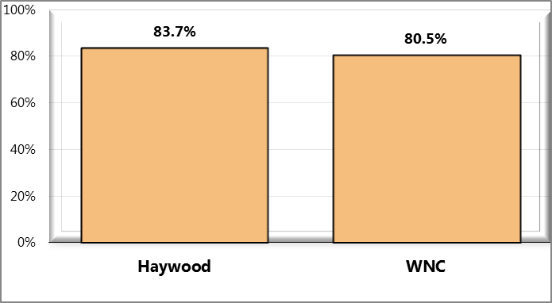

Sources: ● 2012 PRC Community Health Survey, Professional Research Consultants, Inc. [Item 16]

Notes: ● Asked of all respondents.

Figure 82. Length of Time Since Last Routine Check-Up

(WNC Healthy Impact Survey)

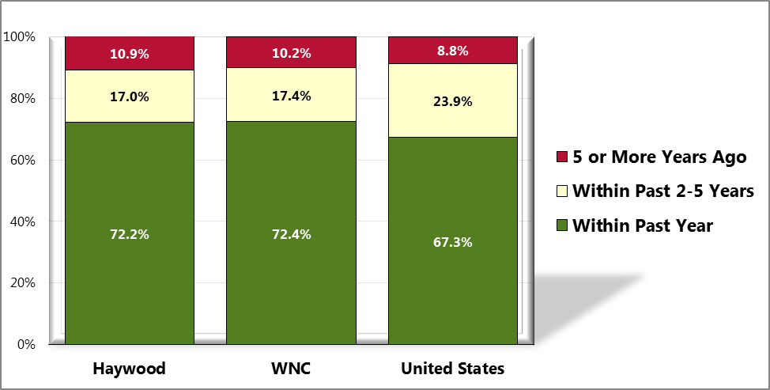

Sources: ● 2012 PRC Community Health Survey, Professional Research Consultants, Inc. [Item 15]

● 2011 PRC National Health Survey, Professional Research Consultants, Inc.

Notes: ● Asked of all respondents.

### Emergency Department Utilization

According to data in Table 49, the diagnoses associated with the highest frequency of emergency department visits in Haywood County in 2010 were chest pain/ischemic heart disease (15.65% of all ED visits), followed by psychiatric disorders (15.61%) and lower respiratory disorders (14.06%). On the regional level, the diagnoses associated with the highest frequency of ED visits were chest pain/ischemic heart disease (11.83% of all ED visits), followed by psychiatric disorders (10.98%) and lower respiratory disorders (9.48%)

Table 49. North Carolina Emergency Department Visits, NC DETECT Data

(2010)

|  |  |  |  |
| --- | --- | --- | --- |
| **Diagnosis** | **Haywood County** | | **WNC Mean** |
| **#** | **%** | **%** |
|  |  |  |  |
| Chest pain/ischemic heart disease | 3,917 | 15.65 | 11.83 |
| Heart failure | 976 | 3.90 | 2.58 |
| Cardiac arrest | 47 | 0.19 | 0.14 |
| Lower respiratory disorders | 3,519 | 14.06 | 9.48 |
| Diabetes | 2,906 | 11.61 | 8.80 |
| Neoplasms | 475 | 1.90 | 1.57 |
| Dental problems | 556 | 2.22 | 1.85 |
| Stroke/TIA | 249 | 0.99 | 0.62 |
| Traumatic brain injury | 130 | 0.52 | 0.30 |
| Psychiatric disorders | 3,908 | 15.61 | 10.98 |
| Substance abuse | 1,016 | 4.06 | 2.99 |
| Total ED Visits | 25,034 | n/a | n/a |
|  |  |  |  |

* % represents percent of total ED visits

Note: for the full description of the disease group diagnosis codes included in each diagnosis line, see the *Data Workbook*.

Table 50 presents a summary of the major first-listed emergency department diagnoses for the WNC region according to DRG code. According to this data, the most common first-listed diagnosis codes in emergency departments across the region are abdominal pain (2.37% of all ED visits) and back pain, sprains of the lumbar spice, and sciatica (also 2.37%). It would appear that some of these cases could qualify for diversion to other health care providers *if* they were present in the community.

Table 50. Most Common First-Listed Diagnosis Codes in Emergency Departments, WNC

NC DETECT Data

2010

|  |  |  |  |
| --- | --- | --- | --- |
| **Diagnosis** | **Diagnosis Codes** | **# ED Visits** | **% of Total ED Visits** |
|
|
|  |  |  |  |
| Abdominal pain | 789.0, 789.00, 789.03, 789.09 | 7,597 | 2.37 |
| Back pain, sprains of lumbar spine, sciatica | 724.2, 724.3, 724.5, 847.2 | 7,590 | 2.37 |
| Essential hypertension | 401.9 | 7,490 | 2.34 |
| Nausea with vomiting or vomiting alone | 787.01, 787.03 | 5,873 | 1.83 |
| Headache, Migraine, unspecified | 784.0, 346.9 | 5,584 | 1.74 |
| Acute URI/Pharyngitis, Streptococcal sore throat | 034.0, 465.9, 462 | 5,458 | 1.70 |
| Cough, Bronchitis | 786.2, 466.0, 490 | 4,703 | 1.47 |
| Dental caries, periapical abscess, tooth structure, disorders | 521.00, 522.5, 525.9 | 4,210 | 1.31 |
| UTI | 599 | 4,027 | 1.26 |
| Fever, Unknown origin | 780.6, 780.60 | 3,285 | 1.03 |
| Asthma, unspecified | 493.90, 439.92 | 2,823 | 0.88 |
| Neck sprains/stains | 723.1, 847.0 | 2,728 | 0.85 |
| Pain in joint | 719.41, 719.45, 719.46 | 2,609 | 0.81 |
| Pain in limb | 729.5 | 2,486 | 0.78 |
| Chest pain | 786.5, 786.50, 786.59 | 2,186 | 0.68 |
| Otitis media | 382.9 | 2,083 | 0.65 |
| Pneumonia | 486 | 1,934 | 0.60 |
| Open wound of hand or finger without complication | 882.0, 883.0 | 1,644 | 0.51 |
| Contusion of face, scalp, and neck except eyes | 920 | 1,622 | 0.51 |
| Syncope and collapse | 780.2 | 1,552 | 0.48 |
| TOTAL ED VISITS |  | 320,429 |  |

### Inpatient Hospitalizations

Table 51 lists the diagnostic categories accounting for the most cases of inpatient hospitalization for 2010. The source data is based on a patient’s county of residence, so the WNC totals presented in the table represent the sum of hospitalizations from each of the 16 WNC counties.

According to data in Table 51, the diagnosis resulting in the highest number of cases of hospitalization in 2010 among Haywood County residents was cardiovascular and circulatory diseases (including heart disease and cerebrovascular disease), which accounted for 1,360 hospitalizations. The next highest number of hospitalizations was for respiratory diseases, including pneumonia and influenza and chronic obstructive pulmonary disease (783 cases), followed by digestive system diseases, including chronic liver disease and cirrhosis (772 cases).

Table 51. Inpatient Hospital Utilization by Haywood County Residents,

by Principal Diagnoses

Excluding Newborns and Discharges from Out-of-State Hospitals

(2011)

|  |  |  |  |
| --- | --- | --- | --- |
| **Diagnostic Category** | **Total # Cases** | | |
| **Haywood County** | **Region** | **North Carolina** |
|
|  |  |  |  |
| INFECTIOUS & PARASITIC DISEASES | 242 | 2,741 | 41,705 |
| -- Septicemia | 143 | 1,604 | 27,412 |
| -- AIDS | n/a | 41 | 1,456 |
| MALIGNANT NEOPLASMS | 249 | 2,599 | 31,225 |
| -- Colon, Rectum, Anus | 23 | 324 | 3,770 |
| -- Trachea, Bronchus, Lung | 28 | 346 | 4,541 |
| -- Female Breast | 19 | 157 | 1,498 |
| -- Prostate | 19 | 192 | 2,505 |
| BENIGN, UNCERTAIN & OTHER NEOPLASMS | 48 | 650 | 8,948 |
| ENDOCRINE, METABOLIC & NUTRITIONAL DISEASES | 184 | 2,905 | 40,208 |
| -- Diabetes | 63 | 1,240 | 18,101 |
| BLOOD & HEMOPOETIC TISSUE DISEASES | 64 | 770 | 14,011 |
| NERVOUS SYSTEM & SENSE ORGAN DISEASES | 136 | 1,597 | 19,315 |
| CARDIOVASCULAR & CIRCULATORY DISEASES | 1,360 | 12,961 | 162,327 |
| -- Heart Disease | 944 | 9,006 | 108,060 |
| -- Cerebrovascular Disease | 213 | 2,259 | 29,429 |
| RESPIRATORY DISEASES | 783 | 8,683 | 93,891 |
| -- Pneumonia/Influenza | 303 | 3,089 | 29,852 |
| -- Chronic Obstructive Pulmonary Disease | 207 | 2,557 | 30,832 |
| DIGESTIVE SYSTEM DISEASES | 772 | 8,527 | 95,068 |
| -- Chronic Liver Disease/Cirrhosis | 12 | 178 | 2,361 |
| GENITOURINARY DISEASES | 383 | 4,123 | 45,978 |
| -- Nephritis, Nephrosis, Nephrotic Synd. | 70 | 1,036 | 14,368 |
| PREGNANCY & CHILDBIRTH | 569 | 7,921 | 125,271 |
| SKIN & SUBCUTANEOUS TISSUE DISEASES | 122 | 1,287 | 17,734 |
| MUSCULOSKELETAL SYSTEM DISEASES | 608 | 5,950 | 58,753 |
| -- Arthropathies and Related Disorders | 350 | 3,155 | 30,683 |
| CONGENITAL MALFORMATIONS | 47 | 294 | 3,318 |
| PERINATAL COMPLICATIONS | 17 | 198 | 4,035 |
| SYMPTOMS, SIGNS & ILL-DEFINED CONDITIONS | 485 | 3,916 | 48,299 |
| INJURIES & POISONING | 666 | 7,474 | 78,637 |
| OTHER DIAGNOSES (INCL. MENTAL DISORDERS) | 410 | 7,329 | 84,657 |
| ALL CONDITIONS | 7,145 | 79,925 | 973,380 |
|  |  |  |  |

Source: *Inpatient Hospital Utilization and Charges by Principal Diagnosis, and County of Residence, North Carolina, 2010 (Excluding Newborns & Discharges from Out of State Hospitals)* Retrieved June 20, 2012, from North Carolina State Center for Health Statistics (NC SCHS), 2012 County Health Data Book website: http://www.schs.state.nc.us/schs/data/databook/

## Dental Services

The significant improvement in the oral health of Americans over the past 50 years is a public health success story. Most of the gains are a result of effective prevention and treatment efforts. One major success is community water fluoridation, which now benefits about 7 out of 10 Americans who get water through public water systems. However, some Americans do not have access to preventive programs. People who have the least access to preventive services and dental treatment have greater rates of oral diseases. A person’s ability to access oral healthcare is associated with factors such as education level, income, race, and ethnicity.

Oral health is essential to overall health. Good oral health improves a person’s ability to speak, smile, smell, taste, touch, chew, swallow, and make facial expressions to show feelings and emotions. However, oral diseases, from cavities to oral cancer, cause pain and disability for many Americans. Good self-care, such as brushing with fluoride toothpaste, daily flossing, and professional treatment, is key to good oral health. Health behaviors that can lead to poor oral health include:

* Tobacco use
* Excessive alcohol use
* Poor dietary choices

There are also social determinants that affect oral health. In general, people with lower levels of education and income, and people from specific racial/ethnic groups, have higher rates of disease. People with disabilities and other health conditions, like diabetes, are more likely to have poor oral health (DHHS, 2010).

### Utilization of Dental Services by the Medicaid Population

Table 52 presents data on the percent of the Medicaid population eligible for dental care that utilizes it. This data represents the Medicaid population of all ages, but split into under-age-21 and age-21-and over-categories. In all three jurisdictions the Medicaid population under age 21 appears to be more likely to utilize dental services than the population age 21 and older. The figures for Haywood County are higher than in the other jurisdictions.

Table 52. Medicaid Recipients Receiving Dental Services, All Ages (2010)

|  |  |  |  |  |  |  |  |
| --- | --- | --- | --- | --- | --- | --- | --- |
| **Geography** | **Medicaid Recipients Utilizing Dental Services (by Ages Group)** | | | | | | |
| **<21 Years Old** | | | **21+ Years Old** | | | |
| **# Eligible for Services** | **# Receiving Services** | **% Eligibles Receiving Services** | **# Eligible for Services** | **# Receiving Services** | **% Eligibles Receiving Services** |
|  |  |  |  |  |  |  |
| Haywood County | 6,665 | 3,851 | 57.8 | 5,448 | 1,823 | 33.5 |
| Regional Total | 85,652 | 42,135 | 49.2 | 62,817 | 18,536 | 29.5 |
| State Total | 1,113,692 | 541,210 | 48.6 | 679,139 | 214,786 | 31.6 |
|  |  |  |  |  |  |  |

Table 53, focusing only on children ages 1-5, helps in understanding why utilization in the under-21 age group is so high. In this youngest age group, half or more of the eligible population received dental services in all three jurisdictions.

Table 53. Medicaid-Recipients Receiving Dental Services, Ages 1-5 (2010)

|  |  |  |  |
| --- | --- | --- | --- |
| **Geography** | **Children (aged 1-5) Enrolled in Medicaid Who Received Any Dental Service In the Previous 12 Months)** | | |
|
| **# Eligible for Services\*** | **# Receiving Services\*\*** | **% Eligibles Receiving Services** |
|  |  |  |  |
| Haywood County | 1,970 | 1,275 | 64.7 |
| Regional Total | 26,820 | 14,407 | 53.7 |
| State Total | n/a | n/a | 51.7 |
|  |  |  |  |

### Dental Screening Results among Children

Table 54 presents 2009 dental screening results for kindergarteners. While the screening process captures other data, this data covers only the average number of decayed, missing or filled teeth. The average number of decayed, missing or filled teeth discovered among kindergarteners screened in Haywood County (1.48 per child) was 32% lower than the mean percentage for WNC (2.18) and 1% lower than the state average (1.50).

Table 54. Dental Screening Results, Kindergarteners (2009)

|  |  |
| --- | --- |
| **Geography** | **Average # Decayed, Missing or Filled Teeth** |
|  |  |
| Haywood County | 1.48 |
| Regional Arithmetic Mean | 2.18 |
| State Total | 1.50 |
|  |  |

### Utilization of Preventive Dental Care

Survey respondents were asked, “About how long has it been since you last visited a dentist or a dental clinic for any reason? This includes visits to dental specialists, such as orthodontists.”

Figure 83. Have Visited a Dentist or Dental Clinic Within the Past Year

(WNC Healthy Impact Survey)

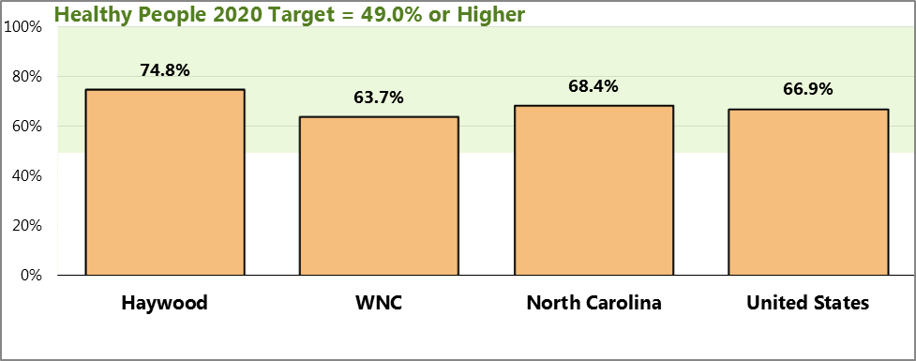

Sources: ● 2012 PRC Community Health Survey, Professional Research Consultants, Inc. [Item 17]

● 2011 PRC National Health Survey, Professional Research Consultants, Inc.

● US Department of Health and Human Services.  Healthy People 2020. December 2010. http://www.healthypeople.gov [Objective OH-7]

● Behavioral Risk Factor Surveillance System Survey Data. Atlanta, Georgia. United States Department of Health and Human Services, Centers for Disease Control and Prevention (CDC): 2010 North Carolina data.

Notes: ● Asked of all respondents.

## Mental Health

Mental health is a state of successful performance of mental function, resulting in productive activities, fulfilling relationships with other people, and the ability to adapt to change and to cope with challenges. Mental health is essential to personal well-being, family and interpersonal relationships, and the ability to contribute to community or society. Mental disorders are health conditions that are characterized by alterations in thinking, mood, and/or behavior that are associated with distress and/or impaired functioning. Mental disorders contribute to a host of problems that may include disability, pain, or death. Mental illness is the term that refers collectively to all diagnosable mental disorders.

Mental disorders are among the most common causes of disability. The resulting disease burden of mental illness is among the highest of all diseases. According to the national Institute of Mental Health (NIMH), in any given year, an estimated 13 million American adults (approximately 1 in 17) have a seriously debilitating mental illness. Mental health disorders are the leading cause of disability in the United States and Canada, accounting for 25% of all years of life lost to disability and premature mortality. Moreover, suicide is the 11th leading cause of death in the United States, accounting for the deaths of approximately 30,000 Americans each year.

Mental health and physical health are closely connected. Mental health plays a major role in people’s ability to maintain good physical health. Mental illnesses, such as depression and anxiety, affect people’s ability to participate in health-promoting behaviors. In turn, problems with physical health, such as chronic diseases, can have a serious impact on mental health and decrease a person’s ability to participate in treatment and recovery.

In addition to advancements in the prevention of mental disorders, there continues to be steady progress in treating mental disorders as new drugs and stronger evidence-based outcomes become available (DHHS, 2010).

The unit of NC government responsible for overseeing mental health services is the Division of Mental Health, Developmental Disabilities and Substance Abuse Services (DMH/DD/SAS). The NC mental health system is built on a system of Local Management Entities (LMEs)—area authorities or county programs—responsible for managing, coordinating, facilitating and monitoring the provision of MH/DD/SAS services in the catchment area served. There are two LMEs serving the population in WNC: Smoky Mountain Center and Western Highlands Network (NC Division of Mental Health, August 2012).

### Mental Health Service Utilization Trends

Table 55 presents figures on the numbers of persons receiving services in Area Mental Health Programs in 2006 through 2010. No clear pattern of service utilization is apparent from this data in any of the three jurisdictions. It should be noted that the mental health system in NC is in some disarray, as reform of the recent past is being reconsidered.

Table 55. Persons Served in Area Mental Health Programs (2006-2010)

|  |  |  |  |  |  |
| --- | --- | --- | --- | --- | --- |
| **Geography** | **# Persons Served in Area Mental Health Programs** | | | | |
| **2006** | **2007** | **2008** | **2009** | **2010** |
|
|  |  |  |  |  |  |
| Haywood County | 3,058 | 3,656 | 4,059 | 2,649 | 2,890 |
| Regional Total | 30,952 | 31,271 | 28,380 | 24,527 | 28,453 |
| State Total | 322,397 | 315,338 | 306,907 | 309,155 | 332,796 |
|  |  |  |  |  |  |

Table 56 presents figures on the numbers of persons receiving services in NC state alcohol and drug treatment centers. Although the pattern of increase is not straight-line in both cases, it appears that increasing numbers of persons in Haywood County and WNC have received services from NC state alcohol and drug treatment centers. Noteworthy at the regional level was a 23% increase in persons being served between 2009 and 2010. In Haywood County there was an annual increase in the number of persons served, with a net increase of 78% between 2006 and 2010.

Table 56. Persons Served in NC State Alcohol and Drug Treatment Centers (2006-2010)

|  |  |  |  |  |  |
| --- | --- | --- | --- | --- | --- |
| **Geography** | **# Persons Served in NC Alcohol and Drug Treatment Centers** | | | | |
| **2006** | **2007** | **2008** | **2009** | **2010** |
|
|  |  |  |  |  |  |
| Haywood County | 40 | 44 | 65 | 60 | 71 |
| Regional Total | 664 | 604 | 774 | 751 | 921 |
| State Total | 4,003 | 3,733 | 4284 | 4,812 | 4,483 |
|  |  |  |  |  |  |

Table 57 presents figures on the numbers of persons receiving services in NC state psychiatric hospitals. The number of persons in Haywood County utilizing these services fell every year from 2006 to 2010, decreasing by 79% over that period. The number of persons in WNC receiving these services also fell. The number of persons in WNC utilizing state psychiatric hospital services in 2010 (564) was 63% lower than the number utilizing services in 2006 (1,509). The decrease in persons receiving services likely was a reflection of a decreasing availability of state services, rather than a decreasing need for services.

Table 57. Persons Served in NC State Psychiatric Hospitals (2006-2010)

|  |  |  |  |  |  |
| --- | --- | --- | --- | --- | --- |
| **Geography** | **# Persons Served in NC State Psychiatric Hospitals** | | | | |
| **2006** | **2007** | **2008** | **2009** | **2010** |
|
|  |  |  |  |  |  |
| Haywood County | 112 | 101 | 84 | 64 | 24 |
| Regional Total | 1,509 | 1,529 | 1190 | 818 | 564 |
| State Total | 18,292 | 18,498 | 14643 | 9,643 | 7,188 |
|  |  |  |  |  |  |

### Poor Mental Health Days

Survey respondents were asked, “Now thinking about your mental health, which includes stress, depression, and problems with emotions, for how many of the past 30 days was your mental health not good?”

Figure 84. Number of Days in the Past 30 Days on

Which Mental Health Was Not Good

(WNC Healthy Impact Survey)

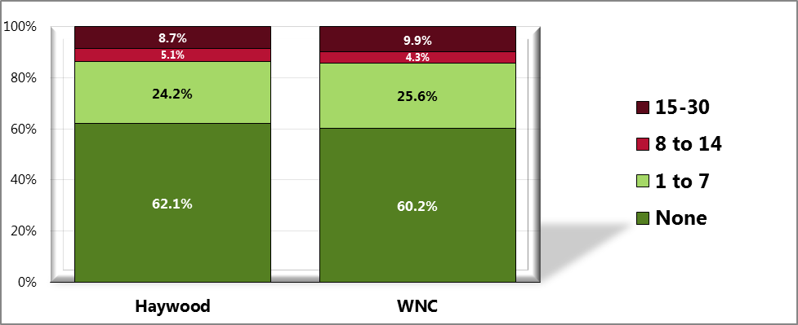

Sources: ● 2012 PRC Community Health Survey, Professional Research Consultants, Inc. [Item 64]

Notes: ● Asked of all respondents.

Figure 85. Average Number of the Past 30 Days

on Which Mental Health Was Not Good (WNC Healthy Impact Survey)

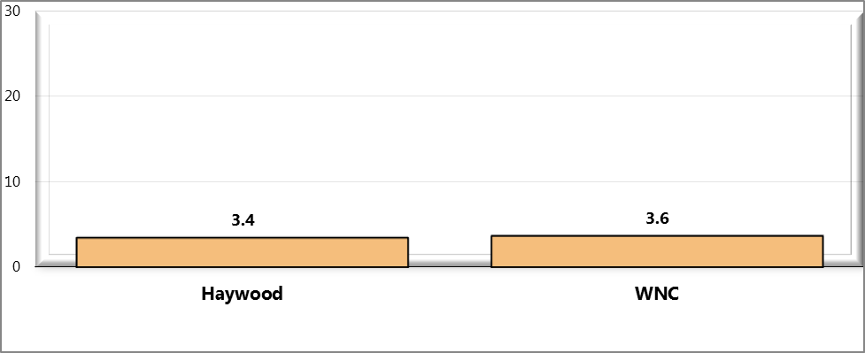

Sources: ● 2012 PRC Community Health Survey, Professional Research Consultants, Inc. [Item 64]

Notes: ● Asked of all respondents.

### Access to Mental Health Services

Survey respondents were asked if they had a time in the past year when they needed mental health care or counseling, but did not get it at that time. Those who responded, “yes,” were asked to name the main reason they did not get mental health care or counseling. Due to small county-level sample sizes, responses to the latter question are displayed below for the region.

Figure 86. Had a Time in the Past Year When Mental Health

Care or Counseling Was Needed, But Was Unable to Get It

(WNC Healthy Impact Survey)

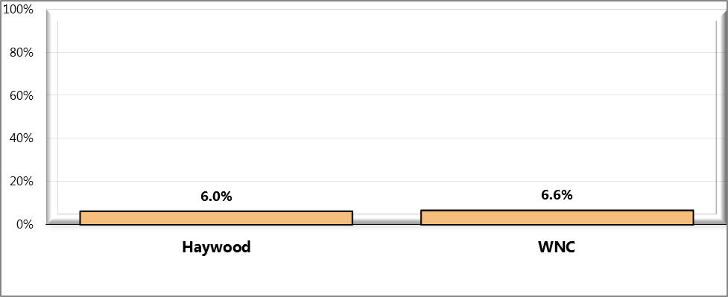

Sources: ● 2012 PRC Community Health Survey, Professional Research Consultants, Inc. [Item 65]

Notes: ● Asked of all respondents.

Figure 87. Primary Reason for Inability to Access

Mental Health Services (WNC Healthy Impact Survey)

(Adults Unable to Get Needed Mental Health Care in the Past Year)

(Western North Carolina, 2012)

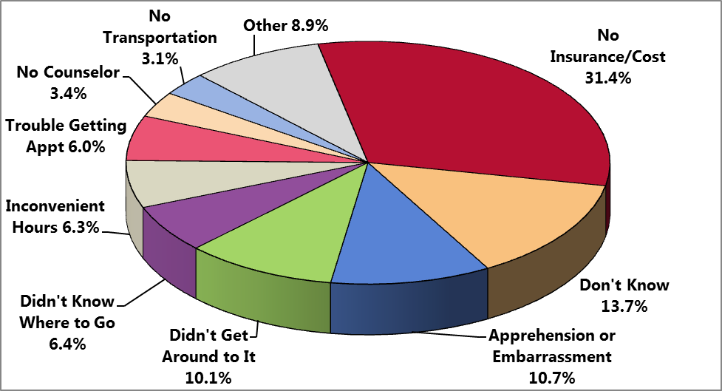

Sources: ● 2012 PRC Community Health Survey, Professional Research Consultants, Inc. [Item 66]

Notes: ● Asked of those respondents who were unable to get needed mental health care in the past year.

## Advance Directives

An Advance Directive is a set of directions given about the medical care a person wants if he/she ever loses the ability to make decisions for him/herself. Formal Advance Directives include Living Wills and Healthcare Powers of Attorney. Survey respondents were asked whether they have any completed Advance Directive documents, and if so, if they have communicated these health care decisions to their family or doctor.

Figure 88. Have Completed Advance Directive Documents

(WNC Healthy Impact Survey)

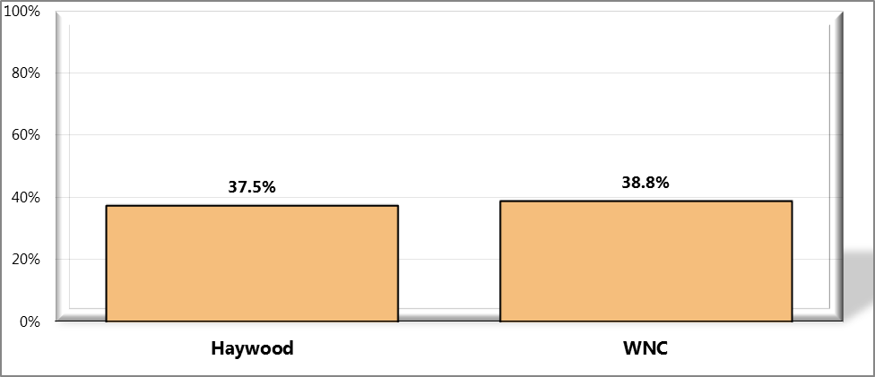

Sources: ● 2012 PRC Community Health Survey, Professional Research Consultants, Inc. [Item 34]

Notes: ● Asked of all respondents.

Figure 89. Have Communicated Health Care Decisions to Family or Doctor

(WNC Healthy Impact Survey)

(Among Respondents with Advance Directive Documents)

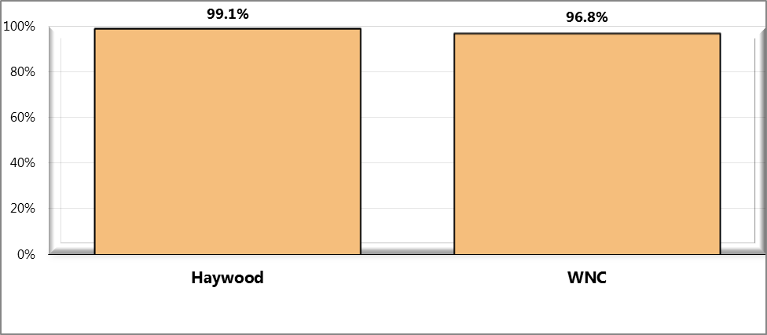

Sources: ● 2012 PRC Community Health Survey, Professional Research Consultants, Inc. [Item 35]

Notes: ● Asked of respondents with completed advance directive documents.

## Care-giving

People may provide regular care or assistance to a friend or family member who has a health problem, long-term illness, or disability. Respondents were asked, “During the past month, did you provide any such care or assistance to a friend or family member?” Those who answered, “yes,” were asked for the age, primary health issue, and the primary type of assistance needed by the person for whom the respondent provides care.

Figure 90. Provide Regular Care or Assistance to a

Friend/Family Member Who Has a Health Problem or Disability

(WNC Healthy Impact Survey)

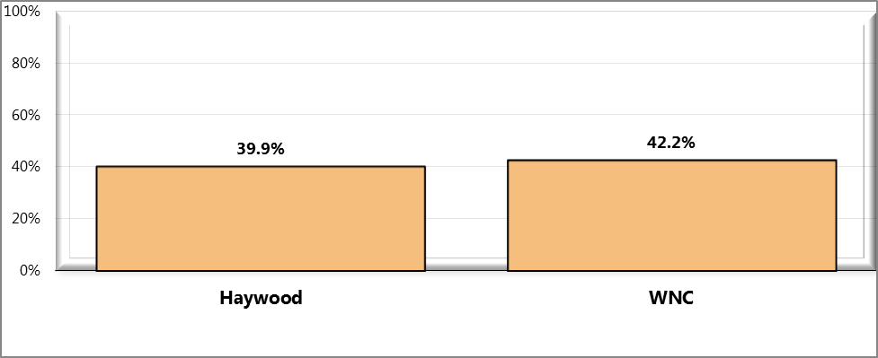

Sources: ● 2012 PRC Community Health Survey, Professional Research Consultants, Inc. [Item 69]

Notes: ● Asked of all respondents.

Figure 91. Age of Person for Whom Respondent Provides Care

(WNC Healthy Impact Survey)

(Among Respondents Acting as a Caregiver for a Friend/Family Member)

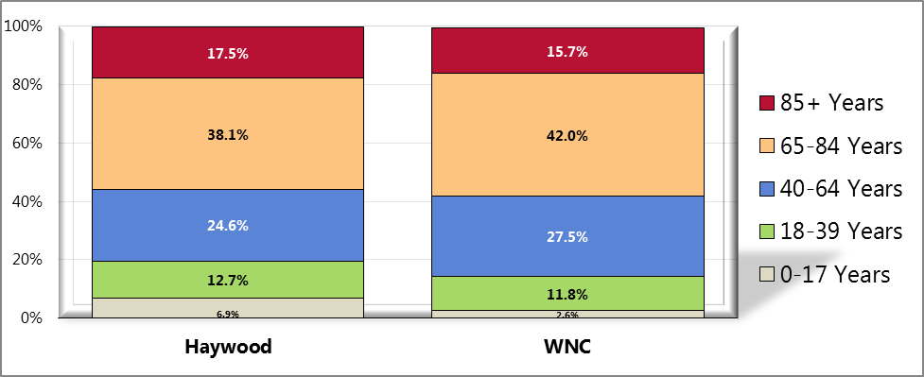

Sources: ● 2012 PRC Community Health Survey, Professional Research Consultants, Inc. [Item 70]

Notes: ● Asked of respondents acting as a caregiver for a friend or family member.

Table 58. Primary Health Issue of Person for Whom

Respondent Provides Care (WNC Healthy Impact Survey)

(Among Respondents Acting as a Caregiver for a Friend/Family Member)



Sources: ● 2012 PRC Community Health Survey, Professional Research Consultants, Inc. [Item 71]

Notes: ● Asked of respondents acting as a caregiver for a friend or family member.

Table 59. Primary Type of Assistance Needed by

Person for Whom Respondent Provides Care (WNC Healthy Impact Survey)

(Among Respondents Acting as a Caregiver for a Friend/Family Member)



Sources: ● 2012 PRC Community Health Survey, Professional Research Consultants, Inc. [Item 72]

Notes: ● Asked of respondents acting as a caregiver for a friend or family member.

# Chapter 6 – Physical Environment

## Air Quality

### Outdoor Air Quality

Nationally, outdoor air quality monitoring is the responsibility of the Environmental Protection Agency (EPA); most of the following information and data originate with that agency. In NC, the agency responsible for monitoring air quality is the Division of Air Quality (DAQ) in the NC Department of Environment and Natural Resources (NC DENR).

The EPA categorizes outdoor air pollutants as “criteria air pollutants” (CAPs) and “hazardous air pollutants” (HAPs). Criteria air pollutants (CAPS), which are covered in this report, are six chemicals that can injure human health, harm the environment, or cause property damage: carbon monoxide, lead, nitrogen oxides, particulate matter, ozone, and sulfur dioxide. The EPA has established National Ambient Air Quality Standards (NAAQS) that define the maximum legally allowable concentration for each CAP, above which human health may suffer adverse effects (US Environmental Protection Agency, 2012).

The impact of CAPs in the environment is described on the basis of emissions, exposure, and health risks. A useful measure that combines these three parameters is the *Air Quality Index* (AQI).

The AQI is an information tool to advise the public. The AQI describes the general health effects associated with different pollution levels, and public AQI alerts (often heard as part of local weather reports) include precautionary steps that may be necessary for certain segments of the population when air pollution levels rise into the unhealthy range. The AQI measures concentrations of five of the six criteria air pollutants and converts the measures to a number on a scale of 0-500, with 100 representing the NAAQS standard. An AQI level in excess of 100 on a given day means that a pollutant is in the unhealthy range that day; an AQI level at or below 100 means a pollutant is in the “satisfactory” range (AIRNow, 2011). Table 60 defines the AQI levels.

Table 60. General Health Effects and Cautionary Statements, Air Quality Index

| **Index Value** | **Descriptor** | **Color Code** | **Meaning** |
| --- | --- | --- | --- |
| Up to 50 | Good | Green | Air quality is satisfactory, and air pollution poses little or no risk. |
| 51 to 100 | Moderate | Yellow | Air quality is acceptable; however, for some pollutants there may be a moderate heath concern for a very small number of people who are unusually sensitive to air pollution. |
| 101 to 150 | Unhealthy for sensitive groups | Orange | Members of sensitive groups may experience health effects. The general public is not likely to be affected. |
| 151 to 200 | Unhealthy | Red | Everyone may begin to experience health effects; members of sensitive groups may experience more serious health effects. |
| 201-300 | Very unhealthy | Purple | Health alert: everyone may experience more serious health effects. |
| 301-500 | Hazardous | Maroon | Health warnings of emergency conditions. The entire population is more likely to be affected. |

Source: AIRNow, Air Quality Index (AQI) – A Guide to Air Quality and Your Health; http://airnow.gov/index.cfm?action=aqibasics.aqi

The EPA reports AQI measures for nine of the 16 counties in the WNC region: Buncombe, Haywood, Graham, Jackson, Macon, McDowell, Mitchell, Swain and Yancey. The WNC figures presented in Tables NN and OO below represent the arithmetic means of the values for those nine counties. This data shows that in Haywood County and WNC there were no days rated “very unhealthy” or “unhealthy” in 2011, and only one day in WNC and two days in Haywood County were rated “unhealthy for sensitive groups”. Of the 2011 mean of 275 days in WNC with an assigned AQI, 227 had “good” air quality and 47 had “moderate” air quality. Of the 262 days monitored in Haywood County in 2011, 201 had “good” air quality, and 59 had “moderate” air quality.

Table 61. Air Quality Index Summary, WNC (2011)

|  |  |  |  |  |  |  |
| --- | --- | --- | --- | --- | --- | --- |
| **Geography** | **No. Days with AQI** | **Number of Days When Air Quality Was:** | | | | |
| **Good** | **Moderate** | **Unhealthy for Sensitive Groups** | **Unhealthy** | **Very Unhealthy** |
|
|  |  |  |  |  |  |  |
| Haywood County | 262 | 201 | 59 | 2 | 0 | 0 |
| Regional Arithmetic Mean | 275 | 227 | 47 | 1 | 0 | 0 |
|  |  |  |  |  |  |  |

Table 62 lists the pollutants causing the air quality deficiencies. This data shows that in both Haywood County and WNC in 2011 the primary air pollutants were ozone (O3) and small particulate matter (PM2.5).

Ozone, the major component of smog, is not usually emitted directly but rather formed through chemical reactions in the atmosphere. Peak O3 levels typically occur during the warmer and sunnier times of the day and year. The potential health effects of ozone include damage to lung tissues, reduction of lung function and sensitization of lungs to other irritants (Scorecard, 2011).

Particulate matter is usually categorized on the basis of size, and includes dust, dirt, soot, smoke, and liquid droplets emitted directly into the air by factories, power plants, construction activity, fires and vehicles. Particulates in air can affect breathing, aggravate existing respiratory and cardiovascular disease, and damage lung tissue (Scorecard, 2011).

Table 62. CAPs Causing Air Quality Problems, WNC (2011)

|  |  |  |  |  |  |  |  |
| --- | --- | --- | --- | --- | --- | --- | --- |
| **Geography** | **No. Days with AQI** | **Number of Days When Air Pollutant Was:** | | | | | |
| **CO** | **NO2** | **O3** | **SO2** | **PM2.5** | **PM10** |
|
|  |  |  |  |  |  |  |  |
| Haywood County | 262 | 0 | 0 | 205 | 0 | 57 | 0 |
| Regional Arithmetic Mean | 275 | 0 | 0 | 156 | 0 | 118 | 0 |
|  |  |  |  |  |  |  |  |

### Toxic Chemical Releases

Over 4 billion pounds of toxic chemicals are released into the nation’s environment each year. The US Toxic Releases Inventory (TRI) program, created in 1986 as part of the Emergency Planning and Community Right to Know Act, is the tool the EPA uses to track these releases. Approximately 20,000 industrial facilities are required to report *estimates* of their environmental releases and waste generation annually to the TRI program office. These reports do not cover all toxic chemicals, and they omit pollution from motor vehicles and small businesses (US Environmental Protection Agency, 2012).

According to EPA data, twelve of the 16 WNC counties had measurable TRI releases in 2010. (Only Clay, Madison, Polk and Transylvania Counties did not.) In 2010, Haywood County in WNC was the eighth leading emitter of TRIs in NC in terms of tonnage of TRI chemicals released.

Although not among the “top ten”, Rutherford County, also in WNC, ranks just off the list, at number eleven. (No other WNC county ranks higher than 21st.) The *Data Workbook* presents detail on toxic chemical releases in all 16 WNC counties.

Table 63 presents the 2010 TRI Summary for Haywood County, which ranks 8th among the state’s 86 ranked counties. The TRI chemicals released in the greatest quantity in Haywood County include methanol, manganese compounds, barium compounds, ammonia and sulfuric acid from the Blue Ridge Paper Products facility (DBA Evergreen Packaging) in Canton.

Table 63. Toxic Release Inventory (TRI) Summary, Buncombe County, 2010

|  |  |  |  |  |
| --- | --- | --- | --- | --- |
| **Total On-and Off-Site Disposal or Other Released, in Pounds** | **Compounds Released in Greatest Quantity** | **Quantity Released, in Pounds** | **Releasing Facility** | **Facility Location** |
| 2,733,776 | Methanol  Manganese compounds  Barium compounds  Ammonia  Sulfuric acid | 1,386,943  277,386  247,825  212,964  174,199 | Evergreen Packaging  Evergreen Packaging  Evergreen Packaging  Evergreen Packaging  Evergreen Packaging | Canton  Canton  Canton  Canton  Canton |

### Indoor Air Quality

#### Environmental tobacco smoke

Tobacco smoking has long been recognized as a major cause of death and disease, responsible for hundreds of thousands of deaths each year in the US. Smoking is known to cause lung cancer in humans, and is a major risk factor for heart disease. However, it is not only active smokers who suffer the effects of tobacco smoke. In 1993, the EPA published a risk assessment on passive smoking and concluded that the widespread exposure to environmental tobacco smoke (ETS) in the U.S. had a serious and substantial public health impact (US Environmental Protection Agency, 2011).

ETS is a mixture of two forms of smoke that come from burning tobacco: sidestream smoke (smoke that comes from the end of a lighted cigarette, pipe, or cigar) and mainstream smoke (smoke that is exhaled by a smoker). When non-smokers are exposed to secondhand smoke it is called involuntary smoking or passive smoking. Non-smokers who breathe in secondhand smoke take in nicotine and other toxic chemicals just like smokers do. The more secondhand smoke that is inhaled, the higher the level of these harmful chemicals will be in the body (American Cancer Society, 2011).

Survey respondents were asked about their second-hand smoke exposure in their workplace. Specifically, they were asked, “During how many of the past 7 days, at your workplace, did you breathe the smoke from someone who was using tobacco?” In order to evaluate community members’ perceptions about environmental tobacco smoke, survey respondents were given a series of three statements regarding smoking in public places and asked whether they “strongly agree,” “agree,” “neither agree nor disagree,” “disagree” or “strongly disagree” with each statement. The statements were: “I believe it is important for universities and colleges to be 100% tobacco-free,” “I believe it is important for government buildings and grounds to be 100% tobacco-free,” and, “I believe it is important for parks and public walking/biking trails to be 100% tobacco free.”

Figure 92. Have Breathed Someone Else’s

Cigarette Smoke at Work in the Past Week (WNC Healthy Impact Survey)

(Among Employed Respondents)

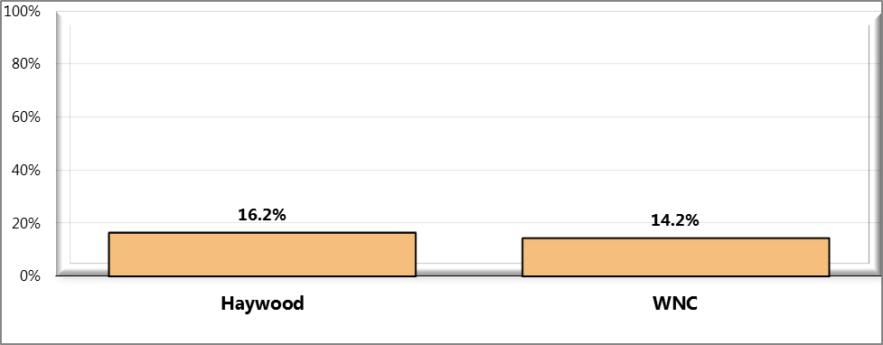

Sources: ● 2012 PRC Community Health Survey, Professional Research Consultants, Inc. [Item 44]

Notes: ● Asked of employed respondents.

Figure 93. “I believe it is important for

universities and colleges to be 100% tobacco-free”

(WNC Healthy Impact Survey)

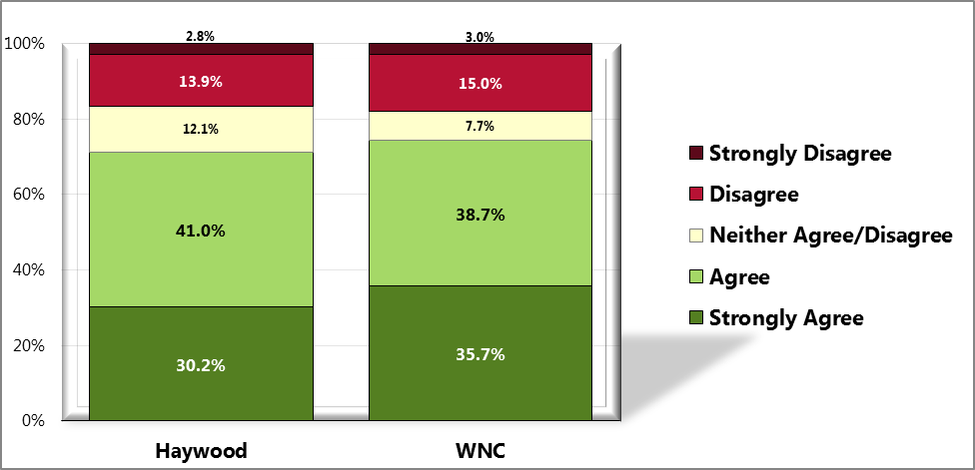

Sources: ● 2012 PRC Community Health Survey, Professional Research Consultants, Inc. [Item 45]

Notes: ● Asked of all respondents.

Figure 94. “I believe it is important for

government buildings and grounds to be 100% tobacco-free

(WNC Healthy Impact Survey)

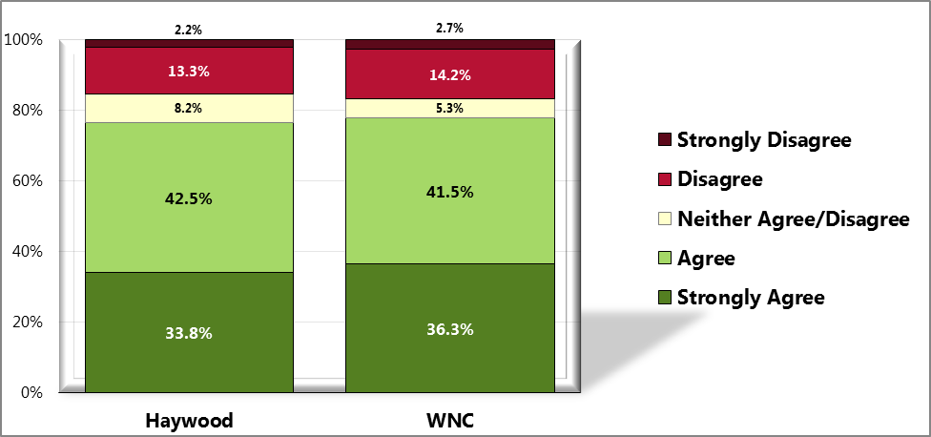

Sources: ● 2012 PRC Community Health Survey, Professional Research Consultants, Inc. [Item 46]

Notes: ● Asked of all respondents.

Figure 95. “I believe it is important for parks and

public walking/biking trails to be 100% tobacco-free

(WNC Healthy Impact Survey)

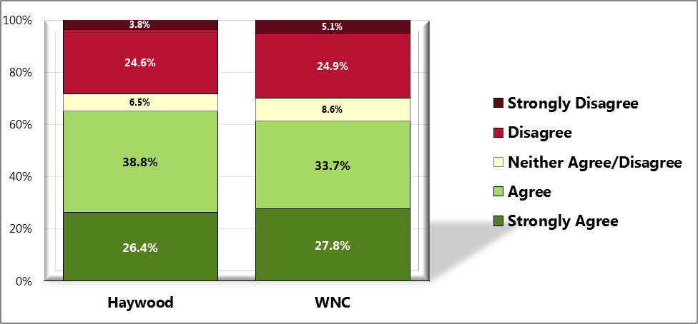

Sources: ● 2012 PRC Community Health Survey, Professional Research Consultants, Inc. [Item 47]

Notes: ● Asked of all respondents.

## Drinking Water

The source from which the public gets its drinking water is a health issue of considerable importance. Water from all municipal and most community water systems is treated to remove harmful microbes and many polluting chemicals, and is generally considered to be “safe” from the standpoint of public health because it is subject to required water quality standards. Municipal drinking water systems are those operated and maintained by local governmental units, usually at the city/town or county level. Community water systems are systems that serve at least 15 service connections used by year-round residents or regularly serves 25 year-round residents. This category includes municipalities, but also subdivisions and mobile home parks. In February 2012, a regional mean of 55% of the WNC population was being served by community water systems (*Data Workbook*). The 45% remaining presumably were being served by wells or by some other source, such as springs, creeks, rivers, lakes, ponds or cisterns.

Individual counties in WNC, however, have highly varied percentages of their populations served by community water systems; in some counties the figure is as low as 18% and in others it is as high as 65%. In Haywood County, 41,426 of 59,036 county residents, or 70.2%, were being served by community water systems in February of 2012. This is the highest proportion of county population served by community water systems in the 16 WNC counties. Presumably the remaining 29.8% were served by wells or other sources.

## Radon

Radon is a naturally occurring, invisible, odorless gas that comes from soil, rock and water. It is a radioactive decay product of radium, which is in turn a decay product of uranium; both radium and uranium are common elements in soil. Radon usually is harmlessly dispersed in outdoor air, but when trapped in buildings it can be harmful. Most indoor radon enters a home from the soil or rock beneath it, in the same way air and other soil gases enter: through cracks in the foundation, floors, hollow-block walls, and openings around floor drains, heating and cooling ductwork, pipes, and sump pumps. The average outdoor level of radon in the air is normally so low that it is not a problem (NC Department of Environment and Natural Resources).

Radon may also be dissolved in water as it flows over radium-rich rock formations. Dissolved radon can be a health hazard, although to a lesser extent than radon in indoor air. Homes supplied with drinking water from private wells or from community water systems that use wells as water sources generally have a greater risk of exposure to radon in water than homes receiving drinking water from municipal water treatment systems. This is because well water comes from ground water, which has much higher levels of radon than surface waters. Municipal water tends to come from surface water sources which are naturally lower in radon, and the municipal water treatment process itself tends to reduce radon levels even further (NC Department of Environment and Natural Resources).

There are no immediate symptoms to indicate exposure to radon. The primary risk of exposure to radon gas is an increased risk of lung cancer (after an estimated 5-25 years of exposure). Smokers are at higher risk of developing radon-induced lung cancer than non-smokers. There is no evidence that other respiratory diseases, such as asthma, are caused by radon exposure, nor is there evidence that children are at any greater risk of radon-induced lung cancer than are adults (NC Department of Environment and Natural Resources).

Elevated levels of radon have been found in many counties in NC, but the highest levels have been detected primarily in the upper Piedmont and mountain areas of the state where the soils contain the types of rock (gneiss, schist and granite) that have naturally higher concentrations of uranium and radium (NC Department of Environment and Natural Resources). Eight counties in NC historically have had the highest levels of radon, exceeding, on average, 4 pCi/L (pico curies per liter). These counties are Alleghany, Buncombe, Cherokee, Henderson, Mitchell, Rockingham, Transylvania and Watauga, five of which are in the WNC region. There are an additional 31 counties in the central and western Piedmont area of the state with radon levels in the 2-4 pCi/L range; the remaining 61 NC counties, mostly in the piedmont and eastern regions of the state have predicted indoor radon levels of less than 2 pCi/L (NC Department of Environment and Natural Resources).

According to one recent assessment, the regional mean indoor radon level for the 16 counties of WNC was 4.3 pCi/L, over three times the national indoor radon level of 1.3 pCi/L. According to this same source, the level for Haywood County was 3.8 pCi/L, almost three times the national indoor radon level (*Data Workbook*).

## Built Environment

The term “built environment” refers to the human-made surroundings that provide the setting for human activity, ranging in scale from buildings and parks or green space to neighborhoods and cities that can often include their supporting infrastructure, such as water supply, or energy networks. In recent years, public health research has expanded the definition of built environment to include healthy food access, community gardens, “walkability", and “bikeability” (Wikipedia, 2012).

### Access to Farmers’ Markets and Grocery Stores

According to the US Department of Agriculture (USDA) Economic Research Service’s *Your Food Environment Atlas,* there were a total of 49 farmers’ markets in the 16 WNC counties in 2009. This number was reported to have grown by 5, to a total of 54, in 2011, an increase of 10%. According to this source, in Haywood County there were four farmers’ markets in 2009 and five in 2011 (*Data Workbook*).

According to the same source, there were a total of 158 grocery stores in the 16 WNC counties in 2007. This number was reported to have shrunken by 4, to a total of 154, in 2009, a decrease of 2%. In Haywood County there were 11 grocery stores in 2007 and 10 in 2009 (*Data Workbook*).

Survey respondents were asked, “How important do you feel it is for your community to make it easier for people to access farmer’s markets, including mobile farmer’s markets and tailgate markets?” Survey respondents in Haywood County were also asked about their access to food, including fresh, affordable produce.

Figure 96. Importance of Communities Making It Easier to

Access Farmer’s Markets, Including Mobile/Tailgate Markets

(WNC Healthy Impact Survey)

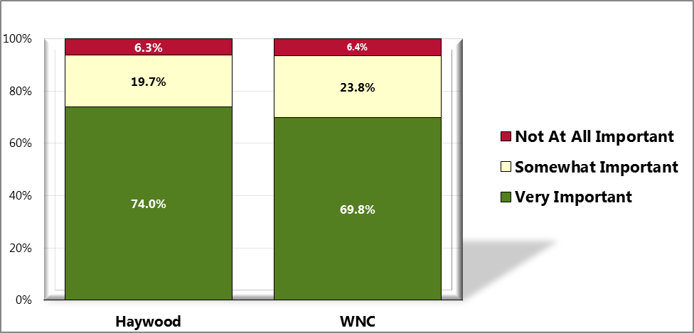

Sources: ● 2012 PRC Community Health Survey, Professional Research Consultants, Inc. [Item 55]

Notes: ● Asked of all respondents.

Figure 97. Level of Difficulty Accessing Fresh Produce

at an Affordable Price (WNC Healthy Impact Survey)

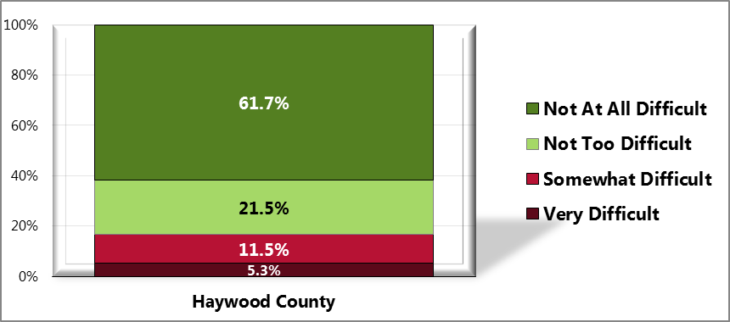

Sources: ● 2012 PRC Community Health Survey, Professional Research Consultants, Inc. [Item 108]

Notes: ● Asked of all respondents.

Figure 98. Have Worried in the Past Year About Food

Running Out Before Having Money to Buy More

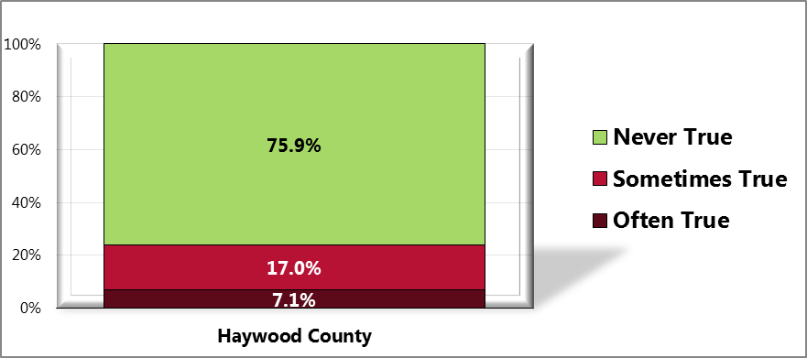

Sources: ● 2012 PRC Community Health Survey, Professional Research Consultants, Inc. [Item 113]

Notes: ● Asked of all respondents.

### Access to Fast Food Restaurants

According to the same source cited above, there were a total of 526 fast food restaurants in the 16 WNC counties in 2007. This number was reported to have dropped by 21, to a total of 505, in 2009, a decrease of 4%. In Haywood County the number of fast food restaurants grew from 37 to 38 over the same period (*Data Workbook*).

Also according to the USDA, mean per capita fast food expenditures in WNC rose 45% (from $514 to $746) between 2002 and 2007, and mean per capita restaurant expenditures in WNC also rose 45% (from $449 to $665) over the same period (*Data Workbook*).

### Access to Recreational Facilities

According to the same source cited above, there were a total of 81 recreation and fitness facilities in the 16 WNC counties in 2007. This number was reported to have dropped by 26, to a total of 55a total of 55, in 2009, a decrease of 32%. In Haywood County the number of recreational and fitness facilities fell from four to two over the same period (*Data Workbook*).

Survey respondents were asked whether they feel it is important for community organizations to explore ways to increase the public’s access to physical activity spaces during off-times, as well as whether it is important for communities to improve access to trails, parks, and greenways. Survey respondents in Haywood County were also asked about the availability of recreational facilities and programs for children and youth.

Figure 99. Importance That Community Organizations Make

Physical Activity Spaces Available for Public Use After Hours

(WNC Healthy Impact Survey)

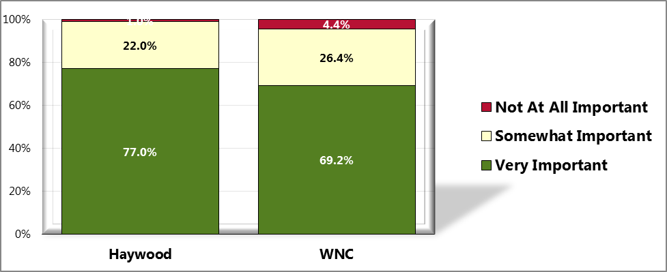

Sources: ● 2012 PRC Community Health Survey, Professional Research Consultants, Inc. [Item 60]

Notes: ● Asked of all respondents.

Figure 100. Importance That Communities

Improve Access to Trails, Parks, and Greenways

(WNC Healthy Impact Survey)

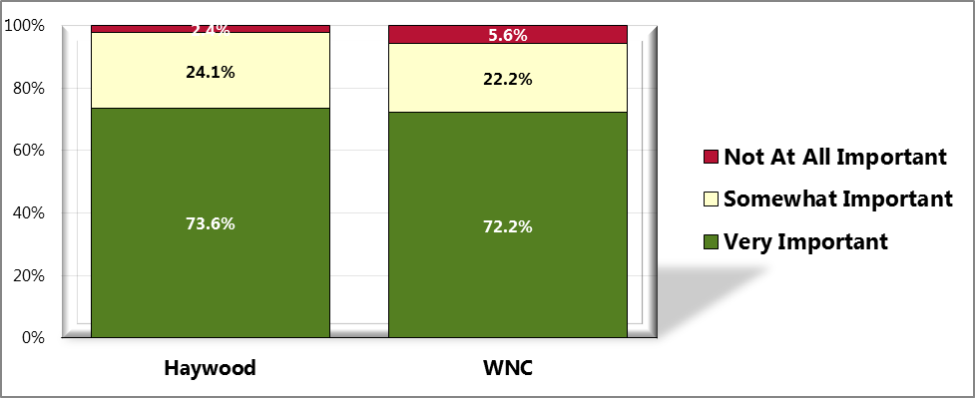

Sources: ● 2012 PRC Community Health Survey, Professional Research Consultants, Inc. [Item 61]

Notes: ● Asked of all respondents.

Figure 101. “I believe my county provides the facilities and programs needed

for children and youth to be physically active throughout the year. “

(WNC Healthy Impact Survey)

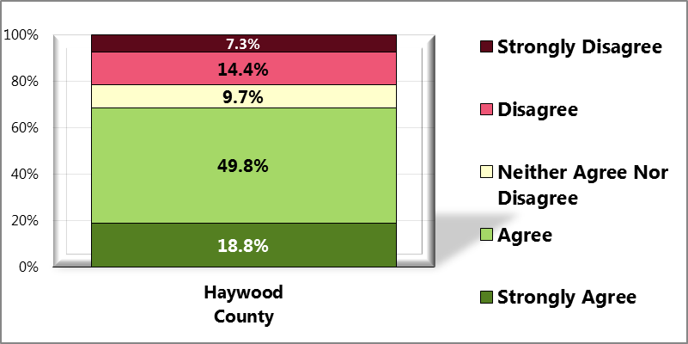

Sources: ● 2012 PRC Community Health Survey, Professional Research Consultants, Inc. [Item 118]

Notes: ● Asked of all respondents.

# Chapter 7 – Quality of Life

## Perception of County

In order to evaluate community members’ perceptions about the quality of life in western North Carolina (WNC), survey respondents were given a series of three statements regarding life in their county (my county is a good place to raise children, my county is a good place to grow old, and there is plenty of help for people during times of need in my county) and asked whether they “*strongly agree*,” “*agree*,” “*neither agree nor disagree*,” “*disagree*” or “*strongly disagree*” with each statement. Survey respondents were also asked about their frequency of getting needed social and emotional support, their satisfaction with life, the one thing that needs the most improvement in their neighborhood or community, and the one issue which has the most negative impact on the quality of life in their county.

Figure 102. “My county is a good place to raise children”

(WNC Healthy Impact Survey)

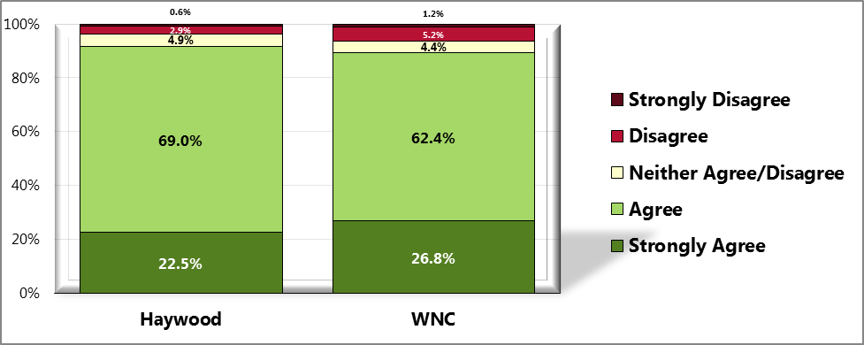

Sources: ● 2012 PRC Community Health Survey, Professional Research Consultants, Inc. [Item 5]

Notes: ● Asked of all respondents.

Figure 103. “My county is a good place to grow old.”

(WNC Healthy Impact Survey)

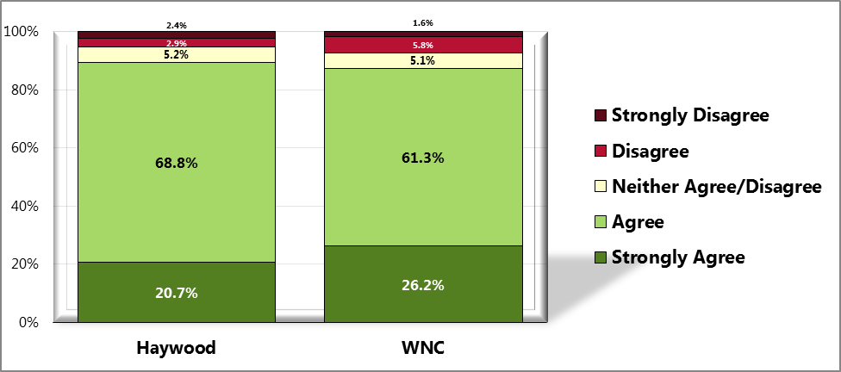

Sources: ● 2012 PRC Community Health Survey, Professional Research Consultants, Inc. [Item 6]

Notes: ● Asked of all respondents.

Figure 104. “There is plenty of help for

people during times of need in my county.”

(WNC Healthy Impact Survey)

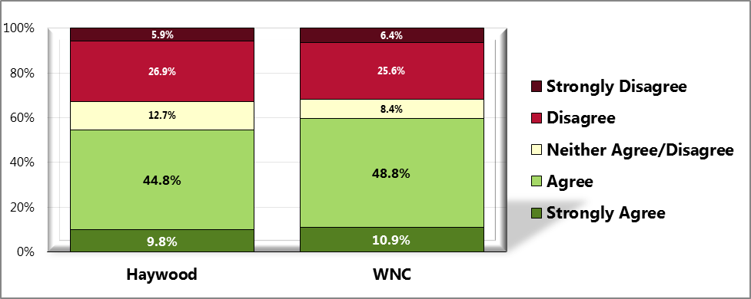

Sources: ● 2012 PRC Community Health Survey, Professional Research Consultants, Inc. [Item 8]

Notes: ● Asked of all respondents.

Table 64. Top Three County Issues Perceived as Having the Most

Negative Impact on Quality of Life (WNC Healthy Impact Survey)

|  |  |  |  |  |  |  |
| --- | --- | --- | --- | --- | --- | --- |
|  | **Economy/ Unemployment** | **Nothing** | **Don’t Know** | **Substance Abuse** | **Government/ Politics** | **Health Care** |
| Haywood | **✓** |  | **✓** |  |  | **✓** |
| WNC | **✓** | **✓** | **✓** |  |  |  |

Sources: ● 2012 PRC Community Health Survey, Professional Research Consultants, Inc. [Item 10]

Notes: ● Asked of all respondents.

Table 65. Top Three Neighborhood/Community Issues

Perceived as in Most Need of Improvement

(WNC Healthy Impact Survey)

|  |  |  |  |  |
| --- | --- | --- | --- | --- |
|  | **Economy/ Unemployment** | **Healthcare Services** | **Activity/Recreation Options** | **Nothing** |
| Haywood | **✓** | **✓** |  | **✓** |
| WNC | **✓** | **✓** |  | **✓** |

Sources: ● 2012 PRC Community Health Survey, Professional Research Consultants, Inc. [Item 9]

Notes: ● Asked of all respondents.

## Social and Emotional Support

Figure 105. Frequency of Getting Needed Social/Emotional Support

(WNC Healthy Impact Survey)

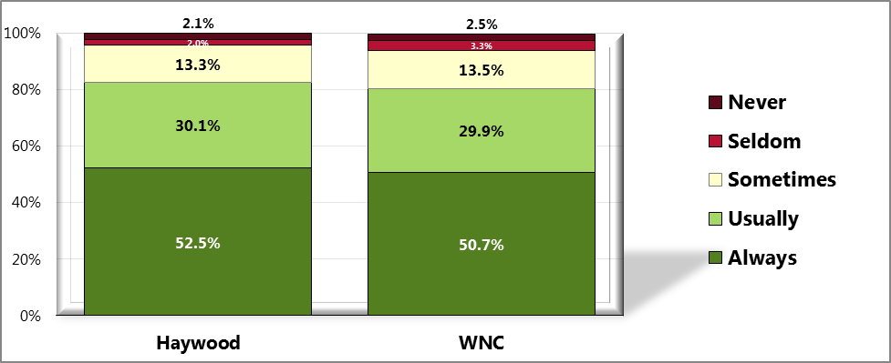

Sources: ● 2012 PRC Community Health Survey, Professional Research Consultants, Inc. [Item 63]

Notes: ● Asked of all respondents.

## Satisfaction with Life

Figure 106. Satisfaction with Life

(WNC Healthy Impact Survey)

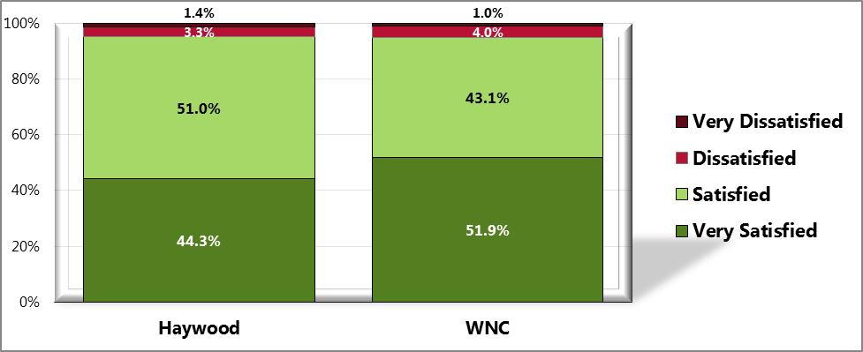

Sources: ● 2012 PRC Community Health Survey, Professional Research Consultants, Inc. [Item 62]

Notes: ● Asked of all respondents.

# Chapter 8 - Healthcare & Health Promotion Resources

## Health Resources

* WNC Healthy Impact:   
  <http://www.wnchealthyimpact.com/>
* Centers for Disease Control and Prevention:   
  <http://www.cdc.gov/nchs/>
* 2010 Census Data:   
  <http://2010.census.gov/2010census/>
* North Carolina Youth Risk Behavior Survey (YRBS):  
  <http://www.nchealthyschools.org/data/yrbs/>
* Behavioral Risk Factor Surveillance System (BRFSS):  
  <http://www.schs.state.nc.us/schs/brfss/index.html>
* North Carolina Center for Health Statistics   
  <http://www.schs.state.nc.us>
* Haywood County Health Department  
  <http://www.haywoodnc.net>
* Healthy Haywood (a program of the Haywood County Health Department)  
  <http://www.healthyhaywood.org>

See Appendix A for a description of the data collection methods used to gather this information.

See Appendix C for a summary list of the healthcare and health promotion resources and facilities available in Haywood County to respond to the health needs of the community.

This resource list addresses specific identified needs to include substance abuse, mental health, prescription use and abuse, homelessness, developmental disabilities, aging, and fitness. 2-1-1 data was also used in the resource inventory process.

## Resource Gaps

Resource gaps have been identified based on input from key community stakeholders, review of data from the CHA, 2-1-1, and Haywood County Health Department Accreditation. Below you will find a list of identified gaps as expressed by key community stakeholders, as well as specific data from 2-1-1.

COMMENT #1

“We need more professional staff, nurses, health educators, sanitarians, etc. We are spread too thin. We are doing an excellent job with what we have, but heavy work-loads/overtime take a toll. We also need salaries and a benefit package that will attract and keep the best qualified. Presently, we can't compete with opportunities that are in Asheville, i.e. Mission Hospitals, Buncombe County Health Department, etc. We have too many gaps in our prevention programs. The state continues to move from prevention toward policy and communications. In the present environment, policy will be a hard sale. Gains in health programs, particularly prevention programs, without more financial resources, will start to decline.”

COMMENT #2

* Transportation
* Affordable Housing
* Jobs
* Health Care

COMMENT #3

“I think there should me more family-oriented programs such as an exercise program in which the whole family can participate. You can either sign up your kids for a class or you can sign up for a class yourself. Lack of child care keeps people from exercising. An additional issue is that a lot of the exercises classes are before 5 pm. I have a membership to the recreation center, and I can barely use it because of the lack of late classes which do not accommodate family life. What is an 8 to 5 person to do, especially if right after 5 you are taking your kids to their activities? By the time they are done, there is nothing for you.”

COMMENT #4

“Making it easier for Health Department and DSS clients to access services; i.e.; transportation, mid-level provider to serve clients, grants to help provide the services.

Futurist goal for county employees: a staff exercise and daycare facility which would include a sick section. What an ideal!!!!”

**2-1-1 INFORMATION**

|  |  |
| --- | --- |
| **Top 25 Needs YTD** | **Calls** |
| **Utility Service Payment Assistance** | 72 |
| **Housing Expense Assistance** | 43 |
| **Food Pantries** | 29 |
| **Homeless Shelter** | 21 |
| **Comprehensive Information and Referral** | 15 |
| **Prescription Expense Assistance** | 13 |
| **Community Clinics** | 12 |
| **Christmas Programs** | 8 |
| **Transitional Housing/Shelter** | 8 |
| **General Legal Aid** | 6 |
| **Housing Authorities** | 5 |
| **Central Intake/Assessment for Psychiatric Services** | 4 |
| **Clothing Donation Programs** | 4 |
| **General Dentistry** | 4 |
| **Medical Appointments Transportation** | 4 |
| **Undesignated Temporary Financial Assistance** | 4 |
| **Central Intake/Assessment for Substance Abuse** | 3 |
| **General Paratransit/Community Ride Programs** | 3 |
| **Home Rental Listings** | 3 |
| **Housing Search Assistance** | 3 |
| **Mentoring Programs** | 3 |
| **Public Housing** | 3 |
| **Residential Substance Abuse Treatment Facilities** | 3 |
| **Transportation Expense Assistance** | 3 |
| **Utility Deposit Assistance** | 3 |
| **Needs Grouped by Category** | **Needs** |
| **Basic Needs** | 167 |
| **No Need Recorded** | 113 |
| **Individual and Family Life** | 37 |
| **Health Care** | 33 |
| **Organizational/Community/International Services** | 31 |
| **Mental Health Care and Counseling** | 20 |
| **Criminal Justice and Legal Services** | 13 |
| **Income Support and Employment** | 13 |
| **Consumer Services** | 7 |
| **Environmental Quality** | 4 |
| **Education** | 2 |

Note: Data is for 2011 year-end. Data assembled as of 6.19.2012.

# Chapter 9 - Health Priorities & Next Steps

## 

## Prioritization Process & Criteria

## 

**Presentation Overview**

A presentation with 92 PowerPoint slides was provided to a group of key stakeholders addressing the following categories:

* Demographic and Socioeconomic Parameters
* Health Status & Health Outcomes
* Health Behaviors
* Clinical Care
* Physical Environment
* Quality of Life
* United Way Data

Each person in attendance completed and individually “scored” a prioritization form after viewing the presentation. This “score” sheet was separated into 10 categories (see chart below), and 5 criteria (magnitude, consequences, feasibility, needs, and interest). Each was rated with low, medium, or high importance. Each was totaled to determine overall results.

*The following is a list of health concerns from the Healthy North Carolina 2010 objectives used in the prioritization process: :*

* Physical Activity & Nutrition
* Unintentional Injury/Including Motor Vehicle, Falls, Poisoning , Workplace Injury
* Maternal/Infant Health/Unintended Pregnancy
* Communicable Diseases/Including STD’s, Infectious Disease,  
  Food-borne Illness
* Substance Abuse  
  (Tobacco, Alcohol, Illicit Drugs)
* Mental Health
* Oral/Dental Health
* Social Determinants of Health/Access to Care
* Environmental Health/Including Indoor & Outdoor Air Quality, Toxic Chemical Releases, Drinking Water, Radon, Recycling
* Chronic Disease/Including Diabetes, Cancer, Cardiovascular,  
  Pulmonary

## 

## Priority Health Issues

*The following is a description of the priorities and progress from previous CHA in 2008*

Below is a list of the three health focus areas along with the interventions that were addressed as a result of the **2008** CHA. There were some interventions that were not able to be completed for various reasons. The number of complete vs. incomplete goals and a summary of key interventions follow.

Healthy Living Action Team – 8 out of 13 interventions addressed

The eight interventions addressed are:

1. **Fitness Challenge** – program designed to offer participants the opportunity to exercise at various centers while also leaning more about proper nutrition through the Healthy Taste of Haywood.
2. **Healthy Tips and Opps/ Healthy Articles** – Monthly newsletter focusing on healthy fitness and nutrition tips and opportunities.
3. **Fitness Finder** – a resource directory for all fitness opportunities within the county.
4. **Inspiration of the Month** – a program created to showcase outstanding people in the community who influence others to aspire to be healthy.
5. **Family Fun Day** – an afternoon health fair event with free swimming for anyone in the community.
6. **Distribute Healthy Recipes** – an effort to improve nutrition to WIC families by sampling and distributing healthy recipes.
7. **Support Breastfeeding** – an effort to promote breastfeeding to WIC mothers by providing nursing covers.
8. **Support the Power of Pink** – a race dedicated to raising money to provide mammograms to women in need.

The five interventions not addressed are:

1. Pilot “Walk to School” program with at least one school in Haywood County.
2. Promote healthy food choice program to faith communities in Haywood County.
3. Expand community gardens to reach populations in need, low income areas, and the senior population.
4. Support/pilot “Think Your Drink” [water bottles] in Haywood County Schools to promote the importance of keeping hydrated with a healthy beverage like water.
5. Pilot a “Supper at School” event. Parents/guardians would be invited to eat a school meal to educate and inform them about school lunch offerings, school lunch funding, and the challenges and goals of improving the school lunch program.

The most successful intervention has consistently proven to be the Fitness Challenge. Over the course of 2009-2012, this program reached 9434 people, raising $94,340. A large amount of funds earned from this program went back into the community to improve fitness and nutrition. Another success that came from the Fitness Challenge was the addition of an event within the event: The Healthy Taste of Haywood. An event designed to demonstrate that it is possible to make healthy choices when dining out and grocery shopping in Haywood County. A few years into the event, farmers from the local tailgate markets began participating as vendors along with area restaurants.

An unexpected and positive surprise has been the success of the “Healthy Tips and Opps” newsletter. This newsletter has been published to an online Fitness Challenge database of nearly 4000 people, as well as in the local newspaper (print and online) every month for nearly two years, thanks to the support of a dedicated volunteer.

The Fitness Finder was printed and distributed to 2000 people over the course of the 4 year span.

Healthy Haywood’s partnership role in the Power of Pink was primarily in support of MedWest Haywood Hospital’s leading role, but we are proud to have been a part of this successful project. The following chart shows the funds raised by Power of Pink events since its origin, along with the number of women who have benefited from receiving free mammograms, biopsies, or other surgical procedures through this annual community fund-raising event.

|  |  |  |  |  |  |  |
| --- | --- | --- | --- | --- | --- | --- |
| **Year** | **Gross** | **Expenses** | **Net** | **# of Procedures** | **# of Women** |  |
|  |  |  |  |  |  |  |
| 2007 | 17,550.05 | 10,144.67 | 7,405.38 | 0 | 0.00 |  |
| 2008 | 18,846.97 | 6579.01 | 12,267.96 | 42 | 41 |  |
| 2009 | 21,811.19 | 5482.01 | 16,329.18 | 148 | 129 |  |
| 2010 | 21,129.31 | 7498.63 | 13,630.68 | 257 | 203 |  |
| 2011 | 18,896.34 | 9759.03 | 9,137.31 | 198 | 167 |  |
| 2012 | 17,200.00 | 5773.81 | 11,426.19 | 161 | 130 |  |
|  |  |  |  |  |  |  |
| **Total** | 115,433.86 | 45,237.16 | 70,196.70 | 806 | 670 |  |

Substance Abuse Action Team – 10 out of 11 interventions addressed

The ten interventions addressed are:

1. **Provide Lunch & Learn** to law enforcement, probation officers, nurses, school reps and churches who offer addiction-focused programs.

1. Provide evidence-based **substance abuse prevention programs to youth.**
2. **TATU(Teens Against Tobacco Use)** High School students will teach 5th grade students tobacco education classes.
3. Host **Healthy Living Mini Camps** to provide substance abuse prevention education.
4. Support community efforts to establish a new **Suboxone Treatment.**
5. Provide **Merchant Education** to local businesses on the laws regarding alcohol and tobacco, and show support to those currently adhering to the laws.
6. Create a **Substance Use** **Resource list** of all substance abuse support interventions, and distribute to the community in print and website form.
7. Coordinate dialogue to promote the recognition and **recording of more accurate and thorough data** about the scope of substance abuse disorders in Haywood County.
8. Develop a policy to administer **Alternative to Suspension (ATS)** program for student who get caught using tobacco and Not On Tobacco (NOT) for students who voluntarily want to quit.
9. Provide **community forum** to increase awareness and provide education about various substance abuse topics.

The one intervention not addressed is:

1. TABU 21: Provide peer taught alcohol education programs to after school, summer camps, and driver education.

By far, the most successful work of this team was the creation of the Prescription for Safety Coalition, a team dedicated to addressing prescription drug abuse within the county. This concern came through discussion among Healthy Haywood’s Substance Abuse Action Team, and falls under the Lunch & Learn and Community Forum intervention. Under the direction and coordination of Healthy Haywood and key stakeholders in the community, the coalition divided into 6 community teams:

* + Law enforcement
  + Concerned citizens
  + School system
  + Faith community
  + Mental health and substance abuse professionals
  + Medical community

Many achievements came from this structure, including the installation of permanent pill drop boxes located at three of the four police departments, Medsafe lock boxes that were purchased and made available to the community, thousands of educational flyers printed and distributed through local pharmacies, creation of a video for educational purposes, and the revision of an emergency procedure that resulted in a reduction of the amount of narcotics that can be prescribed upon an emergency room visit. This list highlights some of the team’s successes. After the coalition’s first year, the decision was made to re-structure and shift to population teams that included moms and babies, youth, adults and seniors. This new structure did not produce as many achievements and lost momentum, so the hope is for the coalition to go back to the original team structure and begin work again.

TATU (Teens Against Tobacco Use) is a comprehensive tobacco prevention program designed to train high school students to teach their peers and younger students about the dangers of tobacco use. The TATU students, accompanied by a TATU-trained health educator, went into every Haywood County elementary school to reach every 5th grade student, as well as presenting to a variety after–school programs. This initiative reached approximately 700 students every year until the health promotion funding was cut from the state budget in 2011.

A Substance Abuse Resource Guide was also created and updated within the time between the previous and current CHA. The creation and distribution of this guide was a collaborative effort by all members of the present Substance Abuse Health Action Team. Healthy Haywood posted the Substance Abuse Resource Guide on the website, and provided further distribution by offering print versions at health promotion events.

Mental Health Action Team – 7 out of 8 interventions addressed

The seven interventions addressed are:

1. Implement evidenced based screening tools **(Healthy Ideas)** for depression in various populations and make referrals.
2. Provide and distribute **anxiety and depression awareness** to schools to educate **youth.**
3. Promote a Mental Health Awareness campaign throughout the community by publishing **healthy articles.**
4. Provide resources to enable outreach for the **faith-based community** regarding **mental health issues.**
5. Set up **booths for Mental Health** at various health fairs.
6. Coordinate **workshop** open to the community on a mental health topic.
7. Provide **education and resources** to the homeless shelter staff and volunteers as well as the **homeless community** who access the shelter.

The one intervention not addressed is:

1. Provide a community discussion about providing resources [education and tools] for families of divorce through the legal system.

One of this team’s greatest achievements has been to regularly provide the community with healthy articles on a variety of mental health topics. The team was able to include a variety of community perspectives through these articles, while the content helped address the stigma that often goes along with those mental health needs.

A “Holiday Recovery” workshop was coordinated by this team to address stress that often accompanies the holidays. Along with a health fair, the primary focus of this event was a series of stress-release education presenters ranging from a laughter therapist to a yoga instructor to a psychologist from the hospital, all of whom delivered lectures, Q & A sessions, and hands-on activities. The team made every effort to provide attendees with healthy snacks to show that maintaining one’s mental health is better balanced from a holistic approach that includes good nutrition.

This team also made great strides in looking at the needs of the homeless community by connecting with a local church group that has been providing shelter to the homeless community. This team coordinated many presentations on site at the homeless shelter. These presentations covered a variety of topics including mental health resources, job placement, and substance abuse, along with a program offering a perspective of hope from a formerly homeless individual with mental health needs. These efforts sparked the development of the homelessness resource guide to support those who work with the homeless community.

List of Health Priorities (continued)

*The following is a list of priority areas selected based on the 2012 CHA*

As a result of the **2012** CHA, the three primary health issues designated as priorities over the next 3 years are substance abuse, physical activity, and nutrition. Two secondary health concerns, chronic disease and social determinants of health/access to care, will also be included as overarching health concerns that need to be addressed in all three primary health concerns because of their direct affect on the those health issues.

## Next Steps

* Plans to disseminate the findings of the CHA results include Facebook postings, websites (including Haywood County Government and Healthy Haywood), and press releases to two local newspapers. Presentations may also be made to key groups and organizations such as the Board of Health, Haywood County School Board, Cooperative Extension, and local Kiwanis and Rotary Clubs.
* Plans to collaborate with agencies, interested community members, and key stakeholders around action planning are underway. First, a presentation about the CHA process and findings, along with top three health priority recommendations, will be given to the Board of Health in February. Potential actions and implementation strategies to accomplish these goals will also be discussed at the next Healthy Haywood partnership meeting with MedWest Haywood Hospital. Lead agencies to help achieve the determined goals will be identified at that time.

# References

AIRNow. (2011, December 9). *Air quality index (AQI) – A guide to air quality and your health.* Retrieved August 1, 2012, from: <http://www.airnow.gov/index.cfm?action=aqibasics.aqi>

American Cancer Society. (2011, November 14). *Secondhand smoke*. Retrieved June 15, 2012, from Learn about Cancer website:

<http://www.cancer.org/Cancer/CancerCauses/TobaccoCancer/secondhand-smoke>

Centers for Disease Control and Prevention. (2012, June 14). Retrieved August 23, 2012, from: <http://www.cdc.gov>

March of Dimes. (2012).  *Prenatal care, low birthweight, smoking during pregnancy*. Retrieved July 30, 2012, from: [http://www.marchofdimes.com](http://www.marchofdimes.com/pregnancy/alcohol_smoking.html)

MedicineNet.com. (2012, March 19). *Definition of nephrosis; Definition of nephritis*. Retrieved July 10, 2012, from MedTerms Dictionary website: <http://www.medterms.com/script/main/art.asp?articlekey=4534>

MedicineNet.com. (2012, June 22).  *Liver disease (hepatic disease)*. Retrieved July 10, 2012, from Diseases and Conditions website:

<http://www.medicinenet.com/liver_disease/article.htm>

Merriam-Webster.com. (2012). *Definition of communicable disease*. Retrieved August 1, 2012, from Merriam-Webster Dictionary website: <http://www.merriam-webster.com/medical/communicable%20disease>

National Cancer Institute, National Institutes of Health. (n.d.).  *Cancer*. Retrieved July 10, 2012, from NCI Dictionary of Cancer Terms website: <http://www.cancer.gov/dictionary?CdrID=45333>

National Institutes of Health. (2012, August). *HIV/AIDS: the basics*. Retrieved August 16, 2012, from AIDS Info website: <http://aidsinfo.nih.gov/contentfiles/HIVAIDS_theBasics.pdf>

National Institutes of Health. National Heart, Lung, and Blood Institute in Cooperation With The National Institute of Diabetes and Digestive and Kidney Diseases. (September 1998). *Clinical Guidelines on the Identification, Evaluation, and Treatment of Overweight and Obesity in Adults: The Evidence Report*.

National Institute on Aging, Nation Institutes of Health. (2012, June 27). *Alzheimer’s disease fact sheet*. Retrieved July 10, 2012, from Alzheimer’s Disease Education and Referral Center website:

<http://www.nia.nih.gov/alzheimers/publication/alzheimers-disease-fact-sheet>

NC Department of Environment and Natural Resources. (n.d.). *Facts about radon; Radon in water; Radon and geology*. Retrieved July 15, 2012, from NC Radon Program Basic Radon Information website:

[http://www.ncradon.org](http://www.ncradon.org/Facts.htm)

NC Department of Environment and Natural Resources. (n.d.) *Health risks of radon*. Retrieved July 15, 2012, from NC Radon Program website: <http://www.ncradiation.net/Radon/Health.htm>

NC Department of Environment and Natural Resources. (n.d.). EPA radon zone map of NC. Retrieved July 15, 2012, from NC Radon Program Basic Radon Information website: <http://www.ncradon.org/zone.htm>

North Carolina Radon Information. (n.d.). *North Carolina counties with detailed radon information*. Retrieved on May 9, 2010, from: <http://nc-radon.info/NC_counties.html>

NC Department of Health and Human Services, Nutrition Services Branch. (2012, April 5). *North* *Carolina nutrition and physical activity surveillance system (NC-NPASS)*. Retrieved August 1, 2012 from Nutrition Services website: <http://www.nutritionnc.com/nutrsurv.htm>

NC Division of Mental Health, Developmental Disabilities and Substance Abuse Services. (2012, August 16). Local contacts: local management entities by county. Retrieved August 17, 2012, from For LMEs and Government website:

<http://www.ncdhhs.gov/mhddsas/lmeonblue.htm>

PubMed Health. (2011, September 20). *Nephrotic syndrome*. Retrieved July 10, 2012, from A.D.A.M Medical Encyclopedia website: <http://www.ncbi.nlm.nih.gov/pubmedhealth/PMH0001520/>

Scorecard. (2011). *Criteria air pollutant descriptions*. Retrieved July 15, 2012, from Pollution Locator website:

<http://scorecard.goodguide.com/env-releases/cap/pollutant-desc.tcl>

US Department of Health and Human Services. (2010 December). *Healthy People 2020*. Retrieved July 15, 2012, from Healthy People website: http://www.healthypeople.gov

US Department of Health and Human Services. (2008). *Physical Activity Guidelines for Americans*, [www.health.gov/PAGuidelines](http://www.health.gov/PAGuidelines)

US Environmental Protection Agency. (2012, July 16). *National ambient air quality standards (NAAQS).* Retrieved August 1, 2012, from Air and Radiation website: <http://www.epa.gov/air/criteria.html>

US Environmental Protection Agency. (2012, January) *Toxics release inventory (TRI) fact sheet*. Retrieved July 15, 2012, from Toxics Release Inventory (TRI) Program website: <http://www.epa.gov/tri/triprogram/TRI_Factsheet_Jan_2012.pdf>

US Environmental Protection Agency. (2011, November 30). *Fact sheet: respiratory health effects of passive smoking.* Retrieved July 15, 2012, from Smoke-free Homes website:

<http://www.epa.gov/smokefree/pubs/etsfs.html>

US National Library of Medicine, National Institutes of Health. (n.d.). *Heart diseases*; *Cerebrovascular disease*; *Diabetes; Pneumonia; Influenza; Sepsis*  Retrieved July 10, 2012, from MedLine Plus Medical Dictionary website: http://www.nlm.nih.gov/medlineplus/mplusdictionary.html

United Health Foundation. (2011). *America’s Health Rankings*. Retrieved June 15, 2012, from <http://www.americashealthrankings.org/mediacenter/mediacenter2.aspx>

West Virginia Health Statistics Center. (2006, September 12). *Chronic lower respiratory disease, a National burden*. Retrieved July 10, 2012, from:

<http://www.wvdhhr.org/bph/hsc/pubs/other/clrd/national.htm>

Wikipedia. (2012, June). *Definition of Built Environment*. Retrieved August 1, 2012, from <http://en.wikipedia.org/wiki/Built_environment>

# Appendices

Appendix A – Data Collection Methods & Limitations

Appendix B – WNC Healthy Impact Survey Instrument

Appendix C – Health Resource Inventory

# Appendix A - Data Collection Methods & Limitations

## 

## Secondary Data

### 

### Secondary Data Methodology

In order to learn about the specific factors affecting the health and quality of life of residents of WNC, the WNC Healthy Impact data workgroup and consulting team identified and tapped numerous secondary data sources accessible in the public domain. For data on the demographic, economic and social characteristics of the region sources included: the US Census Bureau; Log Into North Carolina (LINC); NC Office of State Budget and Management; NC Department of Commerce; Employment Security Commission of NC; NC Department of Public Instruction; NC Department of Justice; NC Division of Medical Assistance; and the Cecil B. Sheps Center for Health Services Research. The WNC Healthy Impact consultant team made every effort to obtain the most current data available *at the time the report was prepared*. It was not possible to continually update the narrative past a certain date; in most cases that end-point was June 30, 2012.

The principal source of secondary health data for this report was the NC State Center for Health Statistics (NC SCHS), including its County Health Data Books, Behavioral Risk Factor Surveillance System, Vital Statistics unit, and Cancer Registry. Other health data sources included: NC Division of Public Health (DPH) Epidemiology Section; NC Division of Mental Health, Developmental Disabilities and Substance Abuse Services; National Center for Health Statistics; NC DPH Nutrition Services Branch; UNC Highway Safety Research Center; NC Department of Transportation; NC DETECT and the NC DPH Oral Health Section.

Because in any CHA it is instructive to relate local data to similar data in other jurisdictions, throughout this report representative county data is compared to like data describing the 16-county region and the state of NC as a whole. WNC Healthy Impact received approval from the NC Division of Public Health to use this regional comparison as “peer” for the purposes of our assessments (and related requirements). County data may not be available for some of the data parameters included in this report; in those cases state-level data is compared to US-level data or other standardized measures. Where appropriate and available, trend data has been used to show changes in indicators over time.

Environmental data was gathered from sources including: US Environmental Protection Agency; US Department of Agriculture, and NC Radon Program.

It is important to note that this report contains data retrieved **directly** from sources in the public domain. In some cases the data is very current; in other cases, while it may be the most current available, it may be several years old. Note also that the names of organizations, facilities, geographic places, etc. presented in the tables and graphs in this report are quoted exactly as they appear in the source data. In some cases these names may **not** be those in current or local usage; nevertheless they are used so readers may track a particular piece of information directly back to the source.

### 

### Data Definitions

Reports of this type customarily employ a range of technical terms, some of which may be unfamiliar to many readers. This report defines technical terms within the section where each term is first encountered.

Health data, which composes a large proportion of the information included in this report, employs a series of very specific terms which are important to interpreting the significance of the data. While these technical health data terms are defined in the report at the appropriate time, there are some data caveats that should be applied from the onset.

#### Error

First, readers should note that there is some error associated with every health data source. Surveillance systems for communicable diseases and cancer diagnoses, for instance, rely on reports submitted by health care facilities across the state and are likely to miss a small number of cases, and mortality statistics are dependent on the primary cause of death listed on death certificates without consideration of co-occurring conditions.

#### 

#### Age-adjusting

Secondly, since much of the information included in this report relies on *mortality* data, it is important to recognize that many factors can affect the risk of death, including race, gender, occupation, education and income. The most significant factor is age, because an individual’s risk of death inevitably increases with age. As a population ages, its collective risk of death increases; therefore, an older population will automatically have a higher overall death rate just because of its age distribution. At any one time some communities have higher proportions of “young” people, and other communities have a higher proportion of “old” people. In order to compare mortality data from one community with the same kind of data from another, it is necessary first to control for differences in the age composition of the communities being compared. This is accomplished by *age-adjusting* the data. Age-adjustment is a statistical manipulation usually performed by the professionals responsible for collecting and cataloging health data, such as the staff of the NC State Center for Health Statistics (NC SCHS). It is not necessary to understand the nuances of age-adjustment to use this report. Suffice it to know that age-adjusted data are preferred for comparing most health data from one population or community to another and have been used in this report whenever available.

#### 

#### Rates

Thirdly, it is most useful to use *rates* of occurrence to compare data. A rate converts a raw count of events (deaths, births, disease or accident occurrences, etc.) in a target population to a ratio representing the number of same events in a standard population, which removes the variability associated with the size of the sample. Each rate has its own standard denominator that must be specified (e.g., 1,000 women, 100,000 persons, 10,000 people in a particular age group, etc.) for that rate.

While rates help make data comparable, it should be noted that small numbers of events tend to yield rates that are highly unstable, since a small change in the raw count may translate to a large change in rate. To overcome rate instability, another convention typically used in the presentation of health statistics is *data aggregation*, which involves combining like data gathered over a multi-year period, usually three or five years. The practice of presenting data that are aggregated avoids the instability typically associated with using highly variable year-by-year data, especially for measures consisting of relatively few cases or events. The calculation is performed by dividing the sum number of cases or deaths in a population due to a particular cause over a period of years by the sum of the population size for each of the years in the same period. Health data for multiple years or multiple aggregate periods is included in this report wherever possible. Sometimes, however, even aggregating data is not sufficient, so the NC SCHS recommends that any rate based on fewer than 20 events—whether covering an aggregate period or not—be considered *unstable*. In fact, in some of its data sets the NC SCHS no longer calculates rates based on fewer than 20 events. To be sure that unstable data do not become the basis for local decision-making, this report will highlight and discuss primarily rates based on 20 or more events in a five-year aggregate period, or 10 or more events in a single year. Where exceptions occur, the text will highlight the potential instability of the rate being discussed.

#### 

#### Regional arithmetic mean

Fourthly, sometimes in order to develop a representative regional composite figure from 16 separate county measures the consultants calculated a *regional arithmetic mean* by summing the available individual county measures and dividing by the number of counties providing those measures. It must be noted that when regional arithmetic means are calculated from *rates* the mean is not the same as a true average rate but rather an approximation of it. This is because most rates used in this report are age-adjusted, and the regional mean cannot be properly age-adjusted.

#### 

#### Describing difference and change

Fifthly, in describing differences in data of the same type from two populations or locations, or changes over time in the same kind of data from one population or location—both of which appear frequently in this report—it is useful to apply the concept of *percent* difference or change. While it is always possible to describe difference or change by the simple subtraction of a smaller number from a larger number, the result often is inadequate for describing and understanding the *scope* or *significance* of the difference or change. Converting the amount of difference or change to a percent takes into account the relative size of the numbers that are changing in a way that simple subtraction does not, and makes it easier to grasp the meaning of the change. For example, there may be a rate of for a type of event (e.g., death) that is one number one year and another number five years later. Suppose the earlier figure is 12.0 and the latter figure is 18.0. The simple mathematical difference between these rates is 6.0. Suppose also there is another set of rates that are 212.0 in one year and 218.0 five years later. The simple mathematical difference between these rates also is 6.0. But are these same simple numerical differences really of the same significance in both instances? In the first example, converting the 6 point difference to a percent yields a relative change factor of 50%; that is, the smaller number increased by half, a large fraction. In the second example, converting the 6 point difference to a percent yields a relative change factor of 2.8%; that is, the smaller number increased by a relatively small fraction. In these examples the application of percent makes it very clear that the difference in the first example is of far greater degree than the difference in the second example. This document uses percentage almost exclusively to describe and highlight degrees of difference and change, both positive (e.g., increase, larger than, etc.) and negative (e.g., decrease, smaller than, etc.)

### 

### Data limitations

Some data that is used in this report may have inherent limitations, due to the sample size, its geographic focus, or its being out-of-date, for example, but it is used nevertheless because there is no better alternative. Whenever this kind of data is used, it will be accompanied by a warning about its limitations.

### 

### Gaps in Available Information

There is a range of currently unavailable data that would be useful in assessing the health of Haywood County such as measured BMI of youth and adults, assessment of dietary intake among youth, accurate statistics on illicit drug use and overdose, and data on the seasonal population shift and its affect on the health status of the county.

## 

## WNC Healthy Impact Survey (Primary Data)

### 

### Survey Methodology

#### Survey Instrument

To supplement the secondary core dataset, meet additional stakeholder data needs, and hear from community members about their concerns and priorities, a community survey, *2012 WNC Healthy Impact Survey* (a.k.a. 2012 PRC Community Health Survey), was developed and implemented in 16 counties across western North Carolina. The survey instrument was developed by WNC Healthy Impact’s data workgroup, consulting team, and local partners, with assistance from Professional Research Consultants, Inc. (PRC). Many of the questions are derived from the Centers for Disease Control and Prevention (CDC) Behavioral Risk Factor Surveillance System (BRFSS), as well as other public health surveys; other questions were developed specifically for WNC Healthy Impact to address particular issues of interest to communities in western North Carolina. Each county was given the opportunity to include three additional questions of particular interest to their county, which were asked of their county’s residents.

**Professional Research Consultants, Inc.**

The geographic area for the regional survey effort included 16 counties: Buncombe, Cherokee, Clay, Graham, Haywood, Henderson, Jackson, Macon, Madison, McDowell, Mitchell, Polk, Rutherford, Swain, Transylvania and Yancey counties.

#### Sample Approach & Design

To ensure the best representation of the population surveyed, a telephone interview methodology (one that incorporates both landline and cell phone interviews) was employed. The primary advantages of telephone interviewing are timeliness, efficiency and random-selection capabilities.

The sample design used for this regional effort consisted of a stratified random sample of 3,300 individuals age 18 and older in Western North Carolina. Our county’s sample size was 200. All administration of the surveys, data collection and data analysis was conducted by Professional Research Consultants, Inc. (PRC). The interviews were conducted in either English or Spanish, as preferred by respondents.

#### Sampling Error

For our county-level findings, the maximum error rate is ±6.9%.

**Expected Error Ranges for a Sample of 200  
Respondents at the 95 Percent Level of Confidence**

Note: ● The "response rate" (the percentage of a population giving a particular response) determines the error rate associated with that response. A "95 percent level of confidence" indicates that responses would fall within the expected error range on 95 out of 100 trials.

Examples:

● If 10% of the sample of 200 respondents answered a certain question with a "yes," it can be asserted that between

5.8% and 14.2% (10% ± 4.2%) of the total population would offer this response.

● If 50% of respondents said "yes," one could be certain with a 95 percent level of confidence that between 43.1%

and 56.9% (50% ± 6.9%) of the total population would respond "yes" if asked this question.

#### Sample Characteristics

To accurately represent the population studied, PRC worked to minimize bias through application of a proven telephone methodology and random-selection techniques. And, while this random sampling of the population produces a highly representative sample, it is a common and preferred practice to “weight” the raw data to improve this representativeness even further. This is accomplished by adjusting the results of a random sample to match the geographic distribution and demographic characteristics of the population surveyed (poststratification), so as to eliminate any naturally occurring bias. Specifically, once the raw data are gathered, respondents are examined by key demographic characteristics (namely gender, age, race, ethnicity, and poverty status) and a statistical application package applies weighting variables that produce a sample which more closely matches the population for these characteristics. Thus, while the integrity of each individual’s responses is maintained, one respondent’s responses may contribute to the whole the same weight as, for example, 1.1 respondents. Another respondent, whose demographic characteristics may have been slightly oversampled, may contribute the same weight as 0.9 respondents. In order to determine WNC regional estimates, county responses were weighted in proportion to the actual population distribution so as to appropriately represent Western North Carolina as a whole.

The following chart outlines the characteristics of the survey sample for our county by key demographic variables, compared to actual population characteristics revealed in census data. Note that the sample consisted solely of area residents age 18 and older.

Population & Sample Characteristics

(Haywood County, 2012)

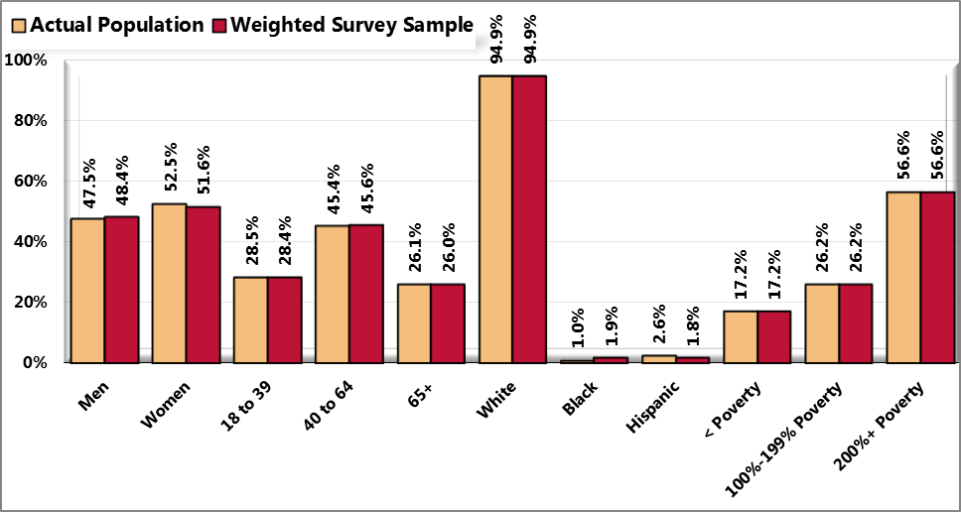

Sources: ● Census 2010, Summary File 3 (SF 3). U.S. Census Bureau.

● 2012 PRC Community Health Survey, Professional Research Consultants, Inc.

Notes: ● Hispanics can be of any race. Other race categories are non-Hispanic categorizations (e.g., “White” reflects non-

Hispanic White respondents).

Poverty descriptions and segmentation used in this report are based on administrative poverty thresholds determined by the US Department of Health & Human Services. These guidelines define poverty status by household income level and number of persons in the household *(e.g., the 2012 guidelines place the poverty threshold for a family of four at $23,050 annual household income or lower)*. In sample segmentation: “very low income” refers to community members living in a household with defined poverty status; “low income” refers to households with incomes just above the poverty level, earning up to twice the poverty threshold; and “mid/high income” refers to those households living on incomes which are twice or more the federal poverty level.

The sample design and the quality control procedures used in the data collection ensure that the sample is representative. Thus, the findings may be generalized to the total population of community members in the defined area with a high degree of confidence.

### 

### Benchmark Data

#### North Carolina Risk Factor Data

Statewide risk factor data are provided where available as an additional benchmark against which to compare local survey findings; these data are reported in the most recent *BRFSS (Behavioral Risk Factor Surveillance System) Prevalence and Trend Data* published by the Centers for Disease Control and Prevention and the US Department of Health & Human Services.

#### Nationwide Risk Factor Data

Nationwide risk factor data, which are also provided in comparison charts where available, are taken from the *2011 PRC National Health Survey*; the methodological approach for the national study is identical to that employed in this assessment, and these data may be generalized to the US population with a high degree of confidence.

#### Healthy People 2020

Healthy People provides science-based, 10-year national objectives for improving the health of all Americans. The Healthy People initiative is grounded in the principle that setting national objectives and monitoring progress can motivate action. For three decades, Healthy People has established benchmarks and monitored progress over time in order to:

* Encourage collaborations across sectors.
* Guide individuals toward making informed health decisions.
* Measure the impact of prevention activities.

Healthy People 2020 is the product of an extensive stakeholder feedback process that is unparalleled in government and health. It integrates input from public health and prevention experts, a wide range of federal, state and local government officials, a consortium of more than 2,000 organizations, and perhaps most importantly, the public. More than 8,000 comments were considered in drafting a comprehensive set of Healthy People 2020 objectives.

### 

### Survey Administration

#### Pilot Testing & Quality Assurance

Before going into the field in the latter half of May, PRC piloted 30 interviews across the region with the finalized survey instrument. After this phase, PRC corrected any process errors that were found, and discussed with the consulting team any substantive issues that needed to be resolved before full implementation.

PRC’s methods and survey administration comply with current research methods and industry standards. To maximize the reliability of research results and to minimize bias, PRC follows a number of clearly defined quality control protocols. PRC uses a telephone methodology for its community interviews, in which the respondent completes the questionnaire with a trained interviewer, not through an automated touch-tone process.

With more than 700 full- and part-time interviewers who work exclusively with healthcare and health assessment projects, PRC uses a state-of-the-art, automated CATI interviewing system that assures consistency in the research process. Furthermore, PRC maintains the resources to conduct all aspects of this project in-house from its headquarters in Omaha, Nebraska, assuring the highest level of quality control.

#### Random-Digit Dialing

PRC employs the latest CATI (computer-aided telephone interviewing) system technology in its interviewing facilities. The system PRC uses is a hybrid variation of a commercial application enhanced with internally developed software applications designed to specifically meet the needs of its health care client base. Since 1998 PRC has maintained, refined and developed proficiency in using this CATI system.

The CATI system automatically generates the daily sample for data collection using a random-digit dialing technique, retaining each telephone number until the Rules of Replacement (see description, below) are met. Up to five call attempts are made on different days and at different times to reach telephone numbers for which there is no answer. Systematic, unobtrusive electronic monitoring is conducted regularly by supervisors throughout the data collection phase of the project.

#### Rules of Replacement

Replacement means that no further attempts are made to connect to a particular number, and that a replacement number is drawn from the sample. To retain the randomness of the sample, telephone numbers drawn for the sample are not discarded and replaced except under very specific conditions.

#### Minimizing Potential Error

In any survey, there exists some degree of potential error. This may be characterized as sampling error (because the survey results are not based on a complete census of all potential respondents within the population) or non-sampling error (e.g., question wording, question sequencing, or through errors in data processing). Throughout the research effort, Professional Research Consultants makes every effort to minimize both sampling and non-sampling errors in order to assure the accuracy and generalizability of the results reported.

**Noncoverage Error.** One way to minimize any effects of underrepresentation of persons without telephones is through poststratification. In poststratification, the survey findings are weighted to key demographic characteristics, including gender, age, race/ethnicity and income.

**Sampling Error.** Sampling error occurs because estimates are based on only a sample of the population rather than on the entire population. Generating a random sample that is representative and of adequate size can help minimize sampling error. Sampling error, in this instance, is further minimized through the strict application of administration protocols. Poststratification, as mentioned above, is another means of minimizing sampling error.

**Measurement Error.** Measurement error occurs when responses to questions are unduly influenced by one or more factors. These may include question wording or order, or the interviewer's tone of voice or objectivity. Using a tested survey instrument minimizes errors associated with the questionnaire. Thorough and specific interviews also reduce possible errors. The automated CATI system is designed to lessen the risk of human error in the coding and data entry of responses.

### 

### Information Gaps

While this assessment is quite comprehensive, it cannot measure all possible aspects of health in the community, nor can it adequately represent all possible populations of interest. It must be recognized that these information gaps might in some ways limit the ability to assess all of the community’s health needs.

For example, certain population groups (such as the homeless, institutionalized persons, or those who only speak a language other than English or Spanish) are not represented in the survey data. Other population groups (for example, pregnant women, lesbian/gay/bisexual/transgender residents, undocumented residents, and members of certain racial/ethnic or immigrant groups) might not be identifiable or might not be represented in numbers sufficient for independent analyses.

In terms of content, this assessment was designed to provide a comprehensive and broad picture of the health of the overall community. However, there are certainly a great number of medical conditions that are not specifically addressed.

## 

## 

## Health Resource Inventory

Determination of available health-related resources and facilities took place through discussion among hospital, health department, and community stakeholders as well as a review of 2-1-1 data. When the three key health topics were determined in 2008, each team identified the need for a resource list for their particular health topic. Note also that each resource guide is revisited periodically to make edits to new and changing resources which prompted the need to identify and possibly address any gaps in resources.

When looking at 2012 priorities, community stakeholders were asked very simply what resources they felt were currently lacking in Haywood County. (See Chapter 8 resource gaps for a list of comments) As the teams begin to meet, these comments will be taken into consideration when choosing goals and action plans.

See Appendix C for a summary list of the healthcare and health promotion resources and facilities available in Haywood County to respond to the health needs of the community.

This resource list addresses specific identified needs to include substance abuse, mental health, prescription use and abuse, homelessness, developmental disabilities, aging, and fitness.

# Appendix B - Community Health Survey Instrument

*Double-click on the survey coversheet below to access the complete survey instrument. If you cannot access this, please contact your local health department for a copy.*



# 

# Appendix C - Health Resource Inventory

Determination of available health related resources and facilities took place through discussion among hospital, health department, and community stakeholders. When the three key health topics were determined in 2008, each team identified the need for a resource list for their particular health topic. Note also that each resource guide is revisited periodically to make edits to new and changing resources which prompted the need to identify and possibly address any gaps in resources.

When looking at 2012 priorities, community stakeholders were asked very simply what resources they felt were currently lacking in Haywood County. (See Chapter 8 resource gaps for a list of comments) As the teams begin to meet, these comments will be taken into consideration when choosing goals and action plans.

* WNC Healthy Impact:   
  <http://www.wnchealthyimpact.com/>
* Centers for Disease Control and Prevention:   
  <http://www.cdc.gov/nchs/>
* 2010 Census Data:   
  <http://2010.census.gov/2010census/>
* North Carolina Youth Risk Behavior Survey (YRBS):  
  <http://www.nchealthyschools.org/data/yrbs/>
* Behavioral Risk Factor Surveillance System (BRFSS):  
  <http://www.schs.state.nc.us/schs/brfss/index.html>
* North Carolina Center for Health Statistics   
  <http://www.schs.state.nc.us>
* Haywood County Health Department  
  <http://www.haywoodnc.net>
* Healthy Haywood (a program of the Haywood County Health Department)  
  <http://www.healthyhaywood.org>
* Medwest Haywood hospital: [www.medwesthealth.org](http://www.medwesthealth.org)
* Haywood County Schools: [www.haywoodk12.nc.us](http://www.haywoodk12.nc.us)
* Eat Smart Move More: [www.eatsmartmovemorenc.com](http://www.eatsmartmovemorenc.com)

Several resources lists have been developed for the public to access. They include the following and can be found on Healthy Haywood’s website at [www.healthyhaywood.org](http://www.healthyhaywood.org) under the “resources” tab.

* Fitness Finder
* Substance Abuse Resource Guide
* Homelessness
* [Substance Abuse & Developmental Disability Services in Haywood County](http://www.healthyhaywood.org/files/MH-SA-%20Dev%20Disability%20Serv-Hay%20%20Co.pdf)

Additionally, the new Senior Resource Center has an abundance of resources for this population. Their physical address is 81 Elmwood Way, Waynesville, NC 28786

Phone: 828 452 2370  
[www.haywoodconnections.org](http://www.haywoodconnections.org)

2-1-1 is also a resource available to the community. You can see more information about 2012 data in Chapter 8. Greater details on these services can be accessed by calling 2-1-1 to speak to a trained staff person or visiting [www.NC211.org](http://www.NC211.org).