2019
[Insert Name of Hospital Facility]
Community Health Needs Assessment (CHNA)
[Insert Date CHNA Made Widely Available]

YOUR LOGO HERE

TEMPLATE NOTE TO WNC HEALTHY IMPACT PARTNERS
*Note: This entire page should be deleted as you finalize your CHNA product*
This document has been created as part of WNC Healthy Impact as a guide for the completion of your hospital facility-specific 2019 Community Health Needs Assessment Product. This template was created as a guide to help support hospital reporting and should be edited and modified to fit the actual situation of each reporting hospital facility. This is not an official legal or tax guidance document. Hospital facilities should consult with their internal advisors to complete final reporting.

General Note:
- This template was created as “wrapping paper” for hospitals to use with their collaborative community health assessment (CHA) products from the local process – to help communicate hospital-specific compliance details in a more streamlined way.
- The CHA was likely lead by your local health department(s). If you have questions about locating or accessing the CHA, contact us and we will help you get in touch with the correct person locally.
- This template has been created using 2 counties as “hospital community.” If your facility has more or less counties in its defined community for the purposes of this reporting, please modify accordingly.

Cover:
- Modify with logos and images as preferred. This is your “2019” CHNA Summary regardless of when it is submitted within the January 2019 – December 2019 window.
- Photos on the cover and in the headers: You may leave the photos as-is; remove them completely, and/or swap the photos for your own images. View a tutorial on how to swap the images here, and credit the photos in the citations section of the report.

Compliance and guidance:
- Our goal is to be supportive of the requirements of hospitals for CHNA in creating this product.
- As always, you will continue to be accountable for final compliance details and will may adjust this template as you see fit.
- Our guidance in this template is not intended as legal, accreditation, or tax advice. Please refer to the IRS website for IRS requirements: Community Health Needs Assessment for Charitable Hospital Organizations - Section 501(r)(3) or the Federal Register for Additional Requirements for Charitable Hospitals; Community Health Needs Assessments for Charitable Hospitals; Requirement of a Section 4959 Excise Tax Return and Time for Filing of the Return.
- Sections related to compliance benchmarks have been highlighted in a red box. This text should be deleted from the final document after you read it and add the content needed in that section.
- The Affordable Care Act requires the Internal Revenue Service (IRS) to review all tax-exempt hospitals every three years for compliance with 501(r) requirements. These reviews are done through an examination of public documents so hospitals do not necessarily know they are being audited.
- As noted in a recent Catholic Health Association eNewsletter (11/28/2018), Common issues that have arisen in these reviews are:
  - Not having the community health needs assessment (CHNA) conspicuously posted on the website
  - Lack of documentation that the board or authorized committee approved the CHNA or implementation strategy
  - Absent or incomplete financial assistance policies and missing list of providers covered by the financial assistance policy
  - Some auditors have told hospitals that the implementation strategy should be posted on their website, even though this is not a requirement. IRS rules call for attaching implementation strategies to Form 990, Schedule H

Formatting:
- Some of the text in this document is written in red like this or in italics like this for data suggestions, which means the text is guidance for you that should be replaced or deleted in the final draft.
- Red text highlighted in yellow tells you where to find the content in the CHA Report provided by your health department(s).
- This report will be submitted and exist electronically; you may use electronic links in the report as desired.
- Depending on what will work best for your key audiences, you may want to consider linking to videos, using QR codes so that people can easily access links even if they’re looking at a paper copy, and embedding links to your community’s Scorecard.
Support WNC Health Network Can Offer:
WNC Health Network is an alliance of hospitals working together to improve health and healthcare in western North Carolina. Contact us if you need support in any of the following as it relates to your CHNA Report:
- Connect you with your local public health agency peers and/or local CHA report
- Proofreading and copyediting
- Minor graphic design (cover layout, headers)
- Formatting assistance
- Hosting study hall sessions to get in-person peer support and maximize your work time.
- Assistance understanding and interpreting regional data and/or inserting any of the data tables, graphs, etc. from WNC Healthy Impact regional data products.
- Assistance with evaluation of actions taken since previous CHNA (e.g. Hospital Implementation Strategy).
- Contact WNC Health Network if you have additional needs related to your CHNA Report.


[Insert Name of Hospital Facility]
COMMUNITY HEALTH NEEDS ASSESSMENT
This document is a hospital facility-specific Community Health Needs Assessment (CHNA) Executive Summary. For more process and data details on counties within our defined community, specific health data, and the collaborative community health assessments for each county, see:

- County A – Community Health Assessment
[Insert details and hyperlink to location if online – you may also want to PDF the CHA Executive Summary as an attachment to this document in the Appendix]
- County B – Community Health Assessment
[Insert details and hyperlink to location if online – you may also want to PDF the CHA Executive Summary as an attachment to this document in the Appendix]

The CHNA report was developed by [hospital facility name] in partnership with [health department(s) & other key partners; include all your health departments if multiple are within your area] as part of a local community health needs assessment process. For a more detailed acknowledgment of all of the partners involved in the creation of this assessment please see “Community Input and Engagement” on page X.
Our community health needs assessment process and products were supported collaboratively by WNC Healthy Impact, a partnership between hospitals and health departments to improve community health in western North Carolina. This innovative regional effort is coordinated, housed and financially supported by WNC Health Network, the alliance of western NC hospitals working together to improve health and healthcare. Learn more at www.WNCHN.org.
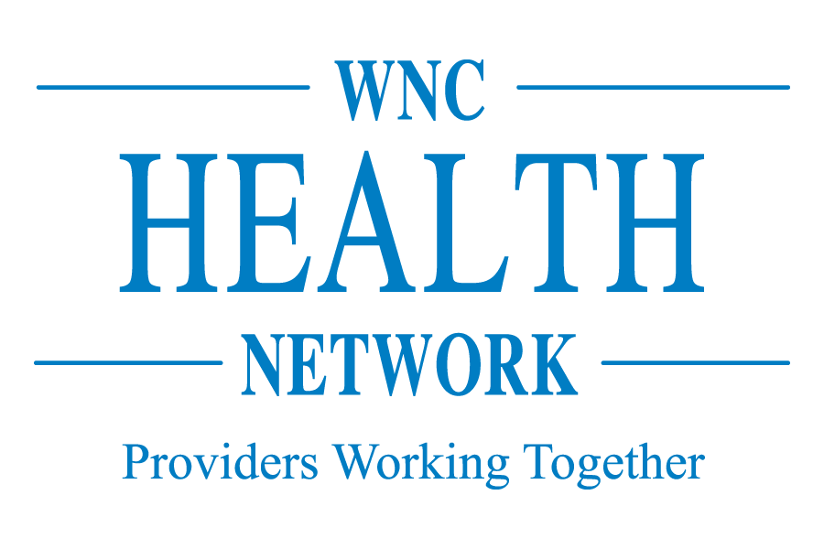

TABLE OF CONTENTS
Evaluation of Actions Taken Since Previous (2016) CHNA X
Community Health Needs Assessment Process X
Community Served X
WNC Healthy Impact X
Data Collection Process X
Community Input & Engagement X
Health Needs in Our Community X
Health Status X
Health Issues X
Priority Health Issues X
Available Resources X
Health Resources X
Next Steps X
Sharing Findings X
Collaborative Planning X
Works Cited X
Appendix X
County A Community Health Assessment X
County B Community Health Assessment X
2-1-1 Resource List X


EVALUATION OF ACTIONS TAKEN SINCE PREVIOUS (2016) CHNA

COMPLIANCE NOTE
A CHNA report adopted for the hospital facility by an authorized body of the hospital facility must include an evaluation of the impact of any actions that were taken, since the hospital facility finished conducting its immediately preceding CHNA, to address the significant health needs identified in the hospital facility’s prior CHNA(s). Treas. Reg. § 1.501(r)-3(b)(6)(i)(F) [delete this box in final reporting]

Making a difference on population level health priorities requires an array of initiatives across the community, and involves the collective participation of the programs, agencies, and service systems striving to address these priority health issues. As part of a collaborative response to addressing health needs in our community, our hospital facility is an important contributor to meaningful progress on these health priorities.
Contact WNC Health Network staff if you need support to learn/practice Results-Based Accountability™ (RBA) to get to better measures for your next implementation strategy. RBA is a disciplined, common-sense approach to thinking and acting with a focus on how people, agencies, and communities are better off for our efforts.
Getting to better measures will enable you to be more confident that your programs are making a difference and help you to communicate the value of the hospital’s efforts to leadership.

The brief summary below provides an overview of the progress and impact of actions taken since our last CHNA that was conducted in 2016.

The information below should come from your previous Hospital Implementation Strategy, which may be in a Scorecard. Contact WNC Health Network staff if you are unsure how to locate your previous Hospital Implementation Strategy or if you would prefer to insert a PDF of your Hospital Implementation Strategy Scorecard instead of filling out the table below.
2015 Priority Area 1 [insert details]
Population Level Data:
[Include a brief statement about what the priority issue was at the time, and how the data has changed– i.e. how the trend is moving. Please be careful to note the timing of the data and timing for which you are reporting actions. Do not attribute changes at the population level to a single program-level action.]

Collaborative Efforts:
[Include a brief update on the collaborative efforts that have taken place, progress that has been made across the community]
Implementation Strategy Update
Hospital Strategy | Evaluation/Note (Prioritize “How Well & Better Off” Measures)
Hospital strategy 1 [insert details] | Include information on: 1) How much did we do? 2) How well did we do it? 3) Is anyone better off?
Hospital strategy 2 [insert details] | Include information on: 1) How much did we do? 2) How well did we do it? 3) Is anyone better off?
Hospital strategy 3 [insert details] | Include information on: 1) How much did we do? 2) How well did we do it? 3) Is anyone better off?
Hospital strategy 4 [insert details] | Include information on: 1) How much did we do? 2) How well did we do it? 3) Is anyone better off?

2015 Priority Area 2 [insert details]
Population Level Data:
[Include a brief statement about what the priority issue was at the time, and how the data has changed– i.e. how the trend is moving. Please be careful to note the timing of the data and timing for which you are reporting actions. Do not attribute changes at the population level to a single program-level action.]

Collaborative Efforts:
[Include a brief update on the collaborative efforts that have taken place, progress that has been made across the community]
Implementation Strategy Update
Hospital Strategy | Evaluation/Note
Hospital strategy 1 [insert details] | Include information on: 1) How much did we do? 2) How well did we do it? 3) Is anyone better off?
Hospital strategy 2 [insert details] | Include information on: 1) How much did we do? 2) How well did we do it? 3) Is anyone better off?
Hospital strategy 3 [insert details] | Include information on: 1) How much did we do? 2) How well did we do it? 3) Is anyone better off?
Hospital strategy 4 [insert details] | Include information on: 1) How much did we do? 2) How well did we do it? 3) Is anyone better off?

2015 Priority Area 3 [insert details]
Population Level Data:
[Include a brief statement about what the priority issue was at the time, and how the data has changed– i.e. how the trend is moving. Please be careful to note the timing of the data and timing for which you are reporting actions. Do not attribute changes at the population level to a single program-level action.]

Collaborative Efforts:
[Include a brief update on the collaborative efforts that have taken place, progress that has been made across the community]
Implementation Strategy Update
Hospital Strategy | Evaluation/Note
Hospital strategy 1 [insert details] | Include information on: 1) How much did we do? 2) How well did we do it? 3) Is anyone better off?
Hospital strategy 2 [insert details] | Include information on: 1) How much did we do? 2) How well did we do it? 3) Is anyone better off?
Hospital strategy 3 [insert details] | Include information on: 1) How much did we do? 2) How well did we do it? 3) Is anyone better off?
Hospital strategy 4 [insert details] | Include information on: 1) How much did we do? 2) How well did we do it? 3) Is anyone better off?

Lessons Learned
Consider writing some thoughts on what you learned about working towards your Hospital Strategies over the past three years. What was successful, what was challenging – and why? How will you apply what you learned moving forward into the next cycle? (Not a requirement)


COMMUNITY HEALTH NEEDS ASSESSMENT PROCESS

Community Served
COMPLIANCE NOTE
Community served by a hospital facility includes the geographic area served by the hospital facility, target population(s) served and principal functions. However, a hospital facility may not define its community to exclude medically underserved, low income, or minority populations who live in the geographic area from which the hospital facility draws its patients (unless such populations are not part of the hospital’s target patient population(s) or affected by its principal functions) Treas. Reg. § 1.501(r)-3(b)(3). [delete this box in final reporting]

CHA LOCATION: Find in CHA Chapter 1 – Community Health Assessment Process, Definition of Community]

How Community Served was Determined
The “Community Served” description in CHAs or on hospital websites does not always include sufficient information. Carefully read any information you copy and paste into this section to make sure that it meets the compliance note above.

Location, Geography, and History of [County]
CHA LOCATION: Find in CHA Chapter 2 – County Name, Location, Geography and History, Population
Describe the geographic area (one or more counties in WNC) served by the hospital facility.

Population
CHA LOCATION: Find in CHA Chapter 2 – County Name, Population
Include basic socioeconomic and demographic characteristics.

WNC Healthy Impact
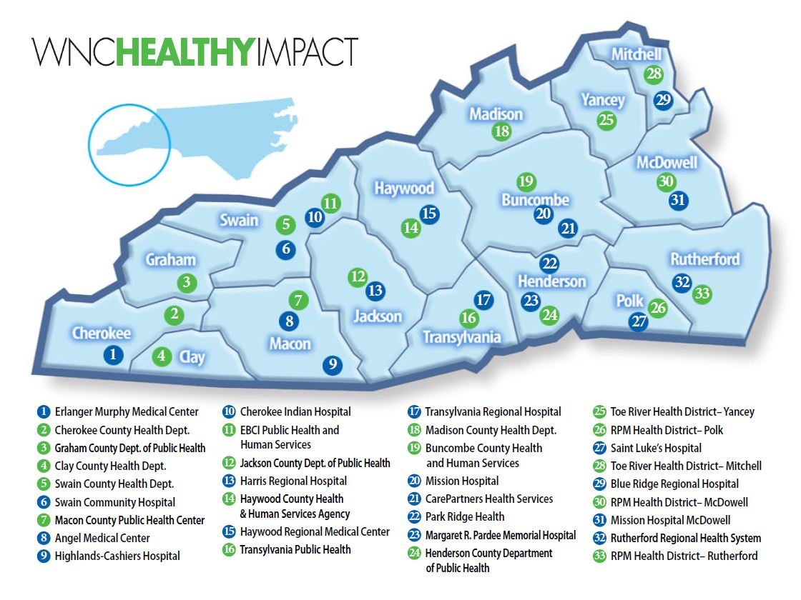
WNC Healthy Impact is a partnership and coordinated process between hospitals, public health agencies, and key regional partners in western North Carolina working towards a vision of improved community health. We work together locally and regionally to assess health needs, develop collaborative plans, take action, and evaluate progress and impact.

This regional initiative is designed to support and enhance local efforts by:
- Standardizing and conducting data collection,
- Creating communication and report templates and tools,
- Encouraging collaboration,
- Providing training and technical assistance,
- Addressing regional priorities, and
- Sharing evidence-based and promising practices.

This innovative regional effort is supported by financial and in-kind contributions from hospitals, public health agencies, and partners, and is coordinated by WNC Health Network. WNC Health Network, Inc. is an alliance of hospitals working together, and with partners, to improve health and healthcare. Learn more at www.WNCHN.org.

Data Collection Process
The set of data reviewed for our community health needs assessment process is comprehensive, though not all of it is presented in this document. Within this community health needs assessment we share a general overview of health and influencing factors, then focus more on priority health issues identified through a collaborative process. Our needs assessment also highlights some of our community strengths and resources available to help address our most pressing issues.

Core Dataset Collection
The data reviewed as part of our community’s health needs assessment came from the WNC Healthy Impact regional core set of data and additional local data compiled and reviewed by our local CHA team. WNC Healthy Impact’s core regional dataset includes secondary (existing) and primary (newly collected) data compiled to reflect a comprehensive look at health. The following data set elements and collection are supported by WNC Healthy Impact data consulting team, a survey vendor, and partner data needs and input:
- A comprehensive set of publicly available secondary data metrics with our county compared to the sixteen county WNC region
- Set of maps accessed from Community Commons and NC Center for Health Statistics
- WNC Healthy Impact Community Health Survey (cell phone, landline and internet-based survey) of a random sample of adults in the county
- Online key informant survey

See County A (insert hyperlink to the document online) and County B (insert hyperlink to the document online) Local Community Health Assessments for more details on the regional data collection methodology.

Additional Community-Level Data
CHA LOCATION: Find in CHA Chapter 1 – Community Health Assessment Process, Additional Community-Level Data
Health Resources Inventory
We conducted an inventory of available resources of our community by reviewing a subset of existing resources currently listed in the 2-1-1 database for our county as well as working with partners to include additional information. Where gaps were identified, we partnered with 2-1-1 to fill in or update this information when applicable. 2-1-1 is a free and confidential service that helps connect people across the country to the local resources that they need. Some examples of topics include emergencies and disasters, food, housing and utilities, human trafficking, and crises.

Gaps in Available Information
[Insert a general statement of any relevant information gaps that you feel limits the hospital’s ability to assess the community’s health needs.]

Community Input and Engagement
COMPLIANCE NOTE
For compliance purposes, this community input section should include a general written description of how the hospital facility solicited and took into account input received from all of the following (1) at least one state, local, tribal, or regional governmental public health department (or equivalent department or agency) with knowledge, information, or expertise relevant to the health needs of the community; (2) members of medically underserved, low-income, and minority populations in the community, or individuals or organizations serving or representing the interests of such populations; and (3) written comments received on the hospital facility’s most recently conducted CHNA and most recently adopted implementation strategy. If the hospital facility solicited, but could not obtain input from one of the required categories of persons, document that it made reasonable efforts to obtain such input, and describe any such efforts.

In addition to the sources listed in 1-3, a hospital facility may solicit and take into account input received from a broad range of persons located in or serving its community, including health care consumers and consumer advocates, non-profit and community-based organizations, academic experts, local government officials, local school districts, health care providers and community health centers, health insurance and managed care organizations, private businesses, and labor and workforce representatives. (Treas. Reg. § 1.501(r)-3(b)(5)) [delete this box in final reporting]

CHA LOCATION: Find in Acknowledgements Section at the beginning of the CHA.
Throughout the collaborative health needs assessment process in our community, input was obtained in a number of ways. See below for a list of all of the organizations that provided input into this process, the period of time they were involved, how their input was obtained, and the nature and extent of their input. Note: This section needs to include ALL the people; local community health coalition, prioritization, work groups, etc.

Agency | Role/ Contribution | Duration of Participant | Method of Input | Agency Website
ABC Health Department | Led CHA Advisory Committee | Winter 2017 | Committee Meetings | www.abchealth.org

Our collaborative health needs assessment process solicited and took into account input from the following:

Public Health Department
In the collaborative assessment process for our community, the [insert specific name – see Healthy Impact partner page for up-to-date public health agency names] is a key partner. They provided coordination for the local process that we help support and partner to implement. [Insert additional information as preferred about this partnership.]
Contact WNC Health Network staff if you have trouble finding this information. It is very important to include it in order to meet IRS requirements.

Medically underserved, low-income, and minority populations
Our process included input regarding the needs of medically underserved, low-income, and minority populations in two ways. (1) As part of our collaborative data collection effort, a community-wide telephone survey was conducted to better understand the specific health needs and status of all of the community, which includes these special populations. [Insert specific population percentages from the WNC Healthy Impact Community Health Survey] (2) In addition, a survey of key informants was conducted to gain input from the individuals and organizations in our community representing the interests of these populations in their local efforts. [Insert organizations and populations represented from the Online Key Informant Survey]
[Edit section to fit local process details and add information as appropriate].

Written Comments
Our facility also considers any written comments received since the last CHNA and implementation strategy. [Add a comment here about how your facility does this or whether you have received any feedback/comments since the 2016 CHNA. Remember, if the hospital facility solicited, but could not obtain input from one of the required categories of persons, document that it made reasonable efforts to obtain such input and describe any such efforts.]

Additional Input
In addition to the input described above, our facility, as part of our collaborative community health needs assessment process, took community input into account in the process of identifying health issues and priorities and identifying health resources available to address these needs. [Insert other info if you have something else not referenced above to still talk about re: community engagement – i.e. local focus groups or other data considered. You can always refer back to additional community-level data for to inform this section or you can delete this paragraph]


HEALTH NEEDS IN OUR COMMUNITY

Health Status
Data on the health status of our community [insert specific county or counties], and health factors that influence health are included in the full community health assessments for each county in our community. See County A and County B assessments for these details. [Insert hyperlinks to website or internal link to the Attachments section of this document if full documents are being included here.]

The collaborative local assessments include a basic review of trends and progress and changes in health status for the broad community. These assessments also include details on populations at risk or facing health disparities in our community.

CHA LOCATION: Find in CHA Chapter 1 – Community Health Assessment Process, At-Risk and Vulnerable Populations
Please confirm that the details on at-risk populations are in the local assessments, otherwise this is something that should be supplemented. Should include basic description of populations at risk/facing disparities in the county and health needs of medically underserved, low-income, and those experiencing health disparities. And/or, you could also list why assessing the health of these specific sub-populations is a challenge (e.g., difficult to access stratified data in rural communities where numbers are small.]

Health Issues

Process
CHA LOCATION: Find in CHA Chapter 8 – Identification of Health Priorities, Process

[Provide detail about the processes and methods used in identifying certain health needs as significant, for example, methods of analyzing data, parties with whom the hospital facility collaborated in this phase of the process. This information is within each local CHA for your reference.]
Identified Issues
Template Note: Find in CHA Chapter 8 – Identification of Health Priorities, Identified Issues
During the above process, the [name of your group] identified the following health issues or indicators:

County A [insert name of actual county and update the list with however many of these were included. This list should be within the local community CHA]:

- Insert name of issue 1: with a one sentence description about what that is/means

- Insert name of issue 2: with a one sentence description about what that is/means

- Insert name of issue 3: with a one sentence description about what that is/means

- Insert name of issue 4: with a one sentence description about what that is/means

- Insert name of issue 5: with a one sentence description about what that is/means

- Insert name of issue 6: with a one sentence description about what that is/means

- Insert name of issue 7: with a one sentence description about what that is/means

- Insert name of issue 8: with a one sentence description about what that is/means

- Insert name of issue 9: with a one sentence description about what that is/means

- Insert name of issue 10: with a one sentence description about what that is/means

County B: [insert name of actual county and update the list with however many of these were included. This list should be within the local community CHA]:

- Insert name of issue 1: with a one sentence description about what that is/means

- Insert name of issue 2: with a one sentence description about what that is/means

- Insert name of issue 3: with a one sentence description about what that is/means

- Insert name of issue 4: with a one sentence description about what that is/means

- Insert name of issue 5: with a one sentence description about what that is/means

- Insert name of issue 6: with a one sentence description about what that is/means

- Insert name of issue 7: with a one sentence description about what that is/means

- Insert name of issue 8: with a one sentence description about what that is/means

- Insert name of issue 9: with a one sentence description about what that is/means

- Insert name of issue 10: with a one sentence description about what that is/means

Priority Health Issues
COMPLIANCE NOTE
Hospital facilities have flexibility to choose how best to prioritize the significant health needs of their particular communities. However, to ensure transparency with respect to a hospital facility's prioritization, the final regulations, like the 2013 proposed regulations, require a hospital facility's CHNA report to describe the process and criteria used in prioritizing the significant health needs identified. In addition, the final regulations require a hospital facility to take into account community input not only in identifying significant health needs but also in prioritizing them. 79 FR 78963 [delete this box in final reporting]

Process & Criteria
CHA LOCATION: Find in CHA Chapter 8 – Identification of Health Priorities, Priority Health Identification, Process
[Insert a brief description of the process used in your community to identify priority health issues. Some placeholder text on criteria that may have been used in this process is included below. Full description of local process is included in local CHA for inclusion or reference. You could also highlight here the specific role the hospital had in deciding priorities.]

Identified Priorities
CHA LOCATION: Find in CHA Chapter 8 – Identification of Health Priorities, Priority Health Identification, Identified Priorities

The following priority health issues are the final community-wide priorities for our county that were selected through the process described above:

County A:

- Priority 1 – and why it was selected
- Priority 2 – and why it was selected

County B:

- Priority 1 – and why it was selected
- Priority 2 – and why it was selected

For more information about the community health priorities selected for COUNTY, read the Priority Issue sections in LINK TO CHA. In our facility-specific Implementation Strategy, we will discuss what role our facility will have in leading, collaborating on, or supporting others in responding to these health issues. The Implementation Strategy will be complete by DATE and available to the public WHEN AND WHERE.

AVAILABLE RESOURCES

Health Resources
COMPLIANCE NOTE
A hospital facility must document in its CHNA a description of resources potentially available to address the significant health needs identified through the CHNA. (Treas. Reg. § 1.501(r)-3(b)(6)(i)(E)). [delete this box in final reporting]
Contact WNCHN staff if if you have trouble finding Health Resources information. It is a requirement for hospital to append, but not for health departments (so it may not be in their CHA)
An inventory of available resources of our community was conducted through reviewing a subset of existing resources currently listed in the 2-1-1 database for our county as well as working with partners to include additional information. Where gaps were identified, we partnered with 2-1-1 to fill in or update this information when applicable. 2-1-1 is a free and confidential service that helps connect people across the country to the local resources that they need. Some examples of topics include emergencies and disasters, food, housing and utilities, human trafficking, and crises.

Process
CHA LOCATION: Find in CHA Chapter 7 – Health Resources, Process

Findings
CHA LOCATION: Find in CHA Chapter 7 – Health Resources, Findings
[Describe general findings about health-related services that are available in your community to address the identified priority health issues. The term “resources” can include programs, organizations, and facilities. Resources of the hospital may also be identified as resource.]

Resource Gaps
CHA LOCATION: Find in CHA Chapter 7 – Health Resources, Resource Gaps
[Based on local review of available resources and collaborative discussions around general availability of services (or those specifically related to prioritized needs), include a brief narrative about resources that are needed but are currently lacking.]


NEXT STEPS
COMPLIANCE NOTE
A hospital facility must make its CHNA report widely available to the public both by making the CHNA report widely available on a Web site and by making a paper copy of the CHNA report available for public inspection without charge upon request. The CHNA must remain posted and made available for public inspection until two subsequent CHNAs have been made widely available to the public (Treas. Reg. § 1.501(r)-3(b)(7). [delete this box in final reporting]

Sharing Findings
Our facility will post its CHNA report on the [insert hospital facility name – include hyperlink] website. The paper copy of our CHNA will be made available, upon request, at our hospital free of charge. Comments and suggestions from the public are welcome, and may be submitted via contact information on this webpage: [insert CHNA website location, if applicable. If not, provide an explanation about how the hospital is planning to accept comments from community members on this document.]

Collaborative Planning
Our hospital facility will participate in a collaborative planning process with our community partners which results in the creation of a community-wide plan at the county level. This plan outlines what strategies and related programs will be aligned, supported and/or implemented to address the priority health issues identified through this assessment process. Our hospital will then develop a facility-specific implementation strategy that speaks to our specific contributions to the identified priority health issues. We aim to leverage existing assets, avoid duplication, and implement evidence-based and innovative efforts, that contribute to the community-wide effort to build a healthy and thriving place to live, work and play.

[Insert other relevant next step information as preferred according to your facility’s processes.]

1/1/2019 Please update this date.
Date authorized by [insert name] body of hospital facility

WORKS CITED

Include all citations here. Citations below are included using APA, 6th edition.
Citation Chart: Easy-to-use cross-walk chart of MLA, APA and Chicago Manual of Style (CMOS) citations.
To cite data using APA in works cited use the following format:
Author/Owner (Year). Title of Data. [Data Type, i.e. Data File, Dataset]. Available/Retrieved from url - link.
- Use “Available from” if the url takes you to a webpage where you can access the data
- Use “Retrieved from” if the url takes you straight to the data source
- Use “Unpublished data” if you are citing local data that is not available to the public
Example: ABC Health Department. (2018). 2018 ABC County Community Health Local Survey. [Data File]. Unpublished data.
Note: Focus group/listening session data does not need to belong in works cited due to confidentiality.
To cite data sources throughout the CHNA document text use the following format:
(Last Name of Author/Owner of Data, Year).

Assessing & Addressing Community Health Needs (II Ed.). (2015). Community Health Association of the United States.

CDC. (2018). CDC Community Health Improvement Navigator. Retrieved from www.cdc.gov/chinav

County Health Rankings. (2018). Health Factors. Retrieved from http://www.countyhealthrankings.org/explore-health-rankings/what-and-why-we-rank/health-factors.

Office of Disease Prevention and Health Promotion. (2018). Healthy People 2020. Retrieved from https://www.healthypeople.gov/2020/topics-objectives/topic/social-determinants-health/interventions-resources/early-childhood-0.

United States Department of Treasury. Internal Revenue Service. Federal Register. No. 250, Vol. 79. Wednesday Dec 31st, 2014, p. 78689-79066

WNC Health Network. (2018). 2018 WNC Healthy Impact Community Health Survey: Data Workbook. [Data set]. Available from https://www.wnchn.org/partner-resources/. The in-text citation for 2018 WNC Healthy Impact Community Health Survey data is (WNC Health Network, 2018).

Photography Credits

Include any photography credits here. In the summary template, all photos should be credited:

Photos used on the cover and in headers from www.pexels.com; accessed October, 2018.

All WNC landscape photos used in the headers courtesy of Patrick Williams, Ecocline Photography.

Reach out to WNC Health Network if you need help accessing more photos from your county(ies).


APPENDIX

Appendix A – County A Community Health Assessment

Appendix B – County B Community Health Assessment

Appendix C – 2-1-1 Resource List

Additional Header Photos (cut and paste; delete when you have what you need. For a tutorial on report headers visit here):

























